**Reference flat-top equilibria for DEMO with aspect ratio 3.1**

***R. Ambrosino, R. Albanese***

***1. Requirements on the PF coils system and on the main plasma parameters***

The requirements imposed by the PROCESS run [1] and by EFDA Garching on the main plasma parameters and on the PF coil system are:

* The plasma equilibrium and the vertical stability calculations shall be carried out with the following plasma current profile parameters:
  + Plasma current $I_{pl}=19.6MA$
  + poloidal beta $β_{p}=1.107$
  + internal inductance $l_{i}=0.8$
  + Two different values of the flux on the plasma boundary with a constant plasma current $I_{pl}=19.6MA$ shall be considered: at Start of Flat Top (SOF) and End of Flat Top (EOF)
* The constraints imposed on the flat-top plasma shape concern plasma elongation, triangularity and volume, namely
$k_{95}≅1.59$

$δ_{95}≅0.33$

$V_{pl}≅2500 m^{3}$

* The maximum vertical force on the central solenoid stack shall not exceed 300 MN.
* The maximum separation force in the central solenoid stack shall not exceed 350 MN.
* The maximum vertical force on a single PF coil shall be 450 MN.
* In the case of two or more PF coils positioned close to each other: over a poloidal length of 3m the maximum total vertical force transferred to the TF coils shall be <450 MN.
* The distance at equatorial level of the plasma to the first wall shall be ≥225 mm.
* The minimum distance of the plasma top to the first wall shall be 600 mm.
* The poloidal coils cross-sections shall be determined assuming a current density limit of $12.5MA/m^{2}$.
* The maximum field on the PF and CS coils of 12.5 T.
* The strike points of the SOF and EOF configurations should be within 50mm

*Plasma vertical stability assessment*   
The growth rate and the stability margin shall be determined. An assessment of the "best achievable performance" shall be carried out providing a rough estimate of the installed power needed to counteract specific perturbations, which will be defined before the end of 2015.   
  
*Performance during breakdown*   
The coil system must be capable of having a pre-magnetization state with large poloidal magnetic flux and small (stray) poloidal magnetic field in a sufficiently large region. This shall be assessed and discussed.

***2. DEMO #01 geometry with spect ratio 3.1 and PF coil system configuration***

In Figure 1 the two-dimensional DEMO#01 geometry with aspect ratio 3.1 proposed by EFDA Garching [2] for the evaluation and the study of the equilibria is illustrated.

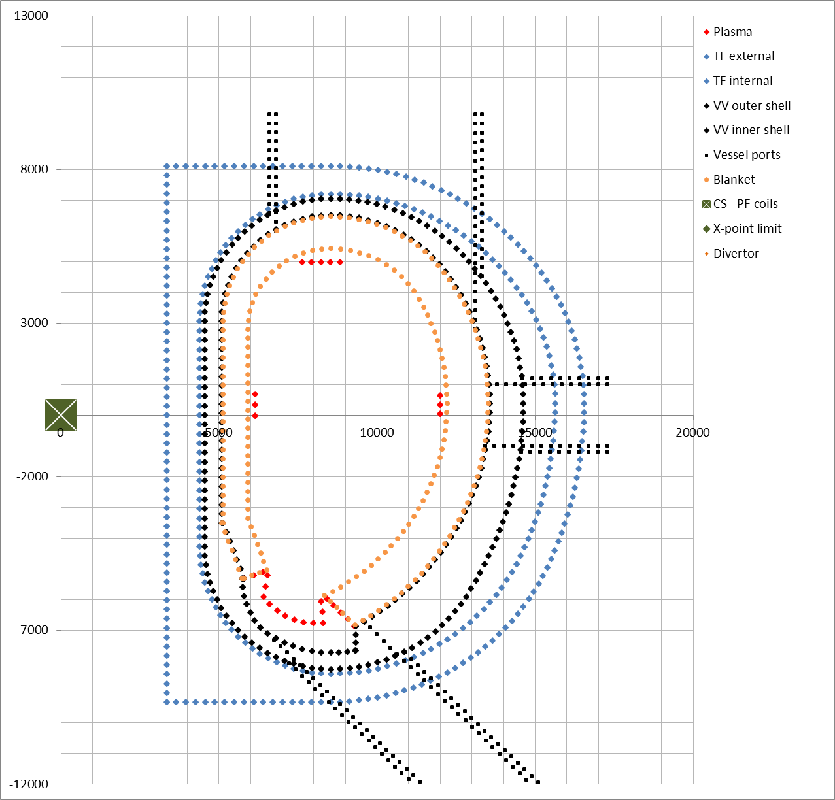

**Figure 1. New two-dimensional DEMO#01 geometry. The blue dots indicate the inner and outer TF walls, the black dots indicate the vessel inner and outer shall and the upper, equatorial and lower port, the orange dots indicate the blanket, the red dots indicate the bounds for the position the of X-point.**

The coil systems geometry assumed for this study is shown in Figure 2 and described in Table 1. The number (eleven) and position of the coils has been fixed starting from the eleven PF coils system configuration proposed in [5] taking into account the constraints related to the port location.

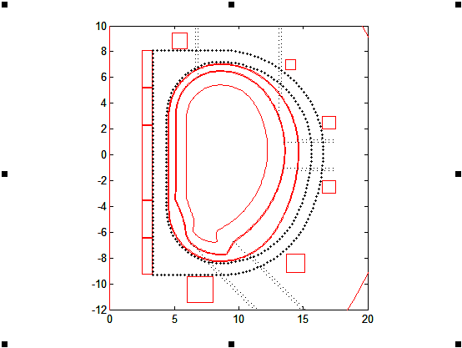

**Figure 2. Demo#01 new coil systems configuration.**

|  |  |  |  |  |  |
| --- | --- | --- | --- | --- | --- |
|  | **R [m]** | **Z [m]** | **DR [m]** | **DZ [m]** | **AR [m2]** |
| **CS3U** | 2.90 | 6.66 | 0.80 | 2.81 | 2.81 |
| **CS2U** | 2.90 | 3.75 | 0.80 | 2.81 | 2.81 |
| **CS1** | 2.90 | -0.61 | 0.80 | 5.71 | 5.71 |
| **CS2L** | 2.90 | -4.97 | 0.80 | 2.81 | 2.81 |
| **CS3L** | 2.90 | -7.88 | 0.80 | 2.81 | 2.81 |
| **P1** | 5.40 | 8.82 | 1.20 | 1.20 | 1.44 |
| **P2** | 14.00 | 7.00 | 0.80 | 0.80 | 0.64 |
| **P3** | 17.00 | 2.50 | 1.00 | 1.00 | 1.00 |
| **P4** | 17.00 | -2.50 | 1.00 | 1.00 | 1.00 |
| **P5** | 14.40 | -8.40 | 1.40 | 1.40 | 1.96 |
| **P6** | 7.00 | -10.45 | 2.00 | 2.00 | 4.00 |

**Table 1. Coils system geometry adopted for this study**

***3. Equilibrium configurations***

We have set up a 2D axisymmetric model for CREATE-NL (23752 nodes, 47186 elements), obtaining a a pre-magnetization of Ψ(*tBD*) = 320 Vs (Fig. 3 and Table II) and two flat top configurations at high beta (Fig. 4 and Table II).

The boundary flux @ EOF is ΨbEOF -157 Vs and cannot further be reduced because of the current and field limits. The boundary flux @ SOF ΨbSOF 143 Vs has been computed via Ejima scaling [4]:

$$Ψ_{b}=Ψ\left(t_{BD}\right)-L_{i}I_{p}-ΔΨ_{RES}≅143Vs$$

since $L_{i}I_{p}=0.5{}_{0}R_{0}l_{i}I_{p}≅88Vs$, $≅$ 88 *Vs* ( assuming).

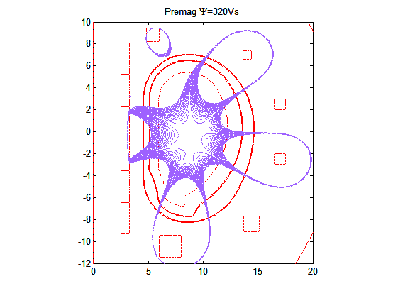

**Fig. 3. Pre-magnetization: A=3.1, Ψ = Ψ(*tBD*) = 320 Vs.**

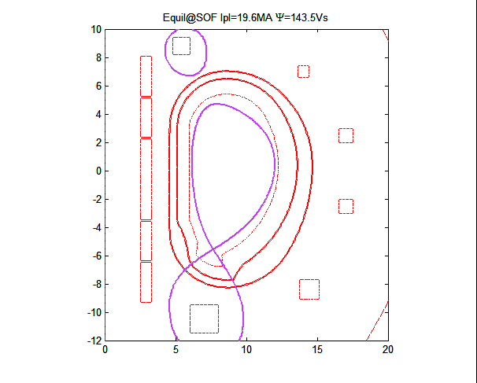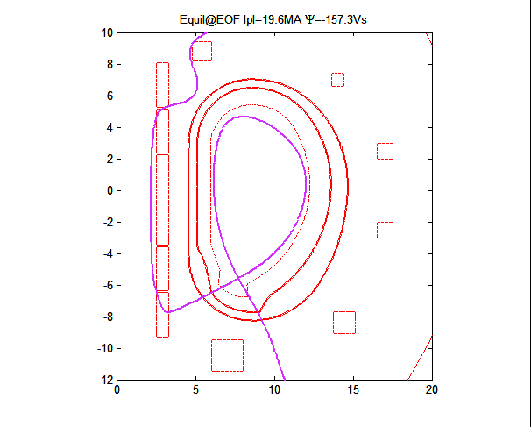

**Fig. 4. Reference equilibria at start of flat-top and end of flat top.**

|  |  |  |  |
| --- | --- | --- | --- |
|  | **Premag** | **SOF** | **EOF** |
| **ICS3U [MAt]** | 28.07 | 9.00 | -0.23 |
| **ICS2U [MAt]** | 28.07 | 5.60 | -28.05 |
| **ICS1 [MAt]** | 57.14 | -8.79 | -57.14 |
| **ICS2L [MAt]** | 28.07 | 7.01 | -27.82 |
| **ICS3L [MAt]** | 20.18 | 8.70 | -15.55 |
| **IP1 [MAt]** | 12.38 | 12.28 | -7.80 |
| **IP2 [MAt]** | 4.63 | -7.44 | -8.00 |
| **IP3 [MAt]** | -3.41 | 1.01 | -0.30 |
| **IP4 [MAt]** | 4.34 | -8.82 | -9.23 |
| **IP5 [MAt]** | -3.20 | -7.35 | -7.75 |
| **IP6 [MAt]** | 19.20 | 18.31 | 7.70 |
| **FzCS3U [MN]** | -820.35 | -3.63 | -6.62 |
| **FzCS2U [MN]** | -99.99 | 82.31 | -848.97 |
| **FzCS1 [MN]** | 32.45 | 5.41 | -52.66 |
| **FzCS2L [MN]** | 320.87 | -104.49 | 525.91 |
| **FzCS3L [MN]** | 619.04 | 24.30 | 566.53 |
| **FzP1 [MN]** | -409.10 | -141.74 | -88.75 |
| **FzP2 [MN]** | -21.07 | 51.39 | -35.88 |
| **FzP3 [MN]** | 19.56 | 13.42 | -4.84 |
| **FzP4 [MN]** | -4.58 | -133.42 | -86.01 |
| **FzP5 [MN]** | -40.97 | 93.49 | 169.64 |
| **FzP6 [MN]** | 404.62 | 120.02 | -130.40 |
| **Bmaxpol CS3U [T]** | 11.38 | 4.00 | 6.66 |
| **Bmaxpol CS2U [T]** | 11.59 | 3.27 | 9.83 |
| **Bmaxpol CS1 [T]** | 11.90 | 2.48 | 10.52 |
| **Bmaxpol CS2L [T]** | 11.51 | 3.45 | 9.99 |
| **Bmaxpol CS3L [T]** | 9.77 | 3.96 | 7.58 |
| **Bmaxpol P1 [T]** | 5.17 | 4.24 | 3.35 |
| **Bmaxpol P2 [T]** | 1.98 | 3.42 | 3.70 |
| **Bmaxpol P3 [T]** | 1.24 | 0.60 | 0.39 |
| **Bmaxpol P4 [T]** | 1.45 | 3.41 | 3.50 |
| **Bmaxpol P5 [T]** | 0.94 | 2.36 | 2.42 |
| **Bmaxpol P6 [T]** | 4.60 | 3.80 | 1.69 |
| **sum(abs(Currents)) [MA]** | 208.70 | 94.29 | 169.57 |
| **Max PF curr. dens. [MA/m^2]** | 12.50 | 11.62 | 12.50 |
| **Max Fz in P1-P6 [MA]** | 409.10 | 141.74 | 169.64 |
| **Max Fz_sep CS [MA]** | 52.02 | 82.14 | 184.18 |
| **Fzup [MN] on CS** | 52.02 | 84.09 | 184.18 |
| **Fzdown [MN] on CS** | 52.02 | -80.19 | 184.18 |
| **Max field in CS [T]** | 11.90 | 4.00 | 10.52 |
| **Max field in P1-P6 [T]** | 5.17 | 4.24 | 3.70 |

**Table 2. Currents, fields and vertical forces of the configurations**

|  |  |  |
| --- | --- | --- |
|  | **SOF** | **EOF** |
| **Ipl [MA]** | 19.60 | 19.60 |
| **Li** | 1.11 | 1.11 |
| **Betapol** | 0.80 | 0.80 |
| **Boundary flux [Vs]** | 143.50 | -157.29 |
| **Axis flux [Vs]** | 296.20 | -4.75 |
| **Rpl [m]** | 9.30 | 9.31 |
| **Zpl [m]** | 0.08 | 0.05 |
| **Raxis - node [m]** | 9.48 | 9.48 |
| **Zaxis - node [m]** | 0.15 | 0.15 |
| **Rbound - node [m]** | 7.62 | 7.67 |
| **Zbound - node [m]** | -5.58 | -5.64 |
| **a [m]** | 2.93 | 2.92 |
| **Btor [T]** | 5.63 | 5.63 |
| **betan** | 0.03 | 0.03 |
| **q_95** | 3.28 | 3.24 |
| **elongation (k)** | 1.76 | 1.76 |
| **k_95** | 1.61 | 1.62 |
| **Triangularity (Delta)** | 0.45 | 0.42 |
| **Delta_95** | 0.34 | 0.32 |
| **Perimeter [m]** | 25.57 | 25.66 |
| **Volume [m3]** | 2408.00 | 2423.87 |
| **growth rate [s-1]** | 2.40 | 2.45 |
| **stability margin (assuming flux conservation)** | 0.94 | 0.93 |

**Table III. Flat top configurations: plasma parameters.**

***4. Conclusions and future work***

Pre-magnetization and high beta plasma configurations @ SOF and EOF have been produced, with PF coil system geometry and currents.

Such configurations satisfy all constraints related to plasma current profile, plasma shape, geometry of the PF coil system, magnetic field, current density and load limits in the conductors.

Future work can be addressed to the optimization of CS/PF coil positions and cross sections, the production of other plasma configurations (e.g., those at low beta), and the vertical stability analysis.

***5. References***

[1] Process output ‘Demo1_a31_2015_04_16c.pdf’ ,produced the 16/04/2015 at 16:10 by Richard Kemp.

[2] DEMO geometry with aspect ratio 3.1 ‘A3.1_Baseline_18TF-1.xlsx’ provided by Christian Bachmann the 17/04/2015 by email.

[3] R. Albanese, R. Ambrosino, and M. Mattei. PMI TS Ref. No. 7.3.1.1 - Vertical Stability: Final Report 2014

[4] S. Ejima, et al., “Volt-second analysis and consumption in Doublet III plasmas”, Nuclear Fusion 22, 1313 (1982).