|  |  |  |  |  |  |
| --- | --- | --- | --- | --- | --- |
| **TS Title:** | *TF coil shaping procedure and configuration scan for 16-18 TF coils* | | | | |
| **Date:** | *28-01-2016* | **WBS Ref. Nr.:** | *PMI-3.2* | **Project:** | *WPPMI* |
| **IDM Ref.** | *EFDA_D_*[*2MLTC7*](https://idm.euro-fusion.org/?uid=2MLTC7) | **TS Ref. Nr.:** | *PMI-3.2-T017* | **Task coordinator:** | *M. Coleman* |

**Technical Specification:**

A procedure/methodology for the shaping the TF coil (winding pack and casing) in 3D shall be developed according to the following constraints:

* Maximum allowable TF ripple in between coils at the 95th percentile flux surface 0.6% (assuming no contributions from ferritic inserts and EUROfer blankets)
* The magnitude of the toroidal field at the centre of the plasma R shall be taken from the respective PROCESS code runs.
* CS coils shall be 100mm off the TF coil surface in the bore.
* PF coils shall be positioned 300mm off the outer TF coil surface. The procedure shall allow the consideration of poloidal exclusion zones for the PF coils (corresponding to the presence of the VV ports).
* The TF coil shall keep a clearance to the vacuum vessel (VV) of 200mm (to allow for integration of the thermal shields and differential thermal expansion). The procedure shall allow consideration of different VV shapes, whilst maintaining the clearance in all locations.
* The PF coils shall keep clearances to the VV ports and to the TF coil (shown in Figure 1)
* The height of the TF shall be minimised
* The required thickness of the TF coil casing shall be kept below a reasonable limit, e.g. 200mm, considering all load conditions and a maximum membrane stress of 660 MPa.
* The stresses in the winding pack shall not exceed the limits defined by MAG.
* The outer-inter coil structures shall be of sufficient size to withstand the loads during operation. These shall also keep a clearance of 200 mm to the VV ports.
* The TF winding pack and stored energy in the TF and PF coil sets will be compatible quench discharge constants. [2MBSE3](https://idm.euro-fusion.org/?uid=2MBSE3)

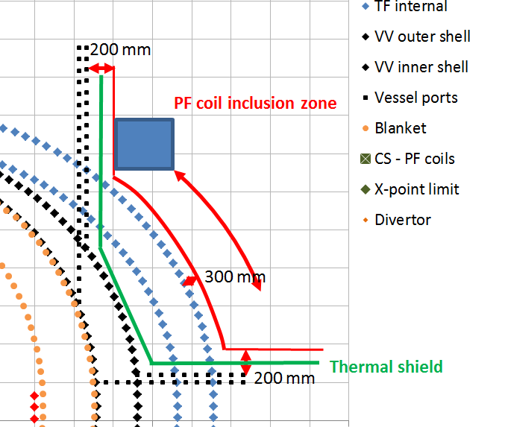

Figure 1 - Inclusion zone for the PF coil (example) – based on [2MG46D](https://idm.euro-fusion.org/?uid=2MG46D)

Methods for homogenising the properties of the winding pack shall be supplied by members of the WPMAG team (and detailed in [2ANVM7](https://idm.euro-fusion.org/?uid=2ANVM7)), and meetings will be held together with the WPMAG team to ensure consistency.

This procedure shall be written and executed in such a way that it can be used by members of the PMU repeatedly to shape the TF coils in 3D (with separate volumes for the winding pack and casing) for the issuing of DEMO CAD baselines. The procedure will account for all electromagnetic forces acting on the TF coils, gravitational loads, reaction loads from the gravity supports, and vertical reaction loads from the PF and CS coil sets transferred through the TF coils. Loads will be evaluated at a number of points across a reference CS flux swing. Emergency loads, such as those resulting from the loss of current in a single TF coil, will not be considered.

The procedure shall be applied to the **EU-DEMO 2015 baseline**:

* PROCESS 1 page output: [2LBJRY](https://idm.euro-fusion.org/?uid=2LBJRY)
* PROCESS full output: [2MDKFH](https://idm.euro-fusion.org/?uid=2MDKFH)
* Plasma equilibrium description and eqdsk files: [2AQ5GP](https://idm.euro-fusion.org/?uid=2AQ5GP)
* Initial 2D geometry (incl. TF shaping): [2MG46D](https://idm.euro-fusion.org/?uid=2MG46D)
* CAD (incl. TF cross-section and 3D): [2M9AJJ](https://idm.euro-fusion.org/?uid=2M9AJJ). NOTE: The cross section for the TF coil shown here is incorrect, and has been adjusted to a winding pack radial thickness of 625 mm, and not 500mm, in the inboard direction. Corrected drawings can be found here: [2LMDTE](https://idm.euro-fusion.org/?uid=2LMDTE).

And two variants of the single-null DEMO, based on 2016 PROCESS runs to find two satisfactory TF coil configurations for these DEMO architectures:

* **SN-16 2016** [A=3.1, n_TF=16]: PROCESS output will be provided
* **SN-18 2016** [A=3.1, n_TF=18]: PROCESS output will be provided

This exercise will contribute to a comparison of 16 vs 18 TF coil architecture options. The following parameters shall be measured for each configuration:

* Metrics relating to total magnet cost, e.g. conductor volume, steel volume
* TF coil height
* Total stored energy within TF magnet set (assuming a balanced discharge of all TF coils)

The results from the above configurations and other design points studied in the optimisation process shall be used to derive some simplified engineering limits and rules of thumb on the minimum allowable radius of the magnet in various locations. NOTE: these limits are only expected to be provided from a structural perspective; manufacturing and/or conductor bend radius limitations are not part of the scope of this work.

**Deliverable(s) of this task:**

|  |  |  |  |  |  |  |  |  |  |
| --- | --- | --- | --- | --- | --- | --- | --- | --- | --- |
|  | | | | | | | **AWP2016** | | |
| **ID** | **Title** | **Start Date** | | **Due date** | **RU** | **Del. Owner** | **ppy** | **ppy**  **Ind.** | **HW**  **[k€]\*** |
| *PMI-3.2-T017-D001* | Report on the TF coil shaping procedure and configuration scan for 16-18 TF coils | 01-03-16 | | 15-08-16 | CCFE | S. McIntosh | 0.4 |  |  |
| *\*) real costs (excluding overheads)* | | | **Total** | | | | **0.4** |  |  |

|  |
| --- |
| **Acceptance criteria for this task:** (Deliverable(s) to be issued and approved through EUROfusion IDM)  - The task shall be carried out along the lines defined in the technical specification.  - The deliverable shall be uploaded to:[2MQ568](https://idm.euro-fusion.org/?uid=2MQ568) |
| **IDM roles** (for the approval of this task specification)   |  |  | | --- | --- | | Author | M. Coleman | | Co-authors |  | | Reviewer(s) | S. McIntosh  L. Zani | | PMU Reviewer | C. Bachmann | | Approver | G. Federici | |