

Alexandria University

OPERATING SYSTEMS

LAB 2

Faculty of Engineering

Project Management

NAME: TOKA SHERIF ID: 5492 Group:5 sec:2

CODE part 1) Matrix Multiplication

Pseudo :

1-Void * Mult (void * arg ){

the function the thread calls to perform 1 elment multiplication

}

2-Void main_element_by_elment ()

{

Perform array data store each row and column need to be multiplied in 1 dimmentional array

Then pass the array through a thread

}

3-Void * mult_join_row (void * arg ){

the function the thread calls to perform multiplication of row by the second matrix all

}

4-Void main_row ()

{

Perform 1 dimensional array of elements of each row and the second matrix as 1 dimensional matrix arranged column by column to be easily multiplied

}

CODE:

#include<stdio.h>

#include<pthread.h>

#include<unistd.h>

#include<stdlib.h>

#include <time.h>

#define MAX 10

FILE *f;

void *mult(void* arg)

{

int *data = (int *)arg;

int k = 0, i = 0;

int columnsA = data[0];

for (i = 1; i <= columnsA; i++)

k += data[i]*data[i+columnsA];

int *p = (int*)malloc(sizeof(int));

*p = k;

pthread_exit(p);

}

int main_elment_by_element ()

{

int rowsA,columnsA,rowsB,columnsB ;

int i,j,k;

f = fopen("matrix_input.txt","r");

printf("ELEMENT BY ELEMENT METHOD\n");

printf("reading file ......\n");

fscanf(f,"%d %d", &rowsA,&columnsA);

int matA[rowsA][columnsA];

for (i = 0; i < rowsA; i++)

{

for (j = 0; j < columnsA; j++)

{

fscanf(f,"%d", &matA[i][j]);

}

}

fscanf(f,"%d %d", &rowsB,&columnsB);

int matB[rowsB][columnsB];

for (i = 0; i < rowsB; i++)

{

for (j = 0; j < columnsB; j++)

{

fscanf(f,"%d", &matB[i][j]);

}

}

printf("\n*****************\n");

printf("Matrix A\n");

// Displaying matA

for (i = 0; i < rowsA; i++)

{

for(j = 0; j < columnsA; j++)

printf("%d ",matA[i][j]);

printf("\n");

}

printf("Matrix B\n");

// Displaying matB

for (i = 0; i < rowsB; i++)

{

for(j = 0; j < columnsB; j++)

printf("%d ",matB[i][j]);

printf("\n");

}

printf("\n*****************\n");

fclose(f);

int max = rowsA*columnsB;

clock_t start, end;

double cpu_time_used;

start = clock();

pthread_t *threads;

threads = (pthread_t*)malloc(max*sizeof(pthread_t));

int count = 0;

int* data = NULL;

for (i = 0; i < rowsA; i++)

for (j = 0; j < columnsB; j++)

{

//storing row and column elements in data

data = (int *)malloc((20)*sizeof(int));

data[0] = columnsA;

for (k = 0; k < columnsA; k++)

data[k+1] = matA[i][k];

for (k = 0; k < rowsB; k++)

data[k+columnsA+1] = matB[k][j];

//creating threads

pthread_create(&threads[count++], NULL, mult, (void*)(data));

}

f = fopen("matrix_output.txt","w");

printf("RESULTANT MATRIX IS :- \n");

for (i = 0; i < max; i++)

{

void *k;

//Joining all threads and collecting return value

pthread_join(threads[i], &k);

int *p = (int *)k;

printf("%d ",*p);

fprintf(f,"%d ",*p);

if ((i + 1) % columnsB == 0)

{

printf("\n");

fprintf(f,"\n");

}

}

end = clock();

cpu_time_used = ((double) (end - start)) / CLOCKS_PER_SEC;

printf("Program took %f seconds to execute \n", cpu_time_used);

fprintf(f,"END1 %f\n",cpu_time_used);

return cpu_time_used;

}

/* *******************************************************************************/

void * mult_join_row (void* arg_2)

{

int *data_2 = (int *)arg_2;

int k = 0, i = 0;

int shifter;

int rowsB = data_2[0];

int columnsB = data_2[1];

int resulted_array[columnsB];

int * p_2 = (int)malloc(rowsB*sizeof(int));

int *l = p_2;

for(shifter=1 ; shifter <= columnsB ; shifter++ )

{

for (i = 2 ; i <= rowsB+1 ; i++)

{

k += data_2[i]*data_2[i+rowsB*shifter];

}

//resulted_array[shifter]=k;

//k=0;

*p_2 ++ = k;

k=0;

}

pthread_exit(l);

}

int main_row()

{

int rowsA,columnsA,rowsB,columnsB ;

// int r1=MAX,c1=MAX,r2=MAX,c2=MAX;

int i,j,k;

FILE *f_2 = fopen("matrix_input.txt","r");

printf("\n********************\n");

printf("\n********************\n");

printf("\n");

printf("ROW BY ROW METHOD\n");

printf("reading file ......\n");

// printf("Enter no. of rows & columns for Matrix A ::");

fscanf(f_2,"%d %d", &rowsA,&columnsA);

int matA[rowsA][columnsA];

//printf("\nEnter values to the matrix :: \n");

for (i = 0; i < rowsA; i++)

{

for (j = 0; j < columnsA; j++)

{

fscanf(f_2,"%d", &matA[i][j]);

}

}

//printf("Enter no. of rows for Matrix B ::");

fscanf(f_2,"%d %d", &rowsB,&columnsB);

int matB[rowsB][columnsB];

//printf("\nEnter values to the matrix :: \n");

for (i = 0; i < rowsB; i++)

{

for (j = 0; j < columnsB; j++)

{

//printf("\nEnter B[%d][%d] value :: ",i,j);

fscanf(f_2,"%d", &matB[i][j]);

}

}

printf("\n*****************\n");

printf("Matrix A\n");

// Displaying matA

for (i = 0; i < rowsA; i++)

{

for(j = 0; j < columnsA; j++)

printf("%d ",matA[i][j]);

printf("\n");

}

printf("Matrix B\n");

// Displaying matB

for (i = 0; i < rowsB; i++)

{

for(j = 0; j < columnsB; j++)

printf("%d ",matB[i][j]);

printf("\n");

}

printf("\n*****************\n");

int max = rowsA+(rowsB*columnsB);

clock_t start, end;

double cpu_time_used;

start = clock();

//declaring array of threads of size r1*c2

pthread_t *threads_2;

threads_2 = (pthread_t*)malloc(rowsA*sizeof(pthread_t));

int count = 0;

int* data_2 = NULL;

for (i = 0; i < rowsA; i++)

{

//storing row and column elements in data

data_2 = (int *)malloc((max+2)*sizeof(int));

data_2[0] = rowsB;

data_2[1] = columnsB ;

for (k = 0; k < columnsA; k++)

data_2[k+2] = matA[i][k];

int counter = 0 ;

for(j =1 ; j <= columnsB ; j ++)

{

for (k = 0; k < (rowsB) ; k++)

{

data_2[k+columnsA*j+2] = matB[k][j-1];

//data1[k+c1*j+2] = matB[k][j-1];

//data[counter+columnsA+2] = matB[k][j];

//counter++;

}

}

//creating threads

pthread_create(&threads_2[count++], NULL, mult_join_row, (void*)(data_2));

}

fclose(f_2);

//f_2=fopen("matrix_output.txt","a");

printf("RESULTANT MATRIX IS :- \n");

for (i = 0; i < rowsA ; i++)

{

void *k_2;

//Joining all threads and collecting return value

pthread_join(threads_2[i], &k_2);

int *p_2 = (int *)k_2;

for(j=0 ; j< columnsB ; j++)

{

fprintf(f,"%d ",*p_2);

printf("%d ",*p_2);

*p_2++;

}

printf("\n");

fprintf(f,"\n");

}

end = clock();

cpu_time_used = ((double) (end - start)) / CLOCKS_PER_SEC;

printf("Program took %f seconds to execute \n", cpu_time_used);

fprintf(f,"END2 %f",cpu_time_used);

fclose(f_2);

fclose(f);

return cpu_time_used;

}

int main()

{

int first_time_elapsed = main_elment_by_element() ;

int secind_time_elapsed = main_row();

}

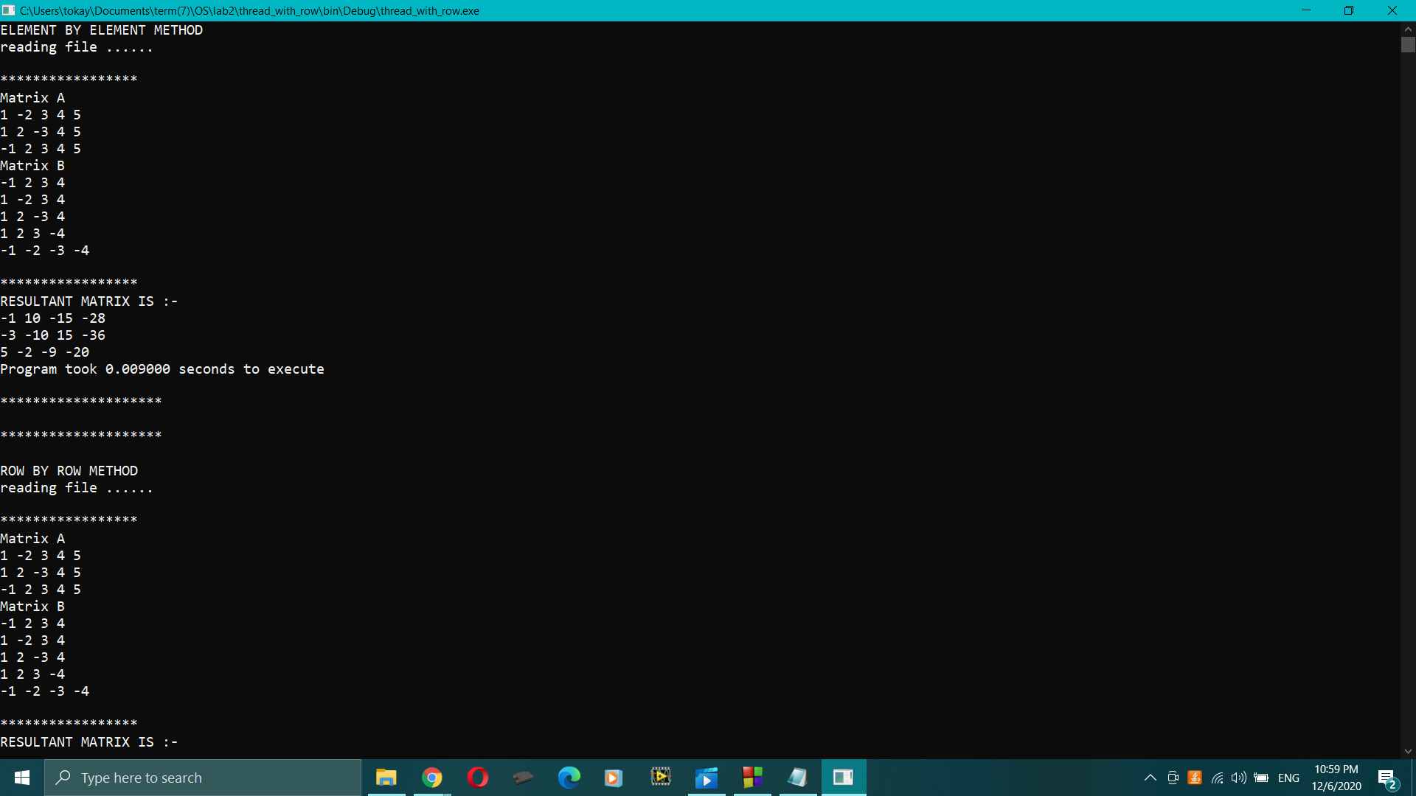

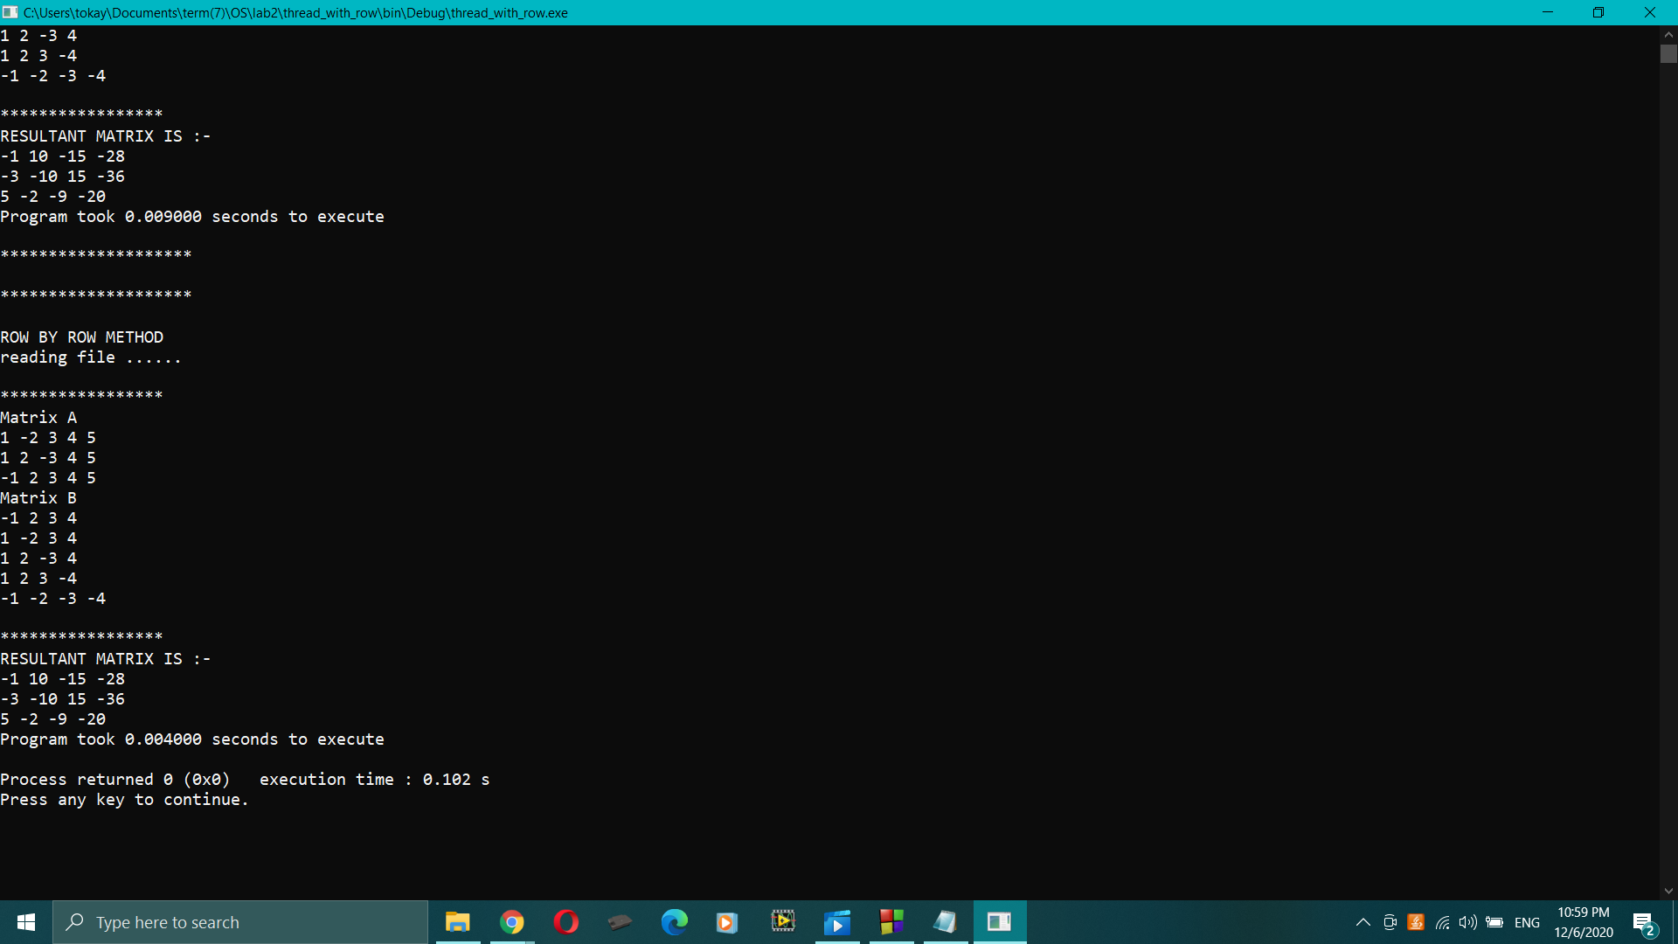

CODE part 2) Merge Sort

Pseudo :

struct struct_list{

int low ;

int high;

}

Merge{

After partiotioning it merge 2 sub-lists to be ordered

}

Void* mergeSort(void* arg )

{

Create 2 structs

Create 2 threads

First thread and struct passed to pthread_create for left list

Join returned values

Second thread and struct passed to pthread_create for right list

Join returned values

Merge all

}

CODE:

/* C program for Merge Sort */

#include <stdio.h>

#include <stdlib.h>

#include <pthread.h>

// Merges two subarrays of arr[].

// First subarray is arr[l..m]

// Second subarray is arr[m+1..r]

struct struct_list {

int low;

int high;

};

int *arr;

void merge( int l, int m, int r)

{

int i, j, k;

int n1 = m - l + 1;

int n2 = r - m;

int L[n1], R[n2];

for (i = 0; i < n1; i++)

L[i] = arr[l + i];

for (j = 0; j < n2; j++)

R[j] = arr[m + 1 + j];

i = 0;

j = 0;

k = l;

while (i < n1 && j < n2) {

if (L[i] <= R[j]) {

arr[k] = L[i];

i++;

}

else {

arr[k] = R[j];

j++;

}

k++;

}

while (i < n1) {

arr[k] = L[i];

i++;

k++;

}

while (j < n2) {

arr[k] = R[j];

j++;

k++;

}

}

void* mergeSort(void* arg)

{

//printf("entred thread\n ");

struct struct_list *data;

data = (struct struct_list*) malloc( sizeof(struct struct_list));

data = (struct struct_list*) arg ;

//printf("low_arg :: %d\n",data->low);

//printf("high_arg :: %d\n",data->high);

int l = data->low;

int r= data->high;

if (l < r) {

int mid = l + (r - l) / 2;

struct struct_list list_left;

list_left.low=l;

list_left.high = mid;

//printf("low_leftthread :: %d\n",list_left.low);

//printf("high_leftthread :: %d\n",list_left.high);

//printf("\n******************\n");

struct struct_list list_right;

list_right.low = mid+1;

list_right.high= r;

//printf("low_rightthread :: %d\n",list_right.low);

//printf("high_rightthread :: %d\n",list_right.high);

//printf("\n******************\n");

pthread_t thread_left;

pthread_create(&thread_left , NULL , mergeSort , (void*) &list_left );

pthread_join(thread_left,NULL);

pthread_t thread_right ;

pthread_create(&thread_right ,NULL , mergeSort , (void *) &list_right);

pthread_join(thread_right,NULL);

merge(l, mid, r);

}

}

void printArray(int A[], int size)

{

FILE * f;

f = fopen("output_merge.txt","w");

int i;

for (i = 0; i < size; i++)

{

printf("%d ", A[i]);

fprintf(f,"%d",A[i]);

}

printf("\n");

}

int main()

{

FILE* f ;

f = fopen("input_merge.txt","r");

int arr_size,i;

fscanf(f,"%d",&arr_size);

arr = (int *)malloc((arr_size)*sizeof(int));

for(i=0 ;i<arr_size;i++)

fscanf(f,"%d",&arr[i]);

printf("THE ARRAY FROM FILE::\n");

for(i=0 ; i< arr_size ; i++)

printf("%d ",arr[i]);

printf("\n**********\n");

struct struct_list * list;

list = (struct struct_list*) malloc( sizeof(struct struct_list));

list->low = 0;

list->high=arr_size-1;

// printf("mainArray_low:: %d\n",list->low);

//printf("mainArray_high :: %d\n",list->high);

// printf("\n******************\n");

pthread_t thread;

pthread_create(&thread , NULL , mergeSort , (void*) list );

pthread_join(thread,NULL);

//printf("returned from merge\n");

fclose(f);

printf("\n**********\n");

printf("\nSorted array is \n");

printArray(arr, arr_size);

return 0;

}

