**Lab 1**

**Operation Systems**

**Name: Toka Sherif Id:5492**

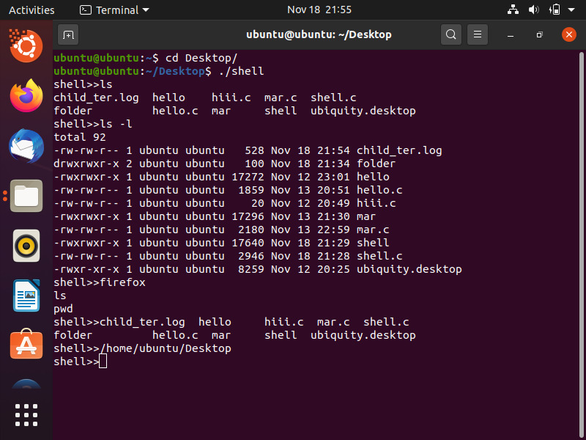

1. Performing command with no arguments



1. Performing command with arguments

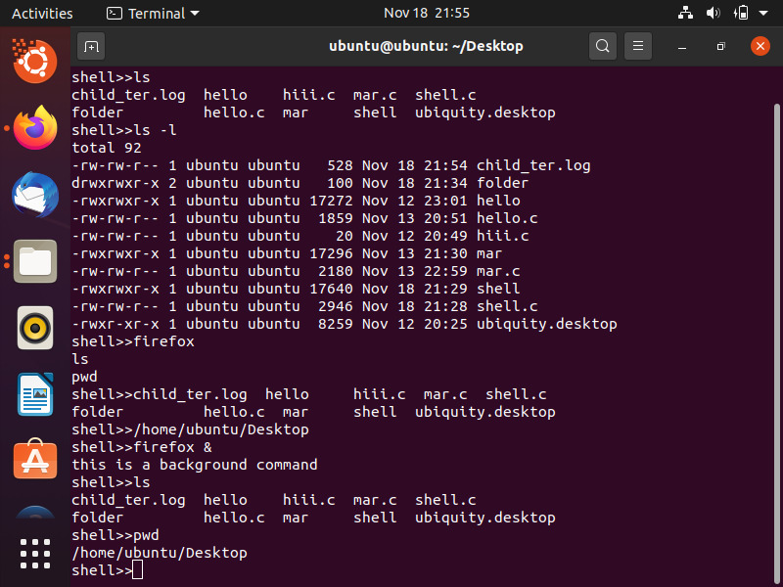

1. Performing command in foreground
2. Performing command in background

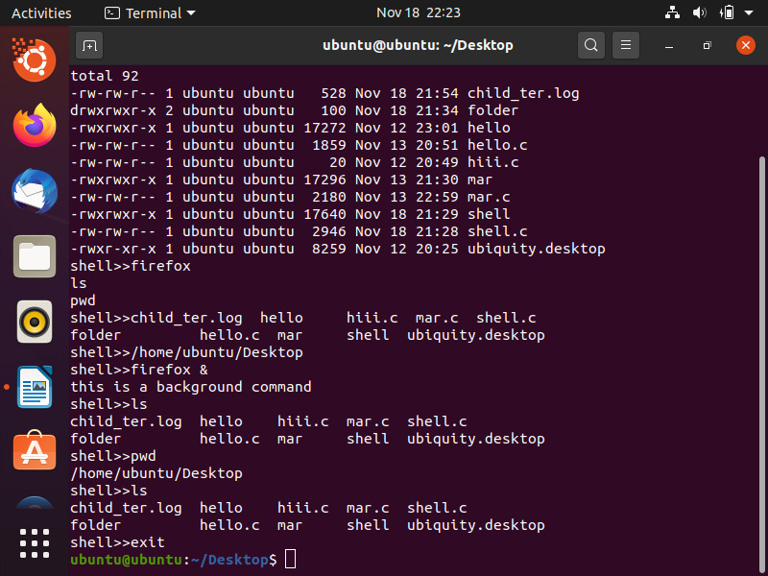

5)performing exit command

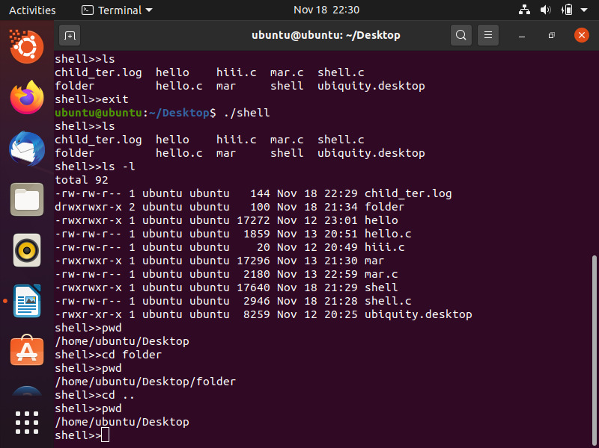

6)performing cd command

**Code:**

#include <stdio.h>

#include <unistd.h>

#include <string.h>

#include<sys/wait.h>

#include<errno.h>

#include <stdlib.h>

#include <signal.h>

#include <sys/types.h>

#include <time.h>

int forking(int flag ,char* argv[])

{

pid_t pid;

pid = fork();

if(pid >= 0)

{

if(pid == 0)

{

if(execvp(argv[0], argv)<0)

{

perror("\nError");

exit(1);

//exit(-1);

}

}

else if(pid > 0)

{

if(flag==0)

{

waitpid(pid,NULL,0);

}

else

{

flag=0;

return flag ;

}

}

}

else

{

perror("\nError in fork");

exit(1);

}

}

void file_handler(int sig)

{

/*FILE * f;

f = fopen ("data.txt","a");

fprintf (f, "The process terminated\n");

fclose(f);*/

time_t current_time;

char* c_time_string;

/* Obtain current time. */

current_time = time(NULL);

if (current_time == ((time_t)-1))

{

(void) fprintf(stderr, "Failure to obtain the current time.\n");

exit(EXIT_FAILURE);

}

/* Convert to local time format. */

c_time_string = ctime(&current_time);

if (c_time_string == NULL)

{

(void) fprintf(stderr, "Failure to convert the current time.\n");

exit(EXIT_FAILURE);

}

FILE *fp ;

fp = fopen("child_ter.log","a");

fprintf(fp,"%s My child terminated \n ", c_time_string);

fclose(fp);

}

int cd(char *path) {

return chdir(path);

}

int main()

{

//reading line

char str[80];

char* command_argument[80] ;

//tokenization

const char s[2] =" ";

char *token;

//termination

int state;

while(1)

{

int bg = 0 ;

int counter = 0 ;

printf("shell>>");

gets(str);

//("%[^\n]",str);

if(strcasecmp(str,"exit") == 0)

{

exit(0);

}

token = strtok(str, s);

while( token != NULL )

{

command_argument[counter] = token ;

token = strtok(NULL, s);

counter ++ ;

}

//check in background

if(strcmp(command_argument[counter-1],"&") == 0)

{

command_argument[counter-1]=NULL;

printf("this is a background command\n");

bg = 1 ;

counter--;

}

//check cd command

else if(strcmp(command_argument[0], "cd") == 0){

if (cd(command_argument[1]) < 0) {

perror(command_argument[1]);

}

continue;

}

else{

command_argument[counter]=NULL;

}

signal(SIGCHLD, file_handler);

bg = forking (bg,command_argument);

}

}