Cairo University Faculty of Computers and Information



**CS352 – Software Engineering II**

**Phase 2-b Template**

**2015**

**Project Team**

|  |  |  |  |
| --- | --- | --- | --- |
| **ID** | **Name** | **Email** | **Mobile** |
| 20120138 | Paula Youssef gerges salama | Paula_youssef696@yahoo.com | 01144385706 |
| 20120168 | Doaa Magdy Mohamed Mahmoud | do3a2magdy2012@gmail.com |  |
| 20120141 | Toka Sobhy Hassan | tokasobhy132@yahoo.com |  |
| 20120131 | Bassem Sarhan Ali | Bassem_sarhan@yahoo.com | 01287297457 |

**Staff: Dr Mohammad El-Ramly m.elramly@fci-cu.edu.eg**

**Eng Ahmed Mohamed Sayed a.mohamed@fci-cu.edu.eg**

**Eng Ayat Khairy ayat.khairy@fci-cu.edu.eg**

Title page has no header or footer.

Docs must be supplied as pdf –files re-named as requested

Contents

Your Restful API 3

Class diagram design 4

Daily scrum Meetings 5

Trello workspace screenshot 5

Github repository link 6

# 

# Your Restful API

**Create Post Service:**

|  |  |
| --- | --- |
| **Service name** | **Createpostservice** |
| **Input type** | **POST** |
| **Service URL** | **http://fci-swe-apps.appspot.com/rest/createpostService** |
| **Parameters** | |  |  |  | | --- | --- | --- | | **postowner** | **content** | **numberoflikes** | | **postowner** | **content** | **numberoflikes** | |
| **Example request** | **POST**  **http://** **fci-swe-apps.appspot.com /rest/createpostService?postowner=** **doaa&content=hello&numberoflikes=0** |
| **Example response** | **{"postowner":"doaa","content":"hello","numberoflikes":"1"}** |

**Page post Service**

|  |  |
| --- | --- |
| **Service name** | **pagepostService** |
| **Input type** | **POST** |
| **Service URL** | **http://fci-swe-apps.appspot.com/rest/pagepostService** |
| **Parameters** | |  |  |  |  |  | | --- | --- | --- | --- | --- | | **postowner** | **content** | **numberoflikes** | **Numberofseen** | **numberofusers** | | **postowner** | **content** | **numberoflikes** | **numberofseen** | **numberofusers** | |
| **Example request** | **POST**  **http://** **fci-swe-apps.appspot.com /rest/pagepostService?postowner=** **doaa&content=hello&numberoflikes=0&numberofseen=1&numberofusers=1** |
| **Example response** | **{"postowner":"doaa","content":"hello","numberoflikes":"1",numberofseen=”1”,numberofusers=”1”}** |

**User post Service:**

|  |  |
| --- | --- |
| **Service name** | **UserpostService** |
| **Input type** | **POST** |
| **Service URL** | **http://fci-swe-apps.appspot.com/rest/userpostService** |
| **Parameters** | |  |  |  |  |  |  | | --- | --- | --- | --- | --- | --- | | **postowner** | **content** | **numberoflikes** | **Numberofseen** | **numberofusers** | **feeling** | | **postowner** | **content** | **numberoflikes** | **numberofseen** | **numberofusers** | **feeling** | |
| **Example request** | **POST**  **http://** **fci-swe-apps.appspot.com /rest/userpostService?postowner=** **doaa&content=hello&numberoflikes=0&numberofseen=1&numberofusers=1&feeling=eating** |
| **Example response** | **{"postowner":"doaa","content":"hello","numberoflikes":"1","numberofseen":"1","numberofusers":"1","feeling":"eating"}** |

**Share post Service:**

|  |  |
| --- | --- |
| **Service name** | **sharepostService** |
| **Input type** | **POST** |
| **Service URL** | **http://fci-swe-apps.appspot.com/rest/sharepostService** |
| **Parameters** | |  |  |  |  |  |  | | --- | --- | --- | --- | --- | --- | | **postowner** | **content** | **numberoflikes** | **Numberofseen** | **numberofusers** | **feeling** | | **postowner** | **content** | **numberoflikes** | **numberofseen** | **numberofusers** | **feeling** | |
| **Example request** | **POST**  **http://** **fci-swe-apps.appspot.com /rest/sharepostService?postowner=** **doaa&content=hello&numberoflikes=0&numberofseen=1&numberofusers=1&feeling=eating** |
| **Example response** | **{"postowner":"doaa","content":"hello","numberoflikes":"1","numberofseen":"1","numberofusers":"1","feeling":"eating"}** |

**Post Privacy:**

|  |  |
| --- | --- |
| **Service name** | **postprivacyService** |
| **Input type** | **POST** |
| **Service URL** | **http://fci-swe-apps.appspot.com/rest/postprivacyService** |
| **Parameters** | |  |  |  |  |  |  | | --- | --- | --- | --- | --- | --- | | **postowner** | **content** | **numberoflikes** | **Numberofseen** | **numberofusers** | **postprivacy** | | **postowner** | **content** | **numberoflikes** | **numberofseen** | **numberofusers** | **postprivacy** | |
| **Example request** | **POST**  **http://** **fci-swe-apps.appspot.com /rest/postprivacyService?postowner=** **doaa&content=hello&numberoflikes=0&numberofseen=1&numberofusers=1&feeling=eating&postprivacy=public** |
| **Example response** | **{"postowner":"doaa","content":"hello","numberoflikes":"1","numberofseen":"1","numberofusers":"1","feeling":"eating","postprivacy":"public"}}** |

**Hashtag statistics Service:**

|  |  |
| --- | --- |
| **Service name** | **Hashtagstatisticsservice** |
| **Input type** | **POST** |
| **Service URL** | **http://fci-swe-apps.appspot.com/rest/ Hashtagstatistics Service** |
| **Parameters** | |  | | --- | | **hashtag** | | **hashtag** | |
| **Example request** | **POST**  **http://** **fci-swe-apps.appspot.com /rest/ Hashtagstatistics Service?hashtag=#** **fci** |
| **Example response** | **{"hashtag":"fci"}** |

**Hashtag trends Service**

|  |  |
| --- | --- |
| **Service name** | **GetMostTenHashTagService** |
| **Input type** | **POST** |
| **Service URL** | **http://fci-swe-apps.appspot.com/rest/hashtagtrendsService** |
| **Parameters** | |  | | --- | | **hashtag** | | **hashtag** | |
| **Example request** | **POST**  **http://** **fci-swe-apps.appspot.com /rest/hashtagtrendsService?hashtag=** #**fci** |
| **Example response** | **{"hashtag":"#fci"}** |

**Pages Service**

|  |  |
| --- | --- |
| **Service name** | **createpageservice** |
| **Input type** | **POST** |
| **Service URL** | **http://fci-swe-apps.appspot.com/rest/ createpageservice Service** |
| **Parameters** | |  |  |  |  | | --- | --- | --- | --- | | **pagename** | **pageowner** | **category** | **type** | | **pagename** | **pageowner** | **category** | **type** | |
| **Example request** | **POST**  **http://** **fci-swe-apps.appspot.com /rest/ createpageservice Service?pagename=** **fashion&pageowner=doaa&category=shopping&type=shose** |
| **Example response** | **{"pagename":fashion,"pageowner":"doaa","category":"shopping","type":"shose"}** |

**Like Service**

|  |  |
| --- | --- |
| **Service name** | **pagelikeservice** |
| **Input type** | **POST** |
| **Service URL** | **http://fci-swe-apps.appspot.com/rest/pagelikeService** |
| **Parameters** | |  |  | | --- | --- | | **likername** | **pagename** | | **likername** | **pagename** | |
| **Example request** | **POST**  **http://** **fci-swe-apps.appspot.com /rest/pagelikeService?likername=** **doaa&pagename=fashion** |
| **Example response** | **{"likername":"doaa","pagename":"fashion"}** |

**Timeline Service:**

|  |  |
| --- | --- |
| **Service name** | **getallpostservice** |
| **Input type** | **POST** |
| **Service URL** | **http://fci-swe-apps.appspot.com/rest/getallpostService** |
| **Parameters** | |  |  |  |  |  |  |  |  |  |  | | --- | --- | --- | --- | --- | --- | --- | --- | --- | --- | | **postowner** | **postcontent** | **membershares** | **hashtag** | **timelineowner** | **feeling** | **posttype** | **pageowner** | **numofseen** | **id** | | **postowner** | **postcontent** | **membershares** | **hashtag** | **timelineowner** | **feeling** | **posttype** | **pageowner** | **numofseen** | **id** | |
| **Example request** | **POST**  **http://** **fci-swe-apps.appspot.com /rest/getallpost?postowner=** **doaa&postcontent=hello&membetshare=toka&hashtag=#doa&timelineowner=toka&feeling=happy&posttype=social&pageowner=fashion&numofseen=10000&id=3** |
| **Example response** | **{"postowner":doaa,"postcontent":"hello","membershare":"toka","hashtag":"#doa","timelineowner":"toka","feeling":"happy","posttype":"social","pageowner":"fashion","id":"3"}** |

# Class diagram design

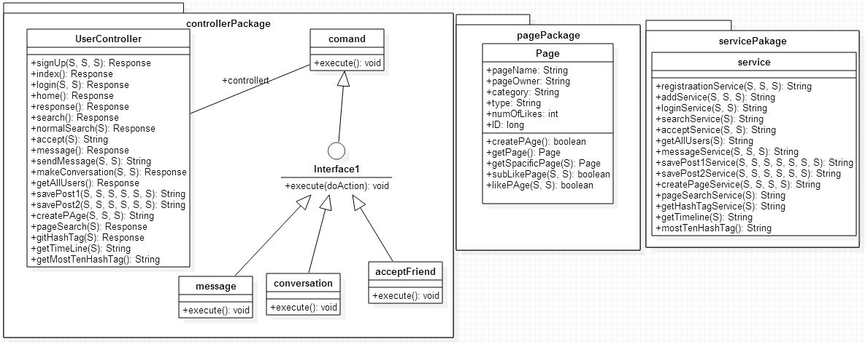

# 

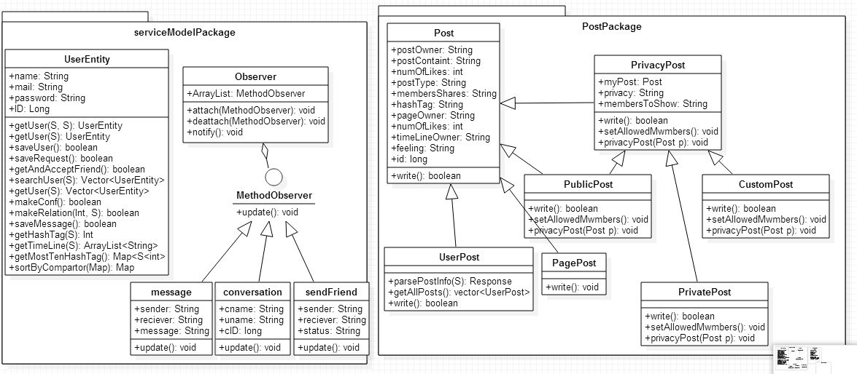

# Trello workspace screenshot

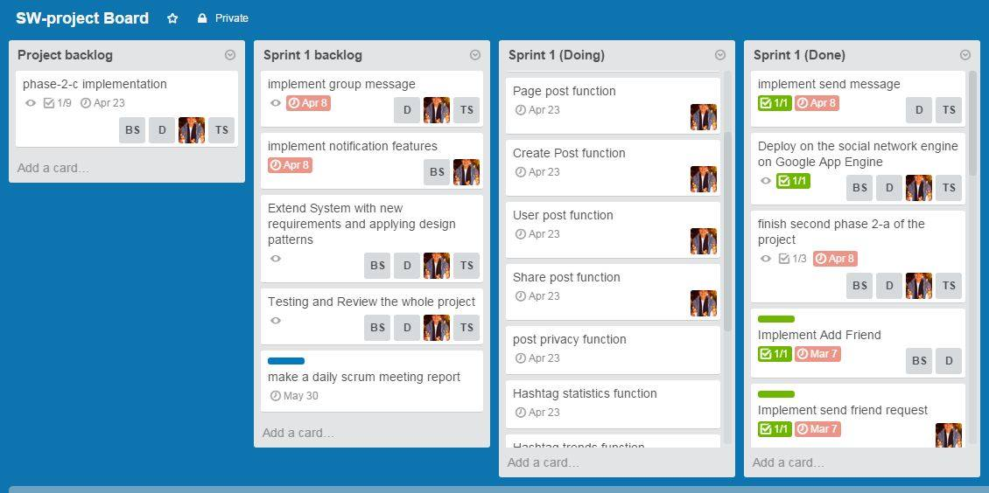

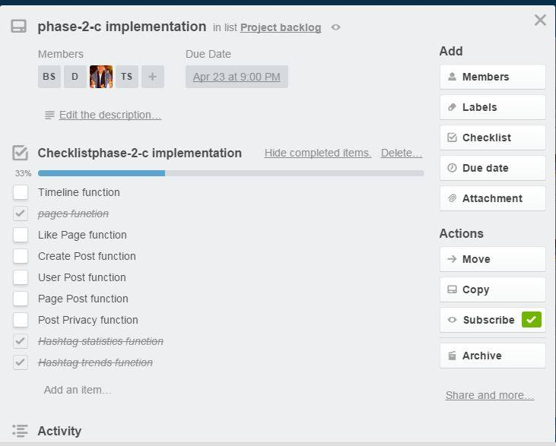

# GitHub repository link

**https://github.com/tokasobhy/FCI-CS352-PSM-Primary-Social-media.git**