Cairo University Faculty of Computers and Information



**CS352 – Software Engineering II**

**Phase 1-a Template**

**2015**

**Project Team**

|  |  |  |  |
| --- | --- | --- | --- |
| **ID** | **Name** | **Email** | **Mobile** |
| 20120138 | Paula Youssef gerges salama | Paula_youssef696@yahoo.com | 01144385706 |
| 20120168 | Doaa Magdy Mohamed Mahmoud | do3a2magdy2012@gmail.com |  |
| 20120141 | Toka Sobhy Hassan | tokasobhy132@yahoo.com |  |
| 20120131 | Bassem Sarhan Ali | Bassem_sarhan@yahoo.com | 01287297457 |

**Staff: Dr Mohammad El-Ramly** [**m.elramly@fci-cu.edu.eg**](mailto:m.elramly@fci-cu.edu.eg)

**TAs: Eng Ahmed Mohamed Sayed a.mohamed@fci-cu.edu.eg**

**Eng Ayat Khairy ayat.khairy@fci-cu.edu.eg**

Contents

Github repository link 2

Used Technologies 3

Frontend environment 3

Role of each member in the team 3

Comments **Error! Bookmark not defined.**

# Github repository link

* **The purpose of the github repository**
* **Historical archiving for everyone in the team work.**
* **We can backtrack for any previous versions if any uncontrollable error happens.**
* **Prevent anyone to upload anything without merge with the latest upload.**
* [**https://github.com/tokasobhy/FCI-CS352-PSM-Primary-Social-media.git**](https://github.com/tokasobhy/FCI-CS352-PSM-Primary-Social-media.git)

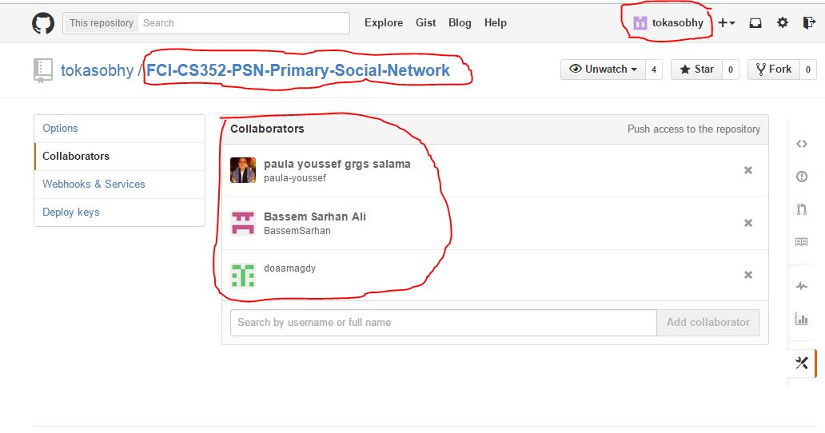

# Used Technologies

* **JSP,Servlet**
* **It used to merge java codes and html codes. We need it to make the welcome pages and do some java code on the input data and help us in making our services**
* **JAX RS**
* **Java API for restful web services, is a set of APIs to develop REST services jersey one of the most popular implementation for JAX-RS. It will help us in our project to write our services in a REST way.**
* **Google big table**
* **No SQl online databases it will help us in our project to save and access our data online by our service in a secure way**
* **Google app engine**
* **It is a platform as a service (PaaS) cloud computing platform for developing and hosting web applications in Google-managed data centers. Applications are sandboxed and run across multiple servers. We will use it as a platform to hosting our service.**
* **Github**
* **Mentioned before in the repository link module.**
* **Trello**
* **The team leader will use it to manage the team and tasks for every member in the team.**

# Frontend environment

Web frontend environment.

# Role of each member in the team

|  |  |
| --- | --- |
| Member name | Role |
| Paula Youssef | Study and teach JSP, servlet then takes one function |
| Doaa Magdy Mohammed | Study and teach Jax RS then takes one function |
| Toka sobhy | Study and teach google big tables then takes one function |
| Bassem sarhan | Study and teach google app engine then merge all functions or classes in one running project then online services |