Cairo University Faculty of Computers and Information



**CS352 – Software Engineering II**

**Phase 1-b Template**

**2015**

**Project Team**

|  |  |  |  |
| --- | --- | --- | --- |
| **ID** | **Name** | **Email** | **Mobile** |
| 20120138 | Paula Youssef gerges salama | Paula_youssef696@yahoo.com | 01144385706 |
| 20120168 | Doaa Magdy Mohamed | Do3a2magdy2012@gmail.com |  |
| 20120141 | Toka Sobhy Hassan | tokasobhy132@yahoo.com |  |
| 20120131 | Bassem Sarhan Ali | Bassem_sarhan@yahoo.com | 01287297457 |

**Staff: Dr Mohammad El-Ramly m.elramly@fci-cu.edu.eg**

**TAs:**

**Eng Ahmed Mohamed Sayed a.mohamed@fci-cu.edu.eg**

**Eng Ayat Khairy ayat.khairy@fci-cu.edu.eg**

Title page has no header or footer.

Docs must be supplied as pdf –files re-named as requested

Contents

Instructions [To be removed] 3

Your Restful API 3

Trello workspace screenshot 4

Daily scrum Meetings 5

Github repository link 5

# Instructions

# Your Restful API

**Repository Link:**

[**https://github.com/tokasobhy/FCI-CS352-PSM-Primary-Social-media.git**](https://github.com/tokasobhy/FCI-CS352-PSM-Primary-Social-media.git)

**Sign out Service**

|  |  |
| --- | --- |
| **Service name** | **Sign out** |
| **Input type** | **POST** |
| **Service URL** | **http://localhost:8888/rest/signoutService** |
| **Parameters** | **No Parameters.** |
| **Example request** | **POST**  **http://localhost:8888/rest/SignoutService?** |
| **Example response** | **Current User=null.** |

**Send Friend Request Service**

|  |  |
| --- | --- |
| **Service name** | **Search** |
| **Input type** | **POST** |
| **Service URL** | **http://localhost:8888/rest/SearchService** |
| **Parameters** | |  |  | | --- | --- | | **NAME** | **Description** | | **uname** | **Provided user name** | | **Friend Name** | **Provided Second User name** | |
| **Example request** | **POST**  **http://localhost:8888/rest/SearchService?uname=** **Doaamagdy** |
| **Example response** | **{"id":1,"Status":"OK","email":"doaa@yahoo","name":"Doaamagdy"}** |

**Accept Service**

|  |  |
| --- | --- |
| **Service name** | **Sign out** |
| **Input type** | **POST** |
| **Service URL** | **http://localhost:8888/rest/AcceptService** |
| **Parameters** | |  |  | | --- | --- | | **NAME** | **Description** | | **uname** | **Provided user name** | |
| **Example request** | **POST**  **http://localhost:8888/rest/AcceptService?uname=** **Doaa** |
| **Example response** | **{"id":1,"Status":"OK","email":"mohamed","name":"Doaa"}** |

# Trello workspace screenshots

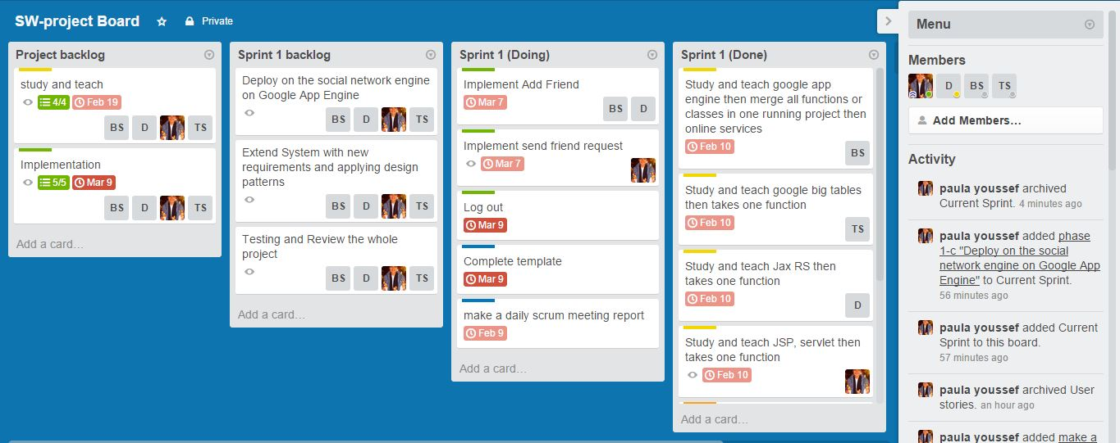

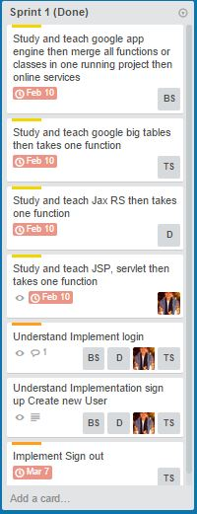

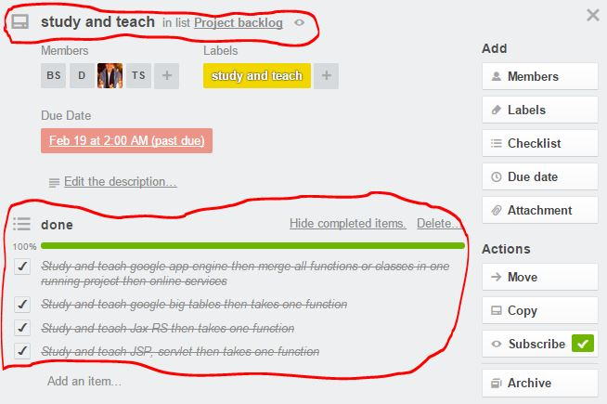

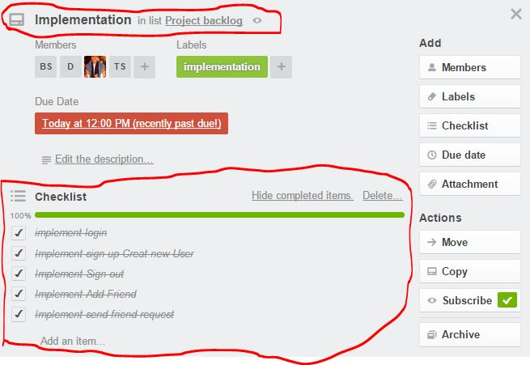

# Github repository link

* [**https://github.com/tokasobhy/FCI-CS352-PSM-Primary-Social-media.git**](https://github.com/tokasobhy/FCI-CS352-PSM-Primary-Social-media.git)