Open File, Memo and Examples
Open File:
While in the session of a meeting or teaching, it is embarrassing to keep others waiting due to searching for a document, or look up for a program or a shortcut. With “Open a File” function, you may have better alternative. By setting up each button in association with the file, all you have to do is clicking the mouse buttons and open all the files instantly.

Example:
1). Shift to Mode 3 – “Open File”.
2). The mouse buttons have association with below details: Button 3rd – Open a PPT File; Button 4th – Open a Text File; Button 5th – Open a Spreadsheet File.
3). Press each mouse button will open the associated file instantly.
4). You can apply this function to mouse buttons of 2, 3, 4, 5, 6, wheel up(UP) and wheel down(DN).
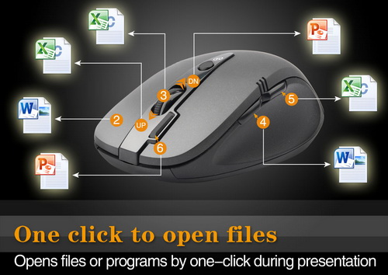
Open Files Instantly
Especially useful for the meeting and teaching, by pressing the buttons all the associative files will be opened instantly without embarrassing.

Memo and Example
Memo:
This “Memo” function will bring a “Memo” screen. By pressing the “Memo” button, all the mouse button settings or associated files will be listed as the reminder. Teacher may take great advantage to keep teaching class in good order by checking each button setting or associated file on the “Memo” screen, and then open them instantly. There are 7 customizable buttons in each of G10 five working modes, press the same button will close the screen.

Example:
1). Shift to Mode 3 – “Open File”.
2). Press 6th button will open the “Memo” screen as shown below, all the button settings or associated files will be listed as the reminder.
3). You can apply this “Memo” function to mouse buttons of 2, 3, 4, 5, 6, wheel up(UP) and wheel down(DN).
