1. Analytical Calculations

a)

In order to ease analytical calculations, it is assumed that there is no fringing flux, flux is distributed homogenously and the core is infinitely permeable. The reluctance and inductance values of the motor is calculated in two rotor positions which are θ is equal to 0 and 90 degrees. The reluctance and inductance at θ is equal to 0 is called as Rd and Ld whereas the reluctance and inductance at θ is equal to 90 is called as Rq and Lq. The reluctance formula was straightforward. Air gap at 0 degrees is 0.5 mm and the cross-sectional area is calculated from multiplying whole cylinder area with the portion of the rotor which is in position with the core. The reluctances at these two positions are calculated as follows:

Next thing to do was calculating inductance values. After calculating reluctance, inductance calculations are done as follows:

Assuming sinusoidal inductance waveform, inductance formula is found as follows:

b)

In order to calculate torque formula, the first thing to do was to calculate energy which is calculated as follows:

The torque is the derivative of the energy which is found in following formula:

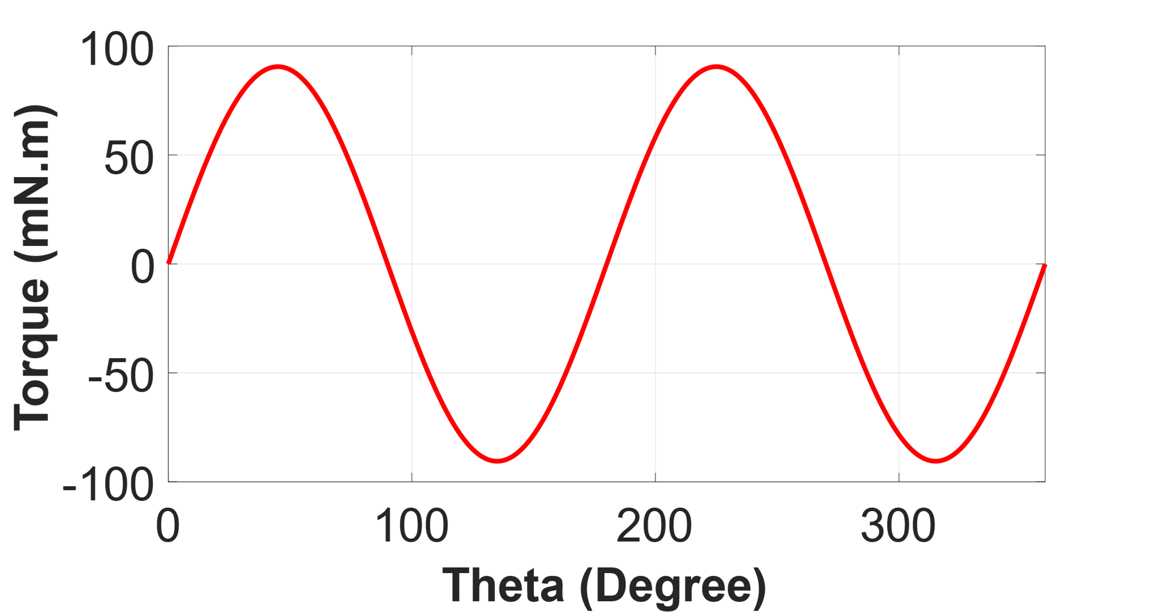

Figure . Waveform of the calculated torque formula.

c)

In order to model the whole system parameters with high accuracy finite element analysis programs can be used. These programs include the effects which are not being taken into the calculations such as fringing flux, non-homogenous flux distribution and saturation of the core material.

2)

a)

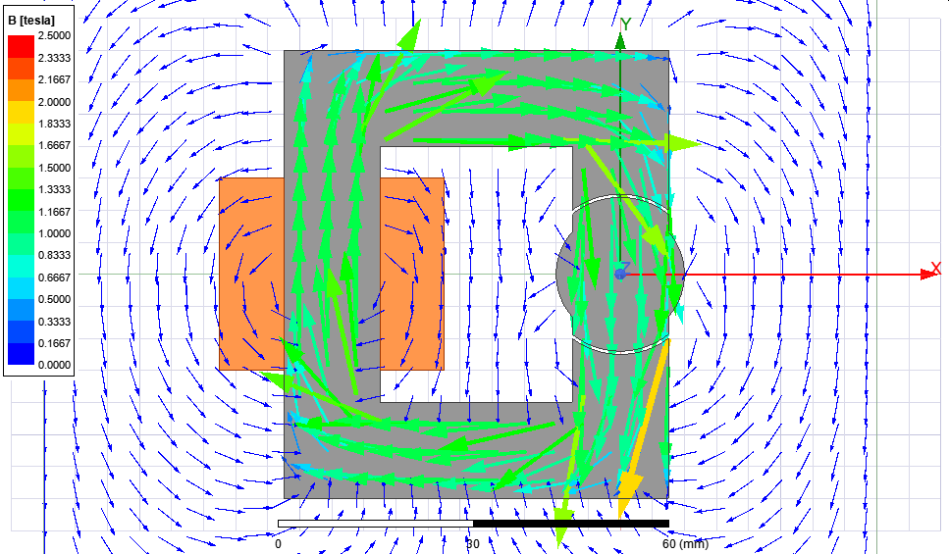

Figure 2. Flux density distribution at theta is equal to 0 degrees.

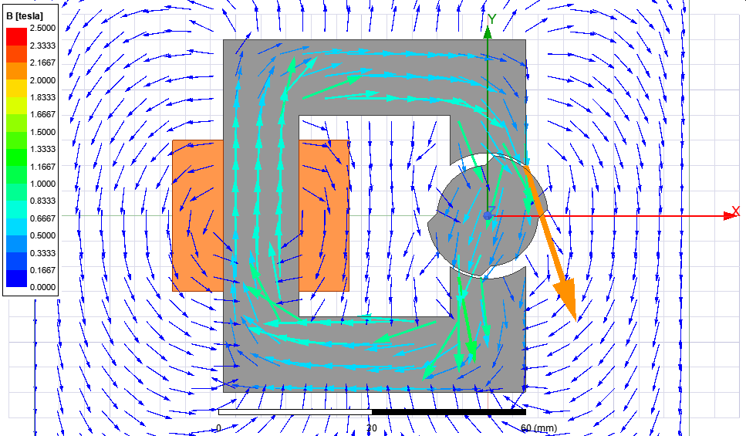

Figure 3. Flux density distribution at theta is equal to 45 degrees.

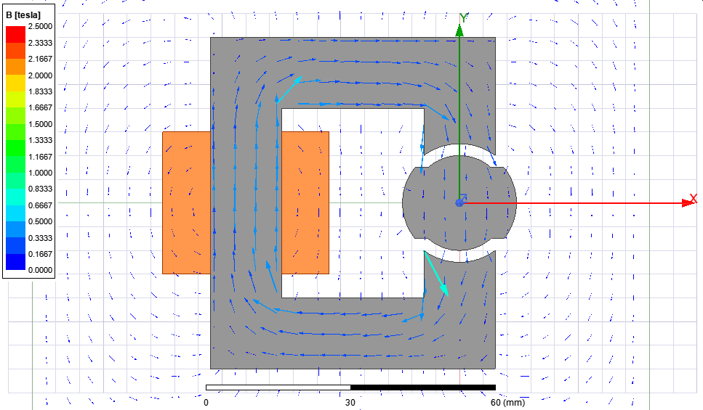

Figure 4. Flux density distribution at theta is equal to 90 degrees.

b)

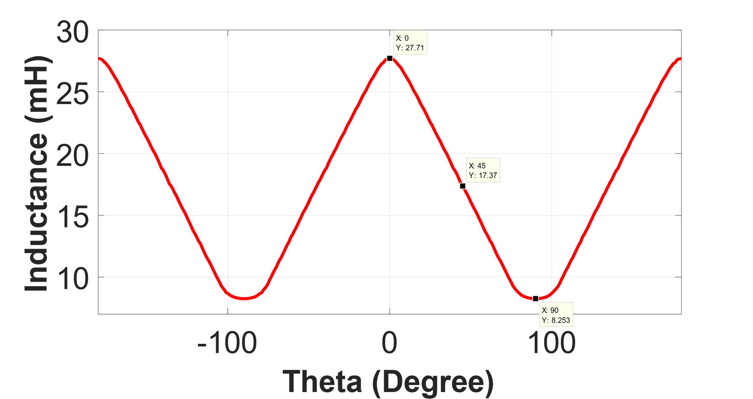

Figure 5. Inductance vs theta waveform of the model with linear material

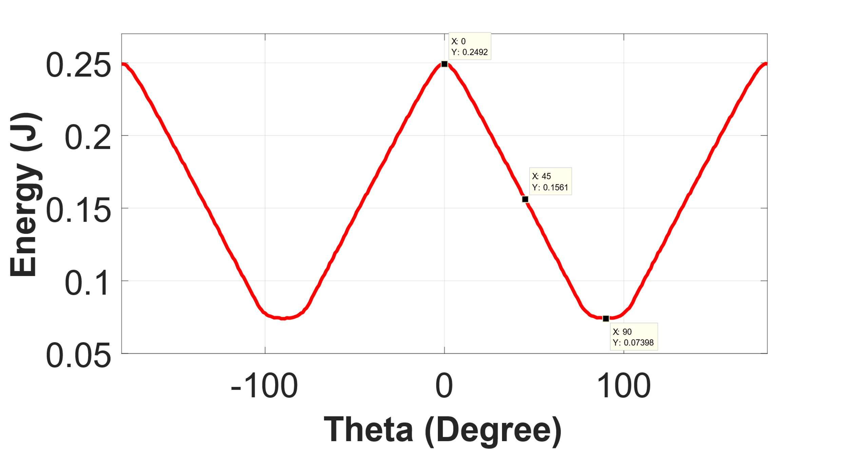

Figure 6. Energy vs theta waveform of the model with linear material

c)

The analytical calculations and finite element analysis results were close the each other but since I have assumed that the inductance of the system is sinusoidal, the waveform was different from what is calculated. Also, the inductance values are found differently from analytical results because of all the assumptions that is made in the beginning in the question. In finite element analysis, fringing flux, non-homogenous distribution of the flux is taken into the account which results in somewhat different outcomes of each calculation methods.

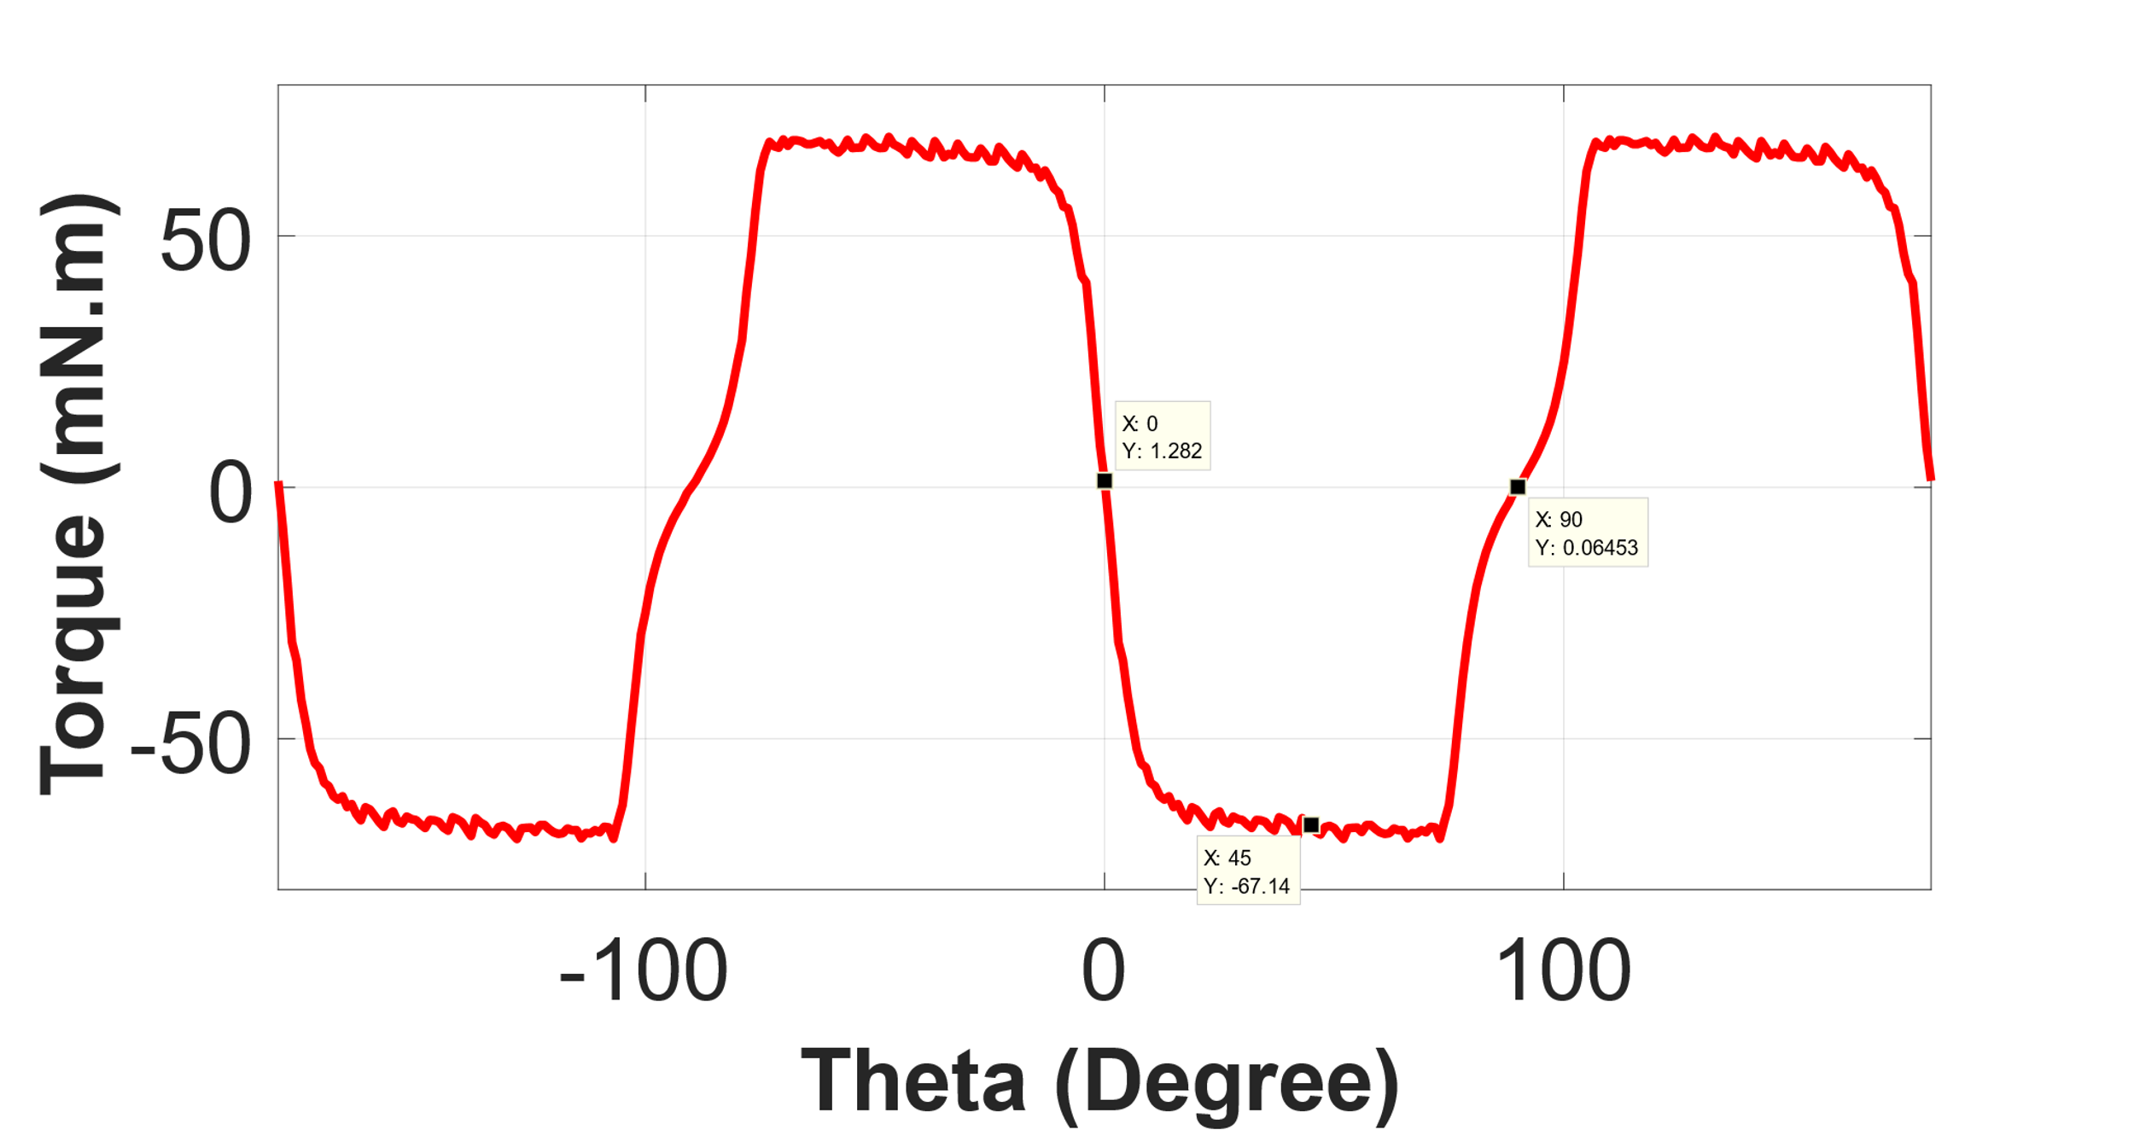

Figure 7. Torque vs theta waveform of the model with linear material

3)

a)

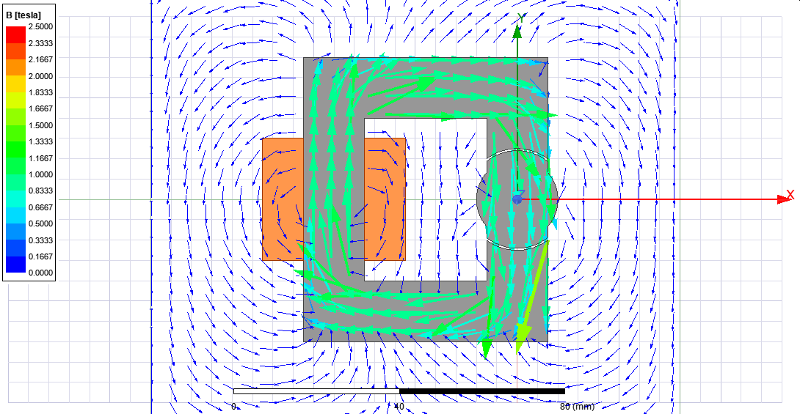

Figure 8.Flux density distribution with non-ideal core at theta is equal to 0 degrees.

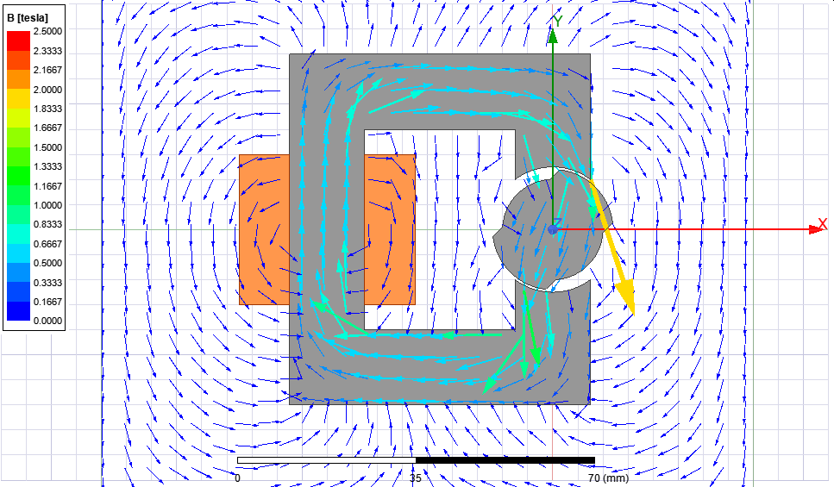

Figure 9.Flux density distribution with non-ideal core at theta is equal to 45 degrees.

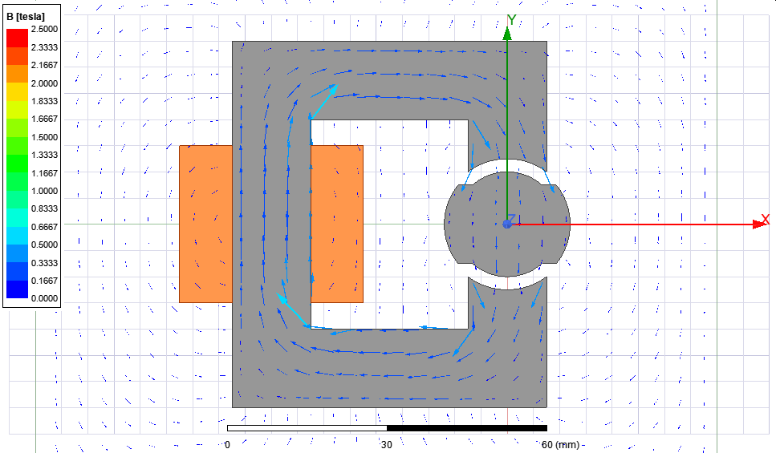

Figure 10.Flux density distribution with non-ideal core at theta is equal to 90 degrees.

b)

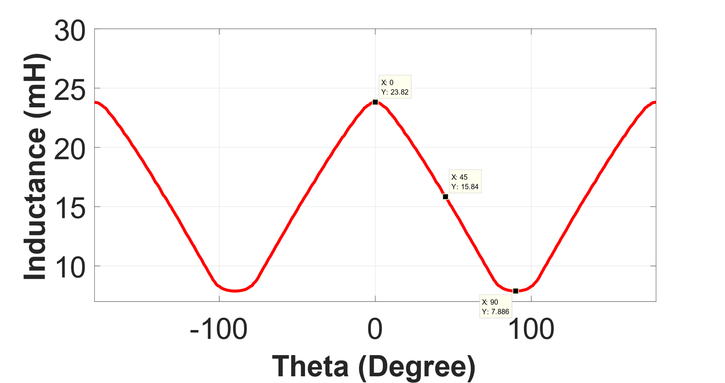

Figure 11. Inductance vs theta waveform of the model with non-linear material

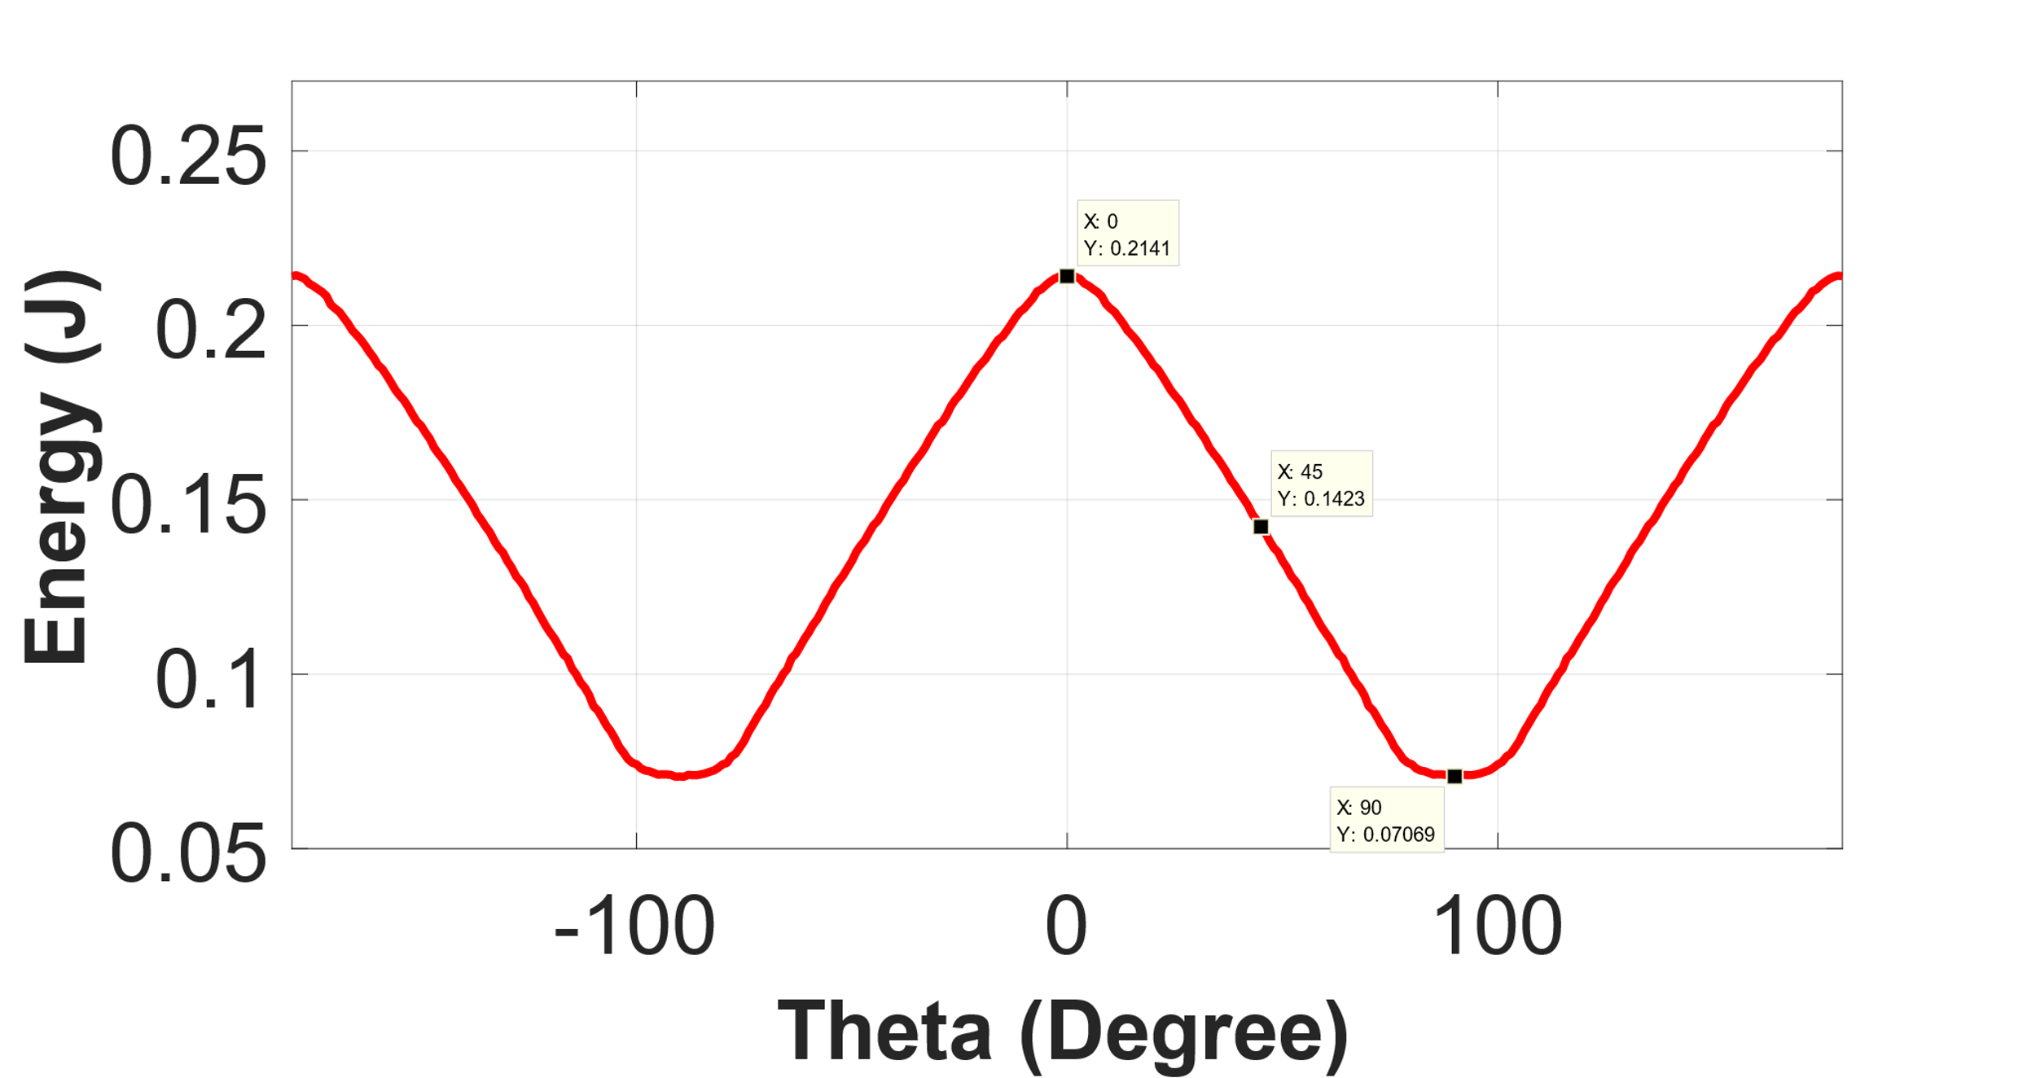

Figure 12. Energy vs theta waveform of the model with non-linear material

c)

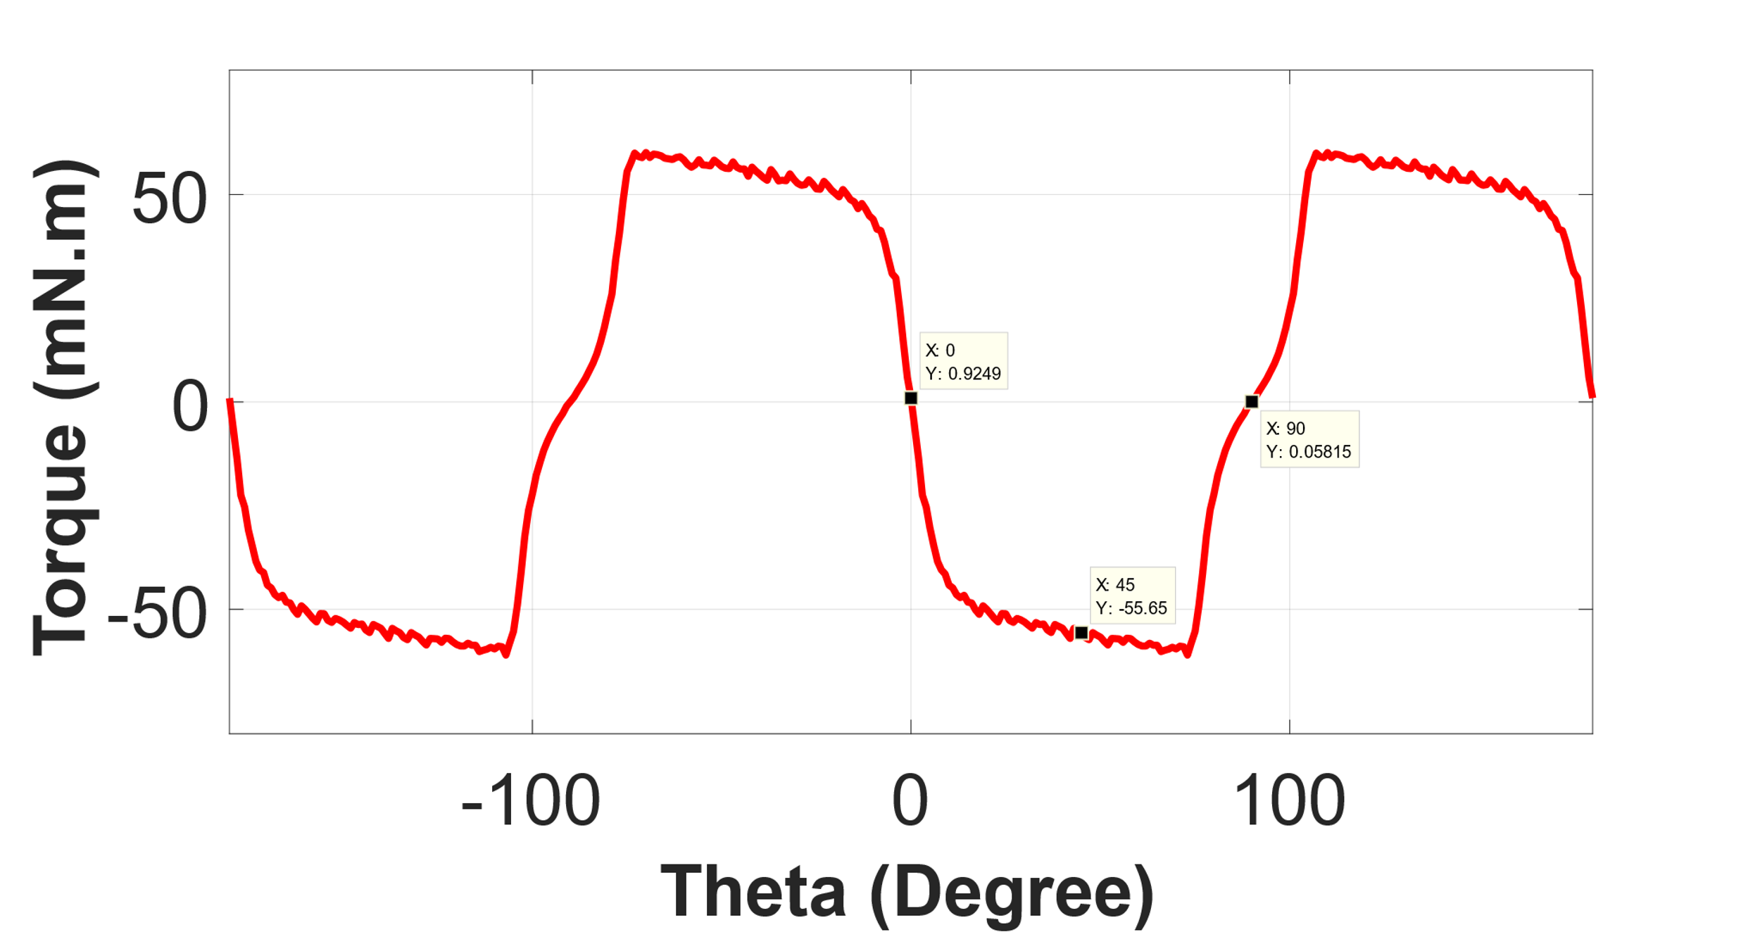

Figure 13. Torque vs theta waveform of the model with non-linear material

d)

The difference between linear and non-linear materials is that core is saturated since flux density exceed saturation flux density of the chosen material, ST1010. This results in lower flux density creation the calculation. Lower flux density means lower inductance and torque values for the same setup.

5)

Animation can be found in following link:

<https://github.com/tokgozfurkan/ee568/blob/master/Result/animation.avi>