31.03.2020

Furkan Tokgöz

**EE568**

**Project-2**

We are asked to design different kinds of motors with various motor parameters. First, integral slot full-pitch motor winding is calculated and designed. Its third and fifth harmonics are investigated. Next, two different fractional slot motor is designed with 20 pole-21 slot and 20 pole-24 slot configurations. Finally, 20 pole 21 slot motor is simulated on ANSYS Maxwell 2D.

**1)**

**Motor Parameters:**

* Q=120 (Number of slot)
* p=20 (Number of poles)
* m=3 (Number of phases)
* q=120/20.3=2 (Number of slot/pole/phase)
* θ=180.20/120=30 (Phase difference betw0een each slot)
* Double-layer
* Full-pitch winding

**Winding Diagram:**

Table . Winding diagram of the integral slot motor.

|  |  |  |  |  |  |  |  |  |  |  |  |  |
| --- | --- | --- | --- | --- | --- | --- | --- | --- | --- | --- | --- | --- |
| ***Slot number*** | ***1*** | ***2*** | ***3*** | ***4*** | ***5*** | ***6*** | ***7*** | ***8*** | ***9*** | ***10*** | ***11*** | ***12*** |
| First Layer | A | A | -C | -C | B | B | -A | -A | C | C | -B | -B |
| Second Layer | A | A | -C | -C | B | B | -A | -A | C | C | -B | -B |

**Distribution Factor:**

i)Fundamental

ii) The Third Harmonic

iii) The Fifth Harmonic

**Pitch Factor:**

i) Fundamental

ii) The Third Harmonic

Note that, negative sign implies that third harmonic rotates in negative direction compared to fundamental.

iii) The Fifth Harmonic

**Winding Factor:**

i) Fundamental

ii) The Third Harmonic

iii) The Fifth Harmonic

The winding factor of the fundamental is very close to unity. The higher the winding factor, the greater the induced voltage. So, it is desired to have a high winding factor for fundamental and low winding factors -even equal to zero- for the harmonics, if a pure sinusoidal induced voltage is aimed. If the design was short-pitched rather than full-pitched, one could achieve zero winding factor for specific harmonic orders. One interesting detail to note here might be that the third harmonic is rotating in reverse direction. This might cause a high induced voltage in high speeds, since the relative frequency difference between rotor and MMF of the third harmonic will increase immensely.

**2)**

**A)**

**Motor Parameters:**

* Q=21
* p=20
* m=3
* q=21/20.3=7/20
* θ=180.20/21=1200/7=171.43

**Winding Diagram:**

Table . Winding diagram of the first fractional-slot winding.

|  |  |  |  |  |  |  |  |  |  |  |  |  |  |  |  |  |  |  |  |  |  |
| --- | --- | --- | --- | --- | --- | --- | --- | --- | --- | --- | --- | --- | --- | --- | --- | --- | --- | --- | --- | --- | --- |
| **Slot Number** | ***1*** | ***2*** | ***3*** | ***4*** | ***5*** | ***6*** | ***7*** | ***8*** | ***9*** | ***10*** | ***11*** | ***12*** | ***13*** | ***14*** | ***15*** | ***16*** | ***17*** | ***18*** | ***19*** | ***20*** | ***21*** |
| **First Layer** | A | -A | A | -A | A | B | -B | B | -B | B | -B | B | C | -C | C | -C | C | -C | C | A | -A |
| **Second Layer** | A | -A | A | -A | -B | B | -B | B | -B | B | -B | -C | C | -C | C | -C | C | -C | -A | A | -A |
| **Phase of Fundamental Voltage** | **0** | 171 | 343 | 154 | 326 | 137 | 309 | **120** | 291 | 103 | 274 | 86 | 257 | 69 | **240** | 51 | 223 | 34 | 206 | 17 | 189 |
| **Phase of Third Harmonic** | 0 | 154 | 309 | 103 | 257 | 51 | 206 | 0 | 154 | 309 | 103 | 257 | 51 | 206 | 0 | 154 | 309 | 103 | 257 | 51 | 206 |
| **Phase of Fifth Harmonic** | 0 | 137 | 274 | 51 | 189 | 326 | 103 | 240 | 17 | 154 | 291 | 69 | 206 | 343 | 120 | 257 | 34 | 171 | 309 | 86 | 223 |

Phase angles of the induced voltages are calculated in Excel, where n is the order of harmonics, θ is the phase difference between each slot, as follows:

As can be seen in Table.2, induced voltages of each phases are 120 degree apart from each other. A rotating MMF waveform is achieved by fractional slot winding. Phasor diagram of the designed motor can be seen in Fig.1.

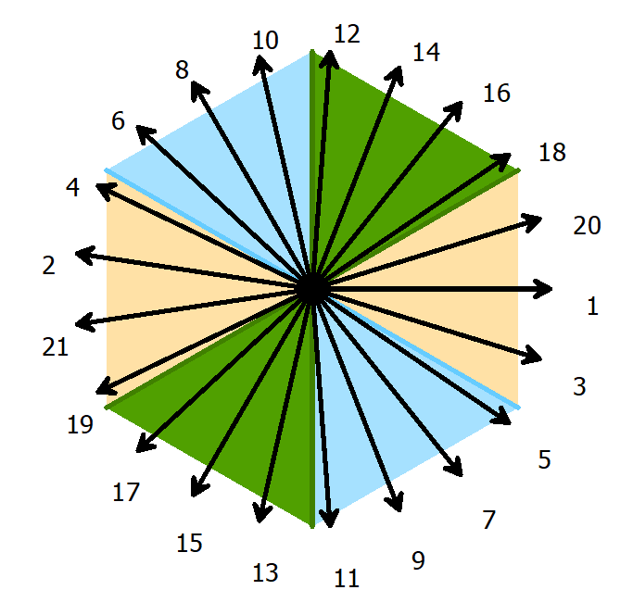

Figure . Phasor diagram of the designed motor.

**Distribution Factor:**

Since, it is a fractional slot winding, slot per pole per phase value becomes smaller than one which makes distribution factor greater than unity. So, distribution factor is calculated from the ratio of vector sum to the scalar sum of the voltages.

i) Fundamental

ii) The Third Harmonic

iii) The Fifth Harmonic

**Pitch Factor:**

i) Fundamental

i) The Third Harmonic

i) The Fifth Harmonic

**Winding Factor:**

i) Fundamental

i) The Third Harmonic

i) The Fifth Harmonic

The winding factor’s of the harmonic is much more smaller than the fundamental’s. Third harmonic is rotating in reverse direction which may cause problems in high speeds. Overall, it has smaller harmonic winding factors than integral slot motor.

**B)**

**Motor Parameters:**

* Q=24
* p=20
* m=3
* q=24/20.3=2/5
* θ=180.20/24=150

**Winding Diagram:**

|  |  |  |  |  |  |  |  |  |  |  |  |  |  |  |  |  |  |  |  |  |  |  |  |  |
| --- | --- | --- | --- | --- | --- | --- | --- | --- | --- | --- | --- | --- | --- | --- | --- | --- | --- | --- | --- | --- | --- | --- | --- | --- |
| **Slot Number** | ***1*** | ***2*** | ***3*** | ***4*** | ***5*** | ***6*** | ***7*** | ***8*** | ***9*** | ***10*** | ***11*** | ***12*** | ***13*** | ***14*** | ***15*** | ***16*** | ***17*** | ***18*** | ***19*** | ***20*** | ***21*** | ***22*** | ***23*** | ***24*** |
| **First Layer** | A | -A | -B | B | C | -C | -A | A | B | -B | -C | C | A | -A | -B | B | C | -C | -A | A | B | -B | -C | C |
| **Second Layer** | A | -B | -B | -C | C | A | -A | -B | B | C | -C | -A | A | B | -B | -C | C | A | -A | -B | B | C | -C | -A |
| **Phase of Fundamental Voltage** | **0** | 150 | 300 | 90 | **240** | 30 | 180 | 330 | **120** | 270 | 60 | 210 | **0** | 150 | 300 | 90 | **240** | 30 | 180 | 330 | **120** | 270 | 60 | 210 |
| **Phase of Third Harmonic** | 0 | 90 | 180 | 270 | 0 | 90 | 180 | 270 | 0 | 90 | 180 | 270 | 0 | 90 | 180 | 270 | 0 | 90 | 180 | 270 | 0 | 90 | 180 | 270 |
| **Phase of Fifth Harmonic** | 0 | 30 | 60 | 90 | 120 | 150 | 180 | 210 | 240 | 270 | 300 | 330 | 0 | 30 | 60 | 90 | 120 | 150 | 180 | 210 | 240 | 270 | 300 | 330 |

Phase angles of the induced voltages are calculated in Excel as follows:

As can be seen in Table.2, induced voltages of each phases are 120 degree apart from each other. A rotating MMF waveform is achieved by fractional slot winding. Phasor diagram of the designed motor can be seen in Fig.2.

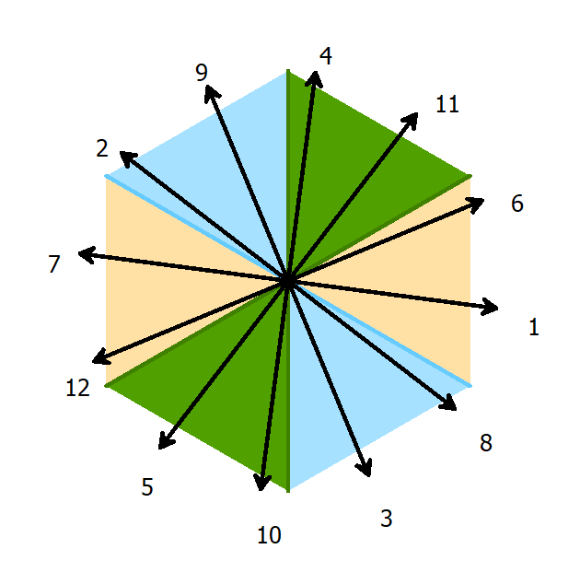

Figure . Phasor diagram of the designed motor

**Distribution Factor:**

Since, it is a fractional slot winding, slot per pole per phase value becomes smaller than one which makes distribution factor greater than unity. So, distribution factor is calculated from the ratio of vector sum to the scalar sum of the voltages.

i) Fundamental

ii) The Third Harmonic

iii) The Fifth Harmonic

**Pitch Factor:**

i) Fundamental

i) The Third Harmonic

i) The Fifth Harmonic

**Winding Factor:**

i) Fundamental

i) The Third Harmonic

i) The Fifth Harmonic

I have designed two different fractional slot motor with 20 pole 21 slot and 24 slot. 21 slot motor has shown a greater winding factor value compared to 24 slot because of high pitch factor. However, 24 slot motor may be more advantageous when we compare cogging torque of the motors. Since, there are more slots on 24 slot, the magnitude of the torque ripple is smaller than a motor with fewer slot. The third and fifth harmonics at 24 slot machine has higher winding factors compared to 21 slot. Overall, my design of option is 20 pole, 21 slot machine since it has higher winding factor and lower harmonics. So, I constructed the motor in ANSYS Maxwell 2D and check the results in the next section.

**3)**

The designed motor is the motor of Toyota Prius whose parameters can be listed as follows: The model created on ANSYS Maxwell 2D can be seen in Fig.3.

* Power: 8 kW
* Voltage: 540 V
* Speed: 600 RPM
* Stator Outer Diameter: 270 mm
* Stator Inner Diameter: 180 mm
* Motor Length: 135 mm
* Number of slots: 21
* Number of poles: 20
* Rotor Outer Diameter: 176 mm
* Rotor Inner Diameter: 100 mm

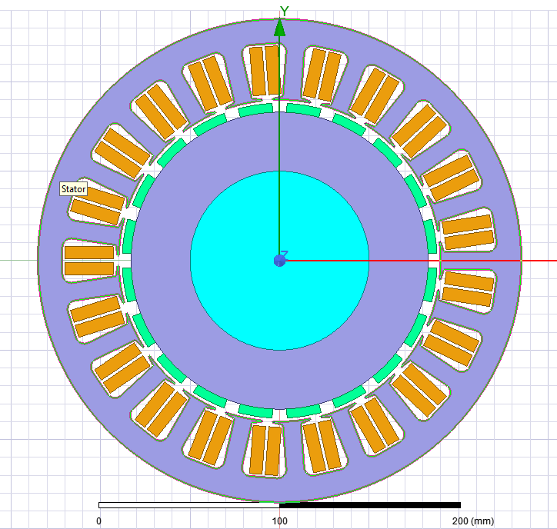

Figure . 2D drawing of the designed motor.

The winding diagram is designed on RMxprt program. It is the same winding diagram which was presented in Table.2.

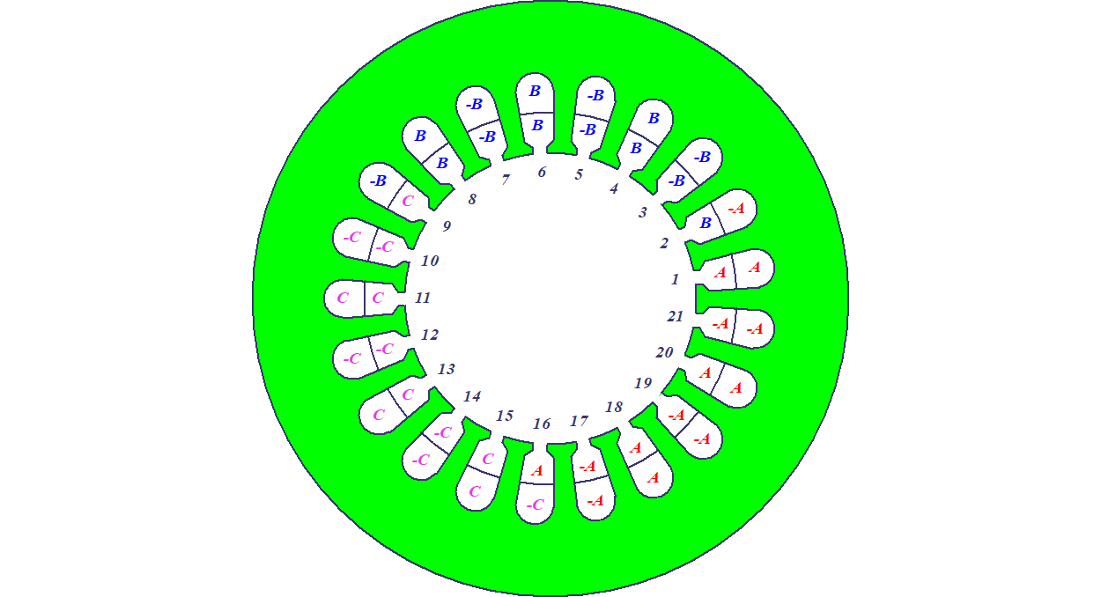

Figure . Winding diagram of the motor on RMxprt

The model is run and induced voltage waveforms are recorded as can be seen in Fig.5. The waveform is slightly distorted because of the harmonics. It is more like a triangular waveform than sinusoidal waveform.

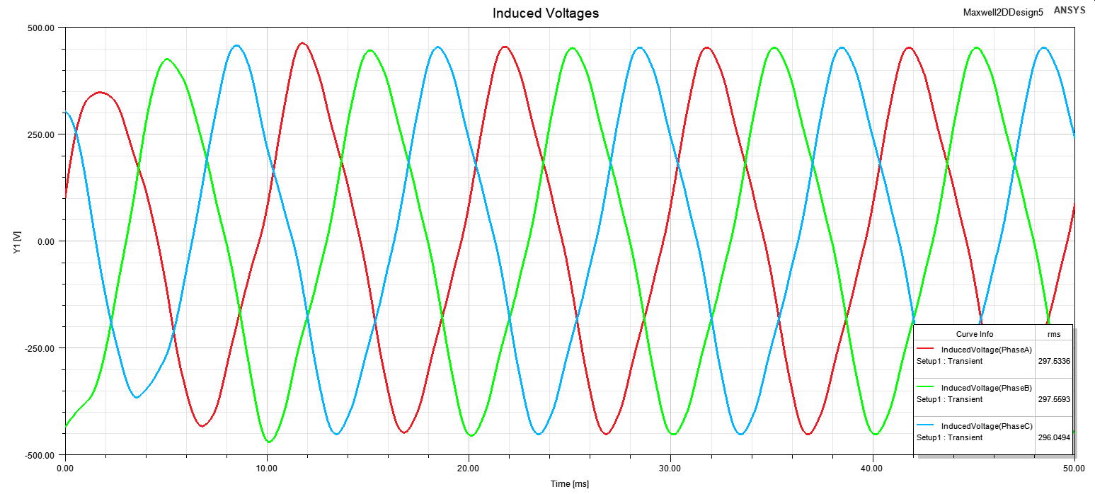

Figure . Induced phase voltages of the motor.

Line-line voltage waveform, which is presented in Fig.6, is more sinusoidal waveform than phase voltages. It is because third harmonic has disappeared in line voltages thanks to Y connection of the windings.

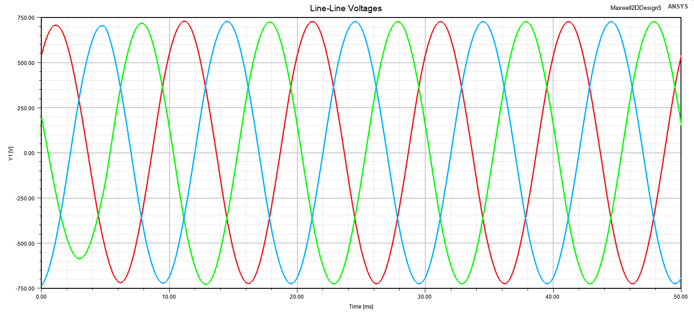

Figure . Line-line voltage waveforms of the motor.

In order to better understand the harmonic content of the voltage waveforms, FFT results of induced phase and line voltages are shown in Fig.7. As said earlier, there are no third harmonics in line voltages. Fundamental voltage is increased by √3.

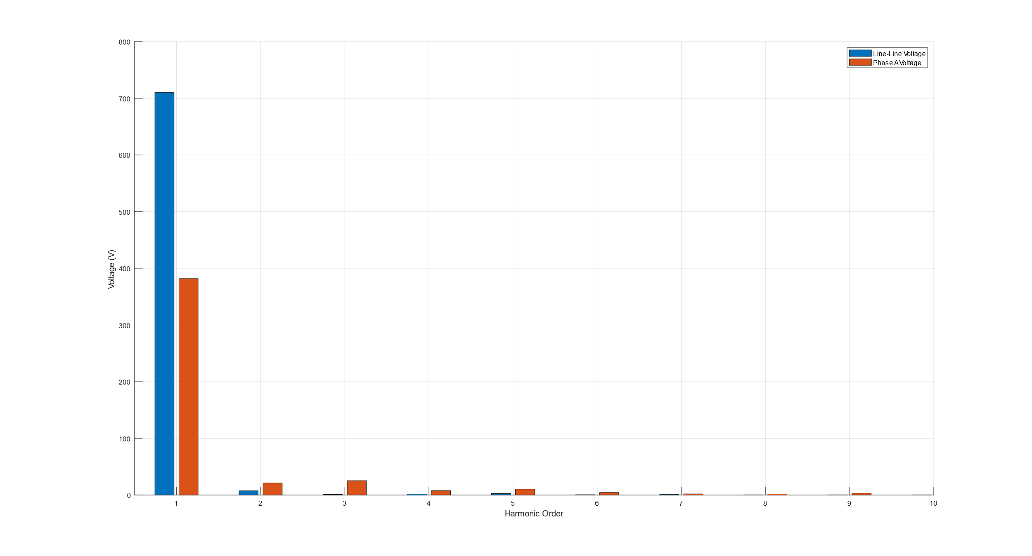

Figure . FFT result of phase and line-line voltages.

Because of the slots and permanent magnets, there are some reluctance torque which causes torque ripple in output torque waveforms. The output torque waveform is presented in Fig.8. Increasing the number of slots may decrease cogging torque effect.

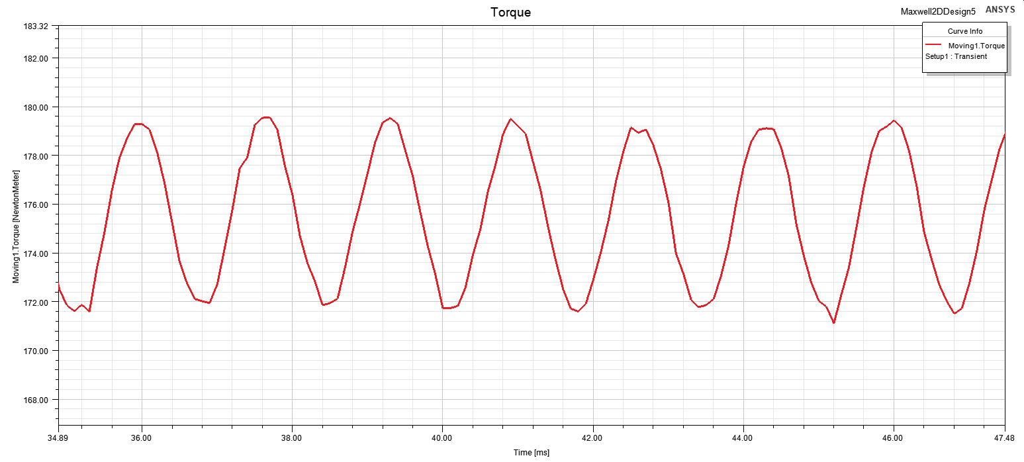

Figure . Cogging torque of the motor.

**Conclusion**

In this project, I have designed three different motors. The first one was integral slot motor with 20 pole and 120 slot. The design of the motor was straightforward since it was a full-pitched motor. Next, I have analysed 20 pole 21 slot motor. This was interesting because calculation of distribution factor was unusual since it was a fractional slot motor. I have used the definition of the distribution factor that is the ratio of the vector sum of voltages to scalar sum. After that, I have designed another fractional slot motor but this time it was 20 pole 24 slot. The winding factors of the harmonics were greater than 21 slot motor. So I chose 20 pole 21 slot motor to be the one which is going to be simulated on ANSYS Maxwell 2D. For this purpose, I have used the motor parameters of a Toyota Prius surface mount permanent magnet synchronous machine. I have configured the slot and pole number to my design and investigated the induced phase and line voltages, torque ripples, harmonics contents of this motor. Overall, I find the project educative in regards of motor design and simulation which will be very useful in my future works.