03.05.2020

Furkan Tokgöz

**EE 568**

**Project 3**

**Introduction**

In this project, we are asked to start from the scratch to fully design of a radial-flux permanent magnet synchronous machine. Air gap flux density, mechanical sizing of the motor, electrical and magnetic loading, tangential stress, output torque and power calculations are done on paper. Then, it is verified by finite element analysis program ANSYS Maxwell. Moreover, the relation between slot ratio and electrical loading, machine sizing, output torque and power of a machine is investigated by comparison of two different motor designs.

1)

a)

In a permanent magnet radial-flux machine, magnetic circuit is as shown in Fig.1. Rm is the reluctance of the magnet, Rl is to represent the leakage flux between magnets, Rg is the reluctance of the air-gap, Rs and Rr is the reluctance of the stator and rotor core respectively. In our case, Rs ,Rr and Rl is ignored by assuming stator and rotor cores are infinitely permeable.



Figure 1. Magnetic circuit of radial-flux permanent magnet machine

In order to find the operating flux density point, area of the magnets and air-gap calculated in (1) and (2). The diameter for calculation of magnet area is chosen as the middle of the magnets.

$$\begin{aligned}A_{m}=\frac{πD.l.k_{embrace}}{p}=\frac{π0,104.0,1.0,8}{4}={6,535.10}^{-3}m^{2}\#\left(1\right)\end{aligned}$$

$$\begin{aligned}A_{g}=\frac{πD.l{.k}_{embrace}}{p}=\frac{π0,108.0,1.0,8}{4}={6,786.10}^{-3}m^{2}\#\left(2\right)\end{aligned}$$

The next thing to do was calculating reluctances of the magnet and the air gap. It is easily done by using well-known reluctance formula in (3) and (4).

$$\begin{aligned}R_{m}=\frac{l_{m}}{u_{r}u_{0}A_{m}}=\frac{{4.10}^{-3}}{1,05.4π{10}^{-7}.{6,535.10}^{-3}}=463890H^{-1}\#\left(3\right)\end{aligned}$$

$$\begin{aligned}R_{g}=\frac{l_{g}}{u_{0}A_{g}}=\frac{{1.10}^{-3}}{4π{10}^{-7}.{6,786.10}^{-3}}=117267H^{-1}\#\left(4\right)\end{aligned}$$

MMF is equal to flux times reluctance. By inserting calculated reluctance and the cross-section area of the magnet, one can find the MMF created by magnets as in (5). Since there are 2 magnets acting as a MMF source, total MMF created by two magnets then divided into to total reluctance of the magnetic path in order to find the flux in (6). Then, peak of the flux density in the air gap can easily be calculated by dividing the flux by the cross-section area as in (7).

$$\begin{aligned}F=ϕ_{m}.R_{m}=B_{r}.A_{m}.R_{m}={1,33.6,535.10}^{-3}.463890=4032A\#\left(5\right)\end{aligned}$$

$$\begin{aligned}2F=2.\left(R_{m}+R_{g}\right).ϕ_{m}=2.\left(R_{m}+R_{g}\right).B_{m}.A_{m}\#\left(6\right)\end{aligned}$$

$$\begin{aligned}B_{m}=\frac{F}{A_{m}\left(R_{m}+R_{g}\right)}=\frac{4032}{{6,535.10}^{-3}.\left(463890+117267\right)}=1,061T\#\left(7\right)\end{aligned}$$

Afterwards, the load line, which can be seen in Fig.2, is drawn with the calculated operating.



Figure 2. Load line of the magnetic circuit

b)

The magnetic loading is calculated by (8). It is found as 0.817 T.

$$\begin{aligned}B=\frac{pϕ_{p}}{πDl}=\frac{{4.1,061.6,535.10}^{-3}}{π.0,108.0,1}=0.817T\#\left(8\right)\end{aligned}$$

c)

The designed machine is simulated on ANSYS Maxwell program. The model with solid stator core can be seen in Fig.3. Resultant air-gap flux density distribution of the motor is found as in Fig.4. The analytical calculation and finite element analysis results showed are in good agreement with each other. The peak of the air-gap flux density is found as 1 T in FEA which is very close the analytical result.

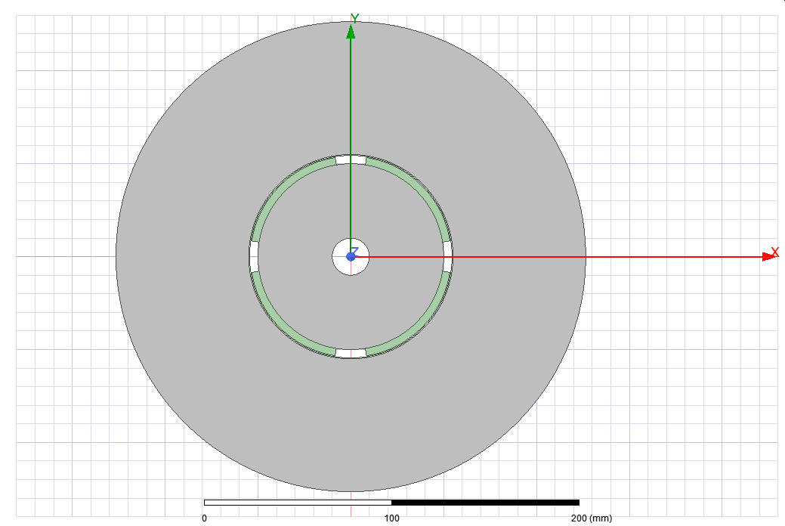

Figure 3. Created finite element analysis model.

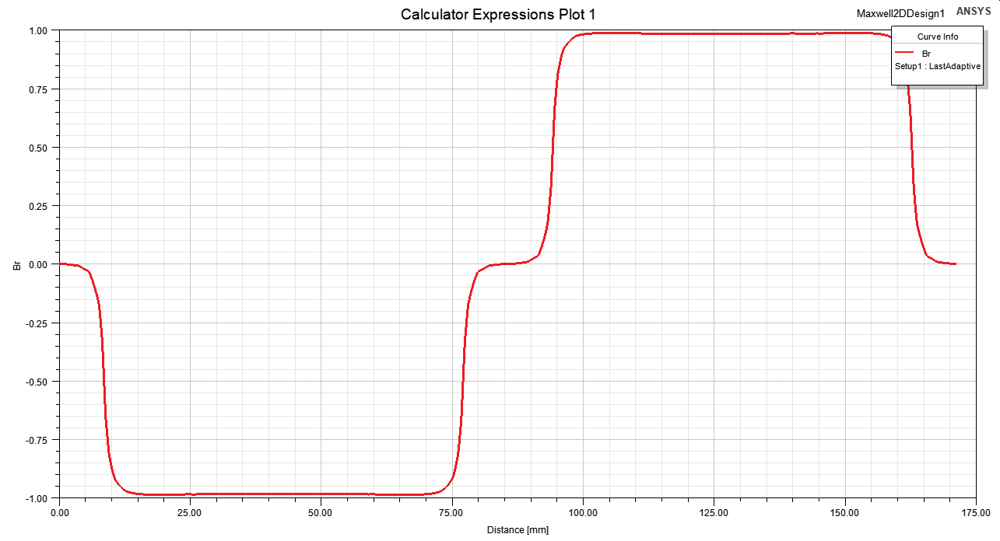

Figure 4. Air-gap flux density distribution of the machine

2)

a)

Assuming slot/pole/phase is equal to 3, stator slot number can be found as 36 as in (9) and (10). Increasing slot number reduces the cogging torque value and MMF harmonics but it increases the magnetizing current. So, an optimum number of 36 is chosen with the winding factor 0.96.

$$\begin{aligned}Q=36\#\left(9\right)\end{aligned}$$

$$\begin{aligned}q=\frac{Q}{p.m}=\frac{36}{4.3}=3\#\left(10\right)\end{aligned}$$

b)

Current density formula known as follows

$$\begin{aligned}J=\frac{I_{rms}}{A_{cable}}\#\left(11\right)\end{aligned}$$

By inserting the values of our design one can find the required cable cross-section area as

$$\begin{aligned}A_{cable}=\frac{I_{rms}}{J}=\frac{2.5}{5}=0.5mm^{2}\#\left(12\right)\end{aligned}$$

AWG 20 has 0.519 mm2 cross section area which is appropriate for our case. Since, the machine will be working at 50 Hz, there will be no problem with skin effect losses.

c)

Generally, slot ratio of the radial-flux machines is chosen between 0.5 to 0.7. For a start, I chose slot ratio as 0.6. Since, the stator inner diameter is 110 mm after calculating magnet thickness and air gap, slot outer diameter is found as

$$\begin{aligned}d=\frac{D_{inner}}{D_{outer}}=\frac{110}{D_{outer}}=0.6\#\left(13\right)\end{aligned}$$

$$\begin{aligned}D_{outer}=183mm\#\left(14\right)\end{aligned}$$

In order to find slot height following formula is used.

$$\begin{aligned}h_{h}=\frac{D_{outer}-D_{inner}}{2}=36.5mm\#\left(15\right)\end{aligned}$$

Since, the motor is assumed to have parallel teeth, width of the slot on inner slot diameter and outer slot diameter are different from each other. By, assuming the slot width at inner slot diameter is equal to tooth width at the same diameter, one can find the slot width as follows

$$\begin{aligned}h_{w-inner}=\frac{πD_{inner}}{2Q}=\frac{π110}{36.2}=4.8mm\#\left(16\right)\end{aligned}$$

$$\begin{aligned}h_{w-outer}=\frac{πD_{outer}}{2Q}=\frac{π183}{36.2}=8mm\#\left(17\right)\end{aligned}$$

The area of the slot can be found as follows

$$\begin{aligned}A_{slot}=\frac{\left(h_{w-inner}+h_{w-outer}\right).h_{h}}{2}=234mm^{2}\#\left(18\right)\end{aligned}$$

The number of turns per slot is found using the fill factor and cable cross section area.

$$\begin{aligned}N_{coils}=\frac{A_{slot}.k_{cu}}{A_{cable}}=\frac{234.0,6}{0.519}=270 coils per slot\#\left(19\right)\end{aligned}$$

The flux density at back core can be found by following formula.

$$\begin{aligned}B_{back-core}=\frac{ϕ_{pole}}{2A_{back-core}}=\frac{B_{m}A_{m}}{2k_{stacking}l_{core}h_{bc}}\#\left(20\right)\end{aligned}$$

By using (20), the required back core thickness in order to have 1 T flux density and 0.95 stacking factor is found as in (21).

$$\begin{aligned}h_{bc}=\frac{B_{m}A_{m}}{2k_{stacking}l_{core}B_{back-core}}=\frac{{1,061.6,535.10}^{-3}}{2.0,95.0,1.1}=35mm\#\left(21\right)\end{aligned}$$

The resultant machine is analyzed on ANSYS Maxwell. The magnitude of the flux density of the machine can be seen in Fig.5. Flux density at back core is found as 1 T, which was the aimed flux density value in analytical calculation.

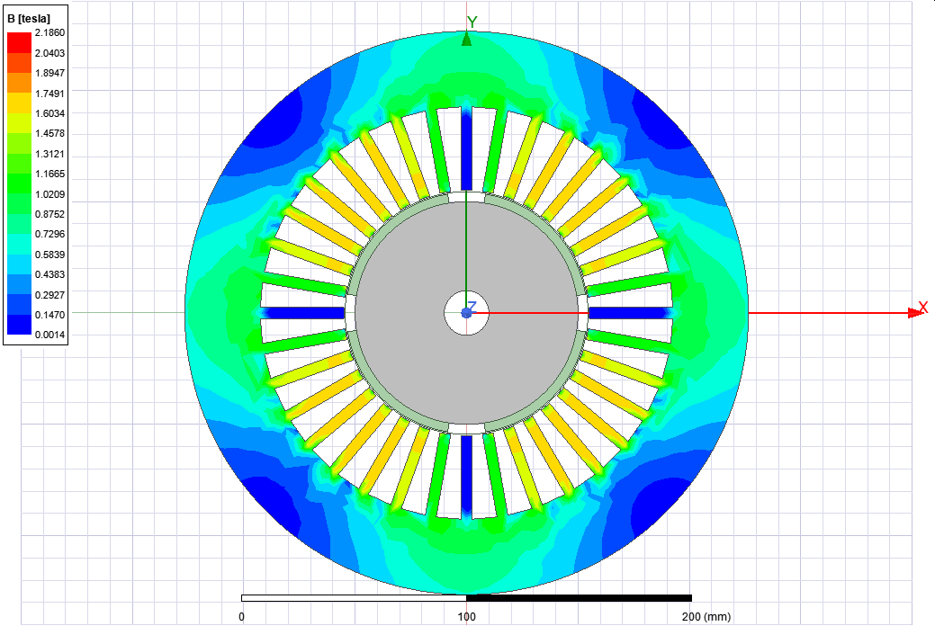

Figure 5. Flux density distribution of the designed motor.

d)

Electrical loading is found as follows

$$\begin{aligned}A=\frac{N.I.Q}{πD_{i}}=\frac{270.2,5.36}{π.0,11}=70317A/m\#\left(22\right)\end{aligned}$$

Generally, for permanent magnet synchronous machines, electrical loading is found between 35 to 65 kA/m. I have found electrical loading above but very close to upper limit.

e)

Since, electrical and magnetic loading of the motor are known, tangential stress is found as in (23).

$$\begin{aligned}σ_{tangential}=\frac{A.B}{\sqrt{2}}=41269Pa\#\left(23\right)\end{aligned}$$

The force that is produced by the motor is found by multiplying the stress with the surface area of the rotor.

$$\begin{aligned}F_{tangential}=S_{rotor}.σ_{tangential}=π.0,1.0,1.41269=1296N\#\left(24\right)\end{aligned}$$

f)

In order to find the output power, produced torque must be known. After finding tangential stress torque calculation is trivial.

$$\begin{aligned}T=S_{rotor}.σ_{tangential}.r_{rotor}=π.0,1.0,1.41269.0,05=64.83N.m\#\left(25\right)\end{aligned}$$

The output power is the multiplication of torque and speed in rad/s and it is found in (26).

$$\begin{aligned}P=T.w=64,83.\frac{1500.2π}{60}=10.18kW\#\left(26\right)\end{aligned}$$

3)

a)

As we derived in the lecture notes, the torque is proportional to cube of the slot ratio as can be seen in (27). In order to create maximum torque, slot ratio should be chosen as 0.58 according to the calculations in (27) and (28).

$$\begin{aligned}T≈\left(1-d^{2}\right)d\#\left(27\right)\end{aligned}$$

$$\begin{aligned}d_{optimum}=\frac{1}{\sqrt{3}}=0.58\#\left(28\right)\end{aligned}$$

The back-core thickness is still unknown to find inner and outer diameter of the slot. Back- core thickness formula was derived in (21) and it is the same formula which is used in (29). Since, the diameter of the magnet and air gap is decreased at the same amount, magnetic loading and operating flux density of the machine does not change.

$$\begin{aligned}h_{bc}=\frac{B_{m}A_{m}}{2k_{stacking}l_{core}B_{back-core}}=\frac{B_{m}π{(D}_{inner}-0.006)l_{core}k_{embr}}{2k_{stacking}l_{core}B_{back-core}p}=\frac{1,057.π.{(D}_{inner}-0.006).0,8}{2.0,95.1.4}\#\left(29\right)\end{aligned}$$

After inserting the values, the relation between inner slot diameter to back core thickness is found as follows

$$h_{bc}=0.35{(D}_{inner}-0.006) \#(30)$$

Since, outer stator diameter is nothing but the summation of outer slot diameter with the stator back-core thickness, inner stator diameter and back-core thickness can be found as follows

$$\begin{aligned}D_{stator}=\frac{D_{inner}}{d}+2.h_{bc}=160mm\#\left(31\right)\end{aligned}$$

$$\frac{D_{inner}}{0.58}+0.7{(D}_{inner}-0.006)=160mm \#(32)$$

$$\begin{aligned}D_{inner}=68mm\#\left(33\right)\end{aligned}$$

$$\begin{aligned}h_{bc}=22mm\#\left(34\right)\end{aligned}$$

The next thing to do was finding slot height. After finding inner diameter of the slot and the back-core thickness, slow height can be found as follows

$$\begin{aligned}h_{h}=\frac{D_{stator}-2.h_{bc}-D_{inner}}{2}=24mm\#\left(35\right)\end{aligned}$$

The rotor outer diameter is found as in (36)

$$\begin{aligned}D_{rotor}=D_{inner}-D_{airgap}-D_{magnet}=68-2-8=58mm\#\left(36\right)\end{aligned}$$

Inner and outer slot width is found as previously calculated.

$$\begin{aligned}h_{w-inner}=\frac{πD_{inner}}{2Q}=\frac{π68}{36.2}=2.97mm\#\left(37\right)\end{aligned}$$

$$h_{w-outer}=\frac{πD_{outer}}{2Q}=\frac{π116}{36.2}=5.06mm \#(38)$$

Then slot area and number of coils that can fit into the slot is calculated in (39) and (40).

$$\begin{aligned}A_{slot}=\frac{\left(h_{w-inner}+h_{w-outer}\right).h_{h}}{2}=96.36mm^{2}\#\left(39\right)\end{aligned}$$

$$\begin{aligned}N_{coils}=\frac{A_{slot}.k_{cu}}{A_{cable}}=\frac{96,36.0,6}{0.519}=111coilsperslot\#\left(40\right)\end{aligned}$$

Slot number is chosen as 36. Then, electrical loading is calculated as follows

$$\begin{aligned}A=\frac{N.I.Q}{πD_{i}}=\frac{111.2,5.36}{π.0,068}=46763A/m\#\left(41\right)\end{aligned}$$

The electrical loading is in good agreement with industrial designs, since it is generally in the range of 35-65 kA/m for permanent magnet synchronous machines. As, magnetic loading does not change and electrical loading found in (41), one can find the tangential stress created by the motor as

$$\begin{aligned}σ_{tangential}=\frac{A.B}{\sqrt{2}}=27015Pa\#\left(42\right)\end{aligned}$$

The force and torque created by tangential stress is then found as

$$\begin{aligned}F_{tangential}=S_{rotor}.σ_{tangential}=π.0,058.0,1.27015=492N\#\left(43\right)\end{aligned}$$

$$\begin{aligned}T=S_{rotor}.σ_{tangential}.r_{rotor}=π.0,058.0,1.27015.0,029=14.27N.m\#\left(44\right)\end{aligned}$$

Although, I have tried the achieve maximum torque with given constraints, since the outer diameter of the motor is decreased, output torque is decreased immensely. So, I have verified that the torque is proportional to the volume of the motor. Magnetic loading did not change with the changing diameter since the magnetic circuit stayed the same whereas electrical loading is decreased since the slot area is decreased with decreasing outer diameter.

**Conclusion**

In this project, analytical calculation and finite element analysis of a radial-flux permanent magnet synchronous machine is done. Starting from scratch, air gap flux density magnetic loading, electrical loading, tangential stress, output torque and power values are calculated. Using ANSYS Maxwell, calculations are verified. The effect of the change of the slot ratio on the motor is investigated by comparing two different designs with different slot ratios. The project was very beneficial since it was a great chance to practice what we have learned in lectures.