**1) WAP in C to print Table of an Integer Number using User Define**

**Functions.**

#include<stdio.h>

int n;

int table(n)

{

int i=0;

while(i++<10)

printf("%d X %d = %d\n",n,i,n*i);

return 0;

}

int main()

{

printf("Enter the number whose table you want to know: ");

scanf("%d",&n);

table(n);

return 0;

}

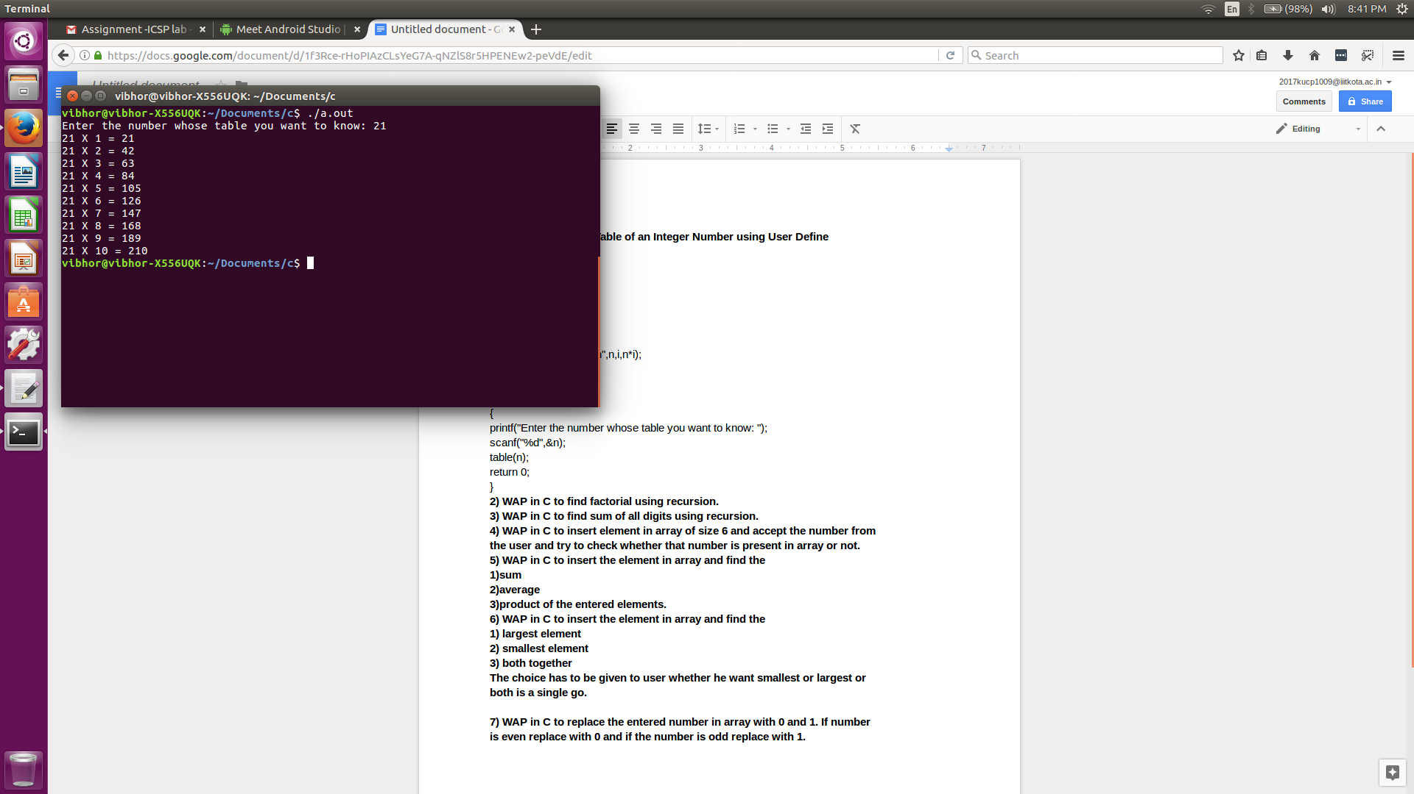

**2) WAP in C to find factorial using recursion.**

#include<stdio.h>

int n;

int factorial(n)

{

if(n==0)

return 1;

else

return n*factorial(n-1);

}

int main()

{

printf("Enter the number whose factorial you want to know: ");

scanf("%d",&n);

printf("\nFactorial of %d is %d.\n",n,factorial(n));

}

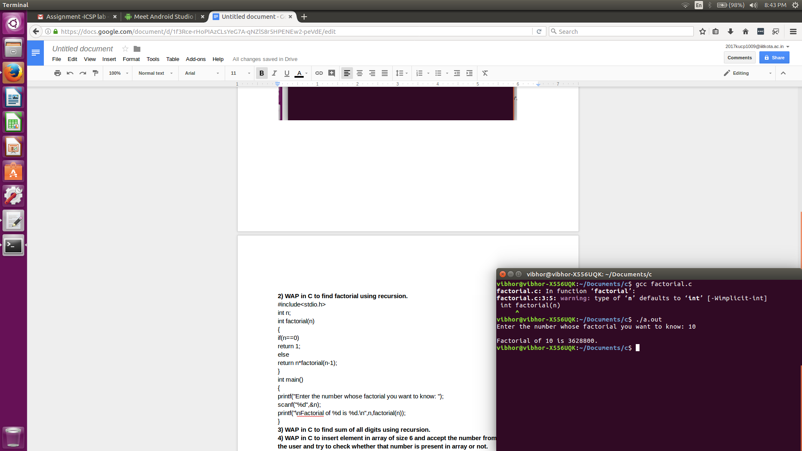

**3) WAP in C to find sum of all digits using recursion.**

#include<stdio.h>

int sum(int n)

{

int rem;

if(n==0)

{

return 0;

}

else

{

rem=n%10;

n=n/10;

rem=rem+sum(n);

return rem;

}

}

int main()

{

int n;

printf("Enter the number: ");

scanf("%d",&n);

printf("\nSum of digits is %d.\n",sum(n));

}

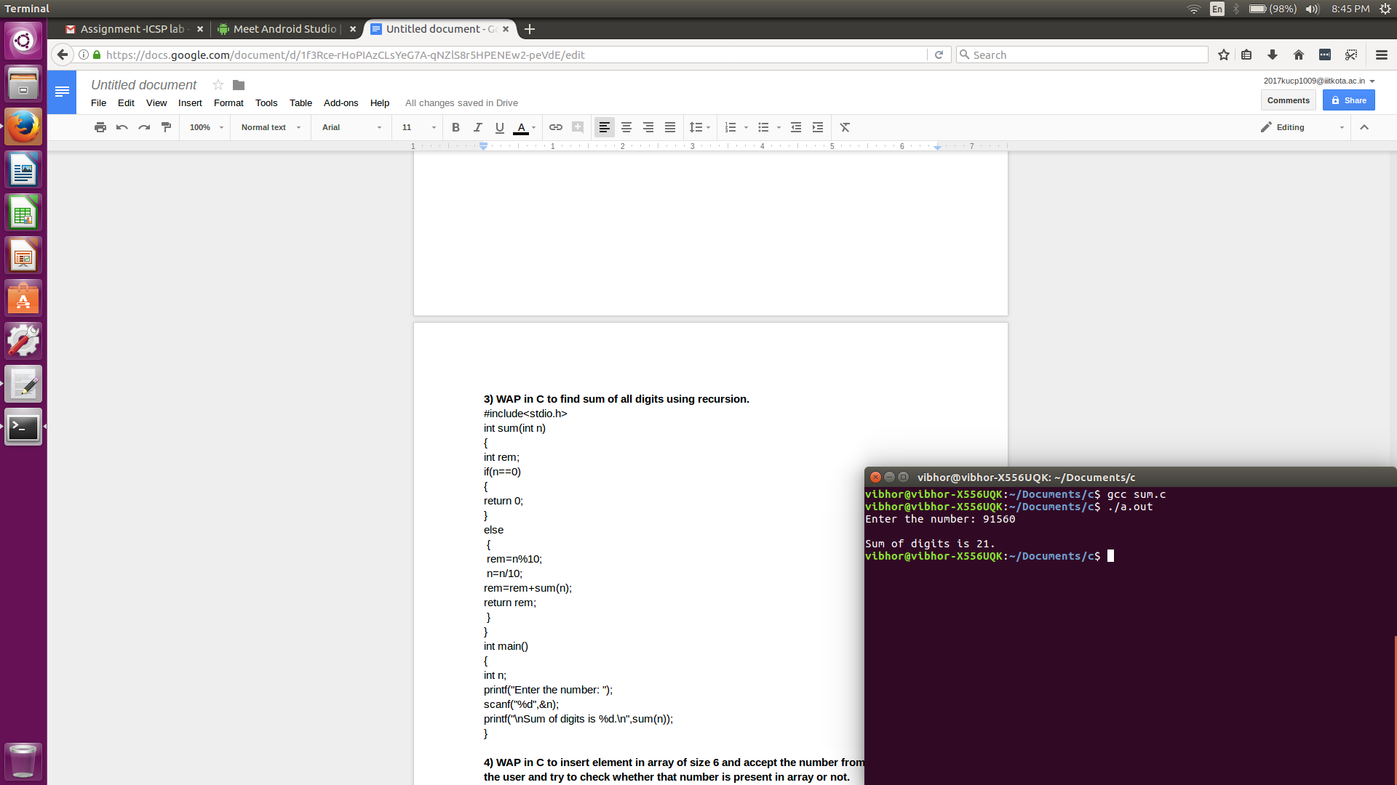

**4) WAP in C to insert element in array of size 6 and accept the number from**

**the user and try to check whether that number is present in array or not.**

#include<stdio.h>

void main()

{

int a[6],n,i,k=0;

printf("Enter 6 numbers to insert them in an array:\n");

for(i=0;i!=6;i++)

scanf("%d",&a[i]);

printf("\nNow enter a number: ");

scanf("%d",&n);

for(i=0;i!=6;i++)

if(n==a[i])

{

printf("\nYou have already entered this number in array.\n");

k=1;

}

if(k==0)

printf("\nYou have not entered this number in array.\n");

}

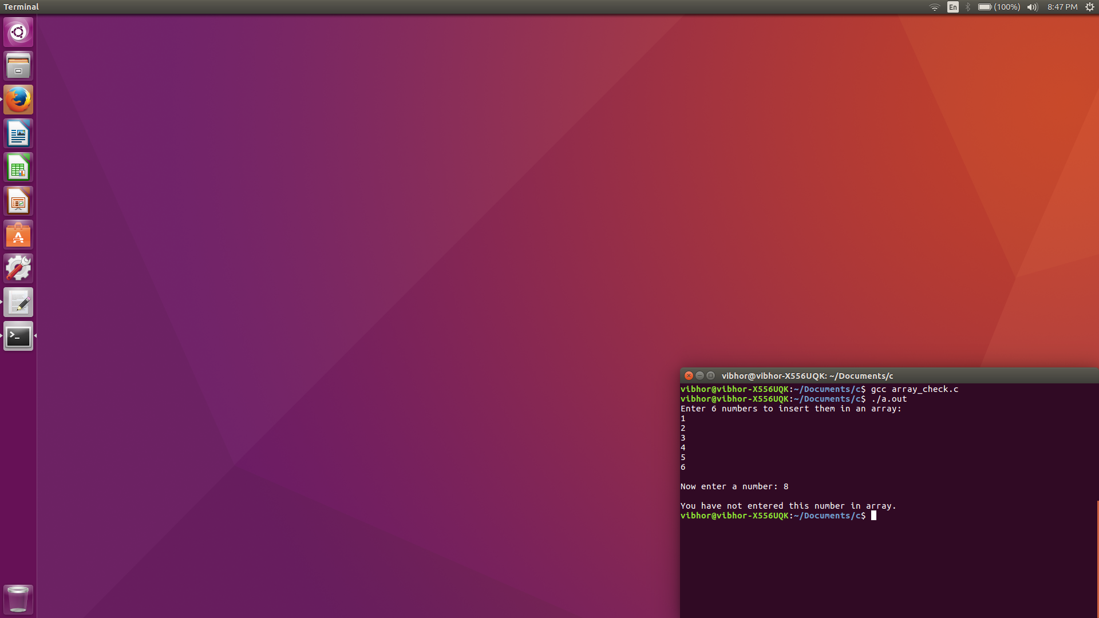

**5) WAP in C to insert the element in array and find the**

**1)sum**

**2)average**

**3)product of the entered elements.**

#include<stdio.h>

int main()

{

int num,n,i,s,avg,pro;

printf("Enter how many numbers you want to input: ");

scanf("%d",&num);

int a[num];

printf("\nNow input values\n");

for(i=0;i<num;i++)

scanf("%d",&a[i]);

for(i=0;i<num;i++)

s+=a[i];

avg=s/num;

for(i=0;i<num;i++)

pro*=a[i];

printf("\nSum=%d\nAverage=%d\nProduct=%d\n",s,avg,pro);

}

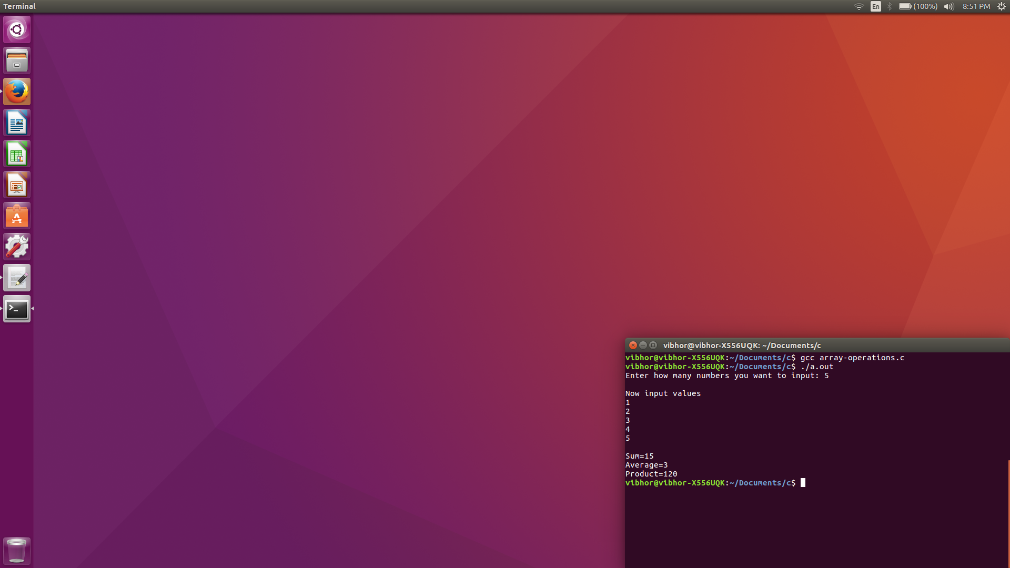

**6) WAP in C to insert the element in array and find the**

**1) largest element**

**2) smallest element**

**3) both together**

**The choice has to be given to user whether he want smallest or largest or**

**both is a single go.**

#include<stdio.h>

void main()

{

int num,i,large,small,choice;

printf("Enter how many numbers you want to input: ");

scanf("%d",&num);

int a[num];

printf("\nNow input values\n");

for(i=0;i<num;i++)

scanf("%d",&a[i]);

printf("\nIf you want to calculate smallest type 0, if largest type 1,if both type 2: ");

scanf("%d",&choice);

small=a[0];

large=a[0];

for(i=0;i<num;i++)

if(small>a[i])

small=a[i];

for(i=0;i<num;i++)

if(large<a[i])

large=a[i];

if(choice==0)

printf("\nSmallest is %d\n",small);

else if(choice==1)

printf("\nLargest is %d\n",large);

else if(choice==2)

{

printf("\nSmallest is %d\n",small);

printf("\nLargest is %d\n",large);

}

}

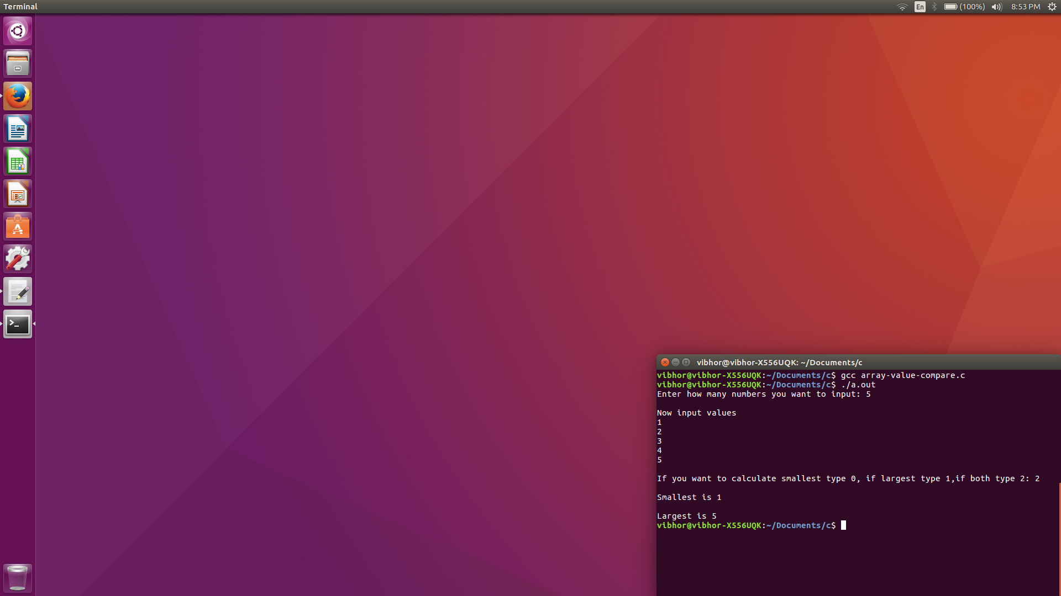

**7) WAP in C to replace the entered number in array with 0 and 1. If number**

**is even replace with 0 and if the number is odd replace with 1.**

#include<stdio.h>

void main()

{

int num,i,large,small,choice;

printf("Enter how many numbers you want to input: ");

scanf("%d",&num);

int a[num];

printf("\nNow input values\n");

for(i=0;i<num;i++)

scanf("%d",&a[i]);

for(i=0;i<num;i++)

if(a[i]%2==0)

a[i]=0;

else a[i]=1;

for(i=0;i<num;i++)

printf("Element no.%d of array becomes %d\n",i+1,a[i]);

}

