ASSIGNMENT – 5

**1.WAP in C to print the all the even number and odd number from the 1 to N. Try to categorize the numbers in given range.**

//printing even and odd numbers

#include<stdio.h>

void main()

{

int n,i=1,j=1;

printf("Enter N to print odd and even numbers : ");

scanf("%d",&n);

printf("\nEven Numbers:\n");

for(i=1;i<=n;i++)

{ if(i%2==0)

printf("%d ",i);

}

printf("\nOdd Numbers:\n");

for(j=1;j<=n;j++)

{ if(j%2!=0)

printf("%d ",j);

}

}

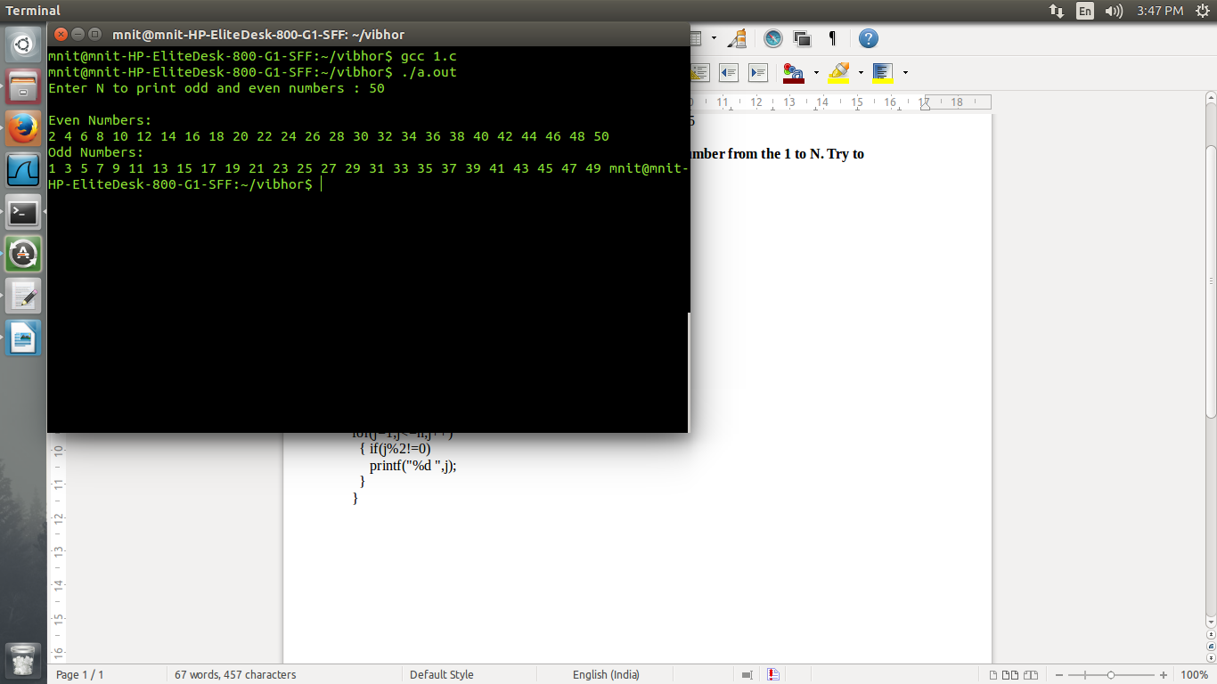

**2. WAP IN C to print the table of numbers between 1 to 10.**

//table of numbers between 1 and 10

#include<stdio.h>

void main()

{

int j,n;

for(n=1;n<11;n++)

{

for(j=1;j<=10;j++)

printf("%d\t",(n*j));

printf("\n");

}

}

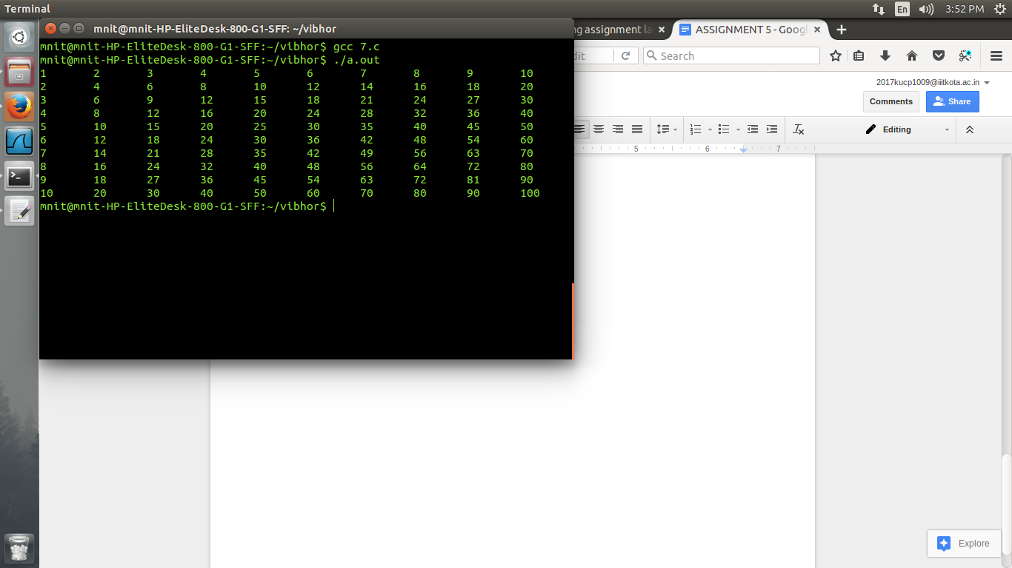

**3.WAP in C to generate the given pattern. (PASCAL’S TRIANGLE)**

//pascal's triangle

#include<stdio.h>

void main()

{

int i,j,k,l,val,n=5;

for(i=1;i<=n;++i)

{

for(j=n-1;j>=i;--j)

printf(" ");

for(k=1,val=i;k<i;++k,++val)

printf("%d",val);

for(l=val;l>=i;--l)

printf("%d",l);

printf("\n");

}

}

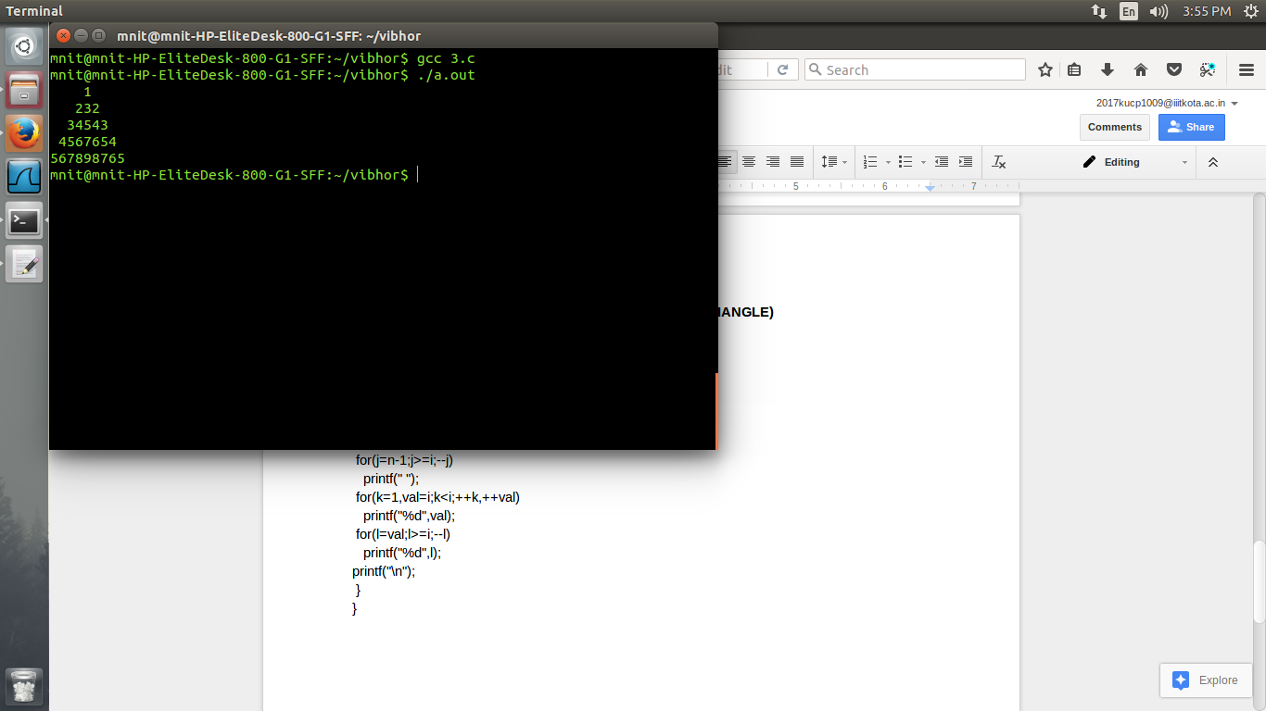

**4. WAP in C to generate the Floyd’s triangle given below.**

//Floyd's Triangle

#include <stdio.h>

int main()

{

int i,c,n=1;

for(i=1;i<=4;i++)

{

for(c=1;c<=i;c++)

{

printf("%d ",n);

a++;

}

printf("\n");

}

return 0;

}

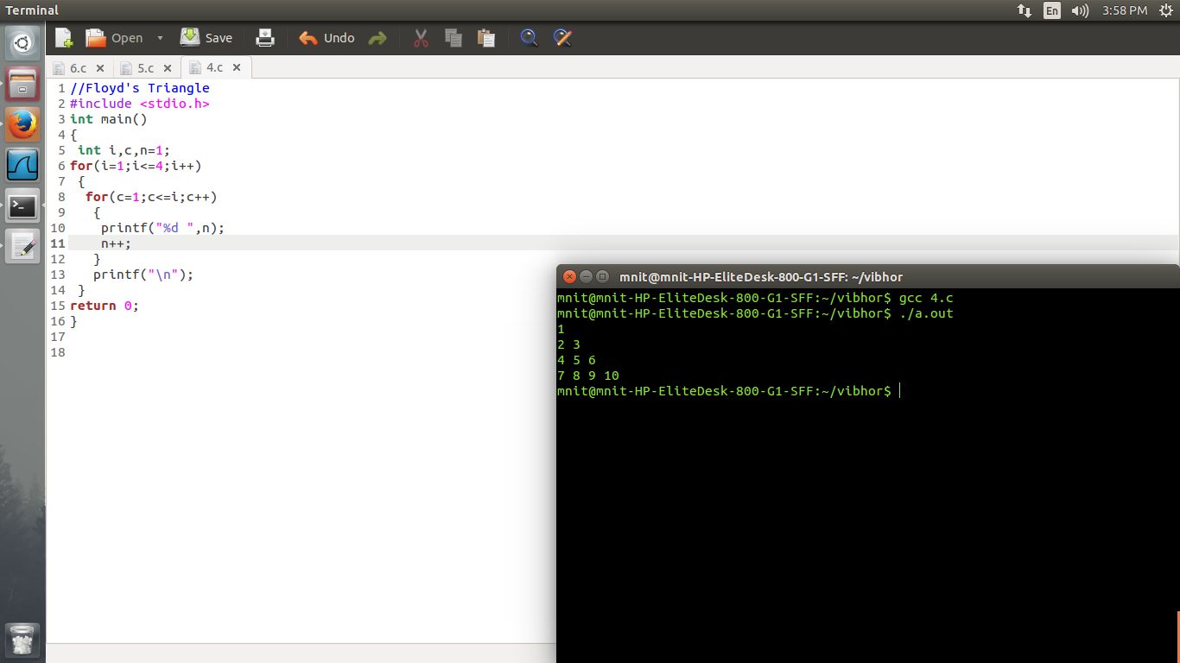

**5. WAP in C to count the number of digits in entered number. Accept the entered number of Long type and if the user type unexpected number Than throw a message “please correct the number and Enter again” until it gives count of digit the program should not end.**

//To Calculate Number of Digits

#include <stdio.h>

int main()

{

long n,c;

int b, count = 0;

printf("Enter integer to calculate the number of digits : ");

scanf("%ld", &n);

b=(int)n;

c=n-b;

if(c==0)

{

while(n != 0)

{

n = n/10;

count++;

}

printf("Number of digits: %d\n", count);

}

else

printf("please correct the number and Enter again");

return 0;

}

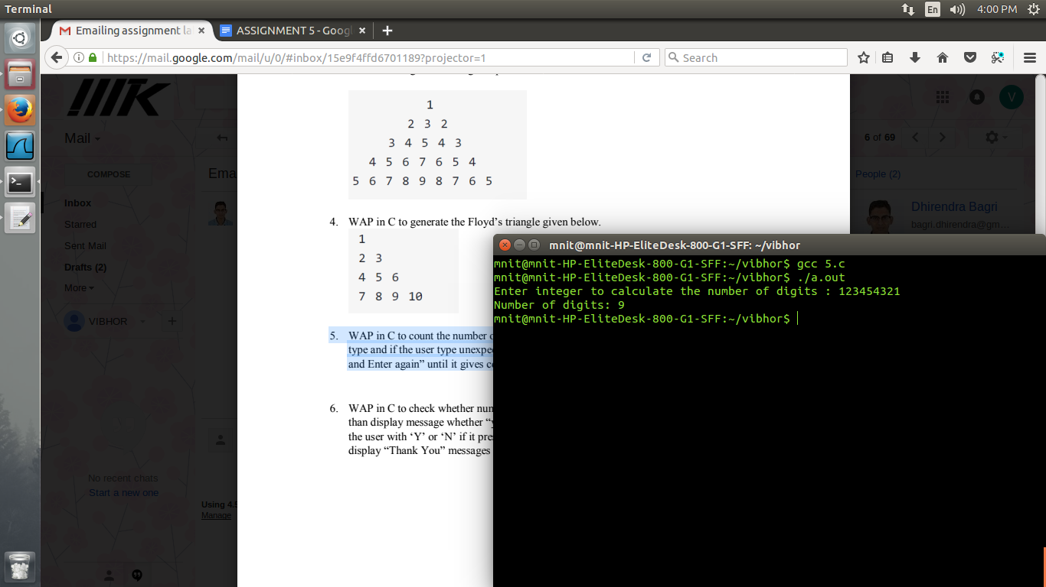

**6. WAP in C to check whether number is positive or negative or Zero. If number is found positive then display message whether “you want to find the factorial of number or not?” give choice to the user with ‘Y’ or ‘N’ if it presses Y then display the factors of pressed integer number. Else display “Thank You” messages for all the cases.**

//Factorial Choice

#include<stdio.h>

void main()

{

int n,c,i;

printf("Enter the number : ");

scanf("%d",&n);

if(n>0)

{

printf("Do you want to find the factorial of number or not?(Y=1,N=0)\n");

scanf("%d",&c);

if(c==1)

{

for(i=n-1;i>0;i--)

{

n=n*i;

}

printf("\n%d",n);

}

else

printf("Thank You");

}

else

printf("Thank You\n");

}

