**Open Access Assignment -8**

**Sudeep Singh Gill (**2017KUCP1003)

**Vibhor Rawal (**2017KUCP1009**)**

**CSE Ist Semester A1**

**Q.1 1. Write a C program to create, declare and initialize structure.**

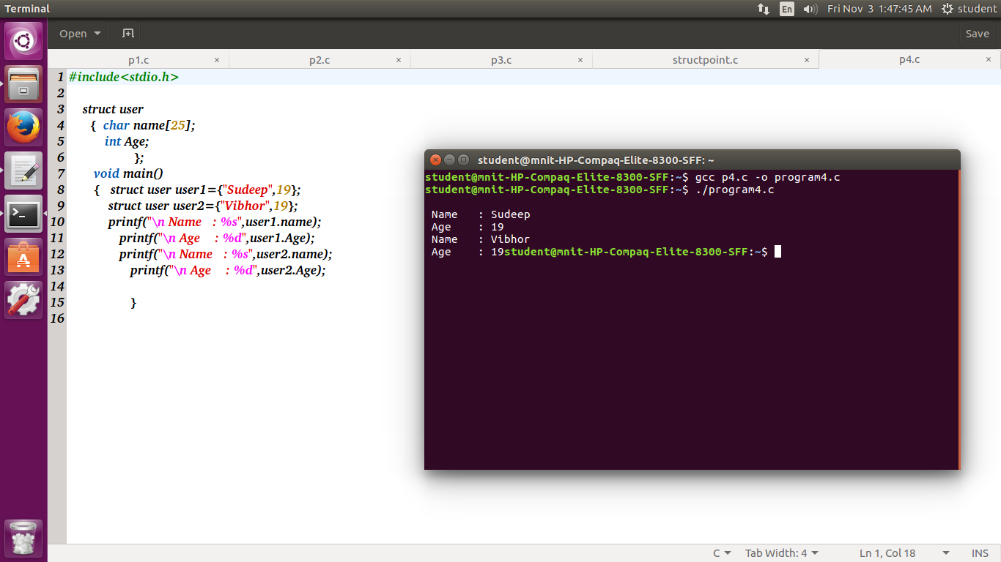

**Q.2 2. Write a C program to read and print an employee's detail using structure.**

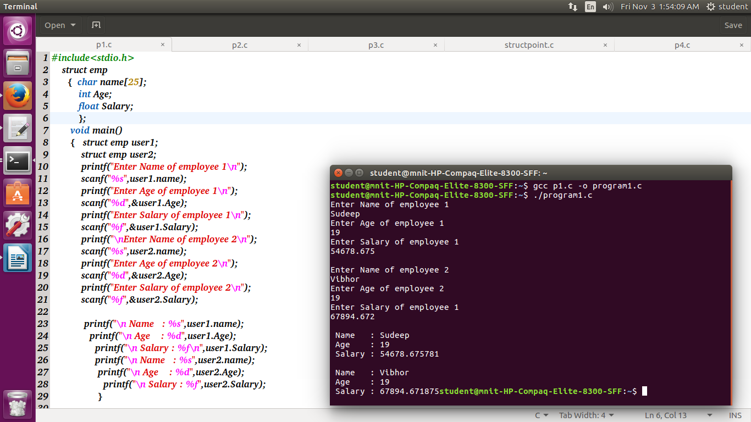

**Q.3 3. Write a C program to demonstrate example of structure pointer.**

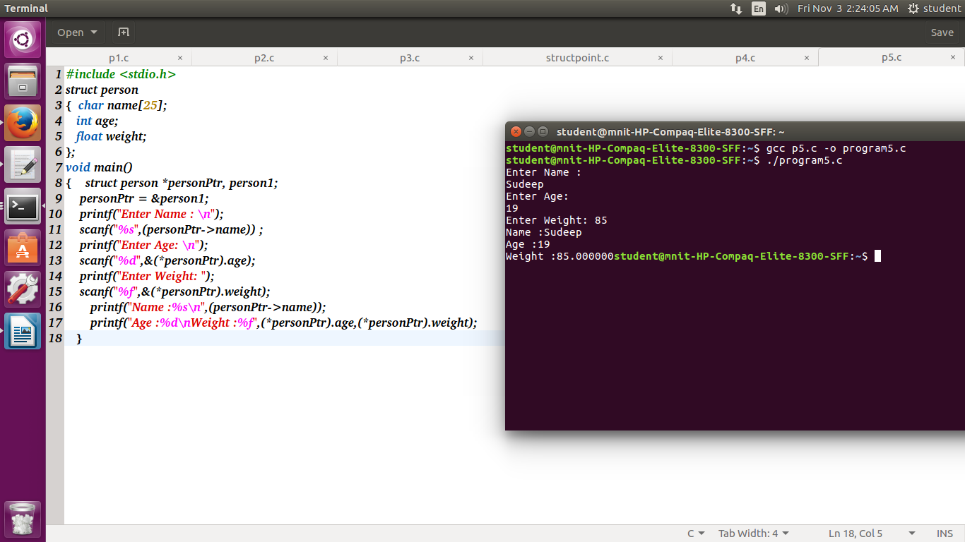

**Q.4 Write a C program to demonstrate example of array of structure.**

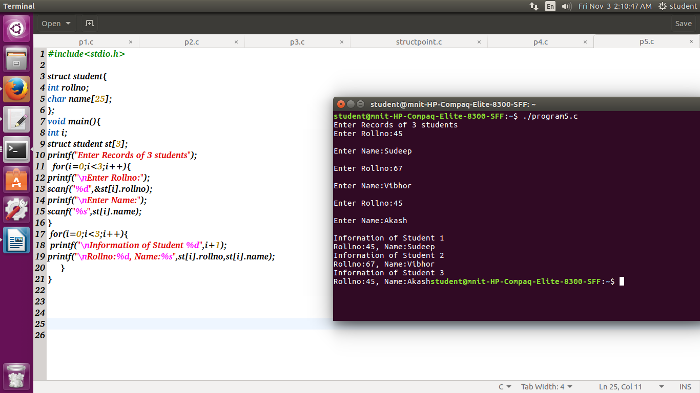

**Q.5 5. Write a C program to add two distances in feet and inches using structure.**

