PROGRAM 1

#include<stdio.h>

struct Employee

{

int emp_ID;

char name[20];

double salary;

char designation[20];

float experience;

};

void main()

{

struct Employee e[5];

int start,end,len;

/* address of the first element of first employee */

start = &e[0].emp_ID;

/* address of the first element of second employee */

end = &e[1].emp_ID;

len = end-start;

printf("\n Size of the structure=%d",len);

}

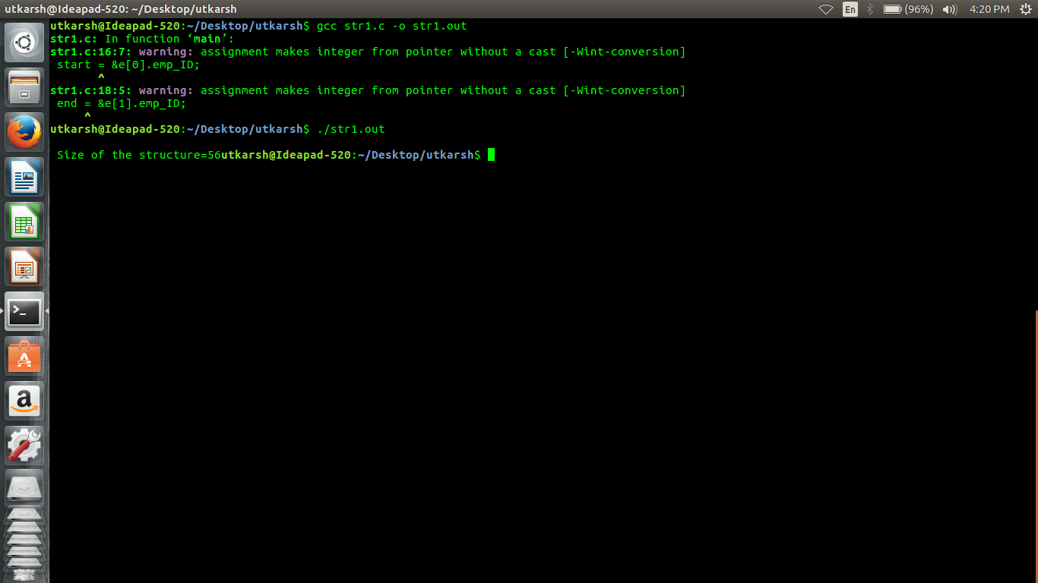

PROGRAM 2

#include<stdio.h>

int main()

{

struct DOB

{

int day;

int month;

int year;

};

struct student

{

int roll_no;

char name[100];

float fees;

struct DOB date;

};

struct student stud1;

printf("\n Enter the Roll no: ");

scanf("%d",&stud1.roll_no);

printf("\n Enter the name: ");

scanf("%s",&stud1.name);

printf("\n Enter the Fees: ");

scanf("%f",&stud1.fees);

printf("\n Enter the DOB:");

scanf("%d%d%d",&stud1.date.day,&stud1.date.month,&stud1.date.year);

printf("\n ## STUDENT DETAILS ##");

printf("\n ROLL No. = %d",stud1.roll_no);

printf("\n NAME = %s",stud1.name);

printf("\n FEES = %f",stud1.fees);

printf("\n DOB = %d - %d - %d",stud1.date.day,stud1.date.month,stud1.date.year);

return 0;

}

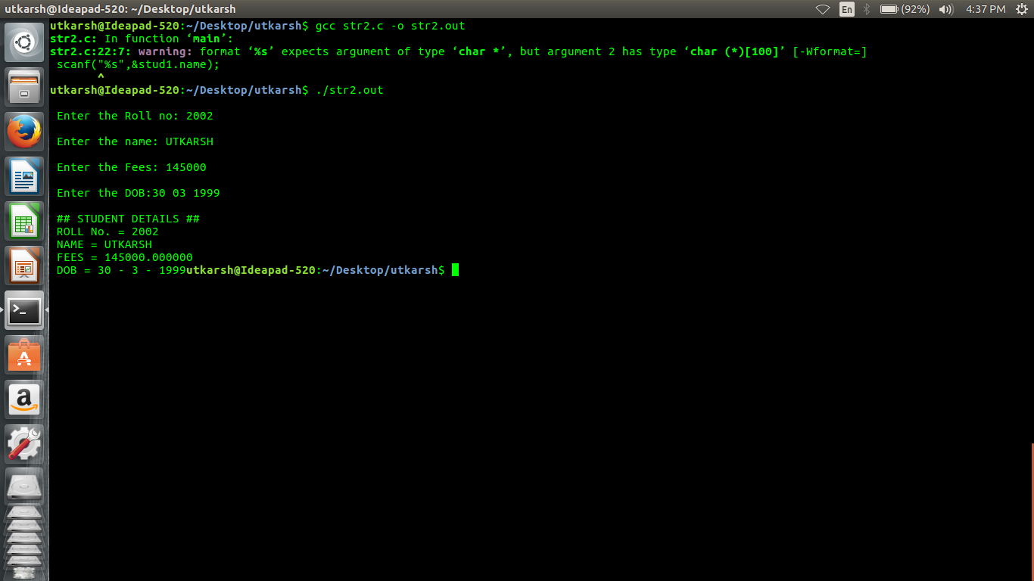

PROGRAM 3

#include<stdio.h>

#include<string.h>

int main()

{

struct student

{

int roll_no;

char name[80];

float fees;

char DOB[80];

};

struct student stud[50];

int n,i,rollno,new_rollno;

float new_fees;

char new_DOB[80],new_name[80];

printf("\n Enter the no of students:");

scanf(" %d ",&n);

fflush(stdin);

for(i=0;i<n;i++)

{

printf("\n Enter the roll no:");

scanf(" %d",&(stud[i].roll_no));

fflush(stdin);

//scanf(" %d",&stud[i].roll_no);

printf("\n Enter the name:");

scanf(" %s",(stud[i].name));

fflush(stdin);

printf("\n Enter the fees:");

scanf(" %f",&(stud[i].fees));

fflush(stdin);

//scanf(" %f ",&stud[i].fees);

printf("\n Enter the DOB:");

scanf(" %s",(stud[i].DOB));

fflush(stdin);

}

for(i=0;i<n;i++)

{

printf("\n ## DETAILS OF THE STUDENT %d ##",i+1);

printf("\n ROLL No. = %d",stud[i].roll_no);

printf("\n NAME = %s ",stud[i].name);

printf("\n FEES = %f ",stud[i].fees);

printf("\n Date of Birth = %s ",stud[i].DOB);

}

printf(" \n Enter the roll no of student whose record has to be edited");

scanf("%d",&rollno);

printf("\n Enter the new roll no:");

scanf(" %d ",&new_rollno);

printf("\n Enter the new name:");

scanf("%s",new_name);

printf("\n Enter the new fees:");

scanf("%f",&new_fees);

printf("\n Enter the new DOB:");

scanf("%s",new_DOB);

stud[rollno-1].roll_no=new_rollno;

strcpy(stud[rollno-1].name,new_name);

stud[rollno-1].fees=new_fees;

strcpy(stud[rollno-1].DOB,new_DOB);

for(i=0;i<n;i++)

{

printf("\n ## DETAILS OF THE STUDENT %d ##",i+1);

printf("\n ROLL No. = %d ",stud[i].roll_no);

printf("\n NAME = %s ",stud[i].name);

printf("\n FEES = %f ",stud[i].fees);

printf("\n Date of Birth = %s ",stud[i].DOB);

}

return 0;

}

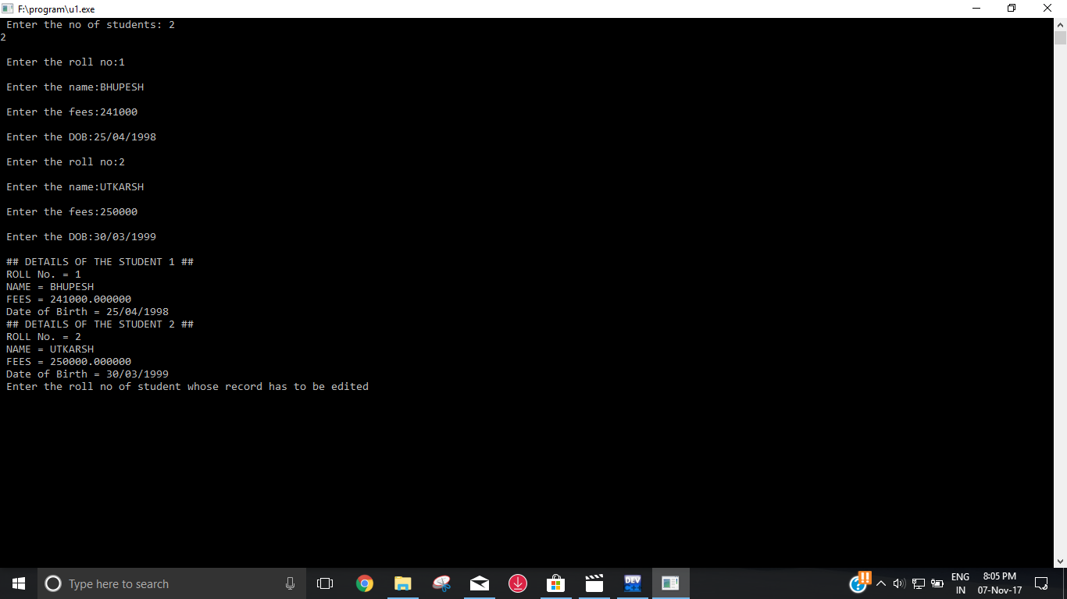

PROGRAM 4

#include<stdio.h>

struct distance

{

int kms;

int metres;

};

struct distance add_distance(struct distance,struct distance);

struct distance subtract_distance(struct distance,struct distance);

struct distance d1,d2,d3,d4;

int main()

{

int option;

do

{

printf("\n *** MAIN MENU ** ");

printf("\n 1. Read the distances ");

printf("\n 2. Display the Distances");

printf("\n 3. ADD the Distances ");

printf("\n 4. SUBTRACT the Distances ");

printf("\n 5. EXIT");

printf("\n Enter your Option ");

scanf("%d",&option);

switch(option)

{

case 1:

printf("\n Enter the first distance in kms & metres :");

scanf("%d%d",&(d1.kms),&(d1.metres));

printf("\n Enter the second distance in kms & metres :");

scanf("%d%d",&(d2.kms),&(d2.metres));

break;

case 2:

printf("\n The first distance is: %d kms %d metres",d1.kms,d1.metres);

printf("\n The second distance is: %d kms %d metres",d2.kms,d2.metres);

break;

case 3:

d3 = add_distance(d1,d2);

printf("\n The sum of two distances is: %d kms %d metres",d3.kms,d3.metres);

break;

case 4:

d4 = subtract_distance(d1,d2);

printf("\n The difference btw two distances is: %d kms %d metres",d4.kms,d4.metres);

break;

}

}while(option !=5);

return 0;

}

struct distance add_distance(struct distance d1,struct distance d2)

{

struct distance sum;

sum.metres = d1.metres + d2.metres;

sum.kms = d1.kms + d2.kms;

if(sum.metres>=1000)

{

sum.metres = sum.metres%1000;

sum.kms += 1;

}

return sum;

}

struct distance subtract_distance(struct distance d1,struct distance d2)

{

struct distance sub;

if(d1.kms>d2.kms)

{

sub.metres = d1.metres - d2.metres;

sub.kms = d1.kms - d2.kms;

}

else

{

sub.metres = d2.metres - d1.metres;

sub.kms = d2.kms - d1.kms;

}

if(sub.metres<0)

{

sub.kms = sub.kms-1;

sub.metres = sub.metres+1000;

}

return sub;

}

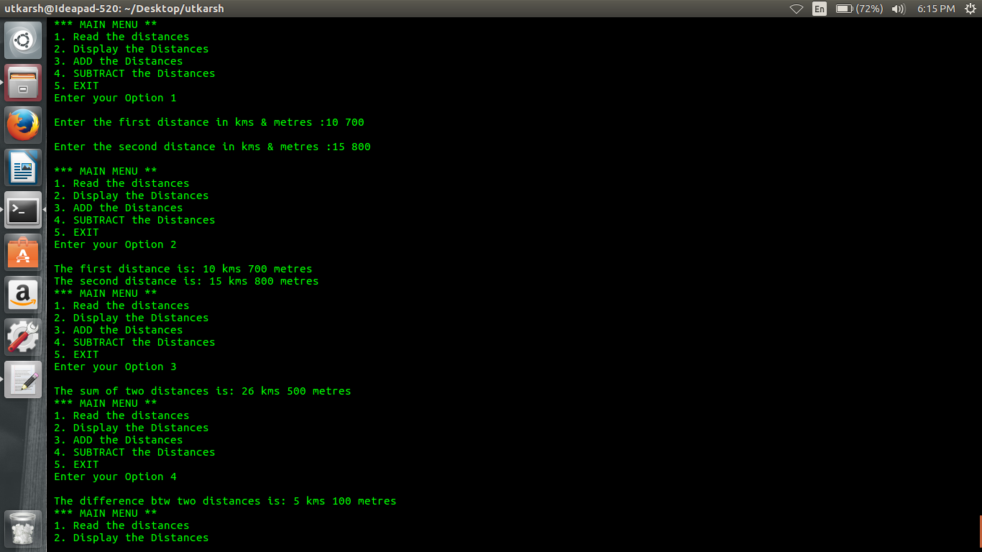

PROGRAM 5

#include<stdio.h>

#include<string.h>

struct student

{

int r_no;

char name[20];

char course[20];

int fees;

};

int main()

{

struct student stud1,stud2,*ptr_stud1,*ptr_stud2;

ptr_stud1=&stud1;

ptr_stud2=&stud2;

ptr_stud1 -> r_no = 1;

strcpy(ptr_stud1->name,"UTKARSH");

strcpy(ptr_stud1->course,"B.Tech");

ptr_stud1->fees = 1000000;

printf("\n Enter the details of the first student:");

printf("\n Enter the ROLL No:");

scanf("%d",&ptr_stud1->r_no);

printf("\n Enter the name:");

scanf("%s",ptr_stud1->name);

printf("\n Enter the course; ");

scanf("%s",ptr_stud1->course);

printf("\n Enter the Fees:");

scanf("%d",&ptr_stud1->fees);

printf("\n Enter the details of the second student:");

printf("\n Enter the ROLL No:");

scanf("%d",&ptr_stud2->r_no);

printf("\n Enter the name:");

scanf("%s",ptr_stud2->name);

printf("\n Enter the course; ");

scanf("%s",ptr_stud2->course);

printf("\n Enter the Fees:");

scanf("%d",&ptr_stud2->fees);

printf("\n DETAILS OF FIRST STUDENT");

printf("\n ROLL No = %d",ptr_stud1->r_no);

printf("\n NAME = %s",ptr_stud1->name);

printf("\n COURSE = %s",ptr_stud1->course);

printf("\n FEES = %d",ptr_stud1->fees);

printf("\n DETAILS OF SECOND STUDENT");

printf("\n ROLL No = %d",ptr_stud2->r_no);

printf("\n NAME = %s",ptr_stud2->name);

printf("\n COURSE = %s",ptr_stud2->course);

printf("\n FEES = %d",ptr_stud2->fees);

return 0;

}

