Department of Computer Science

San Francisco State University

College of Science and Engineering

CSc 699 Independent Study Report for Prof. Jozo J. Dujmovic by Vidit Joy Manglani

Sustainability Evaluation using the LSP Method:

With a case-study using the STARS Sustainability Indicators defined by AASHE

**Abstract:**  This report shows that the LSP Method, as a result of its intuitiveness, is specifically well suited for application in Sustainability Evaluation – which requires extensive stakeholder engagement. The case-study further to suggest that Higher Education Institutions who are currently collecting data for sustainability reporting, and have access to evaluation professionals, begin utilizing these resources with a transparent method such as LSP to actualize the goals of sustainable development.

Vidit Joy Manglani

Candidate for Bachelor of Computer Science

**TABLE OF CONTENTS**

**1. Introduction**

**1.1 Statement of the problem**

**1.2 Survey of literature and projects**

**1.3 Project goals**

**2. Sustainability domain expertise**

**3.  LSP method**

**3.1 Attribute tree**

**3.2 Attribute criteria**

**3.3 Suitability aggregation structure**

**4.  Case study of sustainability evaluation for SFSU**

**4.1 LSP criterion**

**4.2 Numerical results**

**5.  Conclusions and future work**

**1. Introduction**

**1.1  Statement of the problem**

The starting point for this report is that Sustainability is like perfection – it is the end and the means. That without measurement and evaluation, an organization striving for sustainability might as well be lighting candles in the wind. And that “Sustainability assessment is not merely an evaluation, it is an approach to decision making” (Morrison-Saunders et al, 452). When approached as a decision problem, the evaluation of a systems and its sustainable development, is simply and comprehensibly addressable through iterations of informed decisions and analyses of the resulting actions.

Following this thinking, we see this evaluation not only as a process for determining the ability of an organization to satisfy a set of sustainability requirements or to compare the sustainability of organizations to each other, but also for sustainability optimization – particularly for the evaluation, comparison and selection of mitigation projects in sustainability planning and overall development. And most importantly, as part of the inherent decision-making process in an institution, organization or individual.  
In *Introducing the Roots, Evolution and Effectiveness of Sustainability Assessment*;Bond, Pope and Morrison-Saunders recognize that “since anthropogenic decision making has been inextricably linked to environmental problems, any process that directs decision-making towards sustainable development can be simply defined as Sustainability Assessment” (Morrison-Saunders et al, 3). But within the understanding of organizations and Higher Education Institutions, this assessment generally ends at the reporting stage. This report would like to encourage that the data collected to satisfy sustainability reporting will actualize sustainable development only if it is made part of the decision making process, and ideally through the use of intuitive Decision Support Systems.   
“Better decisions are made when there is wide consultation” (Morrison-Saunders et al., 417). In a successful sustainability evaluation, when structuring the problem (selection of indicators, criteria & aggregators) for the various stakeholders required, the intuitiveness of a DSS dictates a more accurate interpretation of the decision. And since “The objective of sustainability assessment is not to determine whether some existing or proposed undertaking is an acceptably positive contributor to sustainability. We want to identify the option that will make the best contribution” (Gibson: Morrison-Saunders et al, 452).

**1.2  Survey of sustainability evaluation literature, and sustainability evaluation projects**

Sustainability Assessment or Sustainability Evaluation is a relatively new and fast-growing science, with professionals from a variety of fields providing developments and using a variety of terminology to describe a vast and detailed subject.Morrison, Pope & Bond point out that there is no universal consensus to the meanings of the words abundantly used in this field and some clarification is required for the particular use of terminology in this report. It will be dealing primarily with the use of the word Evaluation to imply an ex-ante process to aide Decision-Making and this may be used interchangeably with Assessment in our citations. When referring to Post-Ante Evaluation and distinctions between the words Assessment and Evaluation, it will be made clearer in the context. And when referring to Sustainability, especially when used in conjunction with Evaluation or Assessment it is meant as an abbreviation for Sustainable Development, as defined by Huge et al, as a process of directed change or transition, rather than just as an abstract, absolute concept (4). Also, we use Indicators, Attributes and KPI’s interchangeably, while we define Criteria as the function that guides the scoring mechanism for a particular indicator. And finally, we also use the words aggregators interchangeably with operators to define the relationship between Key Performance Indicators. As the research draws on a variety of sources that use different abbreviations and contexts, Multi-Criteria Decision Support Systems are at times described by Multi-Criteria Analysis or Multi Criteria Decision Analysis (MC-DSS, MCA, MCDA).

The literature shows the success of use of MCA methods, discusses the drawbacks of complexity on stakeholder engagement and encourages further development in the field using MCA (Retief: Morrison-Saunders et al), especially for tradeoff analysis and stakeholders engagement/involvement.

Figure 1, below, shows descriptions drawn from the seminal research of Huang et al. comparing the most popular MCDA methods used in Sustainability Assessment. In their review they concluded that the “application of MCDA methods provides a significant improvement in the decision process” and added that the “National Academy of Science has continuously called for the use of formal decision-analytical tools in the environmental decision process”.

Description of other MCDA methods used in Sustainability Evaluation  
(Huang et. al, 2011)

A basic but typical approach is to calculate the total value score for an alternative as a linear weighted sum of its scores across several criteria, i.e., V = Σi wixi, where Σi wi = 1.

AHP (Saaty, 1994), or the Analytic Hierarchy Process (and its extension the Analytic Network Process). This is a family of approaches that uses pairwise comparisons of criteria which ask how much more important one is than the other (this is generally thought to be simple, and can be flexible when multiple stakeholders are involved).

Common is a hierarchical structure (as in value hierarchies described in Keeney, 1992, and essential to the Analytic Hierarchy Process, Saaty, 1994) so that, for example, dimension i is broken down into several subdimensions j, xij is the alternative's score on the jth subdimension of dimension i, vi =Σi wij xij, and V=Σi wi vi.

MAUT, or Multi-Attribute Utility Theory (Keeney and Raiffa, 1976) adds another layer into the model, transforming scores at any level into utility functions (following axioms of von Neumann and Morgenstern, 1944). In a simple case where there is no hierarchical structure and no interactions between attributes, an alternative would have utility U=Σi wi ui (xi), where the xi is typically normalized to a range from the worst to best possible values, and ui ranging from 0 to 1 reflects the decision maker's attitude toward risk within attribute i.

Outranking approaches PROMETHEE (Preference Ranking Organization Method for Enrichment Evaluation) and ELECTRE (ELimination and Choice Expressing Reality) are methods that essentially involve holding various “votes” across dimensions. The range of possible scores for different alternatives is considered within each dimension, to derive alternatives that can be combined across dimensions. An alternative's relative score on a specific dimension is thus a function of how well it compares against the set of other alternatives (e.g., its net flow, which relates to its performance against other alternatives on that dimension). Then weights are applied across dimensions to come up with an overall attractiveness for each alternative

TOPSIS (Technique for Order Preference by Similarity, Hwang and Yoon, 1981) family of methods compares a set of alternatives by identifying weights for each dimension, normalizing scores in each dimension and calculating a distance between each alternative and the ideal alternative (best on each dimension) and the negative ideal alternative (worst) across the weighted dimensions, using one of several possible distance measures (e.g., Euclidean distance). Finally, the ratio between the distance (separation) from the negative ideal and the sum distance from the ideal and negative ideal alternatives is calculated. This ratio is used to calculate alternatives.

*Figure 1*

**1.3 Project goals**

This research leading to this project alludes that the use of sustainability indicators to support decision making, with stakeholder involvement, virtually guarantees sustainable development. The primary goal of this report is to encourage individuals, organizations and institutions to use the Key Performance Indicators available to them to aid decision making in support of sustainable development, with input from all stakeholders. In furtherance of that goal, the report explores and encourages using the intuitive, transparent and comprehensive Decision Support System, the Logic Scoring of Preference (LSP) method; since it has the ability to engage stakeholders as a result of being intuitively graspable. LSP includes the ideas of hierarchy and pairwise comparisons and introduces a set of graded logic operators. These operators closely resemble human reasoning and are thus intuitive to use and transparent in operation, and result in improved stakeholder engagement.LSP doesn’t require reinterpretation of comparisons or tradeoffs into other values, such as those used in other common methods, it simply asks us to define/weigh those relationships and provides relations (aggregators) that are intuitively consistent with human thinking.In furtherance of the primary goal of this report, it includes a case-study that utilizes a subset of the Sustainability-Performance Indicators detailed by AASHE in STARS (described in Section 4). And proposes the use of an intuitive decision support system, the LSP method, to improve stakeholder engagement in sustainability evaluation. Starting with Universities already collecting data for reporting in STARS; the ultimate goal of the research in using the LSP method for Sustainability Evaluation, is to promote sustainable development on all scales of thought.

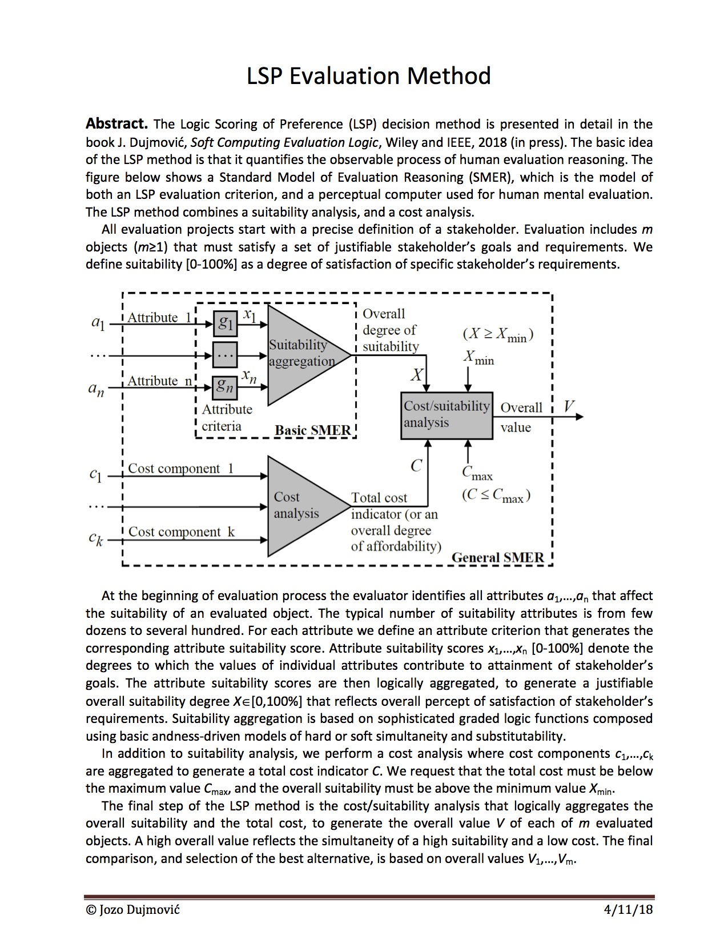

**2. Sustainability domain expertise**

Pope, Bond and Morrison-Saunders conceptualize sustainability evaluation projects with the underpinning sustainability discourse, the representation of sustainability in it assessment process and the decision making context “have objectives which align naturally with the representation of sustainability as a series of triple bottom line indicators” (Reflections on the state of art. Morrison-Saunders et al).

Retief et al explore the handling of trade-offs and conclude decision making is inherently complex. In additional as Jenny Pope et al concluded “sustainability assessment should facilitate greater awareness of the plural interpretations of the processes being applied, and can help to facilitate debate on appropriate discourses and representations of sustainability within a given decision-making context. This recognition presents some potential for ensuring the legitimacy of the process in the eyes of the stakeholders – a known issue with assessment processes” (4). This paper addresses this challenge.

Geneletti et al. discuss that the Weighted Sum Method is commonly used in Impact Assessment as a result of other methods being too complex or not intuitive, for the decision-makers, professionals, and lay-stakeholders. While Huang et al. point out that the “selection of specific methods in practice seems to be driven by availability of specific expertise and software tools. Even though AHP/ANP is widely recognized to have major limitations we observed that it has historically dominated MCDA” (1).

Reed et al. point out that “Only through active community involvement can indicators facilitate progress toward sustainable development goals” (3). The LSP method allows for multi stakeholder input at various stages of the problem structuring process; encouraging transparency, opening communication channels and hence optimizing the outcomes.

As Gibson said “its about making the world better, one decision at a time.” (2).

**3.  LSP method**

The Logic Scoring of Preference method of evaluation has been used in a variety of fields for decision support­ including artificial-intelligence, determining land-use suitability, in neural networks and for computer systems evaluation. It has also been in used in combination with GIS and MAUT systems. The LSP method draws from an intuitive understanding of human reasoning and is grounded in its use of Graded Logic and Partial Absorption aggregators to describe relationships between tradeoffs.

The GL aggregators add a gradient of hardness/softness to the commonly used Logic operators – AND, OR. This allows decision-makers to choose between a range of Simultaneity and Substitutability; operators that would intuitively be used to describe relationships between indicators and tradeoffs. The grading of the Logic Aggregators can be assigned a hardness that defines the exclusivity required from the relationship between indicators and dictates whether smaller or larger values affect the output. In addition to the Graded Logic aggregators, the LSP method finds that, intuitively, human reasoning also involves Asymmetric Simultaneity or Substitutability, and accounts for these using the Partial Absorption aggregators for Conjunction and Disjunction. These operators are used to define relationships between tradeoffs that would naturally tend towards being verbalized with terminology such as mandatory/optional and sufficient/optional, respectively. These operators enable decision-makers to define a certain performance indicators as mandatory, or sufficient, in relation to another, optional, indicator of suitability. And the presence, or absence, of these optional indicators, asymmetrically affects the overall outcome when the mandatory/sufficient indicator is not fully satisfied, which might result in a reward or penalty, depending on the operator used and the situation.

To demonstrate the use of LSP, the report works with a hypothetical scenario, in line with the Sustainable Development goal of the report, for the ‘Selection (and Scoring) of the Sustainability of Banking Institutions on a University Campus’. Along with the the author, the primary stakeholders for this Decision would be the campus community. A subset of the campus community, is the decision makers; whose goal it is to optimize the sustainable development achieved through the use of financial services on campus. They recognize that some of the banks that have a high membership do not share their goals while some of the smaller banks might not be stable enough to promote on campus. They understand that Fees are a limiting factor in the shared access of institutions and want to be able to decide on banks that best fulfil all their criteria.

The use of all the unique aggregators provided by LSP in this example demonstrates the applicability of LSP to comprehensively and comprehensibly model the decision-making process. The fact that LSP intuitively emulates human thinking significantly eases the selection of weights and operators when making trade offs and eventually aids in creating a more transparent decision making process.

**3.1  Attribute tree**

* **1  On-Campus_Banking**   
        **11  Environmental**   
             111  Environmentally Sound Investments   
             112  Environmentally Unsound Divestments   
        **12  Social**   
             121  Availability   
                  1211  Choice of Population   
                  1212  ATM Fee Schedule   
                       12121  Amount Fees Charged   
                       12122  Member of Fee-Free Groups   
             122  Additional Features   
        **13  Financial**   
             131  Invests Back in the Community   
             132  Stability

**3.2  Attribute criteria**

|  |  |  |
| --- | --- | --- |
| **111** | | **Environmentally Sound Investments** |
| Value | % | If the banking institutions invests in repairing the environment |
| 0  1 | 0  100 |

|  |  |  |
| --- | --- | --- |
| **112** | | **Environmentally Unsound Divestments** |
| Value | % | If the Banking Institution divests from projects that hurt the environment. |
| 0  1 | 0  100 |

|  |  |  |
| --- | --- | --- |
| **1211** | | **Choice of Population** |
| Value | % | What Percentage of the Campus Population (Students, Faculty, Staff) are happily using the Banking Institution (i.e, they are not looking for a change, for whatever reason) |
| 0  100 | 0  100 |

|  |  |  |
| --- | --- | --- |
| **12121** | | **Amount Fees Charged** |
| Value | % | Anything above $3.5 is considered unacceptable  $3 is the standard amount charged by big banks, but it is not to be encouraged for campus community  $1.25 is the maximum acceptable Fees, while anything lower than that is preferred. |
| 0  0.25  1.25  2.5  3  3.5 | 100  75  50  25  10  0 |

|  |  |  |
| --- | --- | --- |
| **12122** | | **Member of Fee-Free Groups** |
| Value | % | There are 2 popular fee-free groups that most co-op's are part of. This enables a larger part of the campus community (that elects to bank with smaller institutions) to utilize banking on campus, without being charged. |
| 0  1  2 | 0  50  100 |

|  |  |  |
| --- | --- | --- |
| **122** | | **Additional Features** |
| Value | % | Does the banking institution provide the ability to deposit cash/checks into the ATM.  This is a value added feature and should not be strictly enforced. |
| 0  1 | 0  100 |

|  |  |  |
| --- | --- | --- |
| **131** | | **Invests Back in the Community** |
| Value | % | Does the bank invest back in the community. (i.e, is it a co-op or a big bank) Big Banks actively invest their funds in raising capital for themselves and thus cannot get credit for this |
| 0  1 | 0  100 |

|  |  |  |
| --- | --- | --- |
| **132** | | **Stability** |
| Value | % | This is represented by the age of the bank, to presume that it will continue to be in existence in the foreseeable future. So as to assure the campus community with a stable banking experience. |
| 3  5  10  15 | 0  25  50  100 |

**3.3  Suitability aggregation structure**

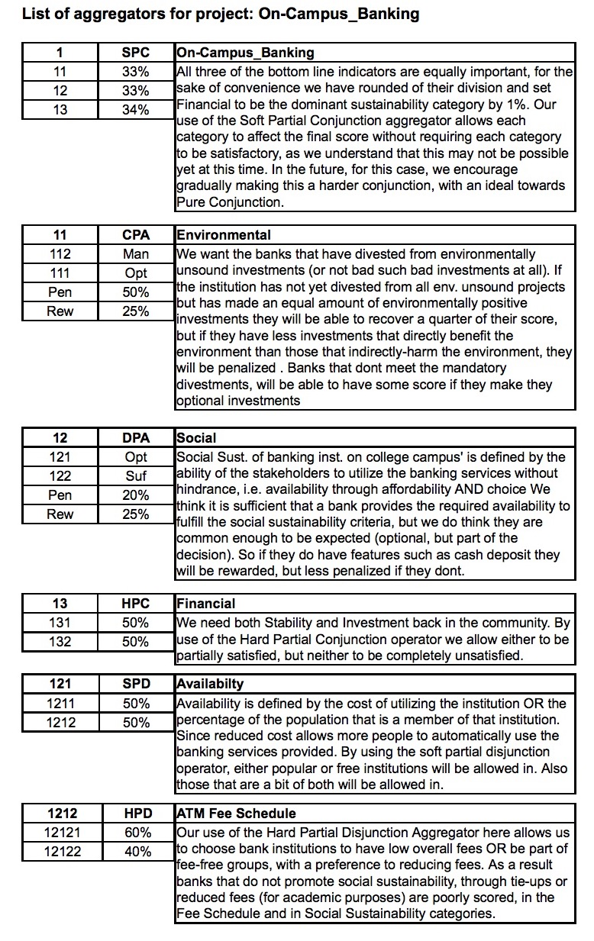

**All competitive systems (Hypothetical Values)**

|  |  |  |  |  |  |
| --- | --- | --- | --- | --- | --- |
| **Id** | **Attribute** | **Big_Bank** | **Credit_Union** | **Normal_Bank** | **Small_Bank** |
|  | Cost | 12000 | 10000 | 7000.00 | 8000.00 |
| 111 | Environmentally Sound Investments | .5 | 1 | 0.2 | 1 |
| 112 | Environmentally Unsound Divestments | .5 | 1 | 0.6 | 1 |
| 1211 | Choice of Population | 20 | 3 | 8 | 2.5 |
| 12121 | Amount Fees Charged | 3.5 | 1.5 | 1 | 2 |
| 12122 | Member of Fee-Free Groups | 0 | 2 | 1 | 2 |
| 122 | Additional Features | 1 | 0 | 1 | 1 |
| 131 | Invests Back in the Community | 0 | 1 | .3 | 1 |
| 132 | Stability | 100 | 25 | 30 | 5 |

**Evaluation results (all values expressed as percentages)   
Missingness penalty: 0 %**

|  |  |  |  |  |  |
| --- | --- | --- | --- | --- | --- |
| **Id** | **Attribute** | **Big_Bank** | **Credit_Union** | **Normal_Bank** | **Small_Bank** |
| 1 | On-Campus_Banking | 9.25 | 87.40 | 44.11 | 64.74 |
| 11 | Environmental | 50.00 | 100.00 | 41.73 | 100.00 |
| 12 | Social | 34.08 | 67.13 | 51.46 | 87.49 |
| 13 | Financial | 0.00 | 100.00 | 40.17 | 33.85 |
| 121 | Availability | 10.64 | 83.83 | 35.49 | 83.75 |
| 1212 | ATM Fee Schedule | 0.00 | 100.00 | 54.05 | 100.00 |
| 132 | Stability | 100.00 | 100.00 | 100.00 | 25.00 |
| 131 | Invests Back in the Community | 0.00 | 100.00 | 30.00 | 100.00 |
| 122 | Additional Features | 100.00 | 0.00 | 100.00 | 100.00 |
| 12122 | Member of Fee-Free Groups | 0.00 | 100.00 | 50.00 | 100.00 |
| 12121 | Amount Fees Charged | 0.00 | 45.00 | 56.25 | 35.00 |
| 1211 | Choice of Population | 20.00 | 3.00 | 8.00 | 2.50 |
| 112 | Environmentally Unsound Divestments | 50.00 | 100.00 | 60.00 | 100.00 |
| 111 | Environmentally Sound Investments | 50.00 | 100.00 | 20.00 | 100.00 |

The purpose of this example was to demonstrate the use of ALL the unique aggregator-types provided by LSP. It is modeled on the factors that would influence, and be influenced by, the results, for the aforementioned purpose, in this hypothetical decision making context. Different scenarios, stakeholders and decisions would use a differing set of indicators and different set of aggregators. To enable a deeper understanding of the LSP method, the paper encourages and enables the questioning of the aggregators used by the author.

The benefits of the LSP method goes beyond its mathematical discipline and its comprehensive aggregators (as a distillation of the human decision making process). Its key contribution to SA, as a result of its intuitiveness, is the transparency it lends to the decision process – which enables stakeholders to engage with decision makers in a meaningful way. And this meaningful engagement is the ‘means and the end’ inherent to the definition of sustainable development.

**4.  Case study in using the STARS Indicators (Princeton Review Subset) with the LSP Method for a comparative sustainability evaluation of SFSU & SJSU**

The primary motivation for the case study is to encourage ‘Triple-Bottom-Line’ conscious universities to use the data they already collect for sustainability reporting, in decision making. With their transition from analysis to action, it is our view, paraphrasing the first man on the moon; One sustainable step for an educational institution, is a sustainable leap for humankind.

The Association for Advancement of Sustainability in Higher Education has been iterating their Sustainability Tracking Assessment and Rating System (STARS) and has received widespread acceptance and implementation. It is now widely used by North American universities as the standard for Sustainability Reporting. STARS consists of a comprehensive curation of sustainability indicators coupled with a scoring system of carefully selected weights for their aggregation. A HEI that is responsibly reporting all the data points asked for by STARS will have over 450 Data-points that can be used for purposes other than reporting. STARS scoring system is designed to encourage reporting and thus, currently, does not have any negative scoring.

The STARS score is also calculated using a Weighted Sum Model; with the weighting for each attribute decided by the STARS committee, involving a variety of experts in the field. In *Multicriteria Assessment for Sustainability Assessment,* Geneletti and Ferretti discuss the wide use of the Weighted Linear Combination method (WLC, aka. WSM, WAM) in SA as a result of its “appealing” nature and “because the method is straightforward, easy to explain and easy to compute.” (Morrison-Saunders et al., pg. 242). But they also warn that since it “is a compensatory method, poor achievement in one category can be compensated by better achievement in others”. The LSP method is straightforward and intuitive like WLC and unlike alternatives, it can be used to easily emulate the STARS scoring system. But instead of using a crude WSM, the use of LSP’s Graded Logic allows for intuitive aggregation of scoring.

The LSP method, as any decision aiding method, requires appropriate, balanced and stakeholder influenced selections for attributes, criteria and aggregations. We use the Princeton Review Subset of the STARS attributes, which is designed to be used by Undergraduate students to compare the triple bottom line scores of their various university choices. Thus for the purposes of the case study the goal of the evaluation is defined by the stakeholder, in this case an undergraduate student, wanting to attend a university based on how sustainable the university is. Following the scoring system designed by STARS allows us to gauge the university as they would’ve wanted us to, but using LSP allows not only the selection or comparison of attributes to be more intuitive but thusly also more accurate.  
Rewording STARS indicators into the LSP method allows us to see the how subtle changes in an evaluation question would require different aggregation. While there is a variety of multicriteria aggregation methods available, STARS is consciously built upon the most simplified, and user-friendly one, the Weighted Sum Model (or the Weighted Additive Model). The logical equivalent of an AND operator. In the Graded Logic of LSP it is equivalent to a Pure Conjunction Aggregator, just one of the six basic types of comparison performed in intuitive human decision making.

Considering that AASHE STARS now already has a well established user-base, and its requirement for an intuitive model for aggregation; we propose that AASHE consider adopting a new method for Multi-Criteria aggregation; this will allow STARS to include the attributes that would not be possible using just an additive model, the most obvious of course is with the Pure Disjunction Aggregator, the logical equivalent of OR, that enables one of two or more attributes to fully satisfy a particular set of attributes; and allows reporters to pursue purely substitutable sustainable options. With LSP these Pure operators would be supplemented with a range of Hard and Soft operators allowing more intuitive and accurate scores, since allowing recognition of suitable alternatives in absence of ideal conditions is a considerable part of sustainability evaluation.

In addition, the GPC and GPD operators emulate the evaluation/decision-making between attributes when when mandatory/optional or sufficient/optional type decisions/aggregation. For e.g. the use of these operators would enable appropriately differentiating between creating sustainable energy and buying energy credit, as per the application of the decision support system. For HEI, this scenario would fit well into sufficient/optional – therefore promoting the creation of sustainable energy but allowing universities to gain credit by purchasing sustainable energy or credit. This allows us to encounter another layer of decision-making (and opportunity for stakeholder engagement) on a micro scale, but also enables us to make more accurate appropriations of aggregation on a macro scale. And all the time being extremely simple, intuitive and transparent to use. Aggregation using LSP can be as simple as WSM, if not faster; because of not having to restructure decisions into a limiting, unnatural or singular model such the ones used by WSM, AH, MAUT, TOPSIS, etc.   
While WSM is too arbitrary a standard it stands well as placeholder when describing KPI’s. But for actual decision support or even for general-scoring it does not stand up to requirements of even simplistic human reasoning. Thus although STARSs use of weighted additive model is (barely) sufficient for comparative scoring; for use in Sustainability Evaluation the method used to aggregate the sustainability indicators will require to stand up to the requirements of human reasoning and include comparisons such as OR, soft ANDs, Hard OR’s, to provide sufficient support in the decision-making process.

The process and Results of applying the LSP method, using LSP.NT, are shown below, starting with creation of the attribute tree, setting the criteria of elementary or composite attributes, using piece-wise linear functions(in this case), selecting aggregators to compare attributes and finally entering in the institutional data to receive a total sustainability score for each institution supplemented with a cost benefit analysis for all tested systems and auto-generated reports, verbalizing the steps taken by the decision support system to reach its final score, at varying levels of detail.

**4.1  LSP criterion**

**1  STARS-Pri_Rvw-StudentAsStakeholder-LSP**   
      **11  Academics**   
           **111  Curriculum**   
                **1111  AC-2 Learning Outcomes**   
                **1112  AC-3 Undergraduate Program**   
                     **11121  Major**   
                     **11122  Minor/Certificate**   
           **112  Research**   
                **1121  AC-9 Research and Scholarship**   
                     **11211  Pct. of Faculty**   
                     **11212  Pct. of Dept.**   
                **1122  AC-10 Support for Research**   
                     **11221  Students**   
                     **11222  Faculty**   
                     **11223  Policy**   
                     **11224  Library**   
      **12  EN-3 Student Life**

**13  Operations**   
           **131  Air and Climate**   
                **1311  OP-1 Greenhouse Gas Emissions**   
                **1312  OP-2 Outdoor Air Quality**   
           **132  Buildings**   
                **1321  OP-3 Building Operations and Maintenance**   
                **1322  OP-4 Building Design and Construction**   
           **133  OP-6 Clean and Renewable Energy**   
           **134  Food and Dining**   
                **1341  OP-7 Food and Beverage Purchasing**   
                     **13411  Third Party Verified or Local & Community-Based**   
                     **13412  Conventional animal products**   
                **1342  OP-8 Sustainable Dining**   
                     **13421  Initiatives**   
                     **13422  Waste Management**   
           **135  OP-9 Landscape Management**   
           **136  Purchasing**   
                **1361  OP-12 Electronics Purchasing**   
                **1362  OP-13 Cleaning Products Purchasing**   
                **1363  OP-14 Office Paper**   
           **137  Transportation**   
                **1371  OP-15 Campus Fleet**   
                **1372  OP-16 Student Commute Modal Split**   
                **1373  OP-17 Employee Commute Modal Split**   
      **14  OP-19 Waste Minimization and Diversion**   
           **141  reducing total waste**   
           **142  minimum performance threshold**   
           **143  recycling**   
      **15  Coordination and Planning**   
           **151  PA-1 Sustainability Coordination**   
           **152  PA-2 Sustainability Planning**   
      **16  PA-8 Committee on Investor Responsibility**

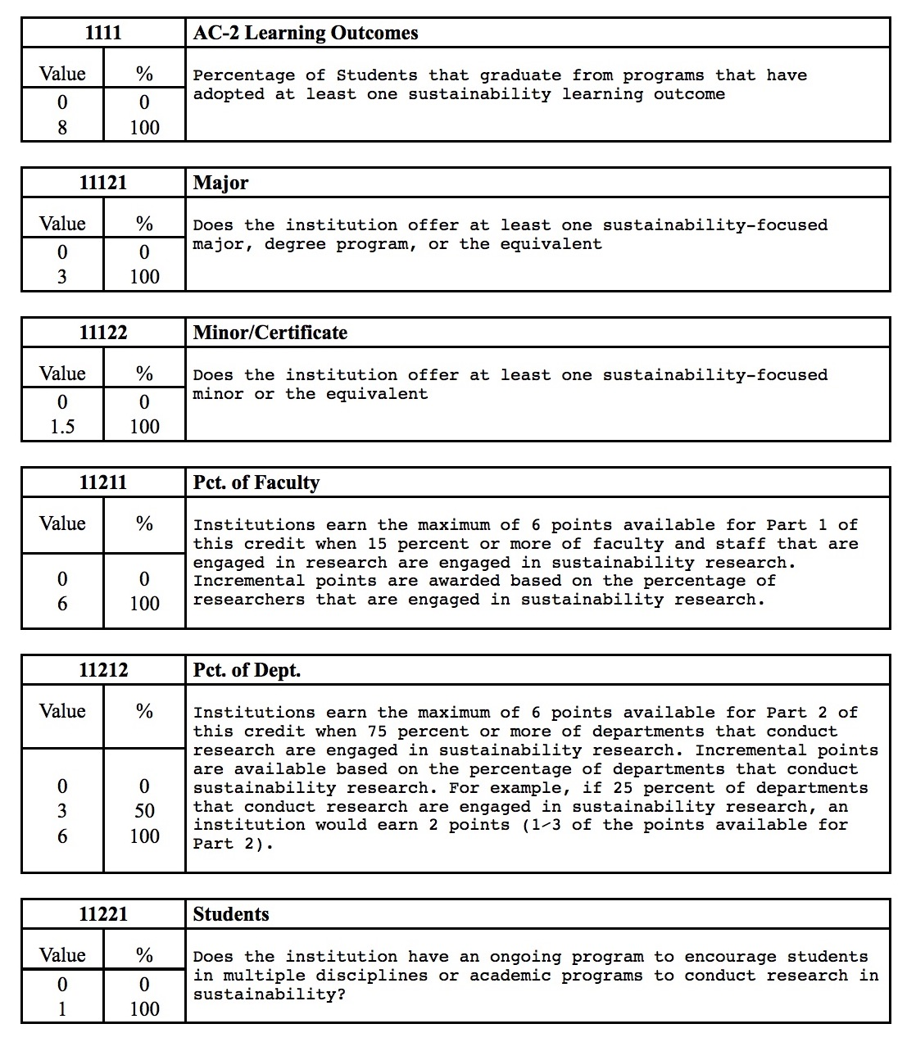

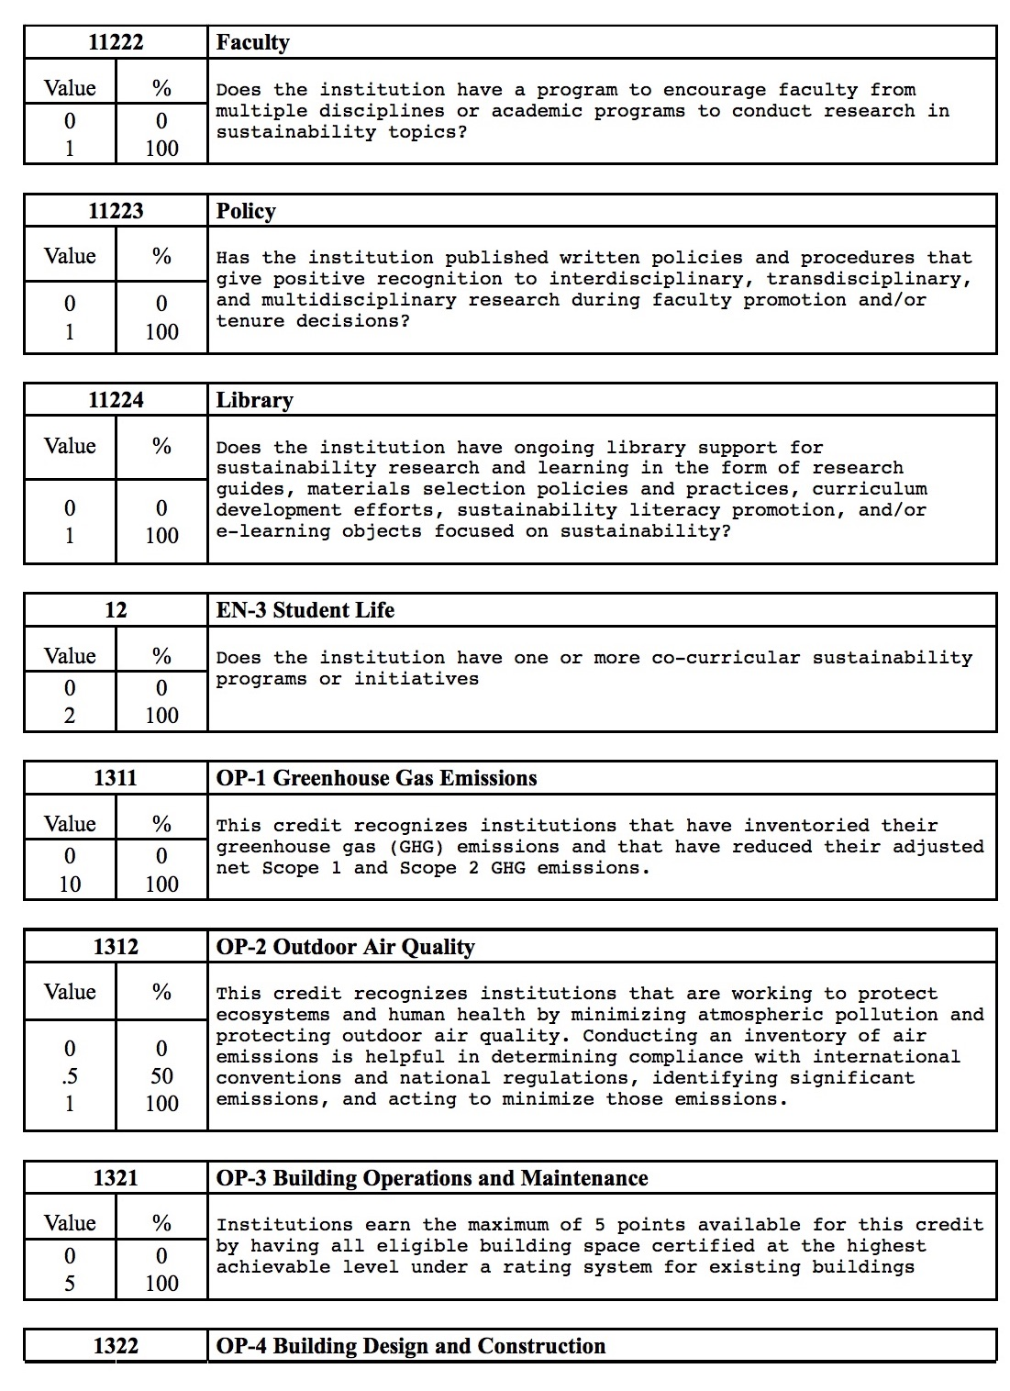

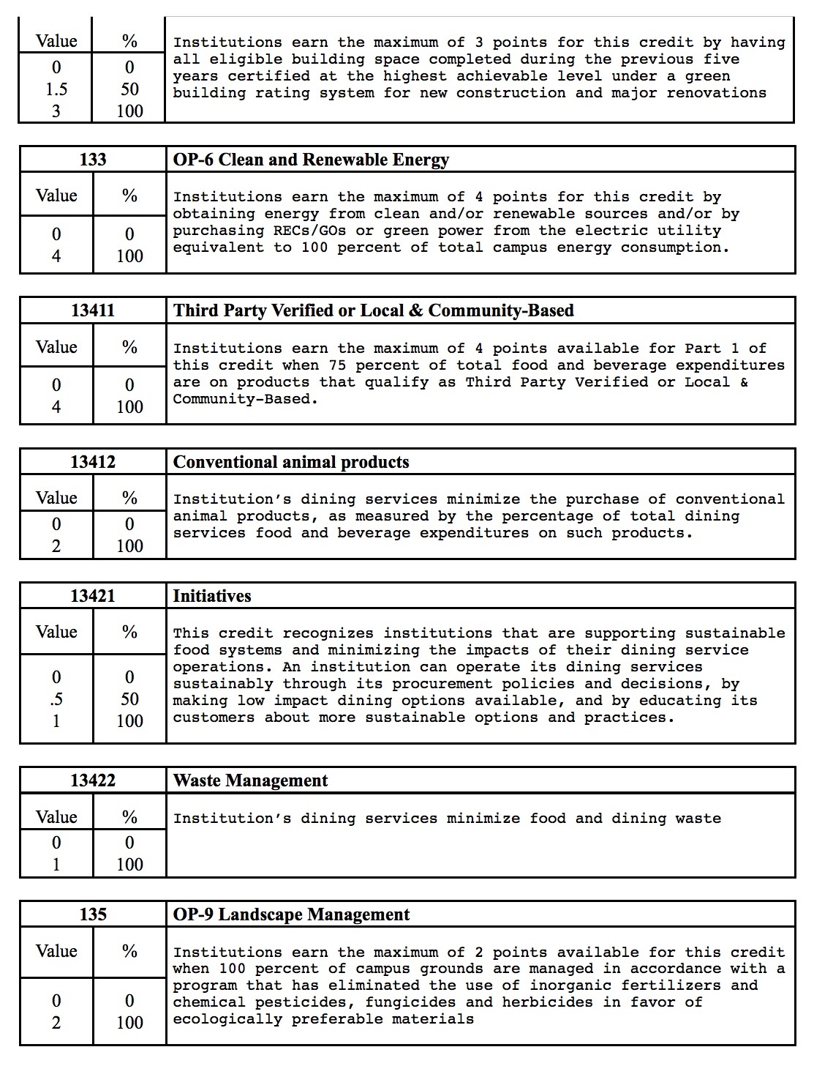

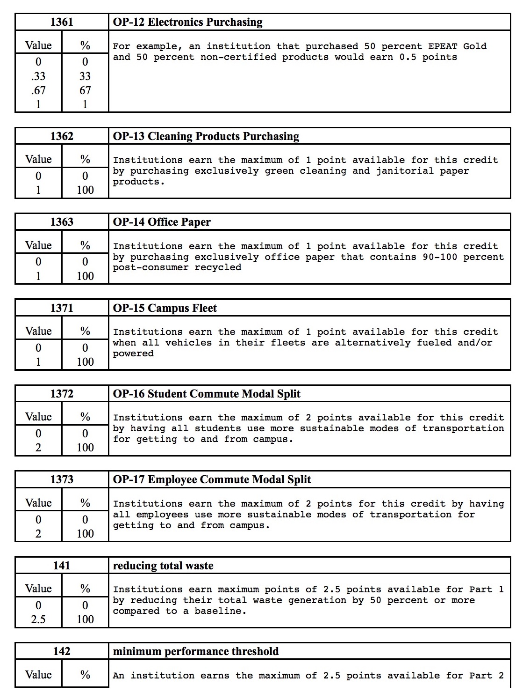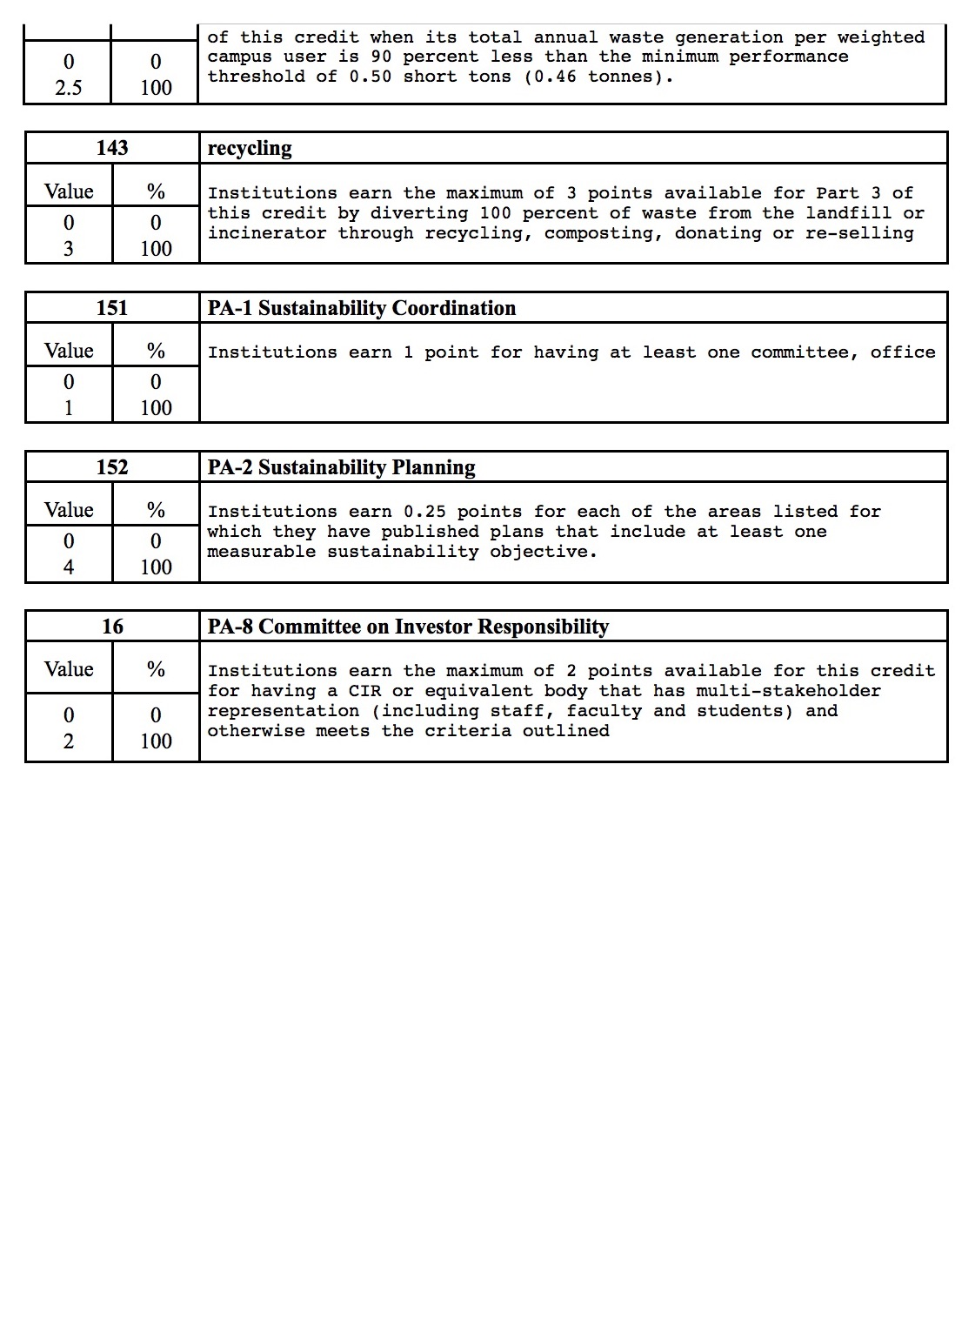

**4.2 LSP aggregators**

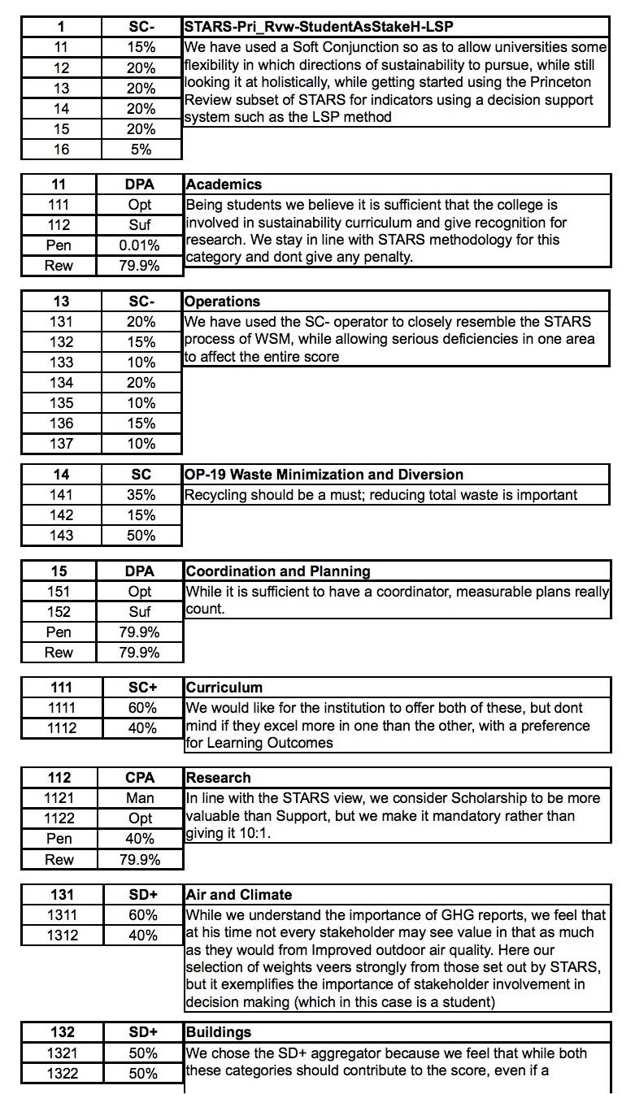

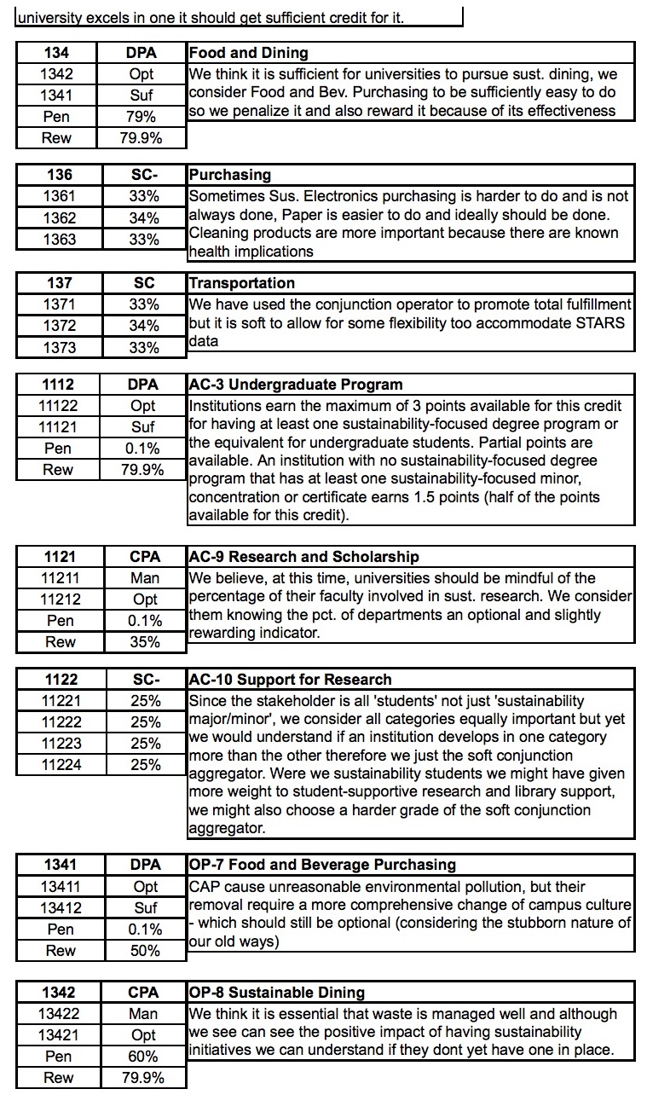

**All competitive systems**

|  |  |  |  |
| --- | --- | --- | --- |
| **Id** | **Attribute** | **San_Francisco_State_University** | **San_Jose_State_University** |
|  | Cost | 16632 | 14976 |
| 1111 | AC-2 Learning Outcomes | 6.02 | 4.32 |
| 11121 | Major | 1.5 | 1.5 |
| 11122 | Minor/Certificate | 1.5 | 1.5 |
| 11211 | Pct. of Faculty | 9.52 | 16.14 |
| 11212 | Pct. of Dept. | 13.21 | 50 |
| 11221 | Students | 0 | 1 |
| 11222 | Faculty | 0 | 1 |
| 11223 | Policy | 0 | 1 |
| 11224 | Library | 0 | 1 |
| 12 | EN-3 Student Life | 2 | 2 |
| 1311 | OP-1 Greenhouse Gas Emissions | 5.62 | 4.65 |
| 1312 | OP-2 Outdoor Air Quality | 1 | 1 |
| 1321 | OP-3 Building Operations and Maintenance | 0 | 1.56 |
| 1322 | OP-4 Building Design and Construction | 0 | 1.81 |
| 133 | OP-6 Clean and Renewable Energy | 0.02 | 0 |
| 13411 | Third Party Verified or Local & Community-Based | 0 | 1.60 |
| 13412 | Conventional animal products | 0 | 0.67 |
| 13421 | Initiatives | 1 | 1 |
| 13422 | Waste Management | 1 | 1 |
| 135 | OP-9 Landscape Management | 0 | 1.5 |
| 1361 | OP-12 Electronics Purchasing | 1 | .97 |
| 1362 | OP-13 Cleaning Products Purchasing | 0.92 | .80 |
| 1363 | OP-14 Office Paper | 0.3 | .47 |
| 1371 | OP-15 Campus Fleet | 0.74 | 0.56 |
| 1372 | OP-16 Student Commute Modal Split | 1.47 | 1.32 |
| 1373 | OP-17 Employee Commute Modal Split | 1.11 | 0 |
| 141 | reducing total waste | 1.55 | 2.42 |
| 142 | minimum performance threshold | 2 | 2.43 |
| 143 | recycling | 0.48 | 2.48 |
| 151 | PA-1 Sustainability Coordination | 1 | 1 |
| 152 | PA-2 Sustainability Planning | 2.5 | 3.33 |
| 16 | PA-8 Committee on Investor Responsibility | 2 | 0 |

**4.3  Numerical results**

**Evaluation results (all values expressed as percentages)   
Missingness penalty: 0 %**

|  |  |  |  |
| --- | --- | --- | --- |
| **Id** | **Attribute** | **San_Francisco_State_University** | **San_Jose_State_University** |
| 1 | STARS-Pri_Rvw-StudentAsStakeH-LSP | 60.83 | 54.95 |
| 11 | Academics | 83.94 | 93.54 |
| 13 | Operations | 28.58 | 37.79 |
| 14 | OP-19 Waste Minimization and Diversion | 33.46 | 89.51 |
| 15 | Coordination and Planning | 72.10 | 87.19 |
| 111 | Curriculum | 83.94 | 67.72 |
| 112 | Research | 59.62 | 100.00 |
| 131 | Air and Climate | 96.25 | 95.41 |
| 132 | Buildings | 0.00 | 48.67 |
| 134 | Food and Dining | 46.95 | 58.04 |
| 136 | Purchasing | 30.75 | 37.77 |
| 137 | Transportation | 67.13 | 17.54 |
| 1112 | AC-3 Undergraduate Program | 100.00 | 100.00 |
| 1121 | AC-9 Research and Scholarship | 100.00 | 100.00 |
| 1122 | AC-10 Support for Research | 0.00 | 100.00 |
| 1341 | OP-7 Food and Beverage Purchasing | 0.00 | 40.00 |
| 1342 | OP-8 Sustainable Dining | 100.00 | 100.00 |
| 16 | PA-8 Committee on Investor Responsibility | 100.00 | 0.00 |
| 152 | PA-2 Sustainability Planning | 62.50 | 83.25 |
| 151 | PA-1 Sustainability Coordination | 100.00 | 100.00 |
| 143 | recycling | 16.00 | 82.67 |
| 142 | minimum performance threshold | 80.00 | 97.20 |
| 141 | reducing total waste | 62.00 | 96.80 |
| 1373 | OP-17 Employee Commute Modal Split | 55.50 | 0.00 |
| 1372 | OP-16 Student Commute Modal Split | 73.50 | 66.00 |
| 1371 | OP-15 Campus Fleet | 74.00 | 56.00 |
| 1363 | OP-14 Office Paper | 30.00 | 47.00 |
| 1362 | OP-13 Cleaning Products Purchasing | 92.00 | 80.00 |
| 1361 | OP-12 Electronics Purchasing | 1.00 | 7.00 |
| 135 | OP-9 Landscape Management | 0.00 | 75.00 |
| 13422 | Waste Management | 100.00 | 100.00 |
| 13421 | Initiatives | 100.00 | 100.00 |
| 13412 | Conventional animal products | 0.00 | 33.50 |
| 13411 | Third Party Verified or Local & Community-Based | 0.00 | 40.00 |
| 133 | OP-6 Clean and Renewable Energy | 0.50 | 0.00 |
| 1322 | OP-4 Building Design and Construction | 0.00 | 60.33 |
| 1321 | OP-3 Building Operations and Maintenance | 0.00 | 31.20 |
| 1312 | OP-2 Outdoor Air Quality | 100.00 | 100.00 |
| 1311 | OP-1 Greenhouse Gas Emissions | 56.20 | 46.50 |
| 12 | EN-3 Student Life | 100.00 | 100.00 |
| 11224 | Library | 0.00 | 100.00 |
| 11223 | Policy | 0.00 | 100.00 |
| 11222 | Faculty | 0.00 | 100.00 |
| 11221 | Students | 0.00 | 100.00 |
| 11212 | Pct. of Dept. | 100.00 | 100.00 |
| 11211 | Pct. of Faculty | 100.00 | 100.00 |
| 11122 | Minor/Certificate | 100.00 | 100.00 |
| 11121 | Major | 50.00 | 50.00 |
| 1111 | AC-2 Learning Outcomes | 75.25 | 54.00 |

**4.4 Cost/preference analysis**

#### Overall value: 100 * (Scorek/Scoremax)w (Costmin/Costk)1-w [%]

|  |  |  |  |  |  |  |  |  |  |  |  |  |  |
| --- | --- | --- | --- | --- | --- | --- | --- | --- | --- | --- | --- | --- | --- |
| **System** | **Cost** | **Relative importance of high score (w)** | | | | | | | | | | | **Overall score [%]** |
| **0%** | **10%** | **20%** | **30%** | **40%** | **50%** | **60%** | **70%** | **80%** | **90%** | **100%** |
| San_Francisco_State_University | 16632 | 90.04 | 90.99 | 91.95 | 92.92 | 93.90 | 94.89 | 95.89 | 96.90 | 97.92 | 98.96 | 100.0 | 60.83 |
| San_Jose_State_University | 14976 | 100.0 | 98.99 | 97.99 | 97.00 | 96.02 | 95.05 | 94.09 | 93.13 | 92.19 | 91.26 | 90.34 | 54.95 |

#### Normalized value

|  |  |  |  |  |  |  |  |  |  |  |  |  |  |
| --- | --- | --- | --- | --- | --- | --- | --- | --- | --- | --- | --- | --- | --- |
| **System** | **Cost** | **Relative importance of high score (w)** | | | | | | | | | | | **Overall score [%]** |
| **0%** | **10%** | **20%** | **30%** | **40%** | **50%** | **60%** | **70%** | **80%** | **90%** | **100%** |
| San_Francisco_State_University | 16632 | 90.04 | 91.92 | 93.84 | 95.80 | 97.80 | 99.84 | 100.0 | 100.0 | 100.0 | 100.0 | 100.0 | 60.83 |
| San_Jose_State_University | 14976 | 100.0 | 100.0 | 100.0 | 100.0 | 100.0 | 100.0 | 98.12 | 96.11 | 94.15 | 92.22 | 90.34 | 54.95 |

EVALUATION REPORT FOR THE PROJECT

This report presents the evaluation results for the following 2 competitive

systems:

1. San_Francisco_State_University

2. San_Jose_State_University

The evaluation is based on 32 elementary criteria grouped in the following 6

major groups:

1. Academics

2. EN-3 Student Life

3. Operations

4. OP-19 Waste Minimization and Diversion

5. Coordination and Planning

6. PA-8 Committee on Investor Responsibility

This summary includes two parts: (1) System Comparison and Ranking, and

(2) Survey of Individual Systems. Deatailed numerical results can be found in

the report entitled "Detailed Evaluation Results of the P_S_Words Project".

(1) System Comparison and Ranking

---------------------------------

The global preference of a system indicates the global percentage of satisfied

requirements. Therefore, the best system has the highest global preference. The

ranking of competitive systems is based on decreasing global preferences, as

follows:

1. 60.83% San_Francisco_State_University

2. 54.95% San_Jose_State_University

Therefore, the best system is San_Francisco_State_University.

This system satisfies 60.83% of the requirements specified by evaluation criteria.

The absolute value of global preference depends both on the quality of each system

and the level of demand imposed by the evaluation criterion function. So, low global

preferences may sometimes reflect too demanding criteria. The relative ranking of

competitive systems is based on normalized preferences so that the best system has

the normalized global preference of 100%. Following is the ranking according to

normalized preferences:

1. 100.00% San_Francisco_State_University

2. 90.34% San_Jose_State_University

The relative differences between systems can be interpreted as follows:

System San_Francisco_State_University dominates system San_Jose_State_University in 39.06% of inputs

The reasons for a specific value of global preference can be explained

by investigating the quality of all major components of the evaluated

systems. Following is the survey of preferences of 6 major system

components: Academics, EN-3 Student Life, Operations,

OP-19 Waste Minimization and Diversion, Coordination and Planning, and

PA-8 Committee on Investor Responsibility:

Systems Academics StudentLife Operations Waste Coordination Committee

-------------------------------------------------------------------------------

San_Fra 83.94 100.00 28.58 33.46 72.10 100.00

San_Jos 93.54 100.00 37.79 89.51 87.19 0.00

-------------------------------------------------------------------------------

COST/PREFERENCE ANALYSIS

Cost/preference analysis is the analysis of relations between the global

cost and the global preference of evaluated systems. The cost/preference

analysis can be performed assuming equal importance of cost and preference,

or assuming different levels of importance. In the case of different levels

of importance it is necessary to specify the relative level of importance

of cost and the relative level of importance of preference. These levels

are specified as two complementary values: p is the relative importance of

cost and 1-p is the relative importance of preference. Both p and 1-p can

be expressed as percentages.

The goal of cost/preference analysis is to compute the aggregated quality

indicator Q that combines the global cost and the global preference in a

single numerical indicator suitable for expressing the global quality of

the evaluated system taking into account all relevant components, both cost

elements and performance variables. Following are two cost preference reports.

The first report shows the results of cost/preference analysis for equal

importance of cost and preference, and the second report shows a spectrum of

results corresponding to various levels of relative importance of cost. In

both cases the results are normalized, so that the best system is assigned

the global quality value Q=100%, and other systems have smaller values. This

enables ranking and justifiable selection of the most appropriate system

COST/PREFERENCE ANALYSIS FOR EQUAL IMPORTANCE OF COST AND PREFERENCE

N o r m a l i z e d v a l u e s : Emax = Qmax = Cmin = 100%

Competitive Systems Global Preference[%] Global Cost[%] Q=ECmin/C[%]

--------------------------------------------------------------------------

San_Francisco_State_Uni 100.00 111.06 99.67

San_Jose_State_Universi 90.34 100.00 100.00

--------------------------------------------------------------------------

COST/PREFERENCE ANALYSIS FOR INCREASING RELATIVE IMPORTANCE OF COST

Table of Q = (Cmin/C)^p * (E/Emax)^(1-p), for p = 0, 10%, ..., 100%

N o r m a l i z e d r e s u l t s : Qmax = 100%

Systems 0% 10% 20% 30% 40% 50% 60% 70% 80% 90% 100%

-------------------------------------------------------------------------

San_Fra 100.0 100.0 100.0 100.0 100.0 99.8 97.8 95.8 93.8 91.9 90.0

San_Jos 90.3 92.2 94.1 96.1 98.1 100.0 100.0 100.0 100.0 100.0 100.0

-------------------------------------------------------------------------

(2) Survey of Individual Systems

--------------------------------

This survey highlights the strongest and the waekest components of

all evaluated systems. In particular, the survey includes lists of

the weakest components that are primary candidates for improvements.

This is an analysis of relative performance and for high quality

systems the weakest component can still satisfy a substantial

percentage of user's requiremenmts. Therefore, improvements are not

equally urgent for all systems. They are primariliy needed for systems

having a relatively low global preference.

San_Francisco_State_University

This system satisfies 60.83% of user's requirements. The best subsystem

of San_Francisco_State_University is EN-3 Student Life.

The best subsystem satisfies 100.00% of specified requirements.

The weakest subsystem of San_Francisco_State_University is Operations.

The weakest subsystem satisfies 28.58% of specified requirements.

Weak components of this system are components that are rated

below the global preference. These are components that primarily

need improvement. Following is the sorted list of weak components,

starting with the weakest component:

ID X E[%] Elementary criterion

-------------------------------------------------------------

11221 0.00 0.00 Students

11222 0.00 0.00 Faculty

11223 0.00 0.00 Policy

11224 0.00 0.00 Library

1321 0.00 0.00 OP-3 Building Operations and Maintenance

1322 0.00 0.00 OP-4 Building Design and Construction

13411 0.00 0.00 Third Party Verified or Local & Community-Based

13412 0.00 0.00 Conventional animal products

135 0.00 0.00 OP-9 Landscape Management

133 0.02 0.50 OP-6 Clean and Renewable Energy

1361 1.00 1.00 OP-12 Electronics Purchasing

143 0.48 16.00 recycling

1363 0.30 30.00 OP-14 Office Paper

11121 1.50 50.00 Major

1373 1.11 55.50 OP-17 Employee Commute Modal Split

1311 5.62 56.20 OP-1 Greenhouse Gas Emissions

San_Jose_State_University

This system satisfies 54.95% of user's requirements. The best subsystem

of San_Jose_State_University is EN-3 Student Life.

The best subsystem satisfies 100.00% of specified requirements.

The weakest subsystem of San_Jose_State_University is PA-8 Committee on Investor Responsibility.

The weakest subsystem satisfies 0.00% of specified requirements.

Weak components of this system are components that are rated

below the global preference. These are components that primarily

need improvement. Following is the sorted list of weak components,

starting with the weakest component:

ID X E[%] Elementary criterion

-------------------------------------------------------------

133 0.00 0.00 OP-6 Clean and Renewable Energy

1373 0.00 0.00 OP-17 Employee Commute Modal Split

16 0.00 0.00 PA-8 Committee on Investor Responsibility

1361 0.97 7.00 OP-12 Electronics Purchasing

1321 1.56 31.20 OP-3 Building Operations and Maintenance

13412 0.67 33.50 Conventional animal products

13411 1.60 40.00 Third Party Verified or Local & Community-Based

1311 4.65 46.50 OP-1 Greenhouse Gas Emissions

1363 0.47 47.00 OP-14 Office Paper

11121 1.50 50.00 Major

1111 4.32 54.00 AC-2 Learning Outcomes

**5.  Conclusions**

LSP is observably comprehensive and intuitive when dealing with modelling decision making scenarios. A detailed comparison with the comprehensiveness of its competitors will help solidify the conviction that it does in fact contain the ability to model human reasoning, more so than its competitors. While neither its comprehensiveness nor intuitiveness can be proved per se, further research in the variety of fields encompassing decision making theory will yield a good test for its intuitiveness.   
Considering the simplicity of use and comprehensibility of the detailed reports one would be hard pressed to not utilize a system such as this, to base their decision making in numerical evaluation.

References

1. Huang et al.

Ivy B. Huang, Jeffrey Keisler, Igor Linkov,

*Multi-criteria decision analysis in environmental sciences: Ten years of applications and trends,*

https://doi.org/10.1016/j.scitotenv.2011.06.022.

(http://www.sciencedirect.com/science/article/pii/S0048969711006462)

1. Morrison-Saunders et al.

Morrison-Saunders, Angus, Jenny Pope, and Alan Bond. 2015.

*Handbook of sustainability assessment*. http://search.ebscohost.com/login.aspx?direct=true&scope=site&db=nlebk&db=nlabk&AN=1075209.

(numerous papers by different authors are referenced from within this book directly in the paper, using the Title and appropriate page number)

1. Reed et al.

Reed, M.; Fraser, E.; Morse, S.; Dougill, A.

*Integrating methods for developing sustainability indicators to facilitate learning and action.* Ecol. Soc. 2005, 10. Available online: http://www.ecologyandsociety.org/vol10/iss1/resp3/

1. Huge et al.

[Pope, J.](http://researchrepository.murdoch.edu.au/view/author/Pope,%20Jennifer.html), Bond, A., Hugé, J. and [Morrison-Saunders, A.](http://researchrepository.murdoch.edu.au/view/author/Morrison-Saunders,%20Angus.html) (2017)

*Reconceptualising sustainability assessment*.

Environmental Impact Assessment Review, 62 . pp. 205-215.