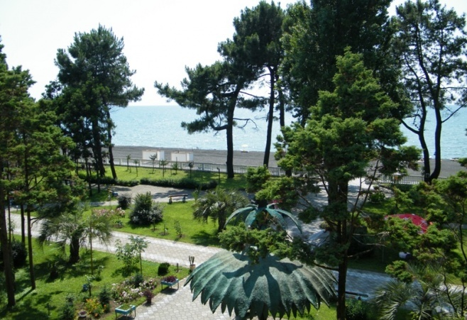
International Scientific Conference
Modern researches and Prospects of their Use in Chemistry, Chemical Engineering and Related Fields
September 21-23, 2016, Ureki, Georgia
The conference is dedicated to the 60th anniversary of R. Agladze Institute of Inorganic Chemistry and Electrochemistry

Conference is organized and financed by:

R. Agladze Institute of Inorganic Chemistry and Electrochemistry of
Iv. Javakhishvili Tbilisi State University

Shota Rustaveli National Science Foundation

About conference

The conference is dedicated to the 60th anniversary of R. Agladze Institute of Inorganic Chemistry and Electrochemistry

The aim of the conference is acquaintance with results of newest fundamental researches and technological achievements in chemistry and related fields; planning of possible joint researches; deepening of partnership in frames of “Horizon 2020”strategy of EU regional socio-economic development.
Conference Topics:

- Nano-processes and nanotechnologies.
● Nanopowders;
● Nano-coatings;
● Nanosensors.
- Fundamental and technological aspects of processing of mineral product and secondary raw materials.
● Fundamental and technological aspects of processing of natural resources of Georgia;
● Fundamental and technological aspects of processing of recyclable materials and industrial waste.
- New methods for ecological and radiation safety, medical and agrarian researches.
●New methods and technologies for purification of waste water and drinking water;
●New materials with radio-protective properties and technologies of radiation safety;
●Modern methods of analysis for safety of medicine and agricultural products.

No fee is charged for conference participants.

FIRST CIRCULAR

Conference Presentation Types

Resume
Resume must contain no more than 100 words, in English.

Abstracts
Abstracts must contain 1 page, format A4, in English.

Papers
Papers: format A4, 4 pages, in English.

Posters
Presentations in this case take the form of printed posters.

Oral presentations
Duration: 15 minutes, followed by 10 minutes for discussion.
Languages: Georgian, English, Russian
Detailed information on how to produce abstracts, posters and papers will be reported lately.
Original papers will be considered for publication in journal of Georgian National Academy of Sciences "Matsne" and Azerbaijanian Journal "Chemical Problems". Abstracts will be published in the form of proceedings.

Important dates:
Conference Dates: September 21-23, 2016
Deadline for registration : June 10, 2016
Deadline for Abstract Submissions: June 30, 2016
Deadline for Paper Submissions: July 31, 2016
Deadline for Poster Submissions: July 31, 2016

Conference Venue: Hotel “Kolkhida”, Ureki, Georgia

Ureki is one of the coastal health resorts of Georgia. It is known for its magnetic sand, which has therapeutic properties.

Hotel “Kolkhida” is located in Ureki, 50 meters from the sea. It is surrounded by pinery, owns tropical garden and 250 meters long private beach. Subtropical climate, warm Black Sea and magnificent magnetic sand guarantees fantastic relaxation after busy days of conference.
Free Wi-Fi and cable TV are provided in every room and apartment at the “Kolkhida” Hotel.
The “Kolkhida” Hotel provides Exclusive rates to participants of the conference.

The nearest to Ureki airports are: Kutaisi (KUT), Batumi (BUS), Tbilisi (TBS)

You can see any information about hotels of Ureki on these websites:

http://reservetour.com/ureki/55-hotel-spa-kolkhida?language=ka
http://www.concordtravel.ge/portal/alias__concordtravel/lang__ka-ge/tabid__1382/default.aspx -
See more at: http://www.georgia-sea.com/kolkhida-sanatorium-ureki#sthash.KwaUoffe.dpuf

Chair of organizing committee: Dr. Grigor Tatishvili
Co. Chair of organizing committee: Dr. Tinatin Lezhava
Co. Chair of organizing committee: Dr. Natela AnaniaSvili
Contact

Contact E-Mail: conf@iice.ge
Web site: www.conference.iice.ge
Head of Secretariat: Dr. Elizaveta Tskhakaia + 995 555 526410
Address: Mindeli str. #11, Tbilisi, Georgia, 0186
Fax: + (995 32) 2301430;

