Appendix D — Automated Test Suite
The automated evidence was generated from the current CrepFinder repository after the final evidence pass. The backend suite uses Vitest with Supertest against the Express app. The frontend suite uses Vitest, React Testing Library, jsdom and jest-axe for selected accessibility checks.

D.1 Test Inventory
ID | File | Behaviour under test | Outcome
T1 | backend/tests/app.test.js | Health endpoint returns { status: ok } for local/container checks | Pass
T2 | backend/tests/app.test.js | OAuth status reports configured Google and LinkedIn providers without starting login | Pass
T3 | backend/tests/app.test.js | Incomplete trust measurement submissions are rejected | Pass
T4 | backend/tests/app.test.js | Explicit PILOT participant codes are accepted at consent and flagged | Pass
T5 | backend/tests/app.test.js | Pilot status is stored directly on trust_measurements | Pass
T6 | backend/tests/app.test.js | Research export excludes pilot rows unless include_pilot=true | Pass
T7 | backend/tests/app.test.js | Review creation is rejected without a completed purchase request | Pass
T8 | backend/tests/app.test.js | Social verification start requests validate required profile evidence before DB access | Pass
T9 | backend/tests/app.test.js | Participant code is passed into listing queries for mutual-connection lookup | Pass
T10 | frontend/src/components/ConsentScreen.test.jsx | Consent screen explains optional OAuth without blocking the study | Pass
T11 | frontend/src/components/ConsentScreen.test.jsx | Consent screen has no obvious automated accessibility violations | Pass
T12 | frontend/src/components/DebriefScreen.test.jsx | Debrief directs participants to the post-task survey with participant code | Pass
T13 | frontend/src/components/DebriefScreen.test.jsx | Survey link URL-encodes participant codes | Pass
T14 | frontend/src/components/DebriefScreen.test.jsx | Debrief screen has no obvious automated accessibility violations | Pass
T15 | frontend/src/lib/listingPresentation.test.js | Marketplace price and UK size copy are formatted consistently | Pass
T16 | frontend/src/lib/listingPresentation.test.js | Google and LinkedIn account anchoring is described without overstating trust | Pass
T17 | frontend/src/lib/listingPresentation.test.js | Database-backed mutual connections override fallback social data | Pass
T18 | frontend/src/lib/listingPresentation.test.js | Controlled badge stimuli stay attached to the seller handle when database IDs change | Pass

Backend result: 1 file, 9/9 tests passing. Frontend result: 3 files, 9/9 tests passing. The frontend production build also completed successfully.
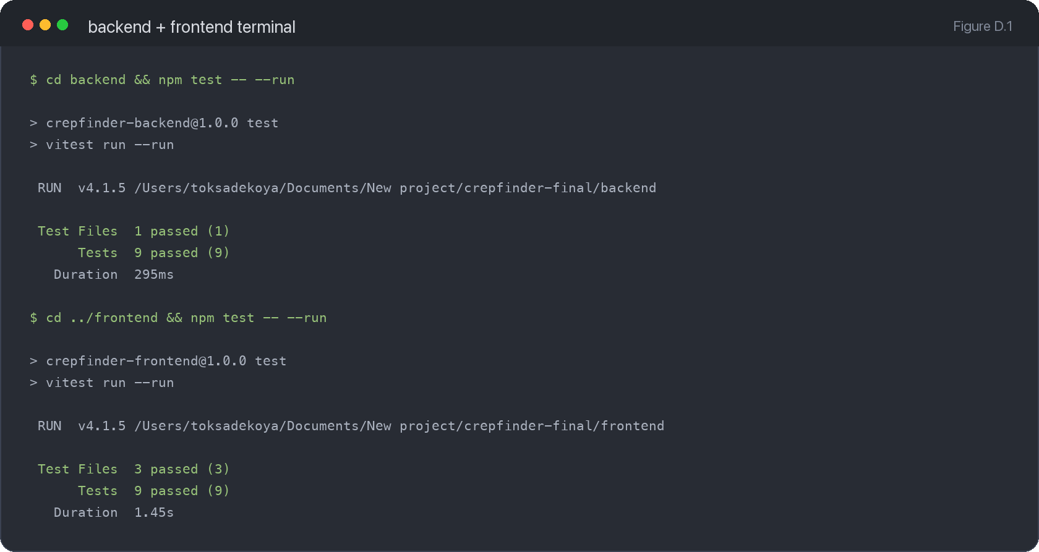
Figure D.1: Combined terminal evidence showing backend and frontend automated test suites passing.

Appendix E — Code Availability
The codebase is organised as a two-part web application: a React/Vite frontend and an Express/PostgreSQL backend. The submitted repository path used to generate this appendix was /Users/toksadekoya/Documents/New project/crepfinder-final.

E.1 Repository Tree
Path | Annotation
backend/ | Express API, database schema, seed script, routes and backend tests.
backend/database/ | PostgreSQL schema, migration and seed data used for the controlled prototype state.
backend/routes/ | API endpoints for listings, study consent, trust capture, research export, OAuth, reviews and messages.
backend/tests/ | Vitest/Supertest API contract tests.
frontend/ | React/Vite client application.
frontend/src/components/ | Participant-facing UI: consent, listing pages, TrustModal, debrief, navbar and seller panels.
frontend/src/lib/ | API client, study session storage, auth helpers and listing-presentation logic.
frontend/public/listings/ | Static listing imagery used by the prototype.
docs/ | Architecture, accessibility, ethics, project-management evidence and screenshots.
exports/ | Local exported trust measurement CSV evidence.
docker-compose.yml | Local Docker setup for frontend, backend and PostgreSQL.

E.2 Setup Instructions
- Install backend dependencies: cd backend && npm install.
- Install frontend dependencies: cd frontend && npm install.
- Create the PostgreSQL schema: cd backend && npm run db:init.
- Seed the controlled prototype data: cd backend && npm run seed.
- Run the API locally: cd backend && npm run dev.
- Run the frontend locally: cd frontend && npm run dev.
- Open the local prototype at http://localhost:5173 with the backend at http://localhost:3001.

E.3 Deployment Notes
The deployment model uses PostgreSQL for data persistence, Railway for the deployed Express backend, and Vercel for the deployed Vite frontend. If Neon is used as the PostgreSQL provider instead of Railway-hosted Postgres, the same DATABASE_URL environment variable pattern applies.
- Set DATABASE_URL, SESSION_SECRET, FRONTEND_ORIGIN, BACKEND_PUBLIC_URL and RESEARCH_EXPORT_TOKEN on the backend service.
- Set Google/LinkedIn OAuth environment variables only when those providers are required.
- Set VITE_API_BASE_URL on the frontend to the deployed backend URL.
- Run schema initialisation/migrations before relying on the deployed backend.
- Verify /api/health, /api/listings and the full consent-to-debrief flow after deployment.

E.4 Licence Statement
MIT licence statement for submitted code: Permission is granted to use, copy, modify, merge, publish, distribute, sublicense and/or sell copies of the software, subject to inclusion of the copyright and permission notice. The software is provided "as is", without warranty of any kind. No standalone LICENSE file was present at repository root when this appendix was generated, so a LICENSE file should be added before public release if formal MIT distribution is required.

Appendix F — Participant-Facing Materials

F.1 Recruitment Message
Provided recruitment copy:
Hey, doing my final year dissertation on trust in sneaker marketplaces. Need 10 min of your time, just browse a prototype and answer a short survey. Anonymous, ethics-approved, no real money involved. Link: https://frontend-pink-rho-83.vercel.app Massive help, share with anyone who buys/sells sneakers 🙏

F.2 Consent Screen Text
- CrepFinder
- Participant Consent
- This study asks you to browse a fictional peer-to-peer sneaker marketplace and evaluate one seller. No real purchase will be made, and the marketplace content is part of a research prototype.
- Participation is voluntary. You may stop at any point before submitting the trust questionnaire.
- Your responses are stored against a participant code rather than your name.
- The interface condition is assigned automatically so the comparison remains controlled.
- You can withdraw after completing the task by quoting your participant code to the researcher before the project analysis is finalised.
- Read participant information
- The evaluation is expected to take approximately 8-15 minutes. You will browse a fictional listing, decide whether to request a purchase, complete a short trust questionnaire, and then open a post-task survey.
- The prototype records your participant code, assigned interface condition, selected listing and questionnaire responses. It does not process payments, contact real sellers, or require account login.
- Some trust cues are controlled research stimuli so that both interface conditions can be compared fairly.
- Optional OAuth sign-in. Not required for the study. Used only if the prototype is configured to demonstrate account anchoring.
- I confirm that I understand the study information and consent to take part in this research prototype.
- Begin Study
- Your participant code will be shown on the debrief screen.

F.3 TrustModal Items
Subscale | Item
Competence | This seller seems knowledgeable about the sneakers they sell.
Competence | This seller appears capable of fulfilling this transaction reliably.
Benevolence | I believe this seller would act in my best interest.
Benevolence | I feel this seller genuinely cares about buyers.
Integrity | This seller's listing description seems honest and accurate.
Trusting Intentions | I would feel comfortable purchasing from this seller.
Trusting Intentions | I intend to proceed with this purchase.

Scale labels: 1 = Strongly Disagree, 4 = Neutral, 7 = Strongly Agree.

F.4 Debrief Screen Text
- Thank you for taking part
- Your trust questionnaire has been recorded. Please keep your participant code in case you need to reference or withdraw your response later.
- Complete the post-task survey
- Thank you for completing the CrepFinder evaluation. Your participant code is: [participant code].
- To complete your participation, please use this code to fill in the short post-task survey below (approximately six minutes). Your responses will form part of the project's final evaluation and analysis.
- Please complete the survey to finalise your participation.
- If the survey does not open automatically, copy your participant code above and paste it into the survey when prompted.
- This research compares two ways of presenting seller trust information in a peer-to-peer sneaker marketplace. Participants are randomly assigned to one interface condition so the study can compare responses fairly.
- Some marketplace signals are simulated research data. In particular, social verification cues such as mutual connections, community buyers, review counts, and seller status labels are controlled stimuli rather than live third-party identity checks. OAuth sign-in, where configured, verifies control of a Google or LinkedIn account only; it does not prove marketplace trustworthiness. This keeps the listings identical across conditions except for the trust signal being studied.
- No payment has been processed and no real seller has been contacted.

F.5 Post-Task Survey Items
SUS items extracted from the local Google Forms response workbook:
- 1. I think that I would like to use this system frequently.
- 2. I found the system unnecessarily complex.
- 3. I thought the system was easy to use.
- 4. I think that I would need the support of a technical person to be able to use this system.
- 5. I found the various functions in this system were well integrated.
- 6. I thought there was too much inconsistency in this system.
- 7. I would imagine that most people would learn to use this system very quickly.
- 8. I found the system very cumbersome to use.
- 9. I felt very confident using the system.
- 10. I needed to learn a lot of things before I could get going with this system.
Qualitative/completion prompts extracted from the local Google Forms response workbook:
- Were you able to complete the purchase request task in the prototype?
- What made you trust or distrust the seller in the listing you viewed?
- Was anything confusing or unclear about the prototype? Is there anything you would change?

Appendix G — Functional Requirements
[Full FR table from Chapter 3 to be inserted here.]

Appendix H — Non-Functional Requirements
[Full NFR table from Chapter 3 to be inserted here.]

Appendix I — Trust and Usability Instruments

I.1 Adapted McKnight Short Form
Item | Subscale | Statement
I1 | Competence | This seller seems knowledgeable about the sneakers they sell.
I2 | Competence | This seller appears capable of fulfilling this transaction reliably.
I3 | Benevolence | I believe this seller would act in my best interest.
I4 | Benevolence | I feel this seller genuinely cares about buyers.
I5 | Integrity | This seller's listing description seems honest and accurate.
I6 | Trusting Intentions | I would feel comfortable purchasing from this seller.
I7 | Trusting Intentions | I intend to proceed with this purchase.

Internal consistency reported in Chapter 6: Competence α = 0.94; Benevolence α = 0.94; Trusting Intentions α = 0.91. Integrity was represented by a single item, so Cronbach's alpha was not calculated for that construct.

I.2 System Usability Scale
- 1. I think that I would like to use this system frequently.
- 2. I found the system unnecessarily complex.
- 3. I thought the system was easy to use.
- 4. I think that I would need the support of a technical person to be able to use this system.
- 5. I found the various functions in this system were well integrated.
- 6. I thought there was too much inconsistency in this system.
- 7. I would imagine that most people would learn to use this system very quickly.
- 8. I found the system very cumbersome to use.
- 9. I felt very confident using the system.
- 10. I needed to learn a lot of things before I could get going with this system.

I.3 SUS Scoring Procedure
- Each SUS item is scored from 1 (Strongly Disagree) to 5 (Strongly Agree).
- For odd-numbered items, subtract 1 from the participant response.
- For even-numbered items, subtract the participant response from 5.
- Sum the ten adjusted scores and multiply by 2.5 to convert to a 0-100 SUS score.
- Higher scores indicate stronger perceived usability.

Appendix J — Phase 1 Survey
Phase 1 was used to inform the trust-signal design before the prototype A/B evaluation. The survey had n=25 valid responses.

J.1 Survey Instrument
- 1. I worry about fake or counterfeit products when buying sneakers, streetwear, or fashion items online.
- 2. I worry that seller reviews on resale platforms can be misleading.
- 3. I trust sellers more when reviews are clearly linked to completed transactions.
- 4. I trust sellers more when their account is verified through a recognised login provider, such as Google.
- 5. I trust sellers more when I can see signs of social proof, such as mutual connections or shared networks.
- 6. Star ratings alone are enough for me to trust a seller.

J.2 Key Results
Measure | Result (n=25)
Star ratings sufficient | 32% agreed
Trust transaction-linked reviews | 80% agreed
Trust verified accounts | 76% agreed
Trust mutual connections/social proof | 68% agreed

Appendix K — Database Schema
The following schema screenshots group backend/database/schema.sql by domain so that the database design can be inspected alongside the implementation evidence.
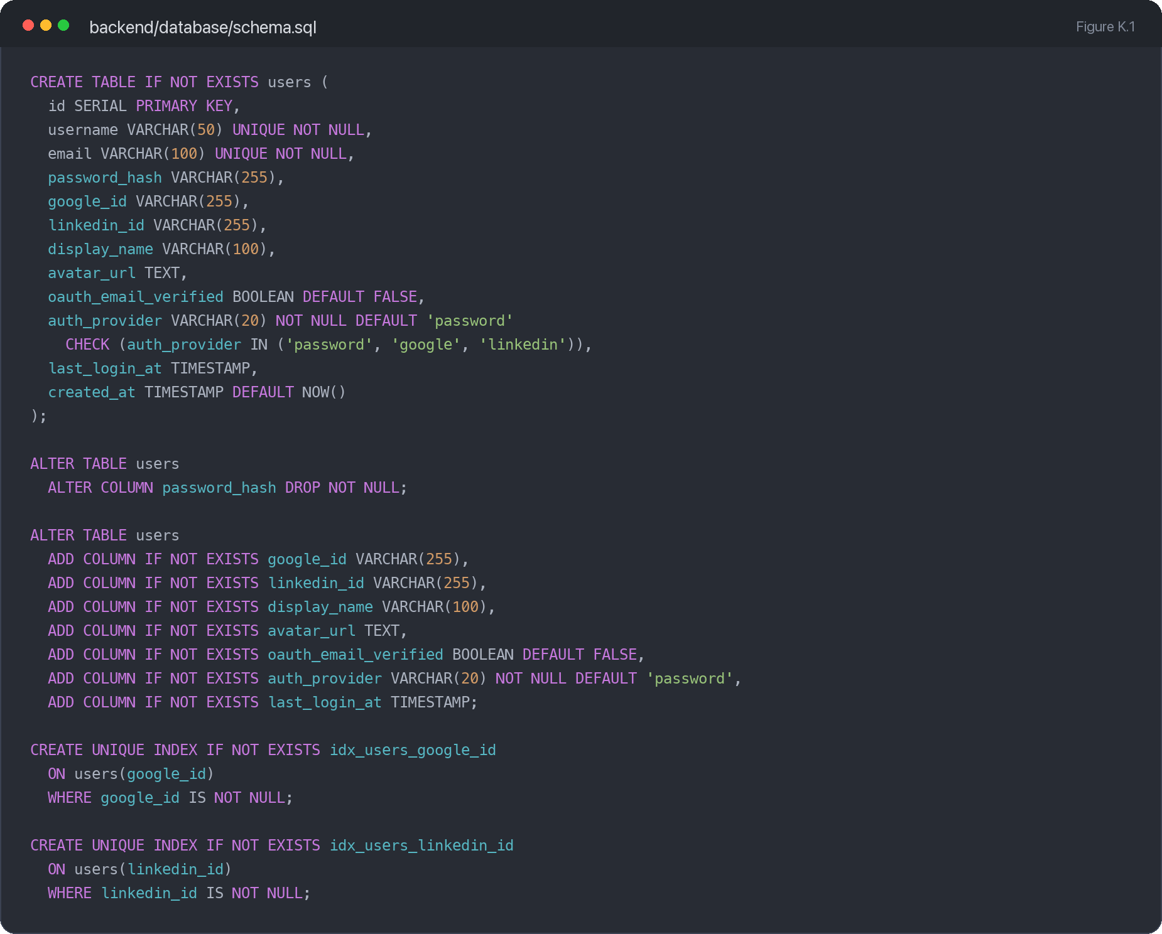
Figure K.1: Users and authentication schema, including user fields, OAuth columns and OAuth indexes.
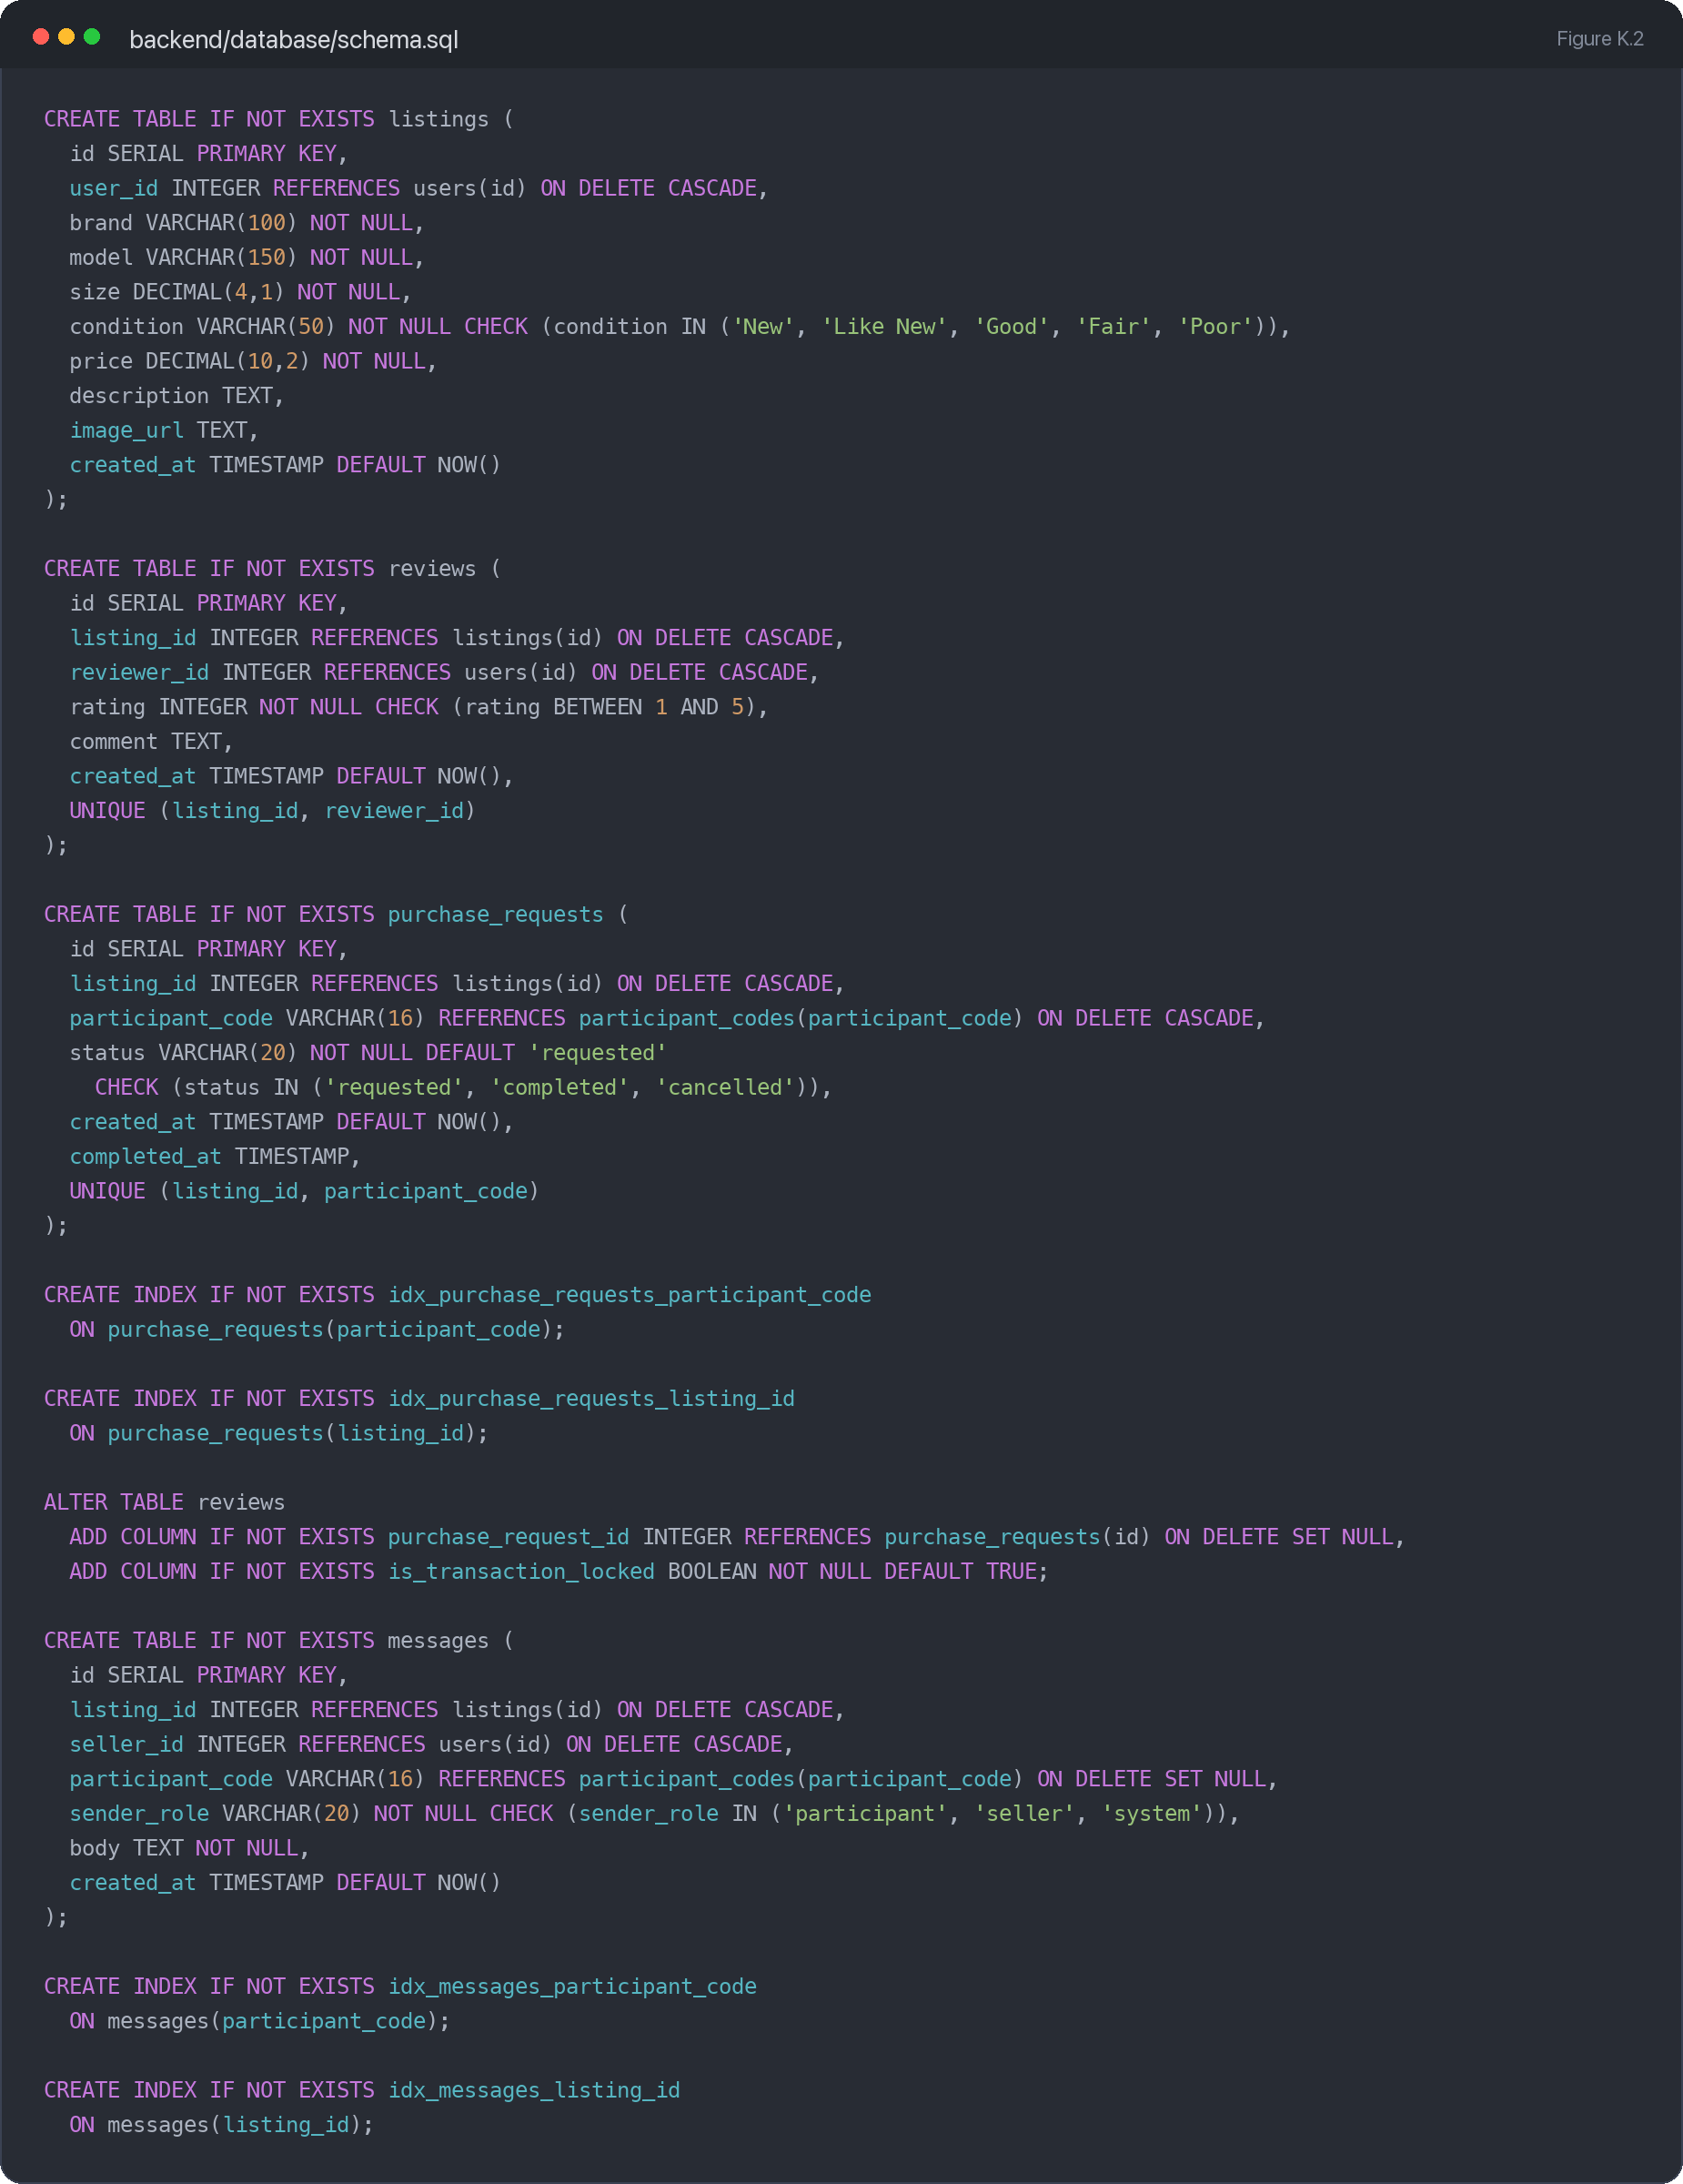
Figure K.2: Marketplace schema for listings, reviews, purchase requests, messages and related indexes.
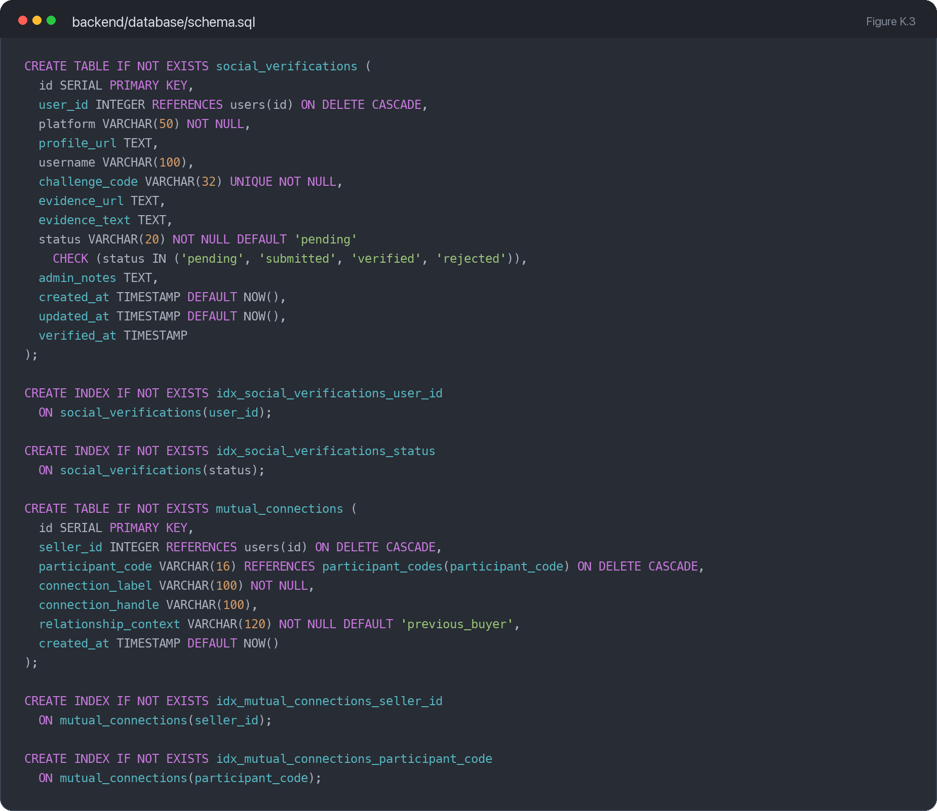
Figure K.3: Trust mechanism schema for social verification, mutual connections and supporting indexes.
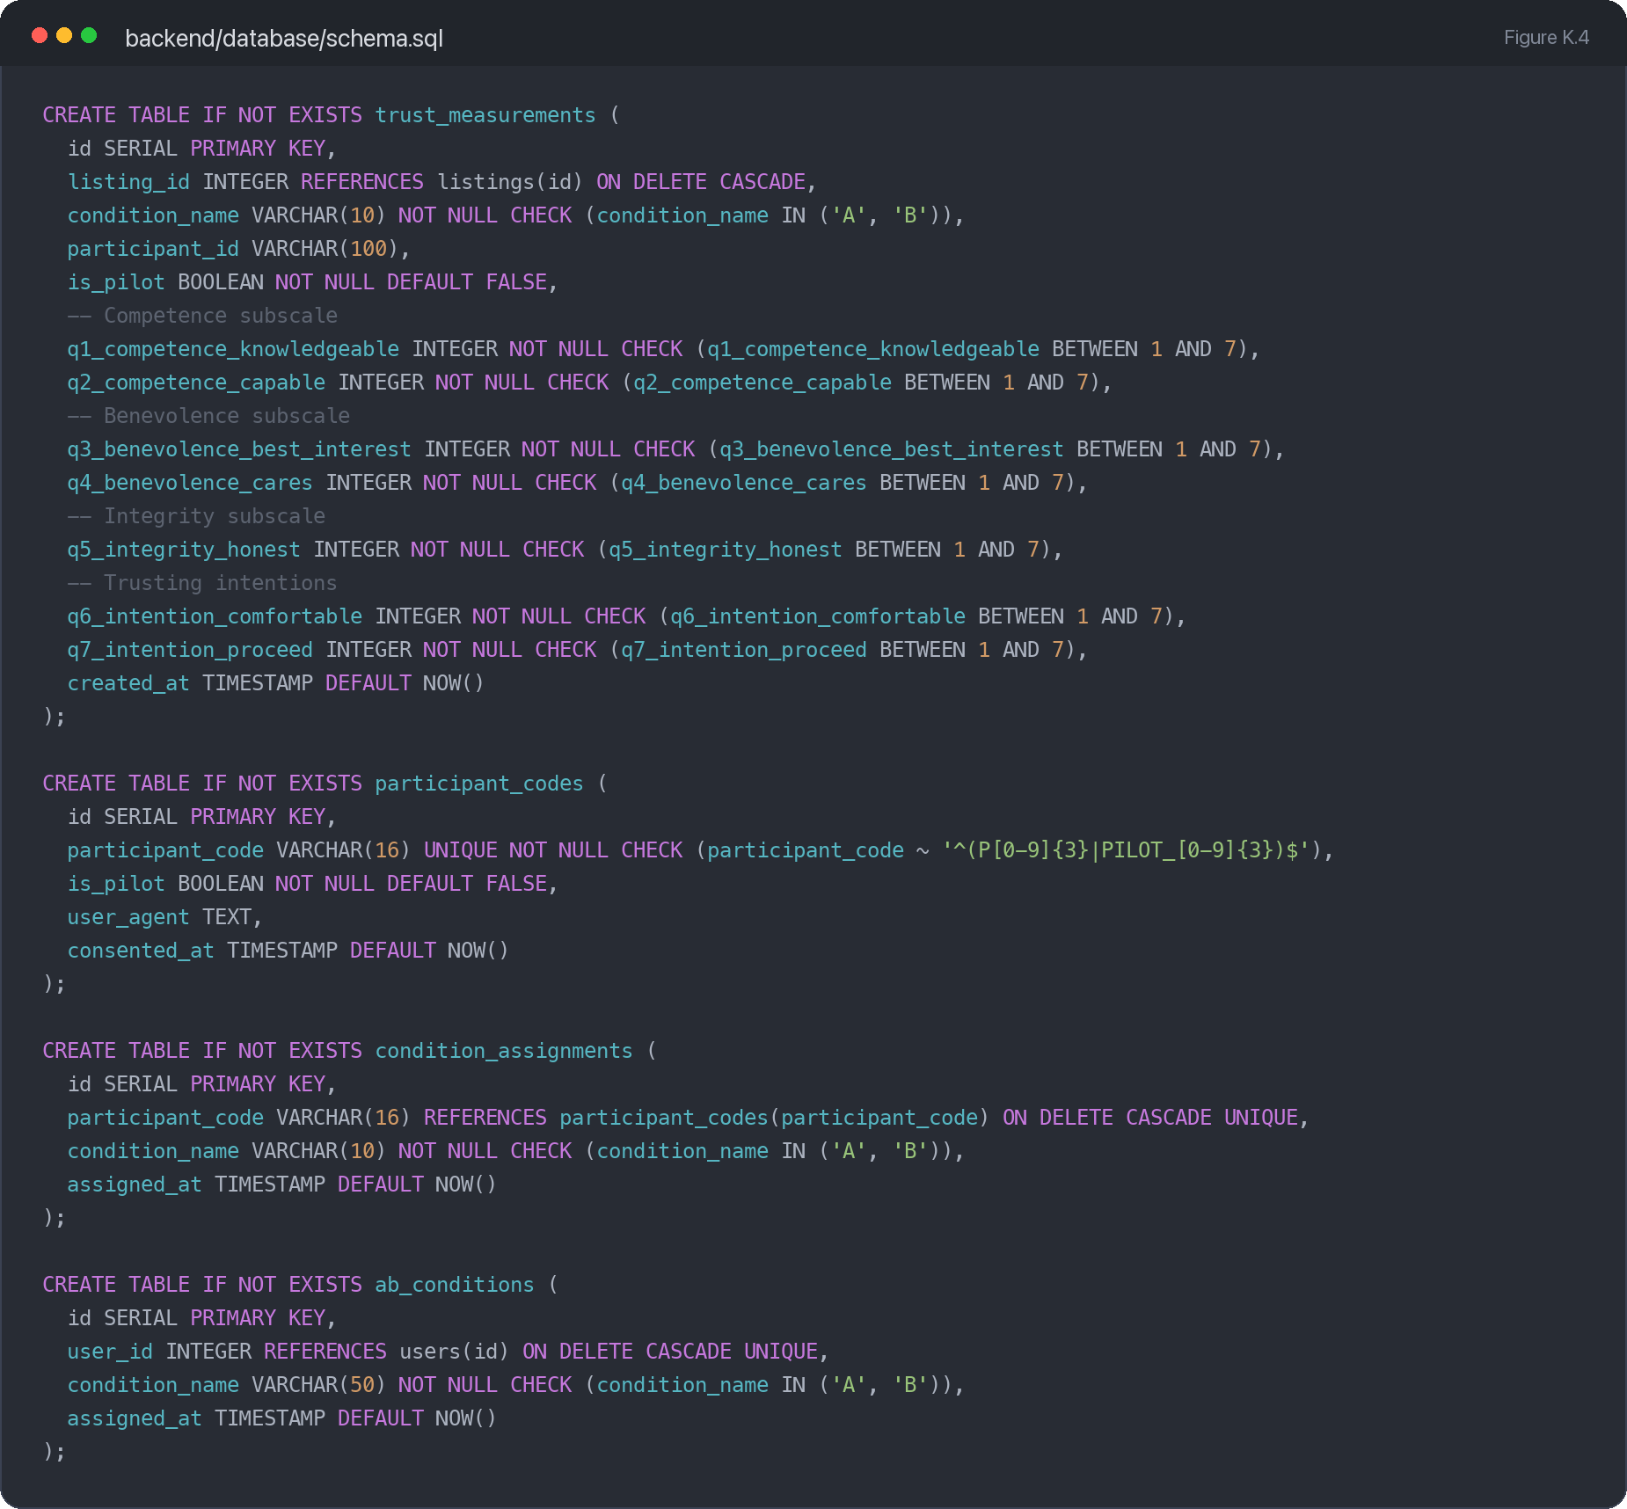
Figure K.4: Evaluation schema for trust measurements, participant codes, condition assignments and A/B condition records.

Appendix L — Qualitative Codebook
The codebook below uses participant-code-labelled comments from the post-task survey workbook where available. Quotes have been kept brief and retain participant wording except for surrounding truncation where needed.
Theme | Code | Participant | Illustrative quote
Verification signals support trust | Profile verification cue | P370 | His profile was verified and there was mention of his social media platform and the handles.
Verification signals support trust | Verification explanation needed | P706 | Some of the verification labels could be explained better because I was not completely sure how they were checked.
Social context shifts judgement | Mutual connections increase comfort | P226 | They knew people I knew, which made me feel more comfortable buying things from them.
Social context shifts judgement | Known-person vouching desired | P543 | If the seller had someone I knew vouch for him would be inclined to buy.
Transaction-linked reviews carry weight | Locked review increases evidence value | P528 | The star rating helped, and the locked review told me what the seller sold and what I can expect to receive.
Transaction-linked reviews carry weight | Low or thin reviews reduce trust | P134 | The star rating was not enough for me to commit to the purchase.
Interface clarity | Clear listing supports completion | P031 | The listing was very clear providing adequate information to proceed.
Interface clarity | Consistency issue noticed | P266 | It said 3, 3 star ratings but they were rated 4 stars, ensure everything is consistent.

If additional qualitative analysis is completed after submission of this appendix, the table can be extended with frequency counts and further representative quotes.

