

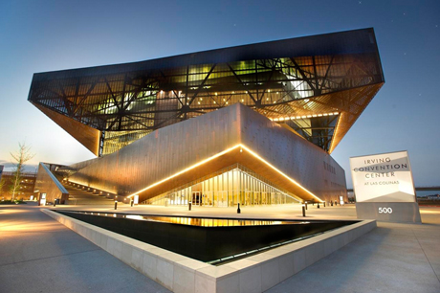

A Proposal for
Kubernetes Community Day Texas
October 6, 2023

Available Dates: October 6, 2023

Convention Center Information:

Proposed function space for your event has been outlined based on your RFP requirements. Should the dates or space needs of this event change, a new estimate will be provided. Please note, space is not currently being held at the facility until a formal request has been made. Pricing is subject to change to the prevailing rates in effect at time of request.

Authorized Area(s) | Date & Time | Purpose | Set
General Ballroom  1-5 | Friday  October 6, 2023  7:00am-11:30pm | Keynote | Theater for 500
Grand Ballroom  6 | Friday  October 6, 2023  7:00am-11:30pm | Breakout | Theater for 200
Grand Ballroom  7 | Friday  October 6, 2023  7:00am-11:30pm | TBD Track 1 | TBD
Grand Ballroom  8 | Friday  October 6, 2023  7:00am-11:30pm | TBD Track 2 | TBD

Rental of Meeting Space:

Total anticipated rental for the space outlined above is waived with a Food & Beverage minimum spend of $26,000.00++ (tax of 8.25% and service charge of 24%).

One-time labor and cleaning fee for the program is $1,000.00+.

One standard room set will be provided for each meeting room. changes to the original set-up or additional required changeovers will be invoiced at the prevailing rate in effect during your event.

Other charges that might be incurred as additional expense would include, but are not necessarily limited to electrical connections, telecommunications and high-speed internet, security, audio-visual, and technical personnel.

Contract Deposits:

A 35% deposit is required at contract signing to secure the date, then payment in full is due 30 days prior to event. An Event Manager will provide an estimate of charges remaining and these fees are due no later than 10 days prior to event.

Security:

Security will be required during your event at a cost to Licensee. The number required is to be determined by ICC based on number of attendees daily. Estimates start at 1 guard per 250 attendees. Current rates are $40.00 per guard, per hour with a 4-hour minimum.

Internet Access:

The Irving Convention Center provides complimentary wireless internet access. Wireless service is 2G up/down and is shared by all users in the facility. Hard line connections are $450.00 for the first and $75.00 for each additional.

Parking:

Daily parking rates at the center are currently $12.00 per car, per day with no in/out privileges.

A/V:

In-house audio-visual services are provided by INSPIRE A/V, however, there is no charge for use of your own equipment or provider. INSPIRE will work directly with you for A/V pricing, should you choose to use them.

All rigging at the center must be done by INSPIRE. Outside vendors will not be permitted to use house sound.

Please contact our on-site representative, Joe Hernandez, for a quote at (972) 401-7748 or josephh@inspiresolutions.com

Catering/Concessions:

Savor…Las Colinas has exclusive rights over food and beverage service in the Irving Convention Center. Service includes a full banquet kitchen as well as concession sales.

Pricing in menus may fluctuate due to global supply chain circumstances.

Liability Insurance:

Liability insurance is required for all events held at the Irving Convention Center. You will need to provide proof of this. If you do not have it, you may purchase it through the Irving Convention Center at a rate of $0.59 per attendee with a $150 minimum.

Event Planning Guide:

Please refer to our website at www.irvingconventioncenter.com and look for the event planning guide. All policies, rules, pricing, and regulations in the Event Planning Guide are considered part of any agreement signed with the Irving Convention Center.

Contact Information:

Bess Coleman
Sales Manager
Irving Convention Center at Las Colinas
500 West Las Colinas Boulevard
Irving, Texas 75039
972.401.7736
bcoleman@irvingconventioncenter.com
www.irvingconventioncenter.com
www.irvingtexas.com

