Reporte Villaclub - Comparativo del período 01/01/2015 al 18/08/2015 vs 01/01/2016 al 18/08/2016

## Resultados de las campañas de Adwords

This is an R Markdown document. Markdown is a simple formatting syntax for authoring HTML, PDF, and MS Word documents. For more details on using R Markdown see <http://rmarkdown.rstudio.com>.

When you click the **Knit** button a document will be generated that includes both content as well as the output of any embedded R code chunks within the document. You can embed an R code chunk like this:

## Gráficos comparativos

You can also embed plots, for example:

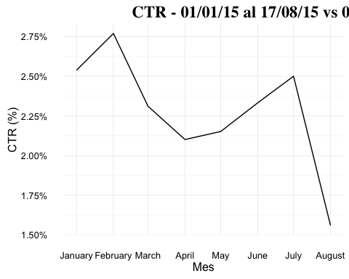

Note that the echo = FALSE parameter was added to the code chunk to prevent printing of the R code that generated the plot.