# **Breif[](https://docs.espressif.com/projects/arduino-esp32/en/latest/installing.html" \l "installing" \o "Permalink to this headline)**

The Tokymaker based on ESP32 chip. It can be programmed by Arduino IDE. This guide will show how to use the Tokymaker on Arduino 2.x.

The guide for users who have mastered:

* Arduino IDE
* Aduino programming

1. **TokyMaker Hardware**

|  |  |  |  |  |
| --- | --- | --- | --- | --- |
| **Pin-Name** | **GPIO** | **Digital Type** | **Analog Type** | **VCC** |
| IN1 | 34(only Input) | Input | ADC | 3.3V |
| IN2 | 33 | Input/Output | ADC | 3.3V |
| IN3 | 32 | IO | ADC | 3.3V |
| IN4 | 39(only Input) | Input | ADC | 3.3V |
| IN5 | 35(only Input) | Input | ADC | 3.3V |
| OUT1 | 23 | Input/Output | - | 5V |
| OUT2 | 26 | Input/Output | DAC | 5V |
| OUT3 | 25 | Input/Output | DAC | 5V |
| OUT4 | 5 | Input/Output | - | 5V |
| OUT5 | 27 | Input/Output | - | 5V |
| SONAR_D1 | 16 | Input/Output | - | 5V |
| SONAR_D2 | 17 | Input/Output | - | 5V |
| TOUCH1 | 12 | Buildin | - | - |
| TOUCH2 | 14 | Buildin | - | - |
| TOUCH3 | 13 | Buildin | - | - |
| RGBLED | 18 | Buildin | - | - |
| LED_LEFT | 4 | Buildin | - | - |
| LED_RIGHT | 15 | Buildin | - | - |
| BUTTON_A | 36 | Buildin | - | - |
| BUTTON_B | 2 | Buildin | - | - |
| OLED_RESET | 19 | Buildin | - | - |
| OLED_SDA | 21 | Buildin | - | - |
| OLED_SCL | 22 | Buildin | - | - |

Note: Wire,SPI,Serial canbe map to any IO.

**3 Installing Arduino IDE**

Download and install the latest Arduino IDE from

## <https://www.arduino.cc/en/software>

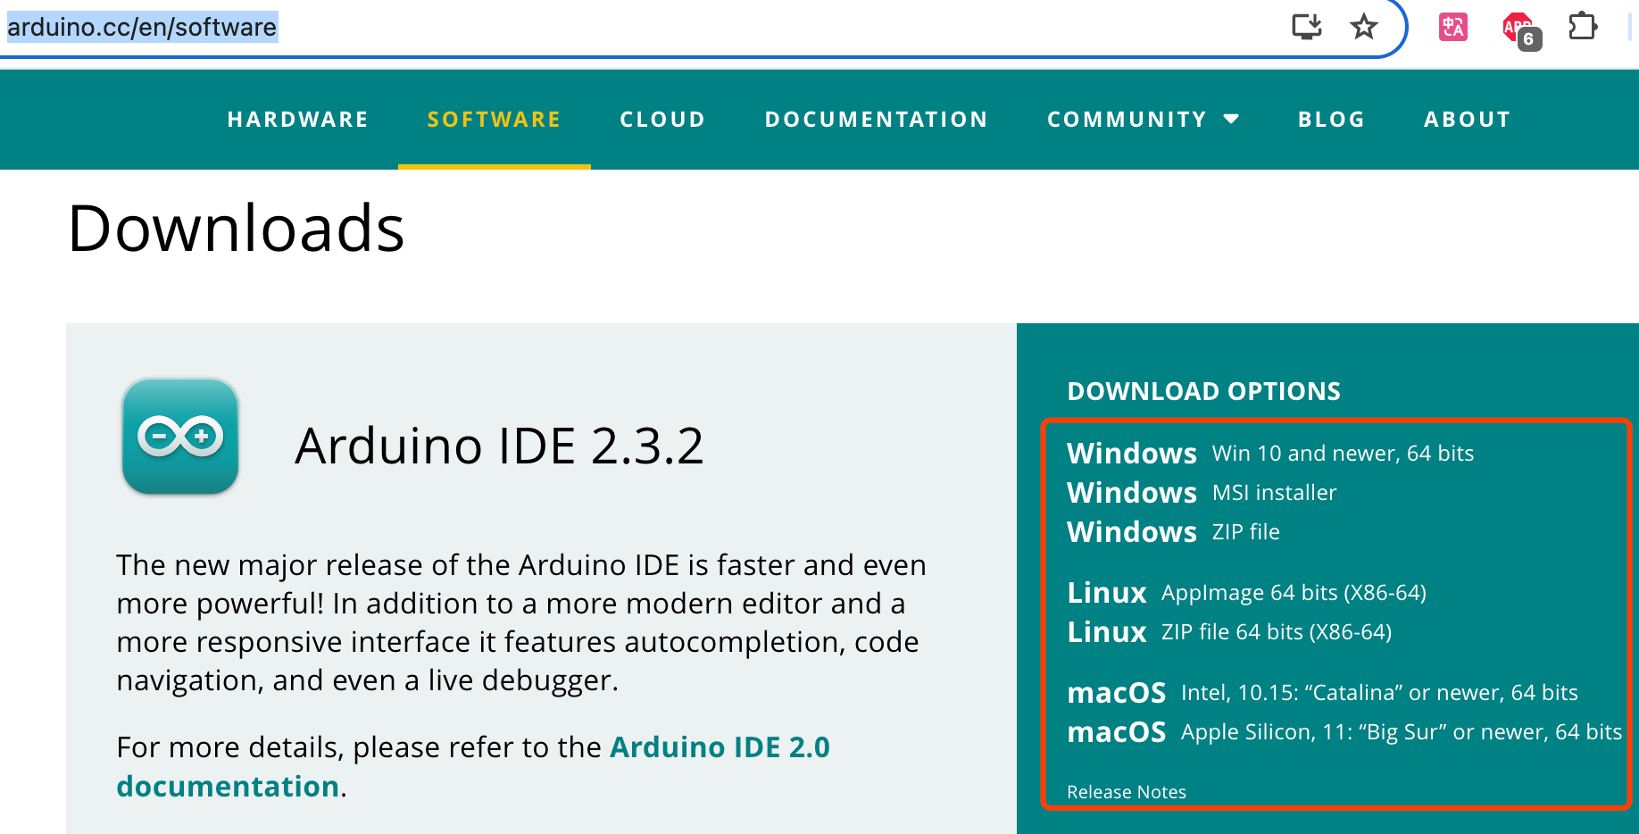

**4 Installing ESP32 Board**

Use Boards Managers to install ESP32 Board

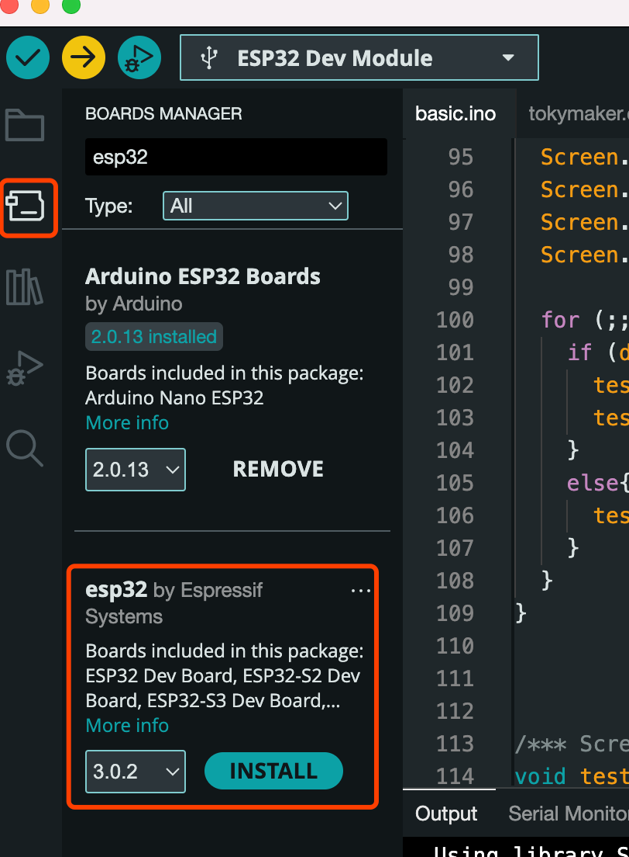

Note: If cannot install by Arduino IDE, install it by manual: https://docs.espressif.com/projects/arduino-esp32/en/latest/installing.html

**5 Installing TokyMaker Library**

Add tokymaker.zip to the arduino as following:

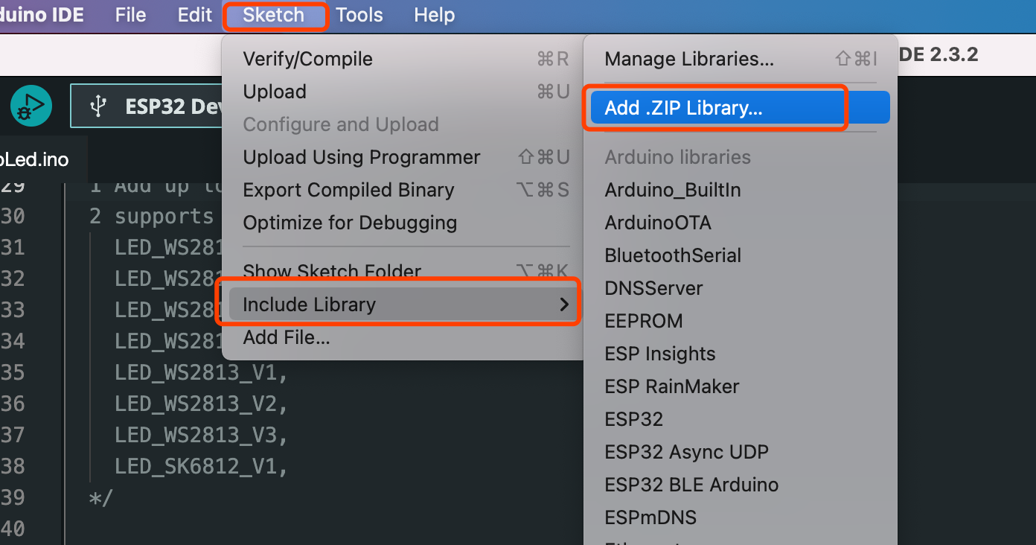

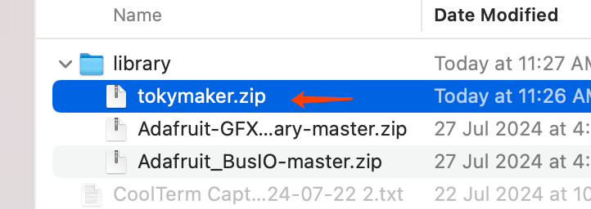

**5 Installing Others Library**

If you want to use OLED, recommend to install the following libraries by ‘LIBRARY MANAGER’ of Arduino IDE:

* Adafruit SSD1306
* Adafruit GFX
* Adafruit BusIO

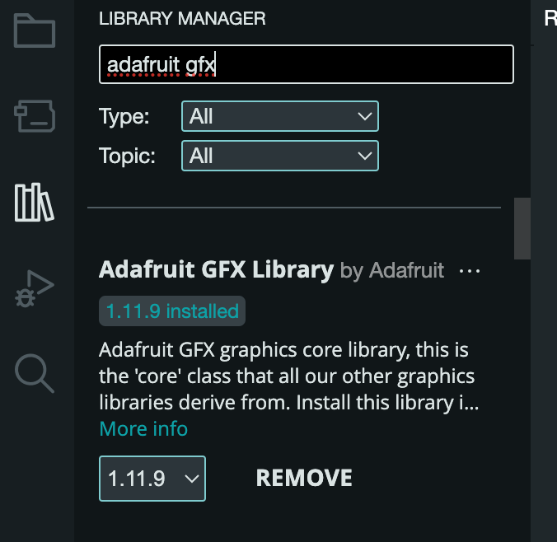

**6 Upload Examples of TokyMaker**

There some examples in the TokyMaker library:

* basic.ino : basic use INx,OUTx and OLED of Tokymaker
* RgbLed.ino: use WS2812 LED strand
* touchpad.ino: use the buildin Touch Pads of TokyMaker

Arduino Settings:

* Board: ESP32 Dev Moudule
* Flash Mode: QIO
* Flash Freq: 80MHz
* Flash Size: 4MB

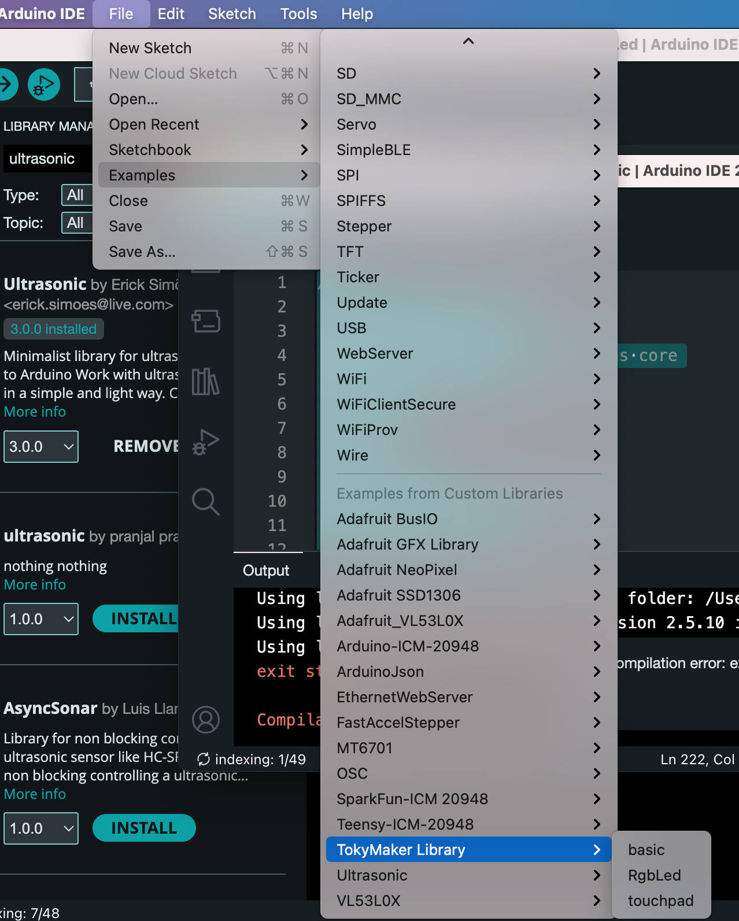

END