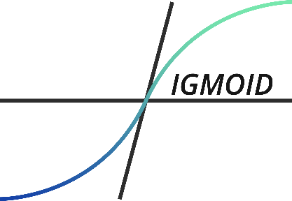

LOGO Report

For {{customer}}

Video : {{video_name}}

Sigmoid, {{year}}

|  |  |
| --- | --- |
| Compary Logo | Number of appearances |
| {%tr for item in logo_appearances %} | |
| {{item.logo}} | {{item.count}} |
| {%tr endfor %} | |