# Small home network –Packet tracer + real life implementation

## Project criteria’s

The aim of this project is to create a plan a small home network using Packet tracer and then calculate the approximate cost of the Project.

Firstly, the following criteria were set:

* Full connection to a simulated wan (wide area network) network using a wireless router
* Connection to at least 3 wired devices and at least 1 wireless device
* Wireless connection secured via WPA2 personal
* The IP addresses of the connected devices had to be set using DHCP

## Cisco packet tracer plan

The Home network was realized using an WRT300N router, 3 wired devices (Laptop, PC, Printer), and 1 wireless device (TabletPC). All wired devices are connected via TP copper network cables using Gigabit ethernet ports (speeds up to 1000mbps).

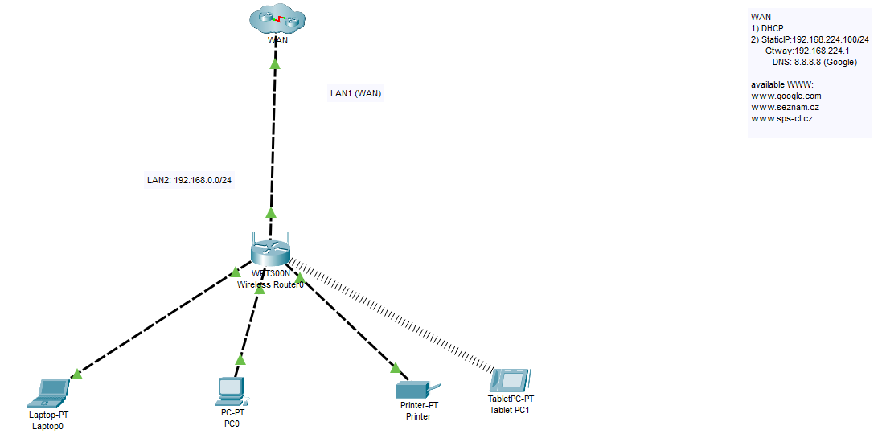

Figure :Home network plan in Cisco Packet tracer

|  |  |  |
| --- | --- | --- |
| Base IP address/Prefix | 10.0.0.0/24 | |
| Device name [1] | IP address | connection |
| Wireless router | 10.3.5.100 | wired |
| Laptop0 | 10.3.5.101 | wired |
| PC0 | 10.3.5.103 | wired |
| Printer | 10.3.5.104 | wired |
| TabletPC1 | 10.3.5.102 | wireless |

## Cost of real-life implementation

Since our wireless router acts as an AP as well as a router, we only need one network device. Then we only need the network cables for connecting the wired devices to the router.

A table of suitable network routers:

|  |  |  |  |
| --- | --- | --- | --- |
| Device name | Cost | Speed | Features |
| TP-Link Archer AX50 | 120$ | 2402Mbps(5Ghz),  574 Mbps(2.4Ghz) | Wifi6, 4 Lan ports,  WPA2 |
| TP-Link Archer AX73 | 200$ | 4804Mbps(5Ghz)  574Mbps(2.4Ghz) | Wifi6, 4 Lan ports,  WPA2 |

As to which we cable we should use, then the best one for our network is a UTP (unshielded twisted pair) Cat5e (speeds up to 1000Mbps). The price for this cable varies, but we should expect the price to be somewhere between 45$ and 100$, depending on the length and the manufacturer of the cable.

estimated final cost: **200$** (280$ if we use Archer AX73 instead of Archer AX50)

## 

1. All the devices serve only for purpose of simulation and do not represent the final realization of the project