Task image



|  |  |  |  |  |  |  |
| --- | --- | --- | --- | --- | --- | --- |
| **Hostname** | **OS** | **Network** | **Interfaces** | **Type** | **IP-address** | **Netmask** |
| **Host** | Ubuntu 22.04 | Net 1 |  |  |  |  |
| **Server_1** | Ubuntu | Net1 | Int1: wlp2s0,MAC: 08002759ACB6, enp0s3 | Static, Bridged adapter | 192.168.24.34/24 | 255.255.255.0 |
|  |  | Net2 | Int2=enp0s8 | Static | 10.91.24.1/24 | 255.255.255.0 |
|  |  | Net3 | Int3=enp0s9 | Static | 10.10.91.1/24 | 255.255.255.0 |
| **Client_1** | CentOS | Net2 | Int1=enp0s8 | «Внутрішня мережа» | 10.91.24.2/24 | 255.255.255.0 |
|  |  | Net4 | Int2=enp0s_ | «Внутрішня мережа» | 172.16.24.2/24 | 255.255.255.0 |
|  |  |  | Lo1 |  | 172.17.34.1/24 | 255.255.255.0 |
|  |  |  | Lo2 |  | 172.17.44.1/24 | 255.255.255.0 |
| **Client_2** | Ubuntu | Net3 | Int1=enp0s3 | «Внутрішня мережа» | 10.10.91.3/24 | 255.255.255.0 |
|  |  | Net4 | Int2=enp0s8 | «Внутрішня мережа» | 172.16.24.3/24 | 255.255.255.0 |

|  |  |  |
| --- | --- | --- |
| **Network name** | **IP-address** | **Netmask** |
| **Net1** |  |  |
| **Net2** | 10.91.24.0/24 | 255.255.255.0 |
| **Net3** | 10.10.91.0/24 | 255.255.255.0 |
| **Net4** | 172.16.24.0/24 | 255.255.255.0 |

**Details about hosts (screenshots) initial state before any IP configuration:**

Server_1

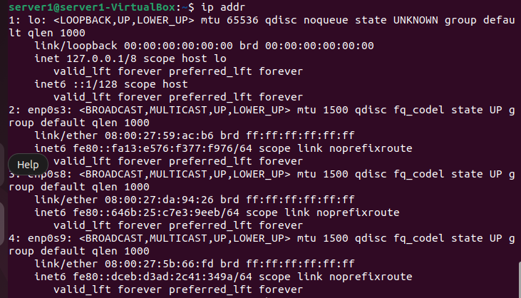

Client_1

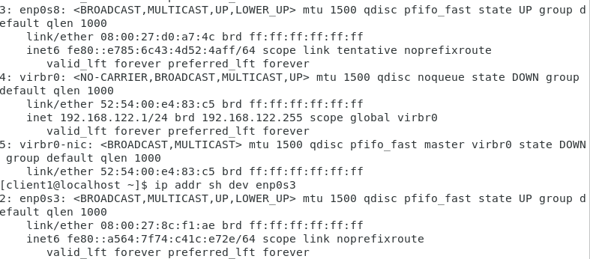

Client_2

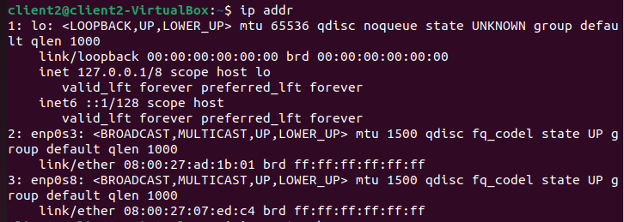

**After configuration of the IP-addresses (screenshots):**

Server_1

configuration file:

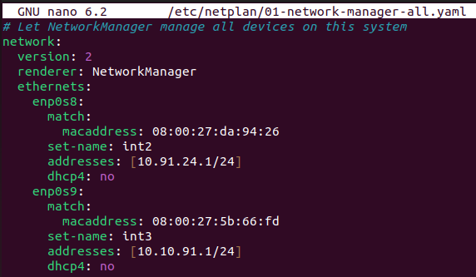

network configurations result:

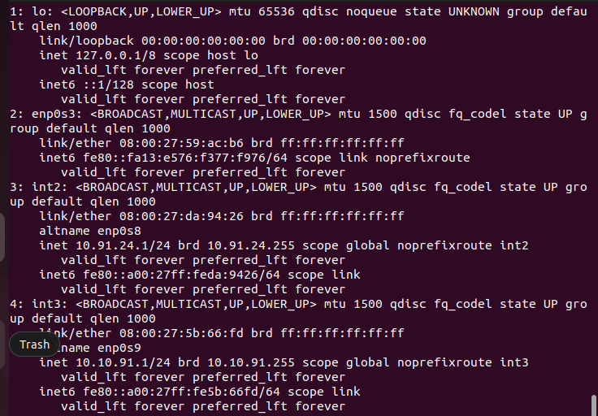

Server_1 (int3) can ping Client_2 (int1) in network Net3 successfully:

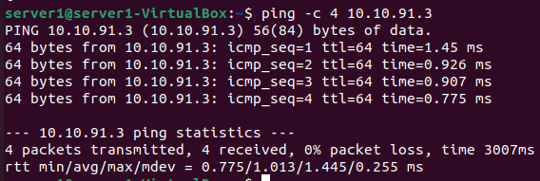

Client_1

Interfaces configuration:

Int1 configuration

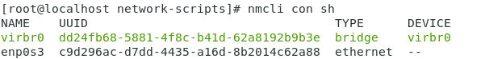



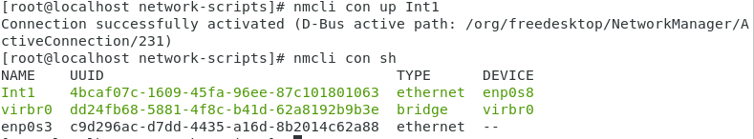

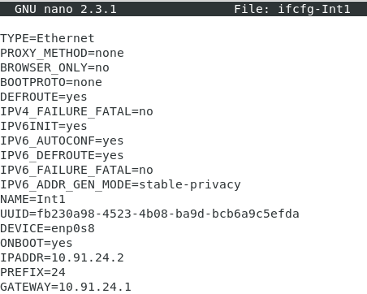

Client_1 cannot ping Server_1 (and Server_1 cannot ping Client_1):

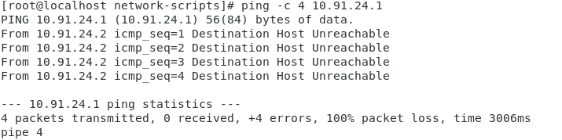

Int2 configuration: -

Client_2

configuration file:

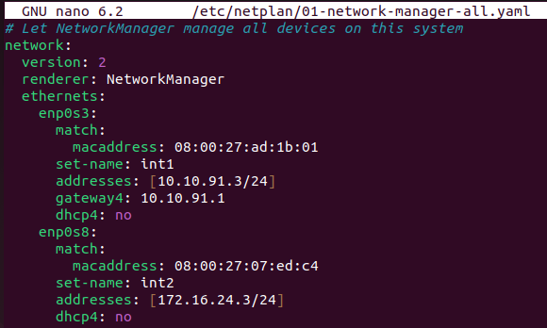

network configurations result:

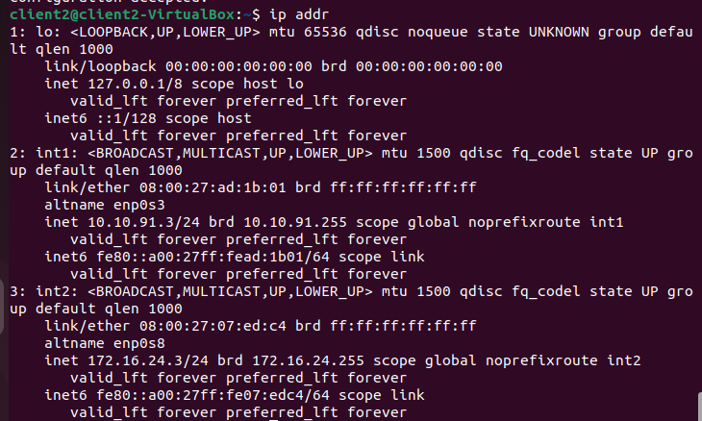

Client_2 (Int1) can ping Server_1 (Int3) successfully in network Net3:

