PART 1

1. Download MySQL server for your OS on VM.
2. Install MySQL server on VM.
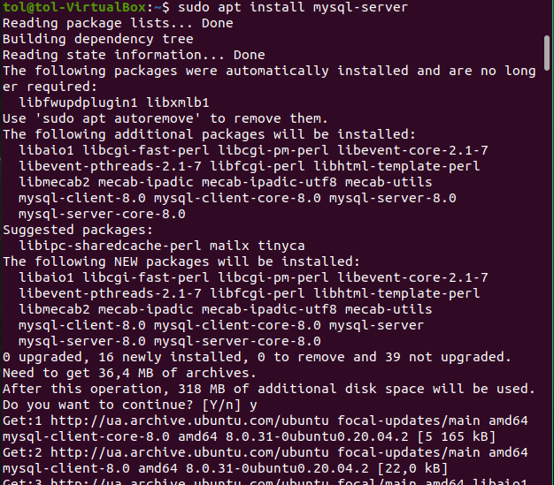
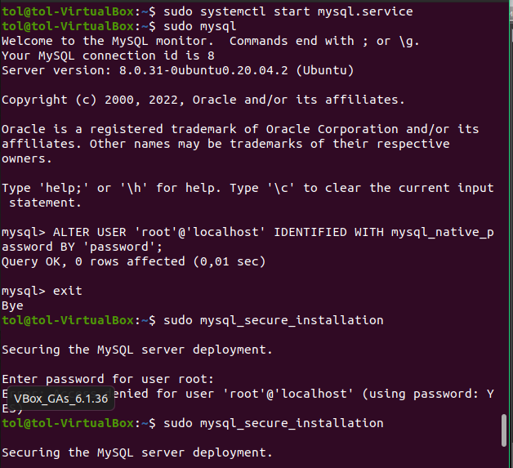
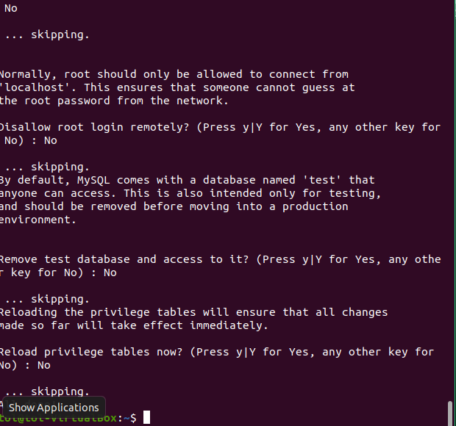
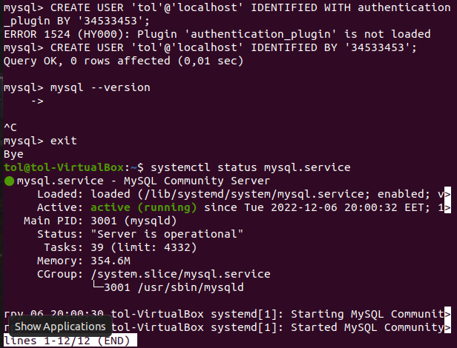
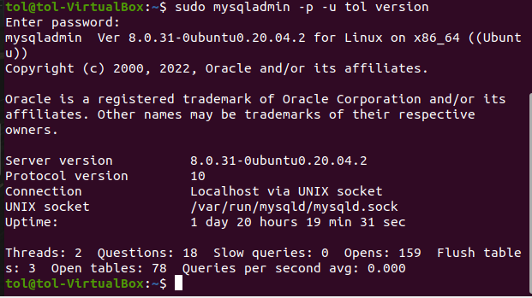

3. Select a subject area and describe the database schema, (minimum 3 tables)
Subject area description: an x-ray diagnostic department, where x-ray technicians make examinations of patients on x-ray device; doctor radiologist gets examinations results and writes descriptions of images; manager organizes the technician and doctor workflow.
X-ray department database
Tech_tbl
Tech_id | Patient_id | Patient_name | Patient_birthdate | Exam_zone | Exam_id | Exam_date | Img_qty | dose
101 | 1001 | Ivanov_I.P. | 1948-12-25 | Chest | 111 | 2022-12-20 | 2 | 1
101 | 1002 | Petrov_V.N. | 1958-02-05 | Cranium | 112 | 2022-12-20 | 2 | 2
102 | 1003 | Sidorov_P.U. | 1966-10-02 | Wrist | 113 | 2022-12-21 | 3 | 0.5
102 | 1004 | Ivanova_T.N. | 1978-11-06 | Heap | 114 | 2022-12-21 | 2 | 2
101 | 1005 | Petrova_B.G. | 1998-09-29 | Chest | 115 | 2022-12-22 | 2 | 1
101 | 1006 | Sidorova_T.K. | 1979-01-27 | Knee | 116 | 2022-12-22 | 2 | 0.5
101 | 1007 | Shevchenko_T.U. | 1949-06-30 | Chest | 117 | 2022-12-22 | 2 | 1

Doc_tbl
Doc_id | Patient_id | Exam_id | Descr_status | Exam_descr | Descr_date
201 | 1001 | 111 | Described | Healthy | 2022-12-21
201 | 1002 | 112 | Described | Healthy | 2022-12-21
201 | 1003 | 113 | Described | Patology | 2022-12-21
201 | 1004 | 114 | Described | Patology | 2022-12-21
201 | 1005 | 115 | Not described | Healthy | 2022-12-22
201 | 1006 | 116 | Not described | Healthy | 2022-12-22
201 | 1007 | 117 | Not described | Healthy | 2022-12-22

Mgr_tbl
Patient_id | Exam_id | Tech_id | Doc_id
1001 | 111 | 101 | 201
1002 | 112 | 101 | 201
1003 | 113 | 102 | 201
1004 | 114 | 102 | 201
1005 | 115 | 101 | 201
1006 | 116 | 101 | 201
1007 | 117 | 101 | 201

4. Create a database on the server through the console.
CREATE DATABASE `x-ray_dept`;
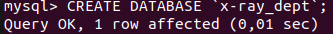
USE x-ray_dept;
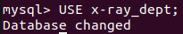
CREATE TABLE tech_tbl (
tech_id int,
patient_id int,
patient_name varchar(30),
patient_birthdate date,
exam_zone varchar(30),
exam_id int,
exam_date date,
img_qty int,
dose real);
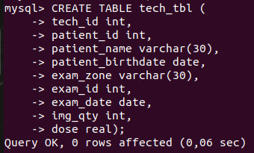
CREATE TABLE doc_tbl (
doc_id int,
patient_id int,
exam_id int,
descr_status varchar(30),
exam_descr varchar(300),
descr_date date);
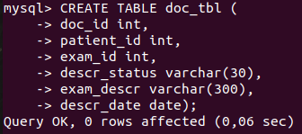
CREATE TABLE mgr_tbl (
patient_id int,
exam_id int,
tech_id int,
doc_id int);
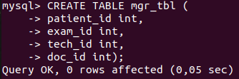

5. Fill in tables.
INSERT INTO tech_tbl (tech_id, patient_id, patient_name, patient_birthdate, exam_zone, exam_id, exam_date, img_qty, dose)
VALUES ('101', '1001', 'Ivanov_I.P.', '1948-12-25', 'Chest', '111', '2022-12-20', '2', '1'),
('101', '1002', 'Petrov_V.N.', '1958-02-05', 'Cranium', '112', '2022-12-20', '2', '2'),
('102', '1003', 'Sidorov_P.U.', '1966-10-02', 'Wrist', '113', '2022-12-21', '3', '0.5'),
('102', '1004', 'Ivanova_T.N.', '1978-11-06', 'Heap', '114', '2022-12-21', '2', '2'),
('101', '1005', 'Petrova_B.G.', '1998-09-29', 'Chest', '115', '2022-12-22', '2', '1'),
('101', '1006', 'Sidorova_T.K.', '1979-01-27', 'Knee', '116', '2022-12-22', '2', '0.5'),
('101', '1007', 'Shevchenko_T.U.', '1949-06-30', 'Chest', '117', '2022-12-22', '2', '1');
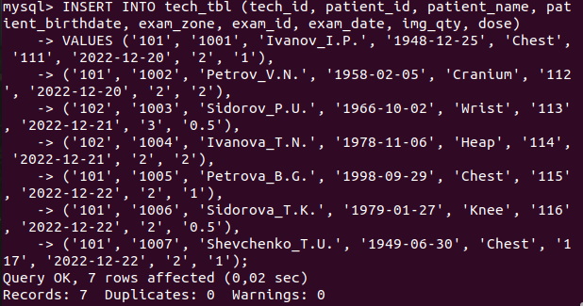
INSERT INTO doc_tbl (doc_id, patient_id, exam_id, descr_status, exam_descr, descr_date)
VALUES ('201', '1001', '111', 'Described', 'Healthy', '2022-12-21'),
('201', '1002', '112', 'Described', 'Healthy', '2022-12-21'),
('201', '1003', '113', 'Described', 'Patology', '2022-12-21'),
('201', '1004', '114', 'Described', 'Patology', '2022-12-21'),
('201', '1005', '115', 'Not described', 'Healthy', '2022-12-22'),
('201', '1006', '116', 'Not described', 'Healthy', '2022-12-22'),
('201', '1007', '117', 'Not described', 'Healthy', '2022-12-22');
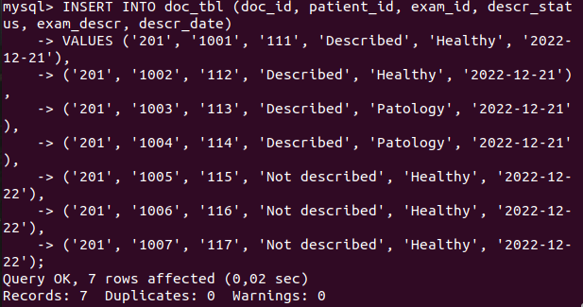
INSERT INTO mgr_tbl (patient_id, exam_id, tech_id, doc_id)
VALUES ('1001', '111', '101', '201'),
('1002', '112', '101', '201'),
('1003', '113', '102', '201'),
('1004', '114', '102', '201'),
('1005', '115', '101', '201'),
('1006', '116', '101', '201'),
('1007', '117', '101', '201');
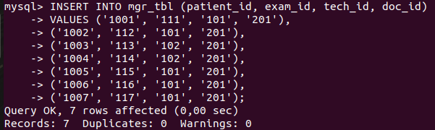

6. Construct and execute SELECT operator with WHERE, GROUP BY and ORDER BY.
SELECT * FROM tech_tbl;
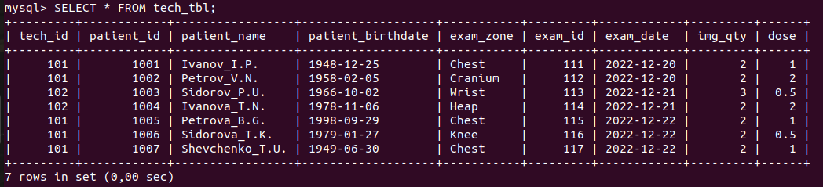
SELECT * FROM doc_tbl;
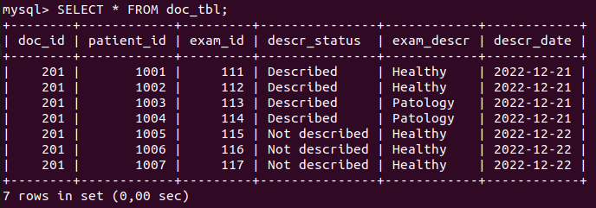
SELECT * FROM mgr_tbl;
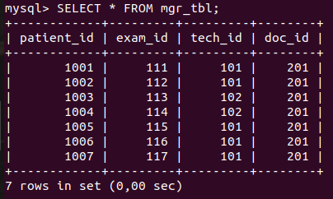
SELECT patient_nameб patient_birthdate FROM tech_tbl;
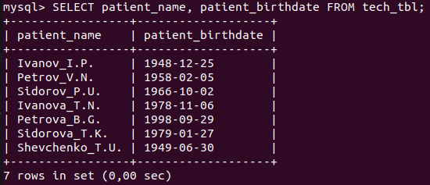
SELECT patient_name, patient_birthdate FROM tech_tbl WHERE patient_name LIKE ‘S%’;
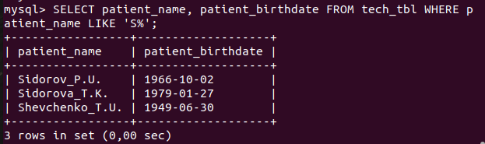
SELECT COUNT(*) AS qty_zones, exam_zone FROM tech_tbl GROUP_BY exam_zone;
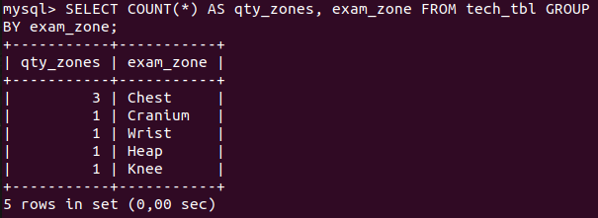
SELECT patient_name, exam_zone, dose FROM tech_tbl ORDER BY dose;
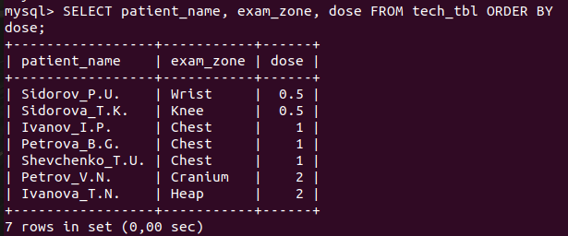

7. Execute other different SQL queries DDL, DML, DCL.
Workers_tbl
Worker_id | Worker_name | Worker_birthdate | Salary, USD
101 | Ivanenko_L.I. | 1966-10-02 | 200
102 | Petrenko_V.Y. | 1976-01-03 | 200
201 | Stepanenko_G.G. | 1967-09-22 | 250
301 | Demchenko_V.G. | 1968-11-12 | 300

CREATE TABLE workers_tbl (
worker_id int,
worker_name varchar(30),
worker_birthdate date,
salary int);
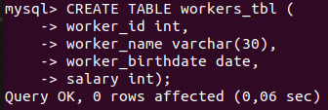
INSERT INTO workers_tbl (worker_id, worker_name, worker_birthdate, salary)
VALUES ('101', 'Ivanenko_L.I.', '1966-10-02', '200'),
('102', 'Petrenko_V.Y.', '1976-01-03', '200'),
('201', 'Stepanenko_G.G.', '1967-09-22', '250'),
('301', 'Demchenko_V.G.', '1968-11-12', '300');
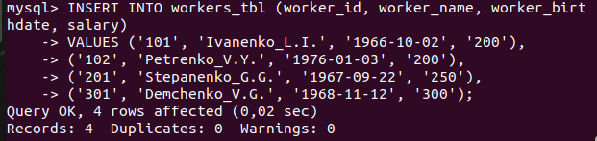
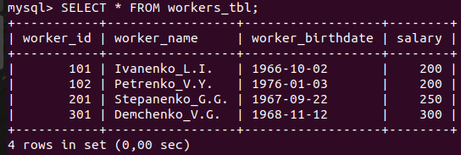
ALTER TABLE workers_tbl RENAME TO workers_x_tbl;
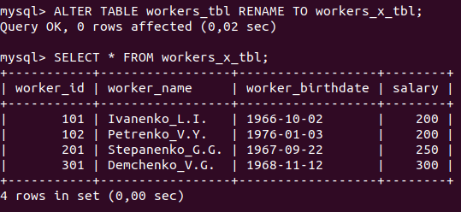
ALTER TABLE workers_x_tbl ADD COLUMN start_work date;
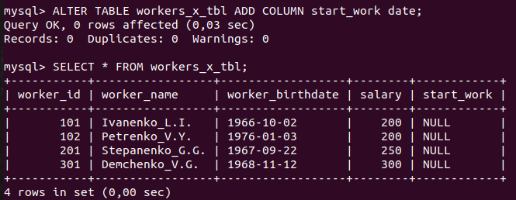
ALTER TABLE workers_x_tbl DROP COLUMN start_work;
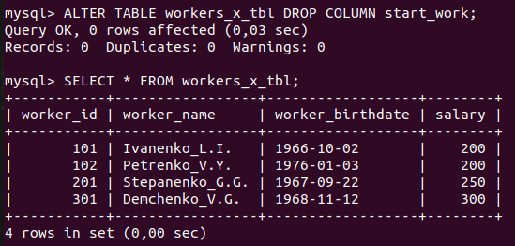
DROP TABLE workers_x_tbl;
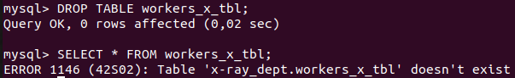

8. Create a database of new users with different privileges. Connect to the database as a new user and verify that the privileges allow or deny certain actions.
CREATE USER 'sammy '@'localhost' IDENTIFIED BY 'password';
ALTER USER 'sammy '@'localhost' IDENTIFIED WITH mysql_native_password BY 'password';
GRANT CREATE, ALTER, DROP, INSERT, UPDATE, DELETE, SELECT, REFERENCES, RELOAD on *.* TO ' sammy '@'localhost' WITH GRANT OPTION;
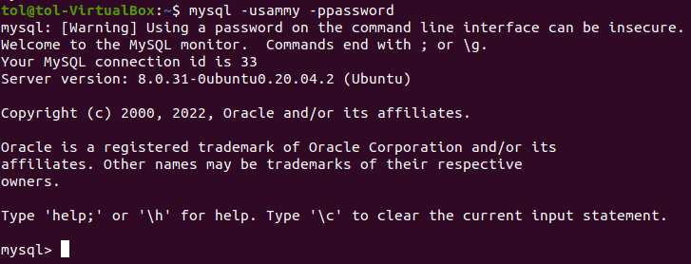

9. Make a selection from the main table DB MySQL.
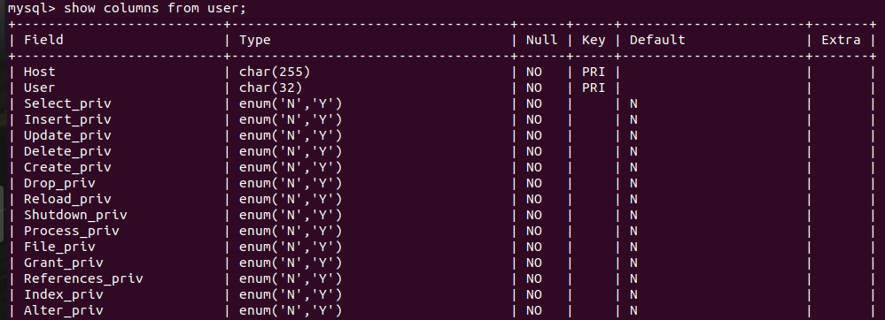
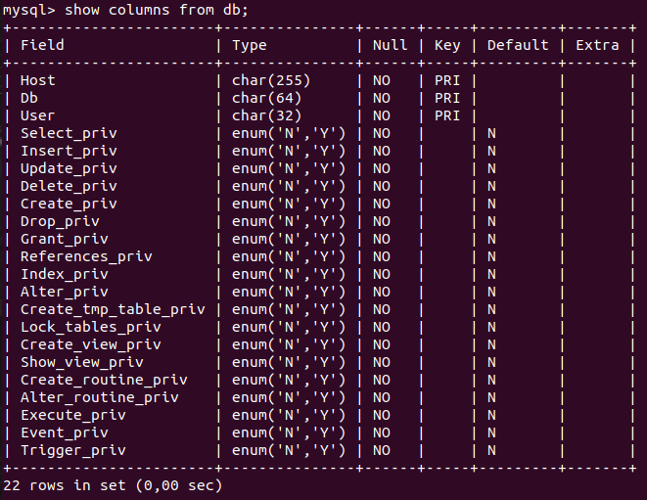
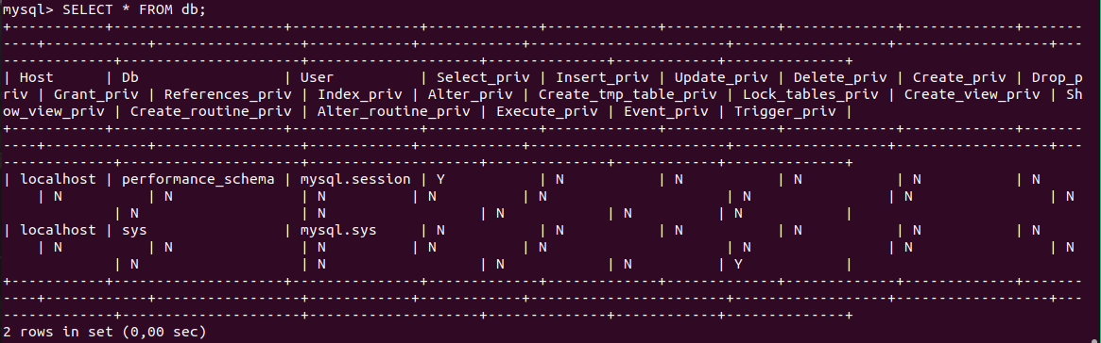

PART 2

10.Make backup of your database.
Mysqldump –u root –p x-ray_dept > db_backup.sql
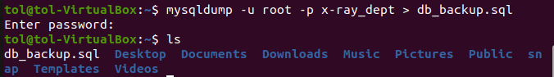

11.Delete the table and/or part of the data in the table.
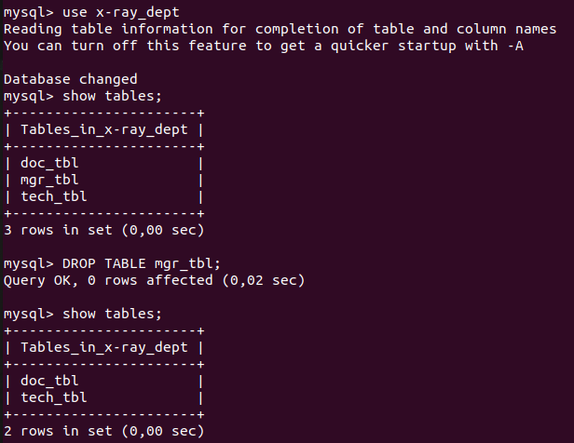
12.Restore your database.
