|  |  |
| --- | --- |
| Name(s): | Adetola Aladekoba |
|  |  |

**Criteria table is available at the submission site.**

**Include images of your results below:** These images should be clipped so that they show only the desired results as shown in the lab manual. Insert as much space as you need but keep all text present in this lab sheet intact. Feel free to insert any comments you would like, especially if you did something above and beyond the requirements that you think should be considered for extra credit.

Be sure to check for anything that might generate penalty points as indicated on the submission site.

1. Place a screen shot of your finished GUI as it appears before any component is clicked.

2. Place a screen shot of your finished GUI after a specific ship name is selected.

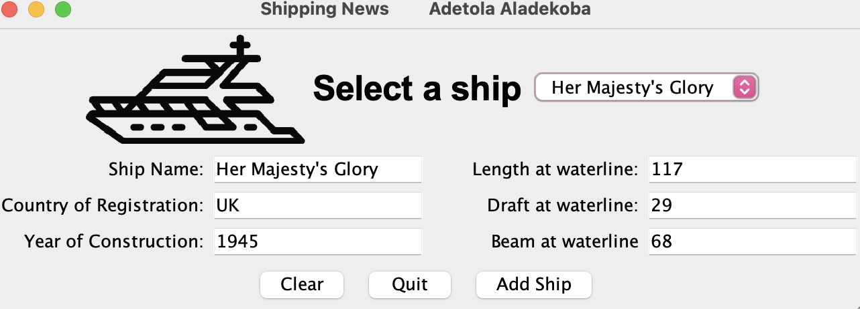

3**. EXTRA CREDIT:** Place a screen shot of your finished GUI after a new ship has been added to the list. This image should be with the list of ships extended and showing the new ship name.

