Documentation For Independent Study

App Name : SmartQ

Done By : Vaibhav Kollipara

**Project Description :**

The users of this app will be able to host a smart queue system using a simple smart phone.Every user of this app can either host a new queue or can request a token number to be part of the queue.This app can be implemented in many situations where people stand in long queues to get their turn.

**Technical Specifications :**

Platform : Android

Backend : Firebase

Minimum Android Version Required : Android Lolipop (Version 5.0)

**Walk Through App :**

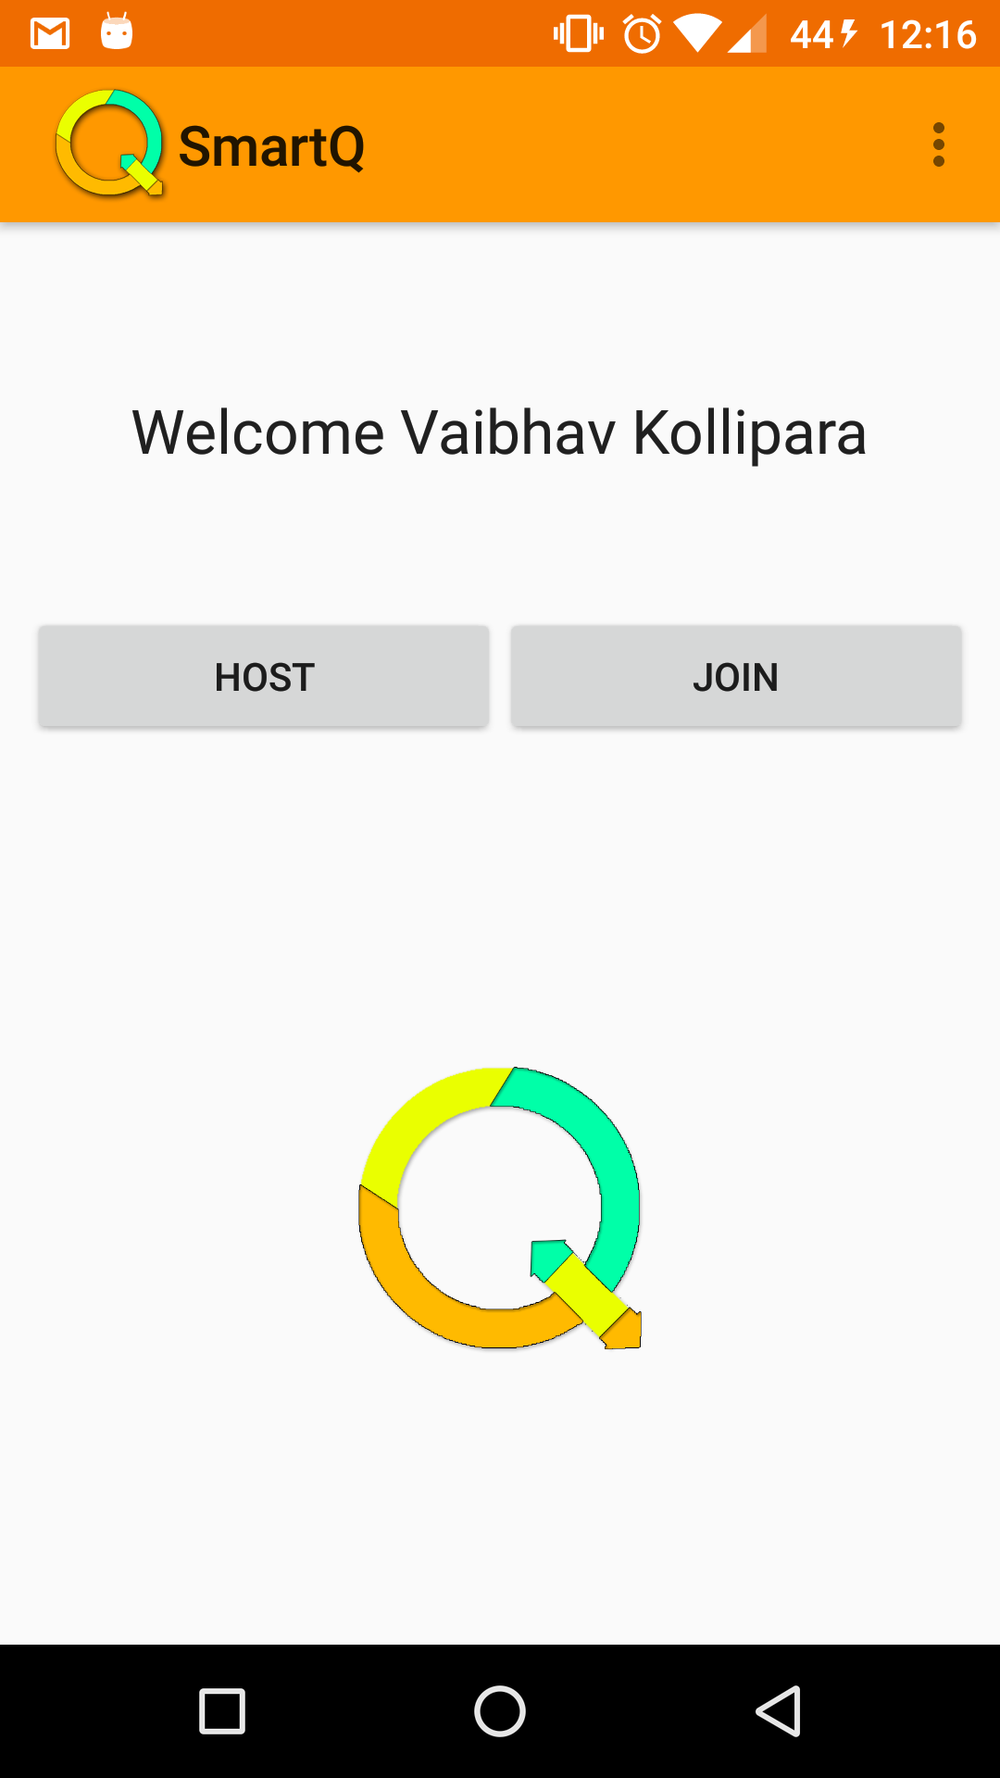

* Initially the above screen appears after user login.

**Queue Hosting :**

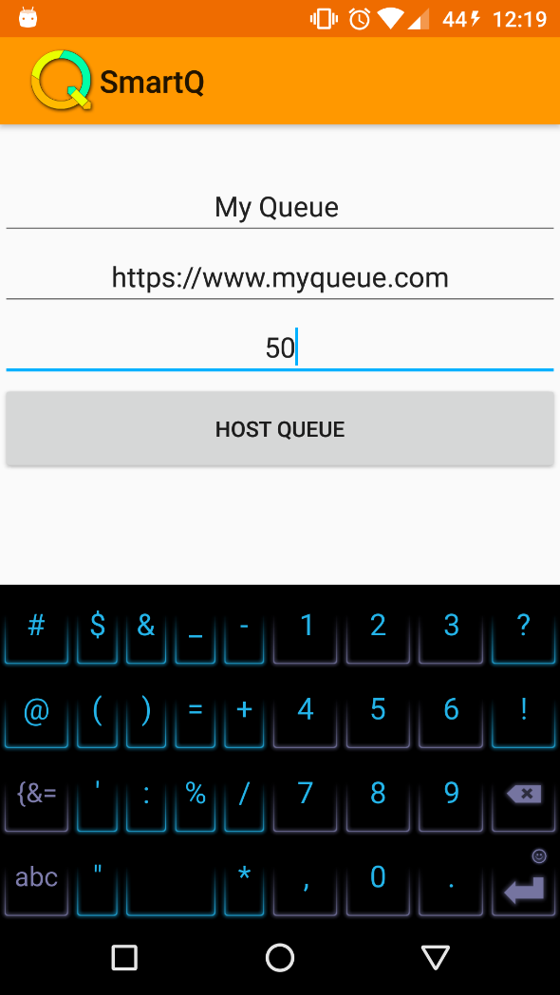

* Once User press Host button from home screen, App navigates to new Activity which takes Queue Details.Once the user inputs all the details and host queue the following UI appears.

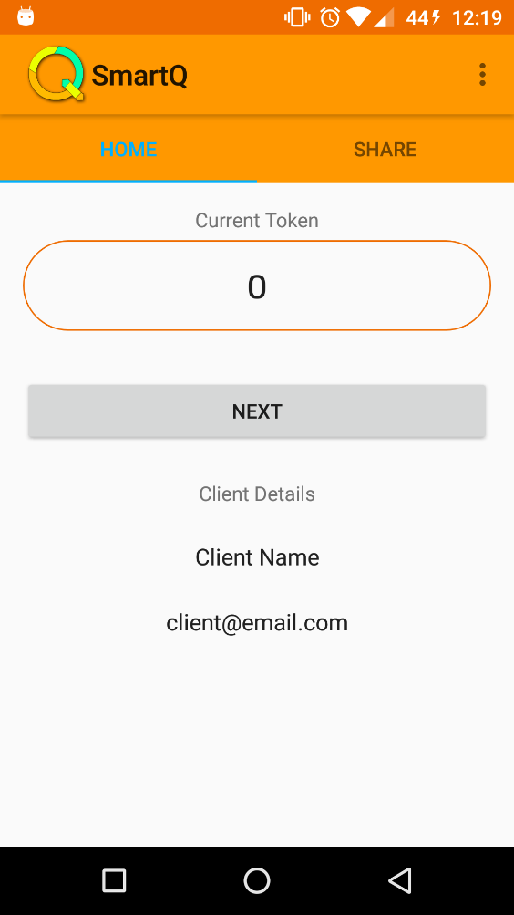

* The Next button calls the next token number and does the time calculations.

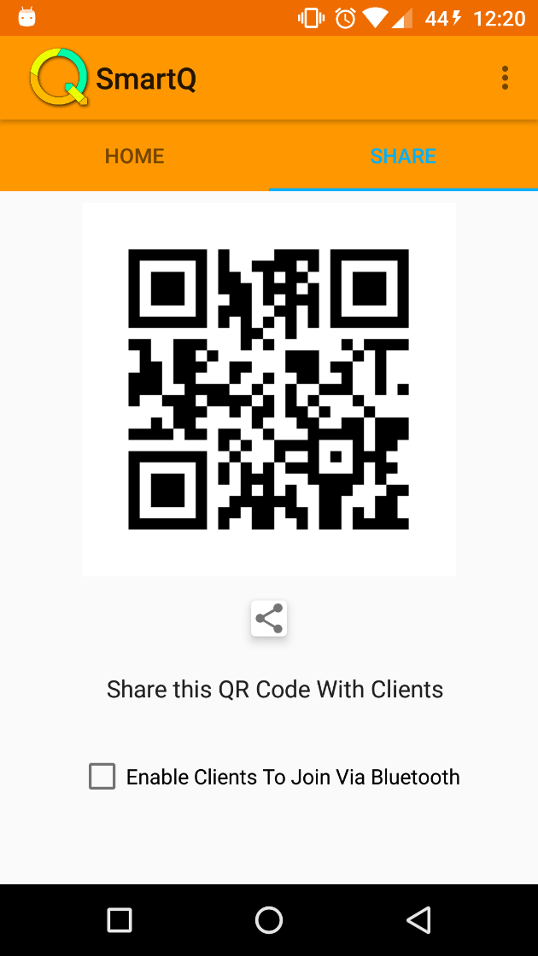

* From the above UI Host can either share QR Code or Enable Bluetooth for Clients to join in the Queue.

**Queue Joining :**

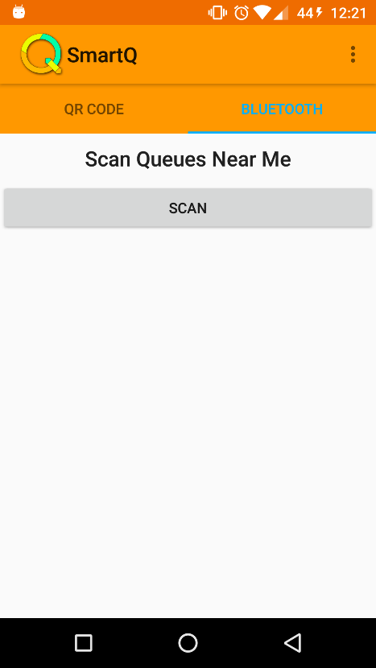

* Once client selects Join button from home screen,the above UI appears where he can scan the queues hosted near by him/her.
* Once the scan completes,the available queues are listed and client can join the desired queue.

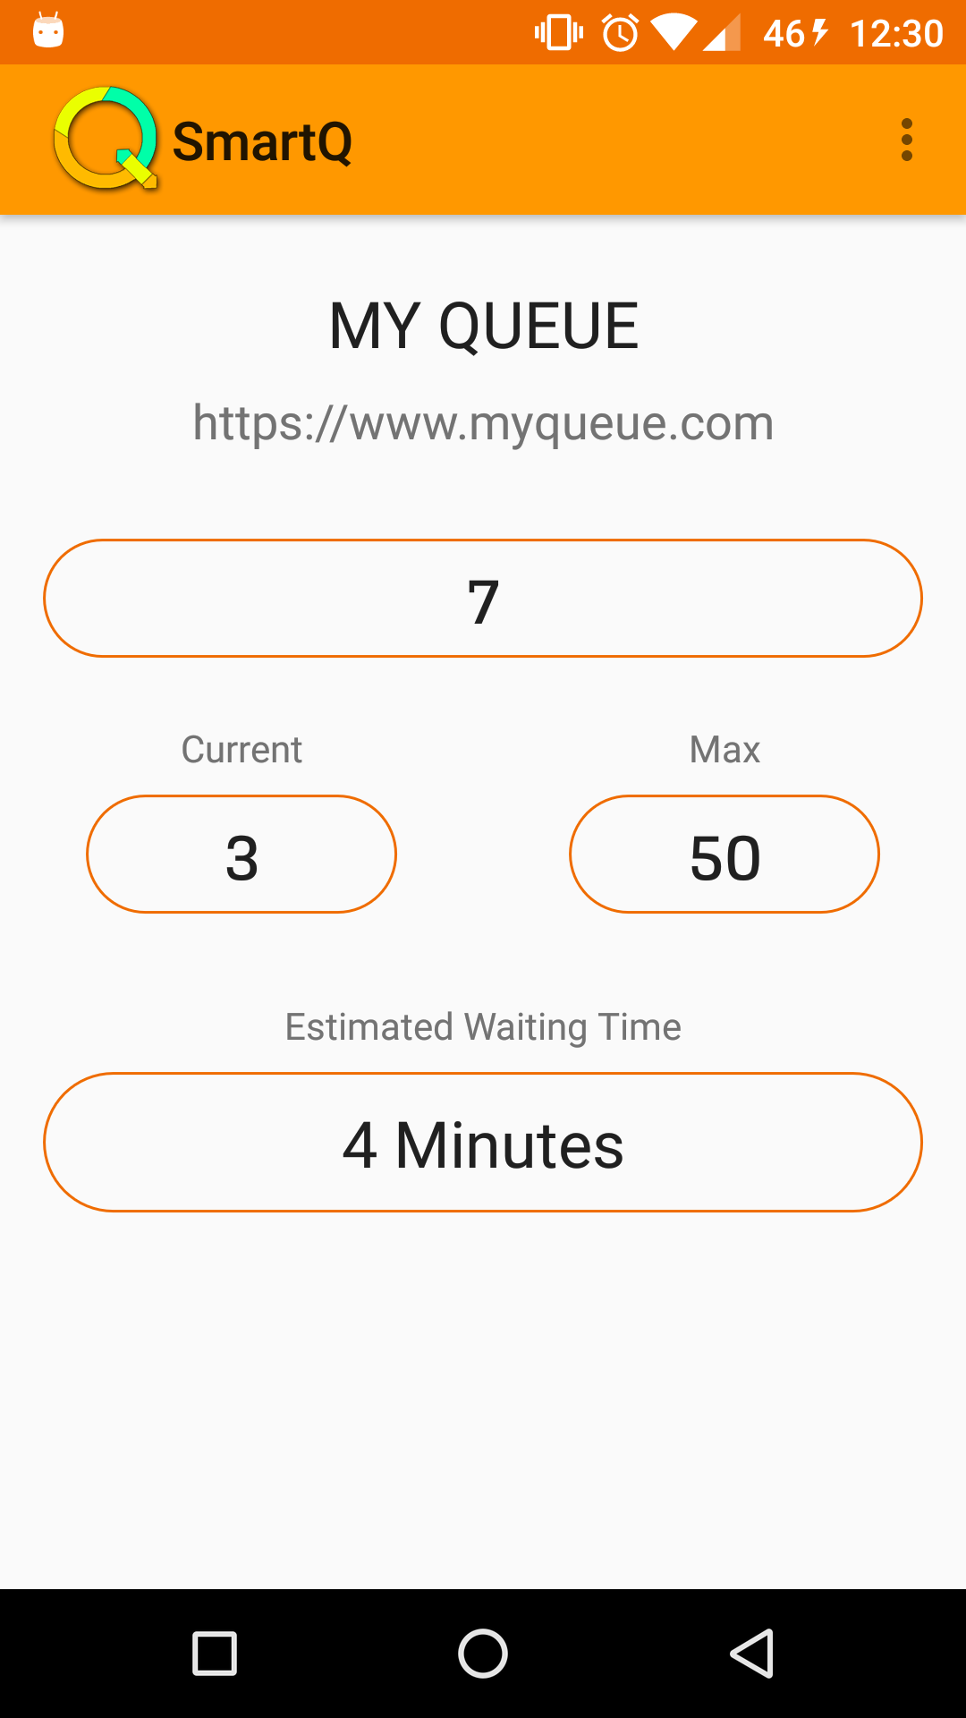

* Once client joins the Queue, he is assigned with a token number and an estimated waiting time for his turn.
* He can check the status of the queue like current token number and next token number to be called and estimated waiting time without physically standing in the queue.