**Probable Conclusions**

Based on the data received from the pivot tables, a few probable conclusions can be made. We do know that it is not a guaranteed, however, there is a possibility that these scenarios could be accurate. The first conclusion is built on the time of the year of the campaign.

**Time (Month of the Year)**

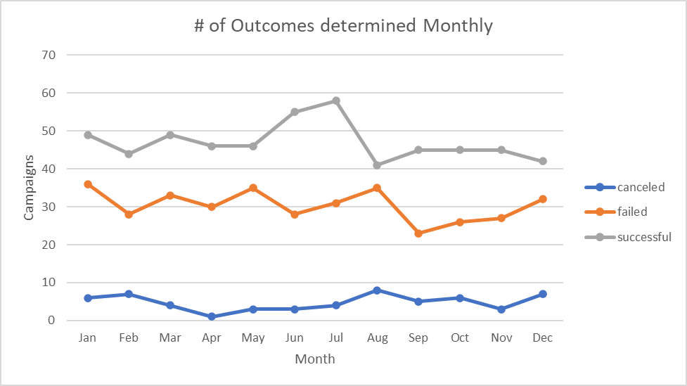

Figure 1.1

Looking at Figure 1.1 we see that July seems to be the most successful month to host a campaign for crowdfunding and June is right behind. However, the biggest hit to crowdfunding came in August. It seems that summer might be the reason for its success. May is typically a stressful time for students and parents. Once school lets out and stress levels decrease, people may be more willing to try new things and more open to suggestions and summer is almost the perfect time. It also seems, with school right around the corner in August, people’s persuasiveness to crowdfunding potential diminished. Of course, there is no guarantee, but studies have shown that stress plays a part in spending. According to Jelani (2016) “researchers at the University of Miami have found that stress leads consumers to save money in general but spend strategically on products they believe are essential.” Potentially, this may be reason why crowdfunding became less successful and failures almost reached an all time high. The data is inconclusive because we lack very pertinent information in this theory. We lack the ages of those who participated in these crowdfunding campaigns. We lack income status and location of the individuals who participated in these campaigns. A graph that would have displayed the average ages of those who participated in these campaigns vs the months could have supported this theory.

**Category & Sub-Category Choices**

Observing the Parent category pivot table and the sub-category pivot table, I observed two more possible conclusions. Looking at figure 1.2, which is the pivot table that displays the outcomes per category, at first glance one would argue that the category theater is the most successful. However, when we look at the tabulated version showing the successful and failed campaigns, we see the true values. It is now evident that the bar diagram is deceiving. Table 1.1 show the percentage of successful and failed categories. This is beneficial because it really tells us that journalism and technology are potentially the best categories to pick from if you desire to have a successful campaign. However, I wouldn’t use journalism because of so few data points. In statistics, it’s always good to have a minimum of 40 data points. Therefore, I would conclude that technology is the best campaign category.

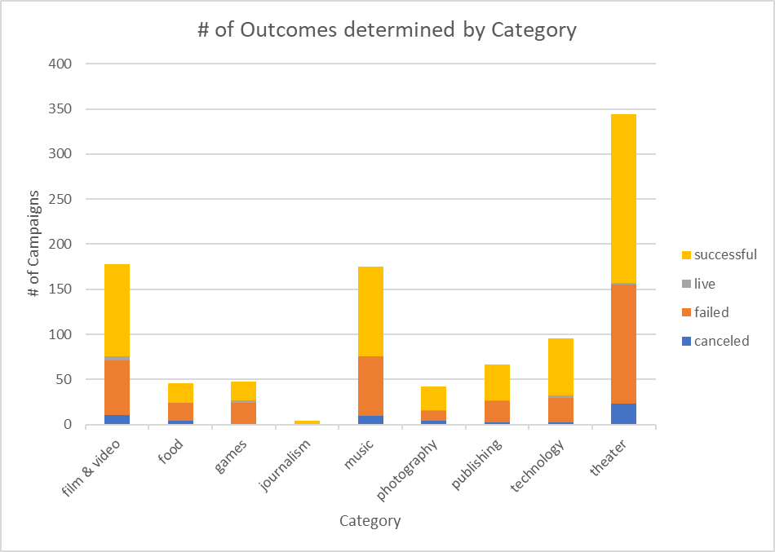

Figure 1.2

Table 1.1

Looking at figure 1.3, which is the pivot table that displays the outcomes per sub-category, at first glance one would argue that the sub-category plays is the most successful. However, when we look at the tabulated version showing the successful and failed campaigns, we once again see the true values. Table 1.2 show the percentage of successful and failed sub-categories. This tells us that audio, web, translations, and television are potentially the best sub-categories to pick from if you desire to have a successful campaign. However, even though audio has a perfect record, it has so few campaigns that I would still argue the validity of making that perdiction. I would lean more to web because it has a total of 51 campaigns. Therefore, I would conclude that web is the best campaign sub-category.

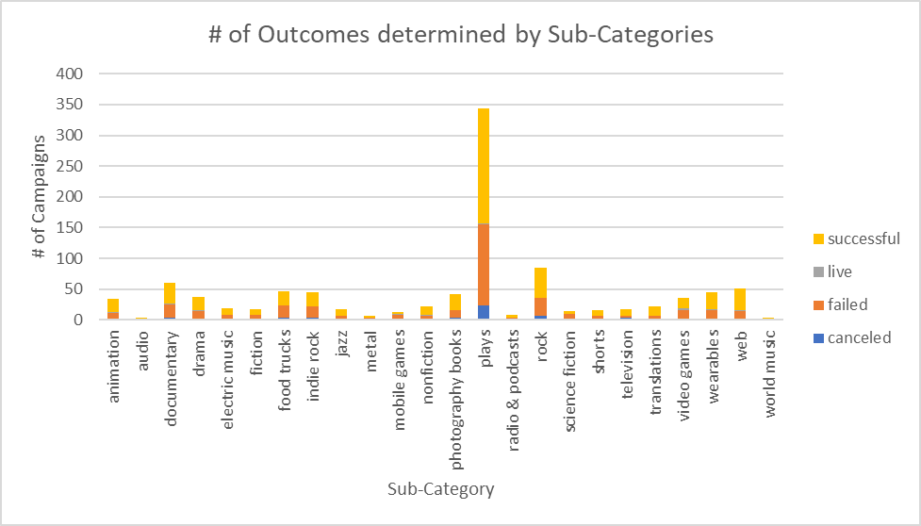

Figure 1.3

Table 1.2

**Limitations and Helpful Information**

Once again, there were many bits and pieces of information that could have been added to workbook that could have validated or dismissed many theories like age, income status, location, sponsors of the campaigns, length of the campaign, money spent on advertising (effort), professionalism, platforms used for crowdfunding (ease of access), overhead, etc. Queries could have been made from all of this information but one thing I struggled with when it came to analyzing this data was the lack of consistency. A successful campaign would look different depending on the country you’re in. Secondly, the currency was inconsistent. Making inferences from multiple different currencies is dangerous. A very helpful table would have been the conversion of money to one currency during the time of the campaign. This is important so that we know the current money exchange rate at that time so that inflation can properly be factored in. It is hard to judge apples to oranges when even the money collected is questionable.

**Analysis**

Table 1.3

After looking at the data, there is not much information to determine if the number of backers makes a difference or not in the success of the campaign. Yes, there mean values were quite different, but their z-scores were roughly the same when comparing the median to the mean according to table 1.3. They both had a fair amount of outliers but the percentage of outliers was roughly the same. Even their frequency tables showed roughly the same bell curve. Based on the data that I observed, I do not believe that there is no statistical significance between variance of the successful and unsuccessful campaigns. Therefore, the amount of backers does not correlate with the success or failure of the campaign.

# **References**

Jelani, V. (2016). *The Effect of Stress on Saving and Spending*. Retrieved from Harvard.edu: https://scholar.harvard.edu/vincentjelani/publications/effect-stress-saving-and-spending