(a) Environment description

The environment’s goal is to reach the goal on the other side of the cliff on a 4x12 grid. The agent can move up, down, left, and right. There is a -1 reward for every move and the episode terminates when the goal is reached. If the agent steps into the cliff on the left there is a -100 reward. There is a transition probability ‘p’ for each state (set to 1.0).

(b) Implement Q-learning
def update(self, state, action, reward, next_state, done):
"""Update Q-table using Q-learning formula"""
current_q = self.q_table[state][action]

if done:
target_q = reward
else:
max_next_q = np.max(self.q_table[next_state])
target_q = reward + self.gamma * max_next_q

# Update Q-value
self.q_table[state][action] += self.lr * (target_q - current_q)

(c) Baseline training
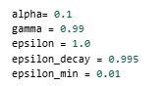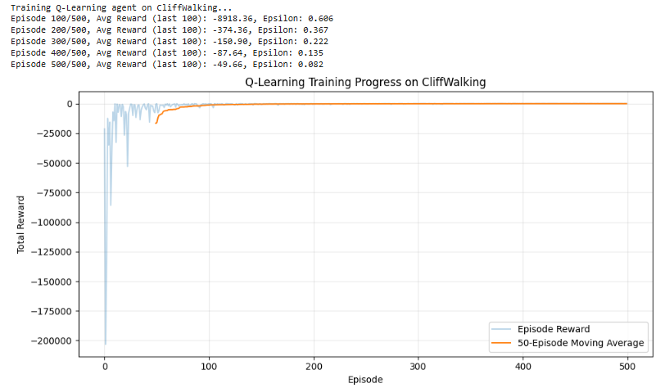

(d) Learning rate experiment
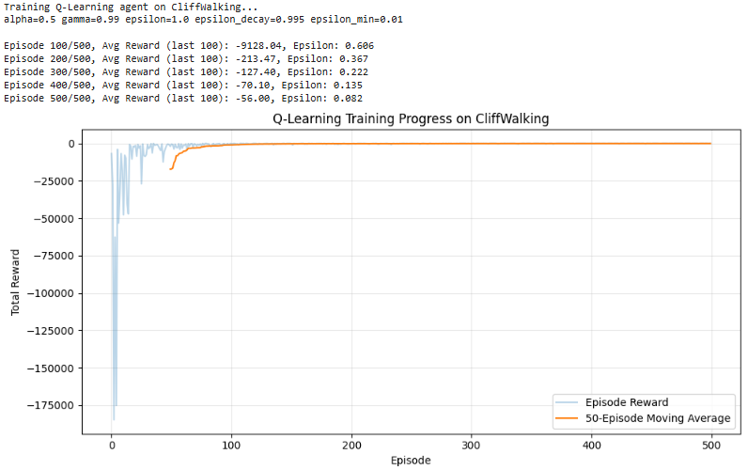
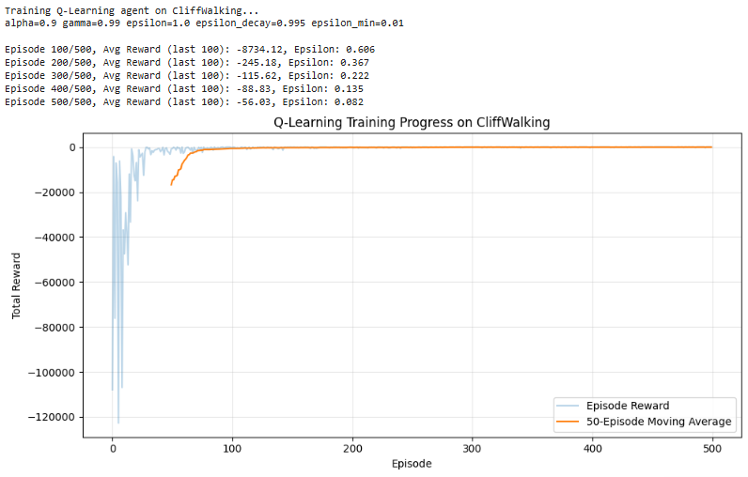
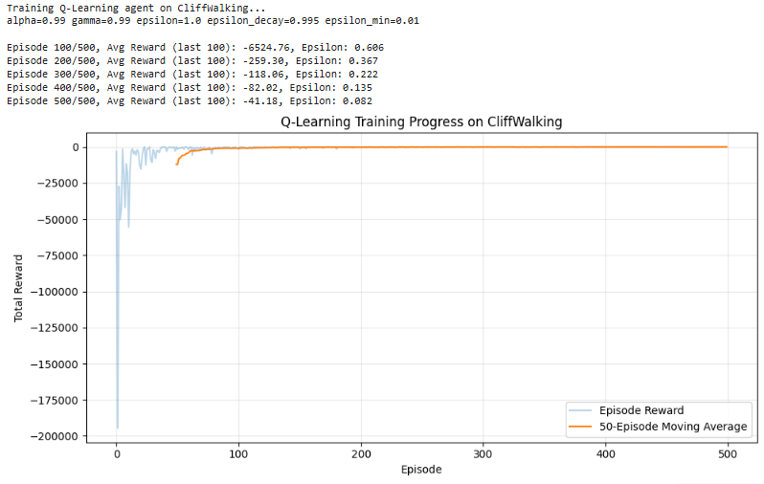

As alpha increased the initial instability increased but after ~50 episodes was less erratic as alpha increased. The agent learned faster when alpha was increased

(e) Discount factor experiment
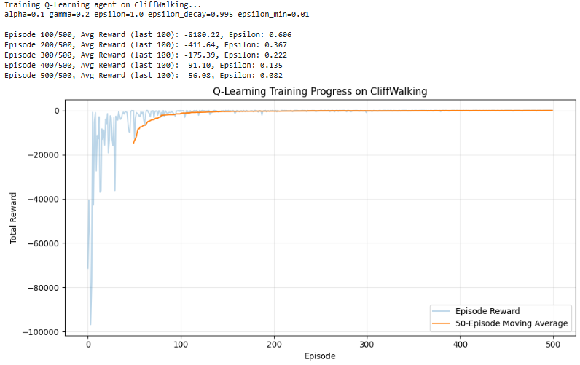
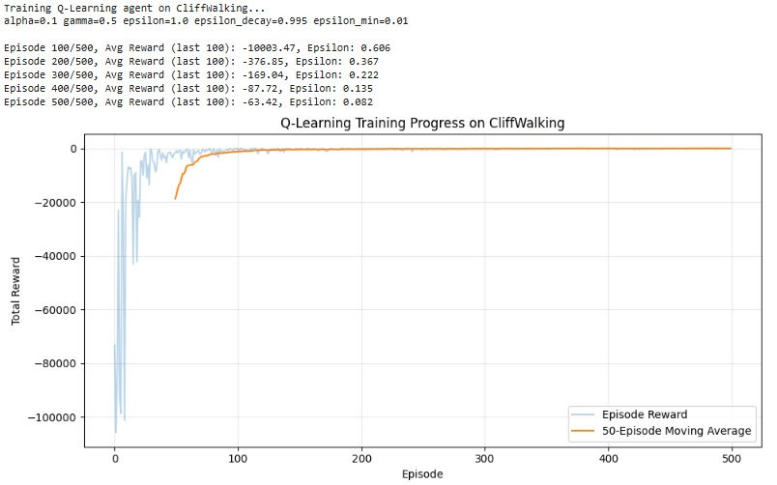
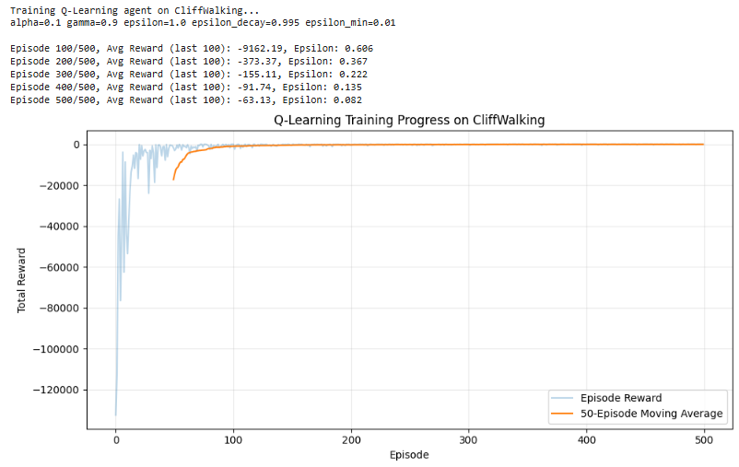
The reward over episodes was less erratic/noisy as gamma increased and learned faster

(f) one additional hyperparameter (epsilon decay)
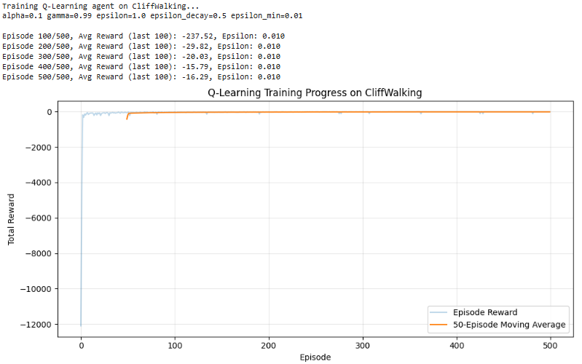
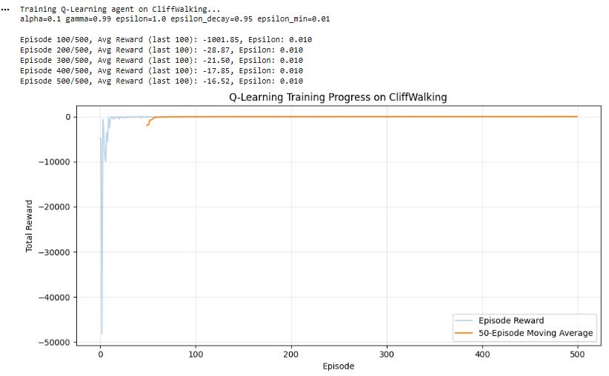
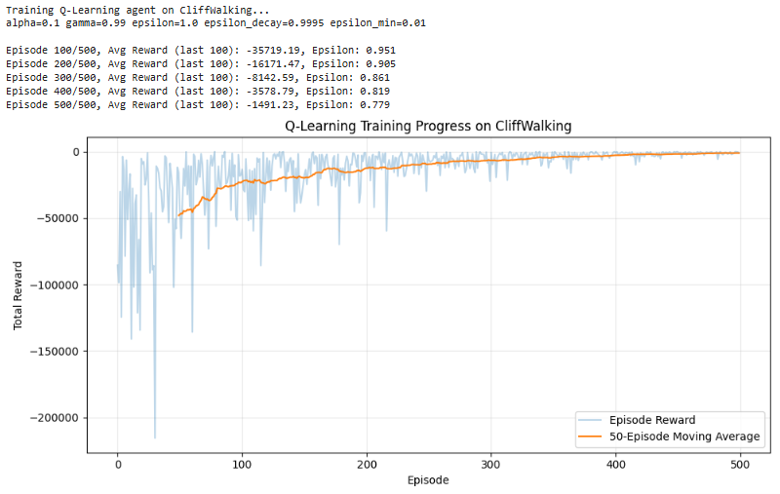
As epsilon decay increased the agent took longer to learn, but learned more smoothly. A low epsilon decay had sometimes increasing average rewards over episodes.

(g) Evaluate best agent
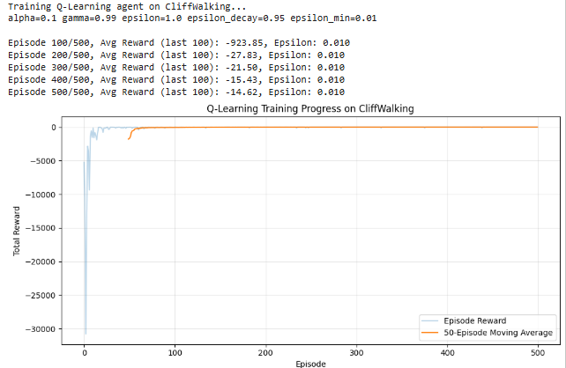
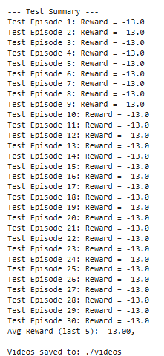
The average reward was -13 which is the shortest path to the goal. The best configuration was chosen based on the best results from tests (c)-(f). The agent learned faster compared to the baseline with better average reward over episodes and less erratic rewards over episodes.

(h) stochastic environment
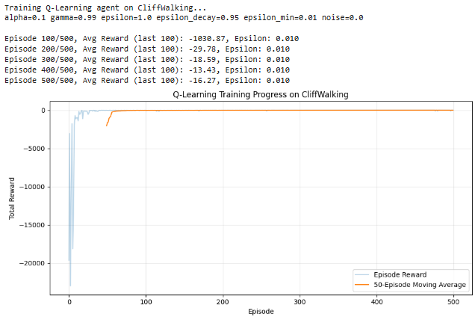
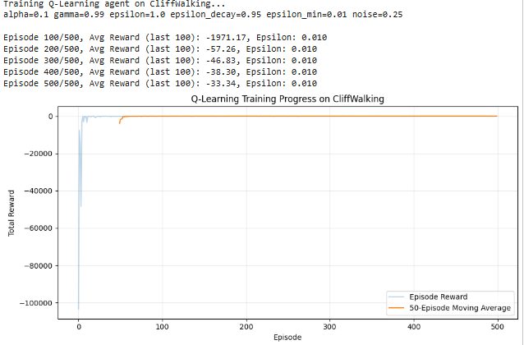

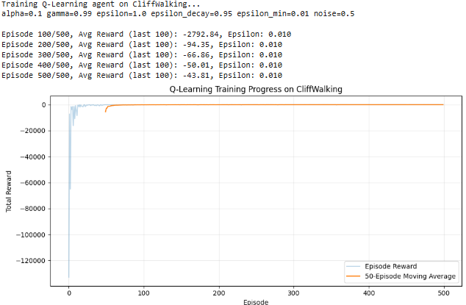
The agent learned slower when noise was added to the environment actions and the final reward was lower as noise increased (possibly due to slower learning), but the policy was more robust.

p=0 trained policy under added noise:

The agent performed poorly when noise was added to the environment actions.

