**CalculateTaxes Application**

The project calculates the 2020 Federal Income Tax Brackets and rates for single and married filing jointly groups based on an annual taxable income (yearly salary). It shows how the annual taxable income is broken down into each tax bracket and provides the total tax amount per bracket based on the tax bracket rate.

**Prerequisites**

The project is written in Python under Windows OS. The following installations are required to edit and run the project.

* Installation of python, version 3 or greater. <https://www.python.org/downloads/>
* Installation of Sublime Text3 for file editing. Download Windows 64 bit version. <https://www.sublimetext.com/download>
* [Optional] Installation of Anaconda for python 3.7. <https://www.anaconda.com/distribution/>

**Installing**

* Clone Code from Github Location <https://github.com/tolbertsf01/CaclculateTaxes>.
* Keep all files together (under same directory).
* Open DOS window and change directory (cd) to the directory where files reside.
* Use the Dir command to validate that all the files listed below are present. *In this example, the files were stored under C:\python-code.*

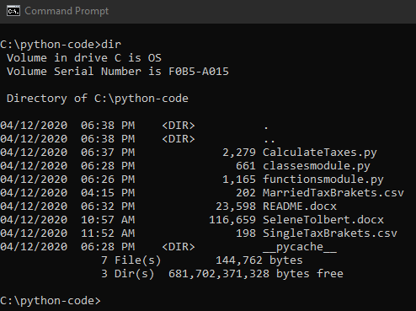

**Execution**

* Open DOS window and change directory (cd) to the directory where the python files reside.

*In this example, the files were stored under C:\python-code.*

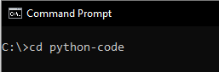

* Run the Main Python Module: CalculateTaxes.py by entering the python command shown below.

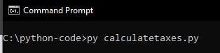

* You will be prompted with questions to answer. Please answer all questions as these are needed to calculate the results.

**Next Steps (Areas for Improvement)**

1. More Robust Error Handling
2. Validation of input parameters allowing for multiple prompts to the user when incorrect input.

**Versioning**

Version 1.0

**Authors**

* Selene Tolbert, <https://www.linkedin.com/in/selene-tolbert-ms-csm-4228b32a/>