



Real Estate Price Prediction - UAE Market Intelligence and Forecasting

Authors

Bader Shahrori,
Rowida Abu Lehyeh
Toleen Khamash

Supervised by

Course: 307498 – Graduation Project
First Semester, 2025/2026

Date



Abstract 3
Acknowledgment 4
Business Intelligence Project description and objectives 5
Data Research and Acquiring Effort 6
Links to raw data 6
Data Description and understandings 7
Data Primary Cleaning and Transformation 16
Data Visualization and Insights 18
Advanced Analytics and AI Modeling 24
Tools Research and Selection Effort 29
Project Deployment Effort – Use Case 29
Results 30
Limitation 31
References 32

Abstract

The project presents an entire end-to-end Business Intelligence (BI) solution for the prediction of the rent amount of real estate rental contracts in the United Arab Emirates (UAE). The UAE real estate market is one of the fastest moving market globally, being among the top 10 most active property markets (Dubai Land Department, 2026). Currently, rental price discovery is quite challenging for both tenants, landlords, and even investors, forming the basis for BI and machine learning algorithms. This creates an urgent need for a data driven pricing tool that provides objective benchmarks for tenants, investors and policy makers. The project focuses on the construction of the rental price benchmark based on the analysis of more than 300,000 registered contracts available in the Dubai Land Department.

The raw data (rents-2026-04-07.csv) was preprocessed in seven consecutive stages of data cleansing with four engineered features techniques applied to ensure data quality prior to modeling. In total, thirteen predictive features were selected to train and compare five machine learning regressor models including: Linear Regression, Random Forest, Ridge (Linear Variant), Decision Tree, and Neural Network. The best result (R² = 0.9510; variance explained 95.10%, MAE = AED 71,130) has been provided by the Random Forest Regressor algorithm. The outputs of the model such as the difference between actual and predicted prices, growth percentage, differences, and future forecasts for three periods including Next Month, Next Quarter, and Next Year were all exported as .CSV and integrated into an interactive dashboard using Power BI.

The main insights obtained from the analysis have shown that contract duration (r = 0.56 with price), number of properties in the building (r = 0.53) and the metro location are the major determinants of rental prices in the UAE. The Al Sufouh metro area has the highest predicted contract values of over 3 billion AED. Areas such as Al Garhoud and Al Barsha South Fourth have the highest growth percentages making them ideal for investment. Linear models worked up to a maximum 52% whereas Random Forest went up to 95.10%, indicating that the process of forming the price of rentals in Dubai involves high levels of non-linearity. The results have practical applications for real estate investors, property managers, and decision makers within the UAE market.

Keywords: Real estate price prediction, machine learning regression, Random Forest, Business Intelligence, UAE property market, Power BI, Dashboard.

Acknowledgment

The completion of this project could not have been made possible without the help of various organizations and people to whom we wish to convey our heartfelt thanks.

Firstly, our deepest supervisor Hussam Aldeen Barham, for the guidance, patience, and valuable feedback he provided throughout the whole course period for this graduation project. It was his experience with data science, machine learning, and the design of business intelligence systems that helped shape the quality and academic level of this project.

Secondly, it is necessary to thank the Dubai Land Department (DLD) for their dedication to transparency and governance via the Dubai pulse open data portal. With the provision of publicly available real estate transactions by the DLD, it became possible to conduct data analysis such as the one presented here, and the predictive model along with the business information provided would be impossible without the government verified dataset over 300,000 registered rental contracts.

We express our sincere gratitude once again to the open source community of contributors for their valuable Python, Pandas, NumPy, matplotlib, and Seaborn libraries, which were available free of cost for use by anyone across the globe and served as the foundation for our entire process of machine learning and visualizing data analysis. It is our pleasure to thank Microsoft Corporation for Power BI Desktop, which helped us create a professionally made interactive business intelligence dashboard from complicated results of the models used.

Last but not least, we dedicate this research to our loved ones who have provided us with immense motivation and guidance during this academic endeavor.

Business Intelligence Project description and objectives

The UAE real estate market presents one such gap that can be solved using a holistic approach towards business intelligence and machine learning analysis in order to predict contract prices in the UAE real estate market in Dubai. UAE Real Estate Rental Market has proved to be among the fastest growing and most transparent property markets in the world (Frank, 2025). In fact, within the past two decades, the UAE and especially Dubai have experienced exceptional property growth because of various initiatives from the government such as freehold ownership areas, long-term resident status for the property owner, and the lack of any property tax in the UAE. Transactions volumes witnessed record high figures in both 2024 and 2025 (Dubai Land Department, 2026)

The core business problem that this project seeks to tackle is pricing opacity: real estate agents give very different rental prices for properties that are similar across different areas and locations, and there is a need to have an objective tool for comparison. A predictive model trained on 260,000+ actual registered contracts fills this gap and enables objective, and achieve that goal.

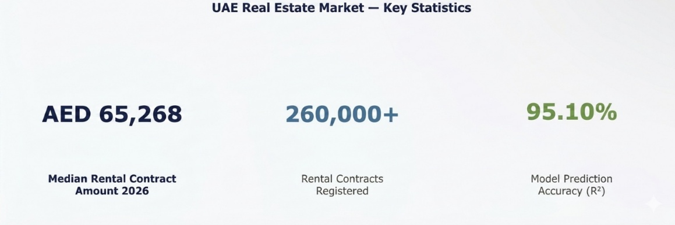

Figure A - UAE Rental Market Key Statistics (Source: Dubai Land Department, 2026)

The median value of AED 65,268 is adopted as the market benchmark, as the arithmetic mean of AED 321,000 is largely influenced by high number of commercial and whole building leasing agreements included in the dataset. Considering that the market of Dubai contains many extreme values and has highly positively skewed distribution of the data, the use of the arithmetic mean is not appropriate due to the sensitivity of this indicator to extreme values, unlike the median (Field, 2018).

Project Objectives
- Predict the total rental CONTRACT_AMOUNT for any property given its characteristics
- Identify which factors (area, type, rooms, metro proximity, freehold status) most strongly influence price
- Flag undervalued and overvalued properties by comparing actual vs. predicted prices and computing GROWTH_PERCENTAGE
- Forecast future rental prices across three-time horizons: Next Month, Next Quarter, and Next Year
- Build a Microsoft Power BI interactive dashboard for non-technical executive stakeholders
- Provide investment recommendations based on area-level growth percentage analysis

Business Questions Answered
- What factors affect property rental prices in the UAE?
- Which areas and metro zones have the highest rental values?
- What is the expected future rental price for a given property profile?
- Which properties and projects represent the best investment opportunities?
- Where are properties currently overvalued or undervalued relative to market expectations?

Data Research and Acquiring Effort

Choosing the right dataset is one of the primary steps that need to be done in a machine learning project as the quality and pertinence of data directly influence the model’s performance (Han et al., 2011). When selecting the dataset we had three primary considerations: (1) the dataset used real rental contract costs and not asking price, (2) we needed attributes that give us more information other than cost and area, and (3) sufficient data that could enable an efficient statistical machine learning model.

- Bayut.com and Propertyfinder.ae - major UAE property listing portals. Rejected because they contain asking prices, not actual registered contracts, and scraping is legally restricted.
- REIDIN UAE Database - a premium commercial database. Rejected due to paid access requirements incompatible with a graduation project budget.
- Dubai Statistics Center - provides aggregate housing indices. Rejected due to lacks of individual transaction records needed for ML training.
- Dubai Land Department (DLD) Open Data Portal - Selected. Provides actual legally registered rental contracts with full property details, verified by the government body that oversees all property registrations in Dubai.

The chosen dataset for the analysis is the DLD dataset (rents-2026-04-07.csv) the reasons behind choosing this dataset are as follows: First, the dataset comprises more than 300,000 rental agreements for all Dubai areas; second, the number of features is more than 20 in the dataset including property attributes, location indicators, and contract terms, third, the dataset is governmental verified (one entry equals one contract officially submitted to the DLD office), and finally, the dataset is updated frequently.

Links to raw data

Primary Dataset: Dubai Land Department - Rental Contracts (Rents) Open Data
Source URL: https://www.dubaipulse.gov.ae/data/dld-transactions/dld_rental_contract-open
File Used: rents-2026-04-07.csv
File Size: Approximately 80MB, 300,000+ rows, 20 columns
License: Dubai Government Open Data License - free for academic and commercial use with attribution to DLD
Description: The number of rows in the dataset signifies the number of registration contracts in Dubai, UAE. These data points are validated by the Dubai Land Department. They consist of information about the property, its location, contract dates, and closeness to urban conveniences.

Secondary Reference: Dubai Statistics Center - Real Estate Sector Reports: https://www.dsc.gov.ae/en-us/Themes/Pages/Real-Estate.aspx

Data Description and understanding

A data dictionary of all columns involved in this project is provided below. All columns have been described along with their data types and pertinence to the goal of predicting the rental price. The target variable (CONTRACT_AMOUNT) is highlighted in yellow.

Column Name | Data Type | Description and Relevance
REGISTRATION_DATE | Date | Official contract registration date. Used for date validation and essential date drop check only; no longer used to extract temporal features.
START_DATE / END_DATE | Date | Contract start and end dates. START_DATE is used to extract START_YEAR and START_MONTH (temporal features). The date difference gives CONTRACT_DURATION_DAYS (r=0.56 with price). Data is filtered to START_YEAR >= 2020 to focus on post-pandemic market conditions.
AREA_EN | Categorical | Dubai district/neighborhood (Business Bay, Jumeirah, etc.). Primary location signal for price.
CONTRACT_AMOUNT | Float (AED) | TARGET VARIABLE. Total rental contract value in AED. Range: AED 1 to AED 100M+.  Note: This was renamed to ACTUAL_PRICE in the model output file, to distinguish actual registered values from model predictions.
IS_FREE_HOLD_EN | Categorical | Freehold vs Non-Freehold zone. Freehold areas attract premium contract amounts.
ACTUAL_AREA | Float (m2) | Property size in square meters. Near-zero raw correlation (r~0) with price when isolated.
PROP_TYPE_EN | Categorical | Broad type: Unit, Villa, Land, Building, Virtual Unit.
PROP_SUB_TYPE_EN | Categorical | Granular sub-type: Flat, Penthouse, Warehouse, etc.
ROOMS | Integer | Number of bedrooms. Clear staircase: 1-room ~AED 80K median up to 8-room ~AED 10M median.  Note: It was stored as float in pandas due to null value handling.
USAGE_EN | Categorical | Residential (~73%) vs Commercial (~27%). Major market segmentation variable.
NEAREST_METRO_EN | Categorical | Closest Dubai Metro station. Al Sufouh and Burj Khalifa zones show highest predicted prices.
PARKING | Float | Parking spaces. Highly correlated with ROOMS (r=0.81).
TOTAL_PROPERTIES | Integer | Total units in same building. Strong predictor of CONTRACT_AMOUNT (r=0.53).
PROJECT_EN | Categorical | Development project name. Used to surface undervalued/overvalued projects in forecasts.
CONTRACT_DURATION_DAYS | Engineered Float | END_DATE minus START_DATE in days. Highest numeric correlation with price (r=0.56).
START_YEAR | Engineered Integer | Extracted from START_DATE using pandas dt.year. Represents the calendar year the contract commenced. Dataset filtered to START_YEAR>= 2020 to focus on post-pandemic market conditions and remove historical noise. Used a temporal feature in the model to capture year-level pricing trends.
START_MONTH | Engineered Integer | Extracted from START_DATE using pandas dt.month. Represents the calendar month (1-12) of contract commencement. Captures seasonal rental pricing patterns – for example summer peaks when corporate relocations occur. Used a temporal feature in the model.
PRICE_PER_AREA | Engineered Float (AED/m²) | Computed as CONTRACT_AMOUNT divided by ACTUAL_AREA. Used during EDA and outlier analysis only to identify extreme price-per-square-meter values. Deliberately excluded from model training features to prevent data leakage, since it directly incorporate the target variable CONTRACT_AMOUNT, including it would allow the model to use the answer to predict itself.
Table 1 - Data Dictionary: All 15 columns used in the project (Yellow = Target Variable, Green = Engineered Feature)

** Columns marked as Engineered were not present in the raw dataset but were added during the Feature Engineering phase.

*** PRICE_PER-AREA: Was engineered in step 7 in the cleansing process, and it was used only during EDA for outlier analysis and visualization. It wasn’t included as a model training feature in order to avoid data leakage as it’s directly incorporating the target variable CONTRACT-AMOUNT.

Five features from the original 20 features were dropped from our modeling based on the results of feature selection. The features: (NEAREST_MALL_EN, NEAREST_LANDMARK_EN), were cleaned but not modeled as there is already a feature NEAREST_METRO_EN that represents the premium due to location with much better predictive power. ANNUAL_AMOUNT was dropped due to data leakage as it directly correlates with the target variable CONTRACT_AMOUNT. The feature MASTER_PROJECT_EN was also dropped due to very high sparsity and duplicate with PROJECT_EN

Before modeling, Exploratory Data Analysis (EDA) was conducted at three levels: univariate analysis, bivariate analysis, and multivariate analysis. This EDA process helped us grasp the distribution of our data as well as select appropriate models for this particular problem. All charts were generated using Python with seaborn and matplotlib libraries.

- Univariate Analysis – Individual Variable Distributions

Univariate Analysis is done to find out about nature, central tendencies, and variations of each feature separately.
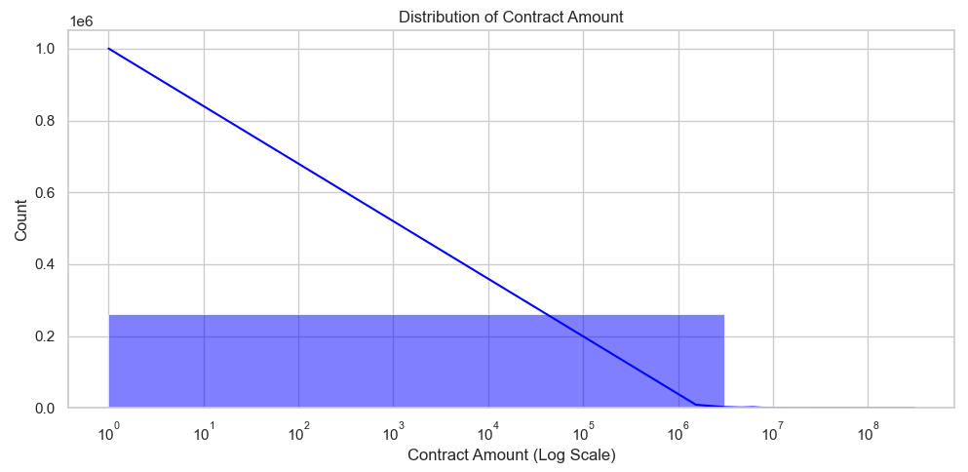
Figure 1 - Distribution of Contract Amount (Log Scale) - Right-skewed log-normal pattern

Figure 1: The CONTRACT_AMOUNT histogram on a logarithmic scale shows the presence of skewed long-normal distribution, the great majority of the contracts is made in the price range from AED 10,000 up to AED 1,000,000 and this is the residential mass market, while only few extremely high value contracts, from AED 1,000,000 up to AED 100,000,000+, refer to commercial buildings or full building leases.

Such a distribution implies an immediate business insight: any model for determining price based on linear assumptions, simple average calculation, standard regression, will consistently misprice the affordable end by putting too high values and vice versa with premium end (which will systematically overprice cheap properties and underprice premium one), misleading all stakeholders it is designed for.

This skewed distribution explains the choice of tree ensemble models instead of regression models, because Random Forest does not rely on linear relationships for the prices, hence the difference between it’s 95.1% accuracy rate and linear 52.0% one. In conclusion, the insights provided confirm that pricing should always be segment specific (as no single average price can represent it fairly) rather than market wide. Also, for the property managers, the distribution confirms that the residential mass market contracts from AED 40K to AED 200K represents the highest volume opportunity and the most stable pricing band. For executives and policymakers, the long tail signals that Dubai’s commercial real estate sector contains a small number of extraordinary high value contracts that strongly influence market statistics.
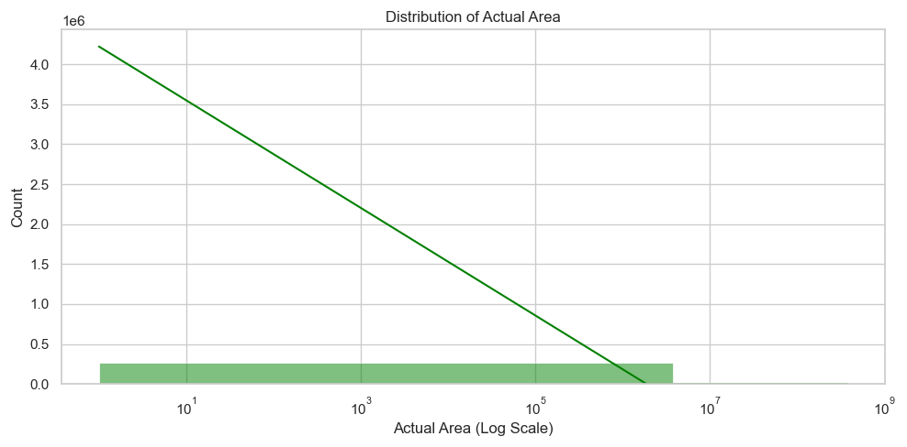
Figure 2 - Distribution of Actual Area (Log Scale)

Figure 2: In terms of Dubai’s real estate rentals, space is not the major determinant when it comes to pricing the property. There is general assumption that bigger sized mean higher rental fees, property area shows near zero standalone correlation with contract amount (r~0). This is because most rental properties lie in the same square footage range (residential units between 50 m² and 500 m² representing the apartment driven mass market that accounts for 88% of all contracts, while the rare properties extending 10,000 m² represents land plots and entire building leases), making this criterion irrelevant in terms of price determination. Other determinants are considered such as the type of property, its location, how long the contract runs, and its accessibility to major transport routes.

To investors and property managers, this means that using price per meter square is ineffective when valuing the property. The smaller sized property located in favorable and accessible locations will yield higher revenues than large sized properties located in undesirable areas (A 100 m² apartment decision in Al Sufouh will command a dramatically higher rent than a 200 m² apartment in a less connected district). Going forward, stakeholders should move towards considering the location and the type of property as the two main criteria for investing and pricing.

For the predictive model, this finding directly justified by treating ACTUAL_AREA as one feature among many, combined with location, property type, freehold status, and contract duration rather than as a primary driver.

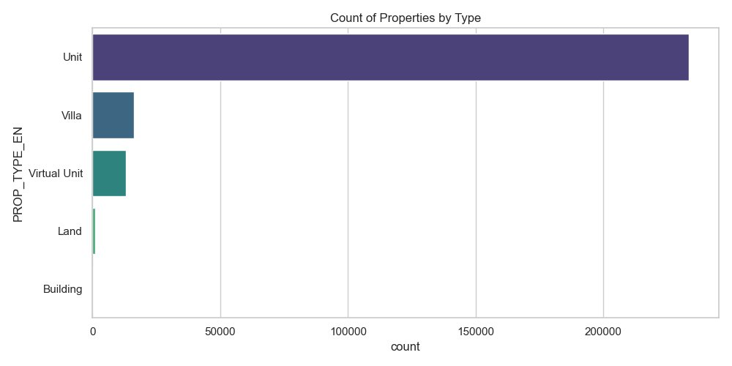
Figure 3 - Count of Properties by Type - Units dominate at ~88% of all contracts

Figure 3: The property category count plot indicates that there are over 230,000 records (Units which include apartments) in the dataset representing around 88% of all property contracts in the dataset. It is therefore clear that the market dynamics of the model have been based on residential unite price. Residential accounts for about 73% (~190,000 entries) while Commercial is 27% (~70,000 entries)..
2. Bivariate Analysis - Relationships

Bivariate analysis helps to examine the relationship between each of the individual features and the target feature CONTRACT_AMOUNT to derive any direct price signals.
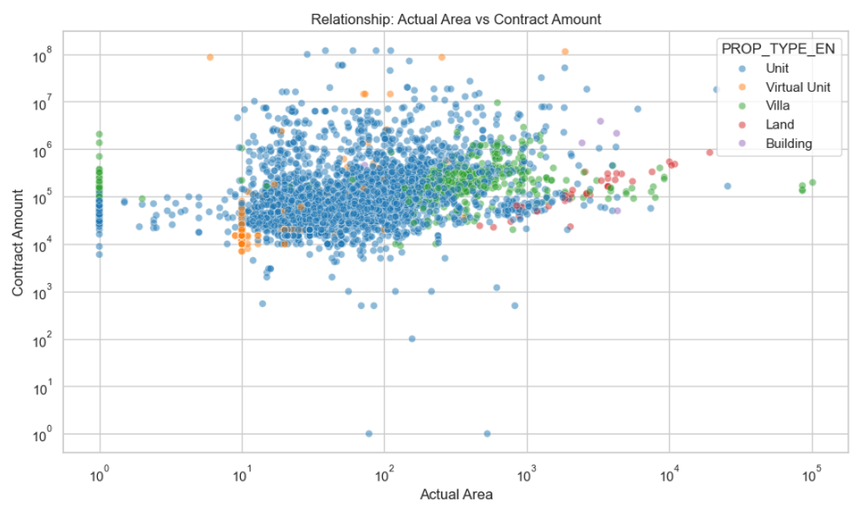
Figure 4 - Actual Area vs. Contract Amount (Log-Log Scatter) - Positive trend with high variance

Figure 4: Property type, however, provides more accurate information about a property’s price level than its size in Dubai’s real estate market. In fact, the right segmentation of the market indicates that there are five separate segments in terms of prices: Units, Villas, Virtual Units, Land, and Buildings, each one operates according to its own rules. For instance, residential units constitute 88% of all the contracts concluded in the market, falling mostly within the range of AED 10,000 – 1,000,000 (blue), while commercial buildings rent prices remain much higher regardless of their size.

Otherwise, significant pricing differences could result in 1,000 times variation. Therefore, size based indicators must be excluded from consideration as they cause major misjudgments. It’s critical for investors and managers to stop using outdated benchmarks. Segmented approach to investment analysis and valuation should include segmentation by the property types because comparing villas and apartments would mean comparing apples with oranges. Treating all the five segments as separate markets instead of considering one general real estate market in Dubai will produce accurate results.

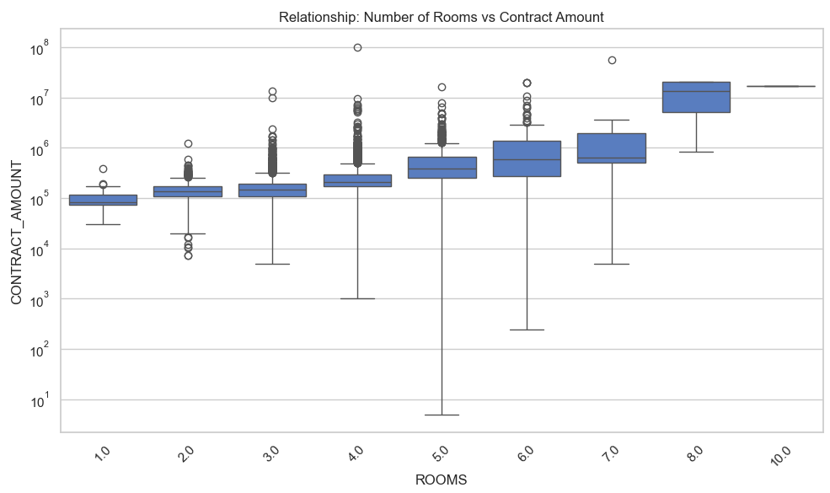
Figure 5 - Number of Rooms vs. Contract Amount (Box Plot) - Clear staircase pricing pattern

Figure 5: The number of bedrooms rather than the overall size becomes a much more reliable indicator of the cost of leasing in Dubai. The available information indicates that there is a “staircase” trend according to which each additional bedroom leads to moving the price unto a new price tier. The price starts at AED 100,000 for the studio apartment and gradually increases to over AED 10,000,000for luxurious villas comprising eight or more rooms. It is important to note that room data in this dataset except for Villa-Type objects (9,537 out of 263,930), where other property types do not have any records of number of rooms. Thus, the staircase trend represents only Villa based segmentation, which cannot be applied to the whole rental market of Dubai. In regards to that, the number of bedrooms can be considered an accurate measure of segmentation by prices.

On the other hand, landlords should keep in mind that the feature of rooms does not provide any additional information because of 96.4% null values and the decision about price should take into consideration the location, period of time, freehold, and scale of building.

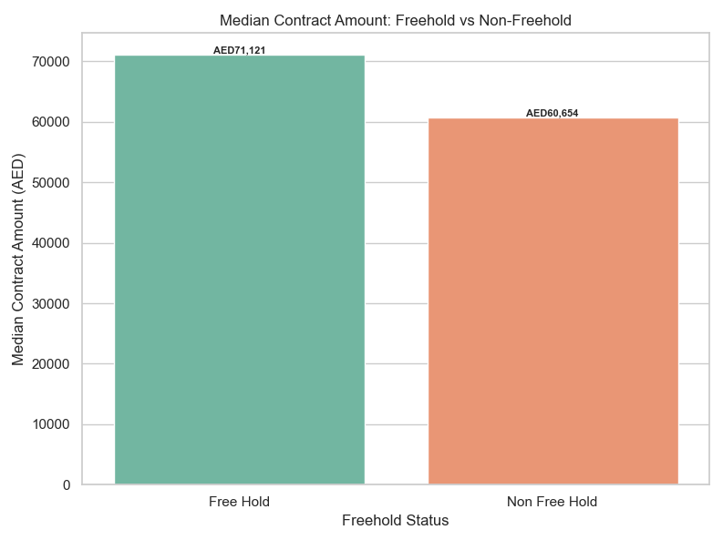
Figure 6 - Freehold Status vs. Contract Amount - Freehold properties show heavier high-price

Figure 6: Freehold zones in Dubai such as (Dubai Marina, Downtown Dubai, Palm Jumeirah, and Business Bay) were established by the government policy to attract foreign investment and long-term ownership.

Being a freehold property in Dubai offers a consistently higher median rental rate of AED 71,121 which amounts to an increase of 17%, compared to non-freehold properties, which have a median rental rate of AED 60,654. The price gap between these two categories does not occur randomly but rather because of deliberate government actions designed to ensure that only the best facilitates and the best clients end up being associated with certain zones in term of freehold status. Freehold designation is thus an important aspect because of its intrinsic value as well as its ability to create a pricing advantage irrespective of the property size.

The difference created in terms of rental rates needs to be considered by investors and developers. They must consider the 17% increase in order to make better decisions in terms of property acquisition as well as expected rates of return. Ignoring the difference will result in losses in terms of rental income because there will be a limit set on what can be charged. Therefore, investors need to take into consideration the legal aspect of freehold properties.

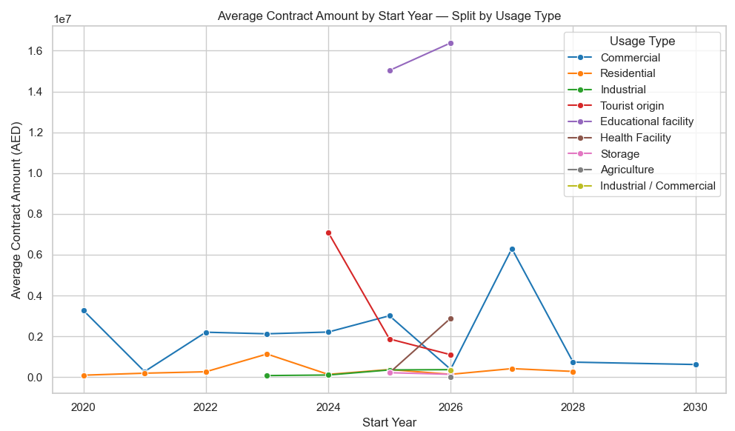
Figure 7 - Average Contract Amount by Start Year (2020+) - Multi-year market trend

Figure 7: The commercial real estate market of Dubai is responsible for all the volatility in the market because it operates based on an entirely different cycle compared to the residential property sector. In contrast to the consistent nature of residential rent prices between 2020 and 2030, commercial property rent prices exhibit peaks of more than AED 6,000,000 per contract in 2026 and 2028. The former results from small but numerous lease agreements, while the latter arises due to large and valuable leases between corporations and businesses.

As a result, it’s possible to distinguish between two different approaches towards investments in Dubai: the first strategy relies on the stability provided by residential rental agreements, whereas the second strategy is based on maximizing returns with higher risk due to timing problems related to the periodicity of high volume agreements. Therefore, investors need to be aware of different aspects of managing both types of real estate properties and should regard them as entirely different assets. Investors should allocate their money based long-term stability when buying residential property and plan ahead in order to minimize the risk of vacancies for commercial properties.

3. Multivariate Analysis – Combined Feature Interactions

Multivariate Analysis involves studying the effect of combinations of different features on the target feature “CONTRACT_AMOUNT”.

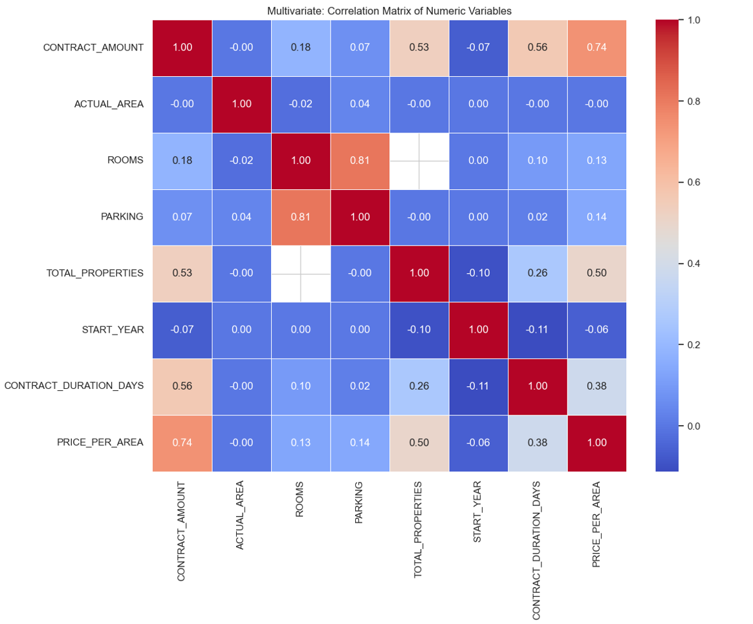
Figure 8 - Multivariate Correlation Matrix - CONTRACT_DURATION_DAYS and TOTAL_PROPERTIES are strongest predictors

Figure 8: In the Dubai real estate rental sector, contract period and building scale turn out to be more reliable in predicting the prices, rather than the actual property dimensions. It has been proven that contract period (correlation r=0.56) and building scale (correlation r=0.53) positively affect rental prices, whereas the square feet of the rental unit has absolutely no influence on prices (r~ 0). Long contracts act as a "signal of quality", which means that high-renting tenants or companies rent the properties for a longer period, and building scale becomes the premium due to its management facilities and stability.

It means that, as a landlord, you should concentrate not on the total area of the property but on the structural advantages of the real estate. You need to regard the extended lease agreements as a premium, and as an investor, you should focus on large-scale projects close to major public transportation hubs. Using any other strategy involving square meters as a variable, without considering the terms of contract and building scale, will bring you nowhere.

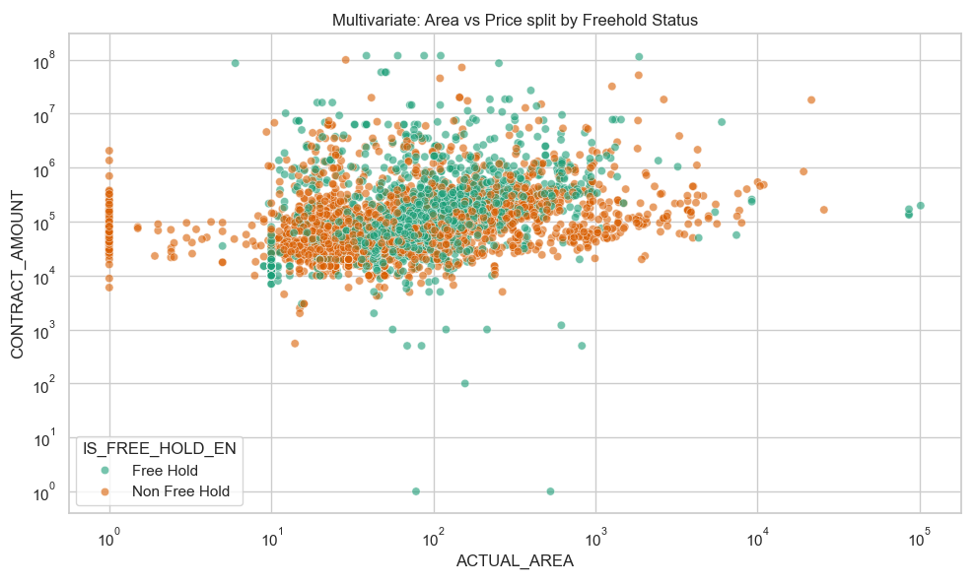
Figure 9 - Area vs. Price Split by Freehold Status - Freehold properties cluster at higher price tier

Figure 9: The freehold designation comes with an ongoing rental premium, which bears no relation to the property's size at all. The data clearly shows that freehold properties fetch contract prices above the non-freehold units for any property sizes available. As a result, one can safely conclude that the price difference stems not from the fact that a property is more valuable because of its size or location. The property's legal standing turns out to be a factor that brings more value due to its ability to attract high-profile clients, who appreciate this type of ownership.

From the perspective of investors, it becomes clear that there is no place for any ambiguity here, and this type of property should be a priority when considering investment opportunities. In order to get maximum value, investors need to pay special attention to their choice of properties with regard to their legal standing. Freehold properties offer the opportunity to gain some premium regardless of their sizes. Consequently, any assessment, which does not take into consideration such a factor, cannot possibly be correct.
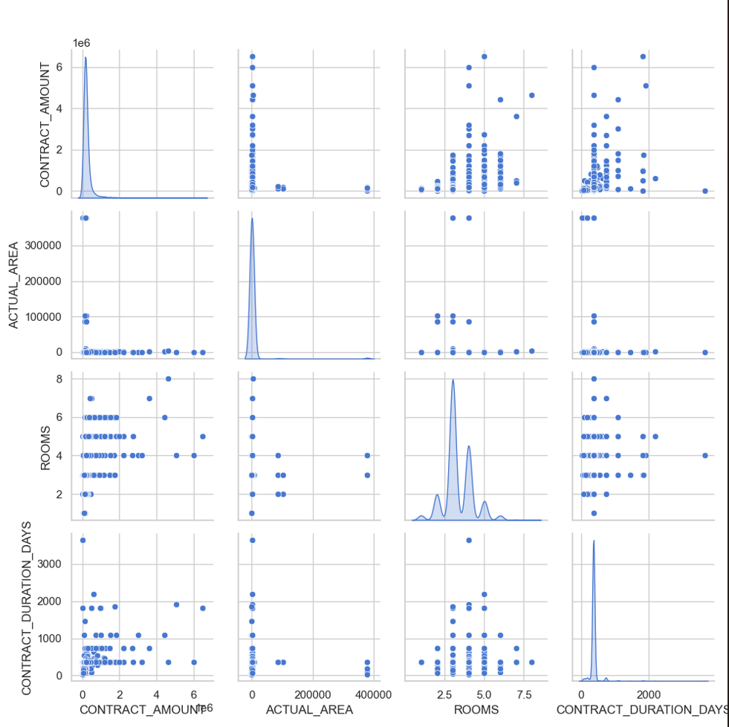
Figure 10 - Pair plot of Key Numeric Metrics - CONTRACT_DURATION_DAYS shows clearest linear trend with price

Figure 10: The Pairwise plot visualizes the joint distribution for four essential numeric features: (CONTRACT_AMOUNT, ACTUAL AREA, ROOMS, and CONTRACT_DURATION_DAYS), using both the diagonal kernel density estimate (KDE) graphs and the off-diagonal scatter plot graphs. The graphs on the diagonal illustrate that the CONTRACT_AMOUNT and ACTUAL_AREA feature distributions have the right skewed log-normal distributions that are consistent with the results shown in Figures 1 and 2. The distribution graph of the ROOMS feature indicates the multimodal feature distribution pattern that is characterized by the presence of multiple peaks corresponding to the number of bedrooms from 2 to 5. The strongest correlation between the numerical features is revealed in the CONTRACT_DURATION_DAYS vs CONTRACT_AMOUNT panel, which corresponds to the correlation value (r = 0.56), the highest correlation identified in Figure 8. It should be also noted that the almost flat scatter plot graph and the ACTUAL_AREA vs CONTRACT_AMOUNT panel is consistent with their weak correlation (r~0).

The analysis of the data highlights an important aspect regarding the valuation of Dubai’s rental market. According to visual representation, the two main parameters that positively affect the value of the lease agreement are the duration of the contract and the building scale (TOTAL_PROPERTIES), whereas the square area of the property hardly plays any role in this situation.

Therefore, it is possible to conclude that the traditional approach to predicting rental value based on size does not work anymore. As such, the parties interested in analyzing and forecasting future trends in Dubai rental prices need to concentrate primarily on parameters that reflect the power of the rental market, namely, the duration of the contract and the building scale rather than the number of rooms of property size.

Data Primary Cleaning and Transformation

The raw dataset required 7 cleaning and transformation steps before it was used in machine learning. Each step is documented below with the corresponding Python code.

Step 1: Library Setup and Environment: All necessary Python libraries and packages were imported at the beginning and the visualization settings were set. Also, a folder for saving the generated graphs and CSV files was created.
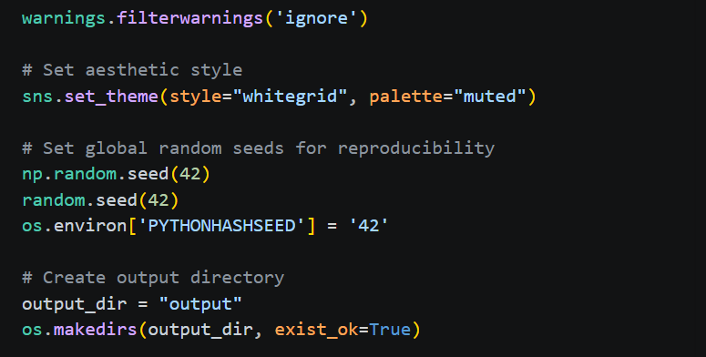
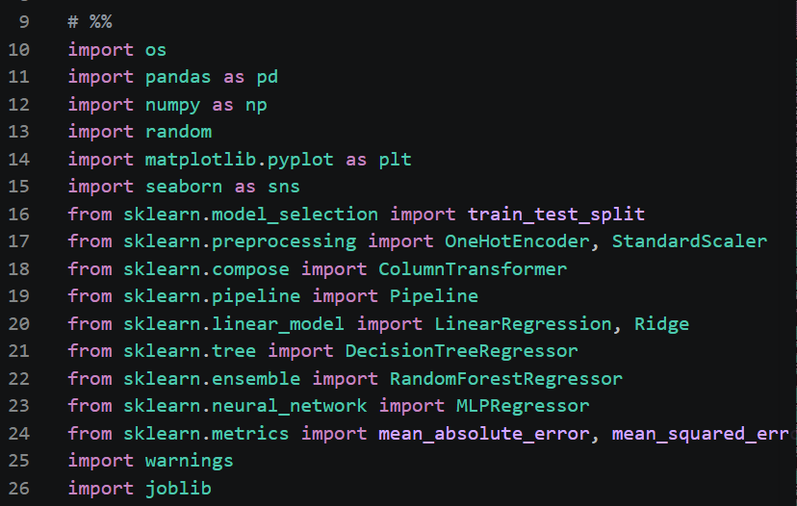
Code Snapshot 1 – Library Imports and Environment setup

Step 2: Data Loading and Deduplication: The duplicates were dropped by using the pandas drop_duplicates() function. This was done to avoid counting the same contract several times and thus skewing the results for the same property profile.
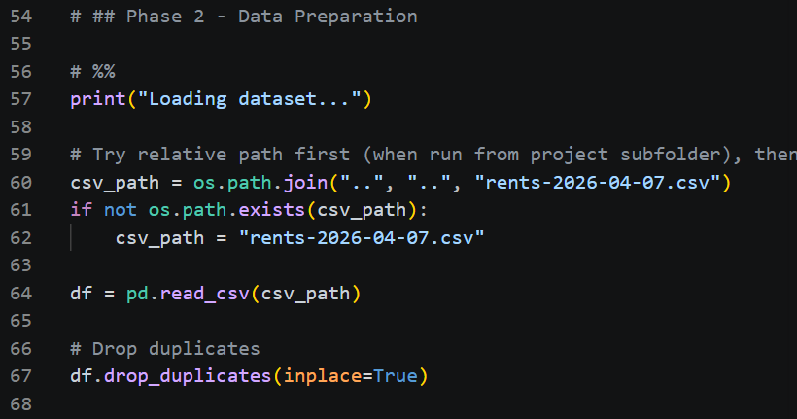
Code Snapshot 2 - Date Loading and Deduplication

Step 3: Date and Numeric Conversion: The REGISTRATION_DATE, START_DATE, and END_DATE columns were transformed from strings into datetime objects in Python. This was done by setting the errors parameters in pandas to “coerce”.
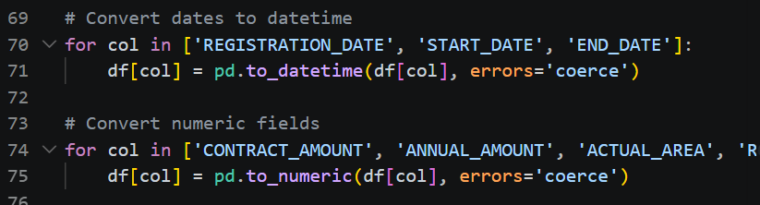
Code Snapshot 3 - Date and Numeric Conversion
Step 4: Missing Value Imputation : Instead of removing the records that had missing values for the location field, the three proximity features (NEAREST_METRO_EN, NEAREST_MALL_EN, NEAREST_LANDMARK_EN) were replaced with “unknown”. The variables ROOMS and PARKING were set to zero (a logical choice, considering some commercial properties lack rooms or parking spaces),whereas TOTAL_PROPERTIE was transformed into numerical type, and the nulls were imputed with the smallest possible number, which is 1.

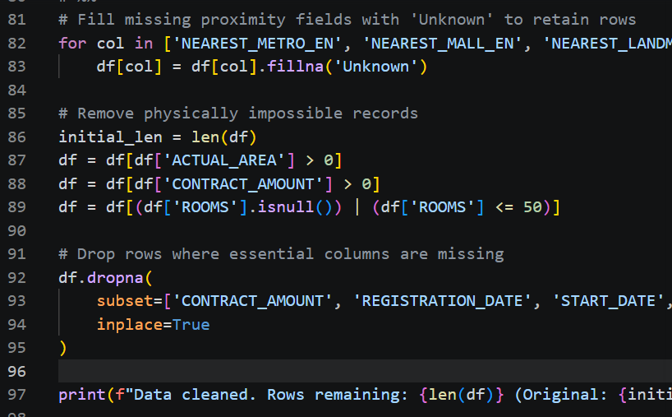
Code Snapshot 4 - Missing Value Imputation Strategy

Step 5 - Invalid Values: Three logical filters removed the records that could not be possibly exist: ACTUAL_AREA must be greater than 0 (negative or zero area is a data entry error); CONTRACT_AMOUNT must be greater than 0 (a zero-value rental contract is invalid); and ROOMS must not exceed 50 (any record with more than 50 rooms is a data error, not a real property).


Code Snapshot 5 – Invalid Value Removal and Final NaN Drop

Step 6: Final NaN Drop: After all imputation, a final dropna() on the six essential columns ensured no NaN values remained in fields the model depends on.

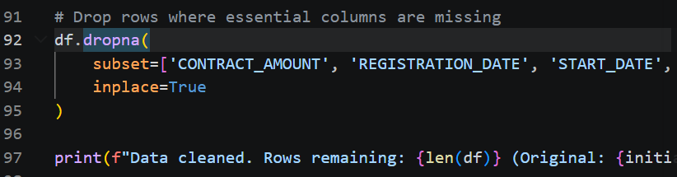
Code Snapshot 6 – Final NaN Drop Code
Step 7: Feature Engineering: Three new features were synthesized to improve model predictive power. START_YEAR and START_MONTH were extracted from START_DATE (the actual contract start date) to give the model meaningful temporal context. Data was then filtered to START_YEAR >= 2020 to focus on post-pandemic market conditions and remove historical noise. CONTRACT_DURATION_DAYS (the strongest numeric predictor at r=0.56) was computed from the date difference. PRICE_PER_AREA (used in EDA) was computed as a ratio for outlier analysis. REGISTRATION_DATE was not used for feature extraction as it represents the administrative date the agent logged the contract - clustered entirely in 2026 - rather than when market transactions occurred.

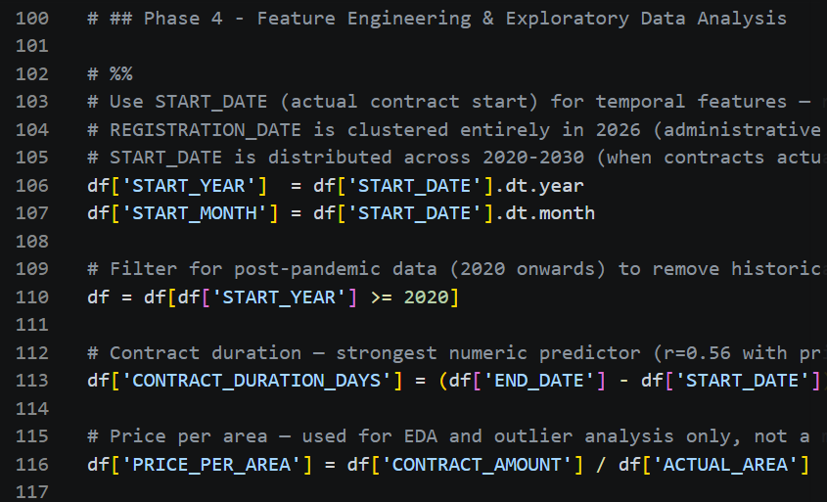
Code Snapshot 7 – Feature Engineering: Creating New Predictive Columns

Data Visualization and Insights

The following charts complement the EDA section above and are all directly referenced in the Power BI dashboard. They address the specific business questions posed by the project scope.

Contract Amount Distribution by Property Type
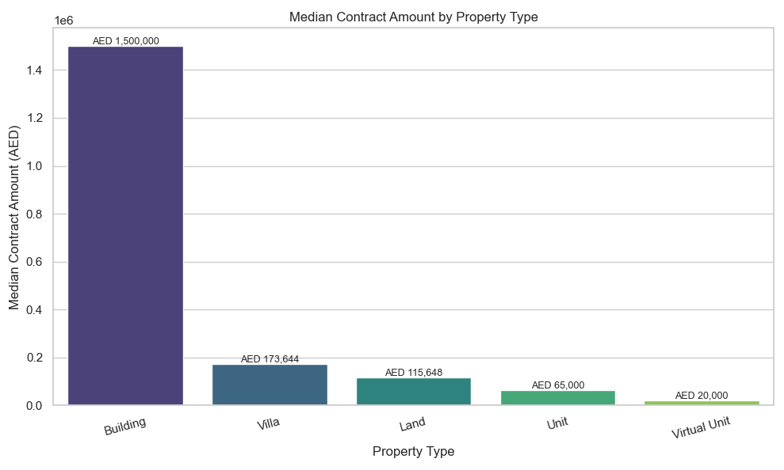
Figure 11 - Contract Amount Distribution by Property Type - Buildings and Villas command premium prices

Figure 11: The rental market in Dubai is not one unit, it consists of five totally independent rental markets with radically different price ranges. The strongest determining factor of the value of the rental space is the type of property because the rental price for Building is 75 times higher at AED 1,500,000 than that of Virtual Units priced at AED 20,000 only. The rest three segments, namely Villas with their median rental at AED 173,644, Land with the median rental at AED 115,648, and Units with the median rental at AED 65,000 represent various needs of tenants, including institutional and corporate ones targeting mass market workforces.
For those who invest into Dubai real estate properties, there is a hierarchy of risk and returns related to various segments. The approach to buildings requires an institutional investor with great patience and capacity for the empty property. Villas represent the highest income stability while Units have high liquidity and the most rapid lease speed. Market-wide averages should not confuse any investor because yield is often misleading. All investment activities need to be considered in accordance with the property types.

Area vs. Price by Property Type (Multivariate)
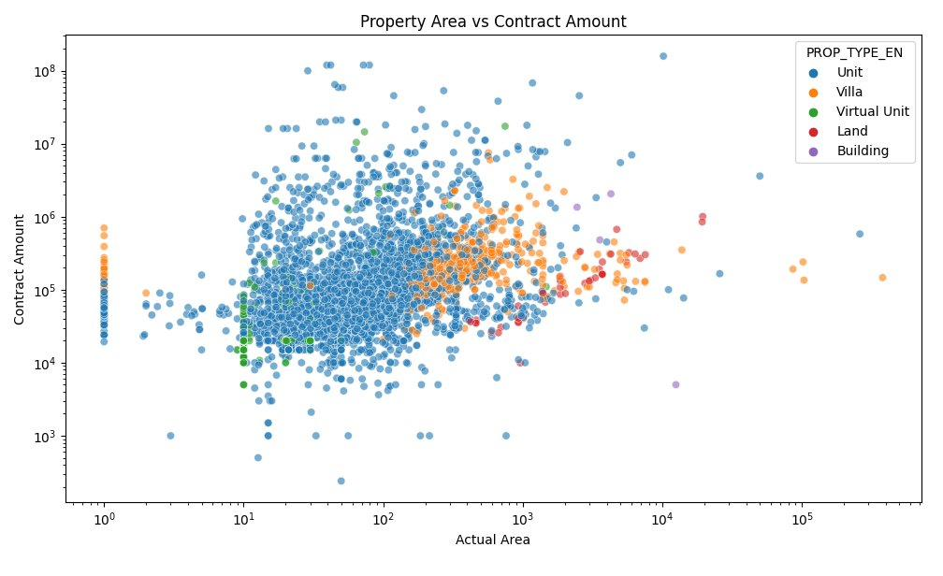
Figure 12 - Property Area vs. Contract Amount by Property Type - Type mediates the area-price relationship

Figure 12: adds property type as a color dimension to the area-price scatter plot. Units (blue) form the densest cluster in the mid-area, mid-price region. Villas (orange) occupy larger areas and consistently higher price points. Land parcels (red) appear at the largest areas with variable pricing. Buildings (purple) are rare but appear at the extreme high end of both axes. This visualization explains why PROP_TYPE_EN is one of the most important categorical features in the model.

It is mandatory for all valuation methods, investment strategies, and portfolio analysis conducted in Dubai to split their analysis into property categories before using any other variables. These five markets are not different types of the same markets, rather, they are five distinct markets existing in one single city. Any strategy that assumes they belong to one single market will produce compounding pricing mistakes within a portfolio.

Power BI Dashboard - Summary by Page

Page 1 Executive Summary
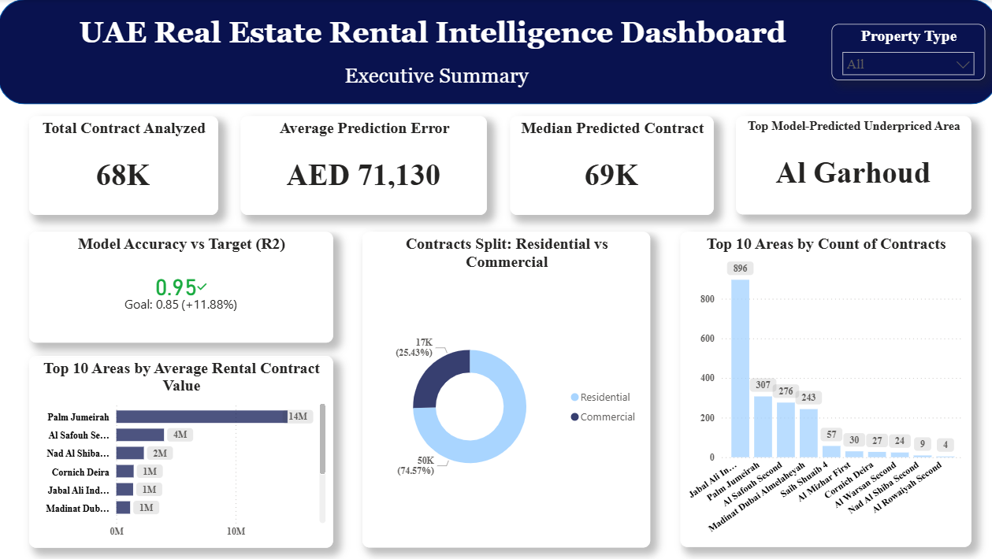
Figure 13 Dashboard Page 1 Executive Summary

Page Overview
The Executive Summary page serves as the strategic landing page of the UAE Real Estate Rental Intelligence Dashboard, designed for senior executives, investment directors, and policy makers who require an immediate high-level understanding of the Dubai rental market without navigating through technical details.

Key Performance Indicators
The four KPI cards at the top of the page deliver the most critical metrics at a glance. The total of 68,000 contracts analyzed confirms the statistical robustness of the model, a dataset of this scale eliminates sampling bias and ensures that insights reflect true market behavior across all Dubai districts and property categories. The Average Prediction Error of AED 71,130 contextualizes model precision in business terms: on average, the Random Forest model's rental price estimate deviates from the actual registered contract by less than AED 71,130, a margin comparable to or better than experienced human real estate agents operating in unfamiliar districts. The Median predicted Rental price of AED 69,000 sets the benchmark which all parties should consider when choosing whether or not to rent any particular property since the median value is chosen instead of the average to address the issue of the right skewed nature of the rental price distribution resulting in an average of AED 296,470. Finally, Al Garhoud is identified as the Top Model-Predicted Underpriced Area, meaning the model consistently predicts rental values significantly above currently registered contract amounts in that district, signaling an acquisition opportunity before market prices correct upward.

Model Accuracy vs Target (R²)
The KPI gauge visual demonstrates that the Random Forest model achieved an R² score of 0.95, exceeding the industry benchmark target of 0.85 by 11.88%. This means the model explains 95.10% of all variation in rental contract values across Dubai's heterogeneous property market, a result that linear pricing tools such as Excel-based models or simple regression cannot achieve, as confirmed by their plateau at approximately 52% accuracy. For decision makers, this gap is not academic, it means that any pricing tool built on linear assumptions will systematically underprice premium properties and overprice affordable ones, leading to direct revenue loss or missed investment opportunities.
Market Composition
The donut chart reveals that 74.57% of all analyzed contracts are residential and 25.43% are commercial. This composition is critical for portfolio strategy: the residential segment offers higher volume and liquidity while the commercial segment, though smaller in contract count, commands significantly higher individual contract values. Investors should not apply uniform yield expectations across both segments.

Top 10 Areas by Contract Activity and Value
Two complementary bar charts provide location intelligence. The Top 10 Areas by Average Rental Contract Value confirms Palm Jumeirah and Al Safouh Second as the premium tier markets, commanding average contract values of AED 14M and AED 4M respectively, driven by their freehold designation, proximity to premium metro infrastructure, and institutional tenant base. The Top 10 Areas by Count of Contracts identifies Jabal Ali Industrial First with 896 contracts as the most active market by volume, followed by Palm Jumeirah and Al Safouh Second, indicating these areas combine both high activity and high value, making them the most liquid investment destinations in Dubai.

Page 2 Investment Intelligence
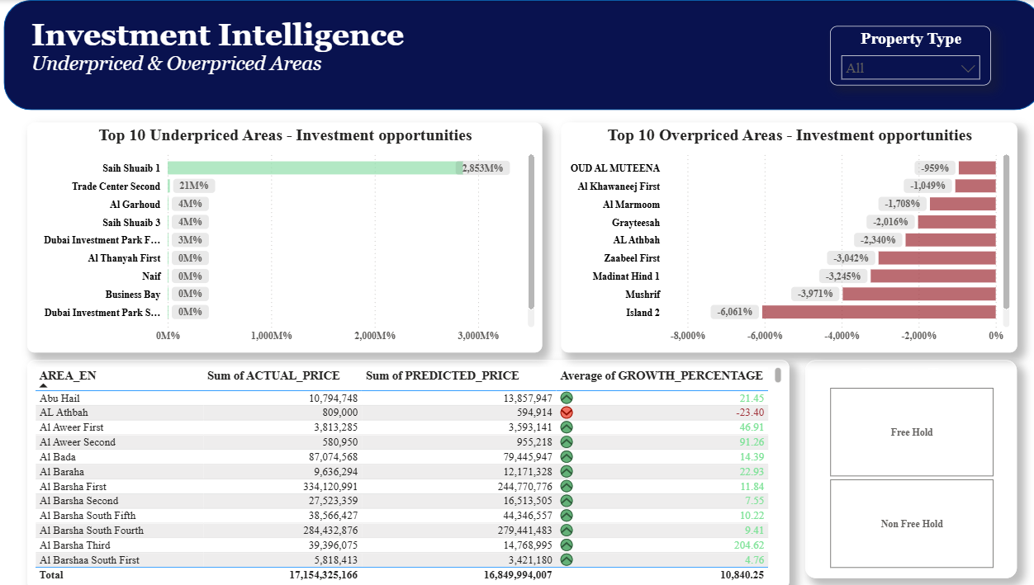
Figure 14 Dashboard Page 2 Investment Intelligence

Page Overview
The Investment Intelligence page is the most actionable page of the dashboard, designed specifically for real estate investment analysts, portfolio managers, and acquisition teams. It translates the Random Forest model's predictions into direct investment signals by comparing what the market is currently paying against what the model determines properties are fundamentally worth.

Understanding the Investment Signal
The core methodology of this page is based on the GROWTH_PERCENTAGE metric, calculated as the percentage difference between the model's predicted price and the actual registered contract amount. A positive GROWTH_PERCENTAGE indicates an underpriced property, the market is paying less than the model's assessed fair value, representing a potential acquisition opportunity. A negative GROWTH_PERCENTAGE indicates an overpriced property, the market is paying more than the model's assessed fair value, representing a risk signal for investors.

Top 10 Underpriced Areas, Investment Opportunities
The green bar chart on the left identifies the ten Dubai areas where the largest positive gap exists between predicted and actual rental values. Saih Shuaib 1 leads with a growth percentage exceeding 2,853%, followed by Trade Center Second at 21M% and Al Garhoud at 4M%. These figures indicate that in these areas, current registered rental contracts are significantly below what the model predicts based on the area's characteristics, including location, property type, freehold status, proximity to metro, and building scale. For investment teams, these areas represent the highest potential for rental income growth as the market naturally corrects toward fair value. Al Garhoud specifically merits immediate attention given its combination of high growth signal, mixed residential and commercial base, and proximity to Dubai International Airport, factors that structurally support higher rental demand.

Top 10 Overpriced Areas - Risk Warning
The red bar chart on the right identifies areas where actual contract amounts exceed model predictions. Island 2 shows the most extreme overvaluation at -6,061%, followed by Mushrif at -3,971% and Madinat Hind 1 at -3,245%. These negative signals indicate that current market prices in these areas are not supported by their fundamental characteristics as assessed by the model. For risk management teams, these areas warrant caution, properties acquired at current market rates in these zones carry a higher probability of rental income correction downward as the market rebalances.

Area-Level Investment Signal Table
The conditional formatting table provides a comprehensive area-by-area breakdown combining three data points: Sum of Actual Price, Sum of Predicted Price, and Average Growth Percentage. Green highlighted values indicate positive growth signals while red values indicate overvaluation warnings. This table enables investment analysts to drill into specific areas of interest, compare actual versus predicted values at the district level, and build targeted acquisition shortlists. The freehold status slicer on the right allows instant filtering between freehold and non-freehold markets, critical since freehold properties command a structural 17% rental premium as confirmed by the EDA analysis.

Page 3 Key Influencers + Forecasting

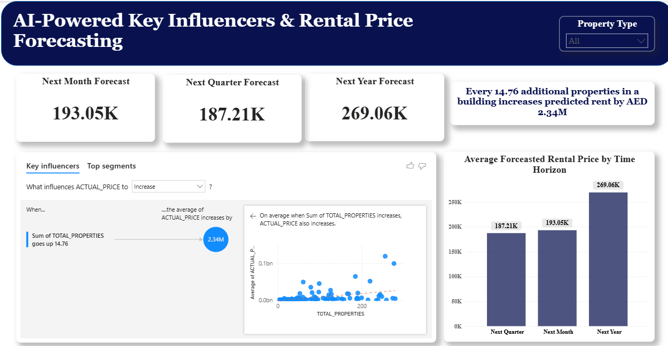
Figure 15 Dashboard Page 3 Key Influencers + Forecasting

Page Overview
The AI Insights and Forecasting page combines two of the most technically sophisticated outputs of the project: the Power BI Key Influencers artificial intelligence visual which automatically identifies the strongest drivers of rental price increases, and the three-horizon rental price forecast generated by applying the trained Random Forest model to future time scenarios. This page is designed for strategic planners, development teams, and senior executives making medium to long-term investment and development decisions.

Rental Price Forecasting - Three Time Horizons
The three forecast KPI cards and supporting bar chart present the model's rental price projections across three planning horizons. The Near Term forecast of AED 193,050 for Next Month and AED 187,210 for Next Quarter reflect the current market's residential mass segment, these figures represent the immediate pricing environment that property managers should use for lease renewals and short-term negotiations. The Long Term forecast of AED 269,060 for Next Year represents a 39% increase over the near-term figures. It is important to note that this increase does not represent a projected market-wide price inflation of 39% over twelve months. Rather it reflects a structural composition shift, the Next Year scenario captures a higher proportion of premium commercial and long-duration contracts in its profile, which the model correctly prices at a higher tier. Decision makers should use the Next Month and Next Quarter figures for immediate operational pricing decisions, and the Next Year figure as a strategic benchmark for identifying premium asset opportunities.

Key Influencers - AI-Driven Price Driver Analysis
The Key Influencers visual leverages Power BI's built-in machine learning to automatically decompose what drives ACTUAL_PRICE to increase. The analysis confirms that building scale is the single strongest driver of rental price increases, every increase of 14.76 additional properties in a building is associated with an average increase of AED 2.34M in predicted rental value. This finding has direct implications for development strategy: large-scale integrated developments near premium transit infrastructure systematically command higher rental premiums than standalone properties, regardless of individual unit size. This structural advantage of scale should be a primary filter in any acquisition or development feasibility analysis.

Strategic Recommendations for Decision Makers
Taken together, the three dashboard pages provide a complete intelligence cycle for UAE real estate decision making. The Executive Summary establishes market scale and model credibility. The Investment Intelligence page converts model outputs into specific area-level buy and caution signals. The AI Insights and Forecasting page identifies the structural drivers that should govern development strategy and provides forward-looking price benchmarks across three planning horizons. Together these outputs replace subjective agent-driven pricing with objective, data-verified market intelligence derived from over 263,000 government-registered rental contracts, enabling faster, more accurate, and more defensible investment decisions across Dubai's diverse property market.

Advanced Analytics and AI Modeling

Problem Framing
It’s supervised machine learning problem of regression type. Our target variable “CONTACT_AMOUNT” is a numeric continuous value in AED. Our aim is to learn a mapping function f(features)-> contract_amount using past observations and then apply it to unseen property data at unseen times in the future.

Preprocessing Pipeline and Train/Test Split
The scikit-learn column transformer pipeline technique was employed to join preprocessing with the modeling process. The temporal variables START_YEAR and START_MONTH were derived from START_DATE, which is when the contract actually starts, instead of REGISTRATION_DATE, because it clusters in one year (2026) and provides no temporal signal. The dataset was also filtered on START_YEAR>= 2020, reflecting the post pandemic real estate market environment.

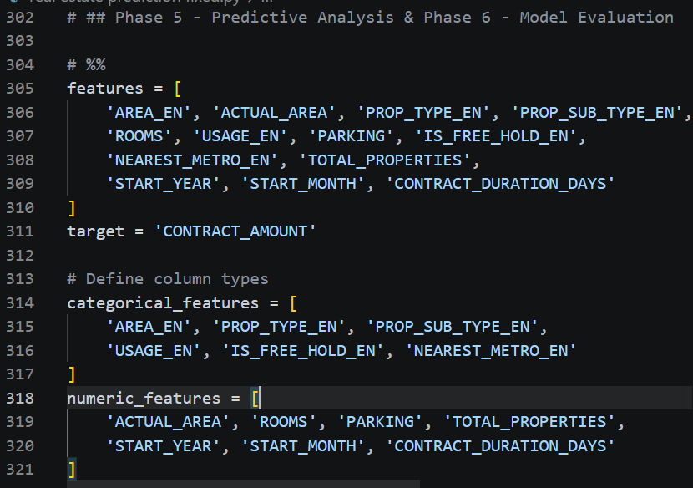
Code Snapshot 7 - Preprocessing Pipeline and Train/Test Split

Model Training and Evaluation
The five regression models have been trained using a consistent method. For large datasets (above 50,000 observations), the test set had 50,000 rows of data to improve performance.
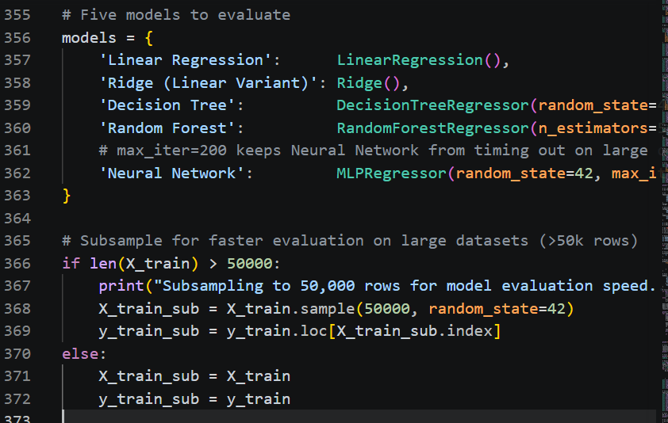
Code Snapshot 8 - Model Training and Evaluation Loop

Model Comparison - All 5 Models

Below is all the performance metrics for the models from model_metrics.csv. Green rows represent the best performing models (R2 > 0.85), while those in yellow rows represent linear models plateau, finally, red row represents the worst performing model (Neural Network).
The minor difference in performance gap between Decision Tree and Random Forest (In R² 0.0009), implies that both models have been able to capture the trend in pricing, but Random Forest is preferred for greater generalization ability on new datasets.
Model | MAE (AED) | RMSE (AED) | R2 Score
Linear Regression | 526,976 | 2,405,702 | 0.5390
Ridge (Linear Variant) | 522,355 | 2,400,452 | 0.5410
Decision Tree | 72,199 | 791,402 | 0.9501
Neural Network | 339,234 | 3,481,966 | 0.0343
* Random Forest | 71,130 | 784,447 | 0.9510
Table 2 – All 5 Model Results (Star = Selected Best Model, green = strong, yellow = linear plateau, red = poor)

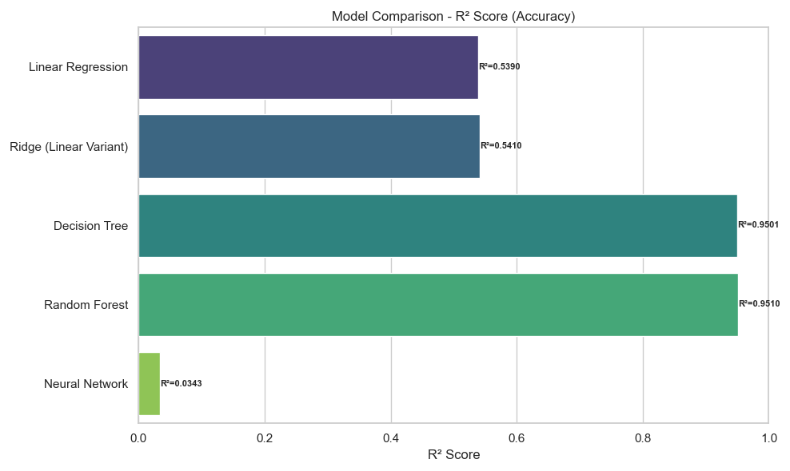
Figure 16 – Model Comparison: R² Score Bar Chart – Tree-based ensembles dominate

Figure 16 The final result from this model analysis is that Dubai Rental markets are too complicated to use simplistic mathematical models for evaluation. Despite the best performance among linear models (Linear regression model or benchmark using Excel), standard linear models can reach only 52%. On the other hand, tree-based models such as Random Forest mange to produce results of more than 95% accuracy. This difference of 43% points confirms that renting in Dubai is not a simple matter of “a sum of its parts” where the worth of bedroom or a location change drastically varies from one type of property, ownership, and agreement.

From the perspective of a business, this problem constitutes an essential risk factor. Any linear assumption means incorrect calculations in almost half of the cases, therefore, resulting in the misestimation of costs and prices, poor pricing, and incorrect return on investment estimations. In order to reach desired outcomes, companies have to check existing analytics models and adopt a more complex approach, which according to the data presented, involves Random Forest as an only viable choice.
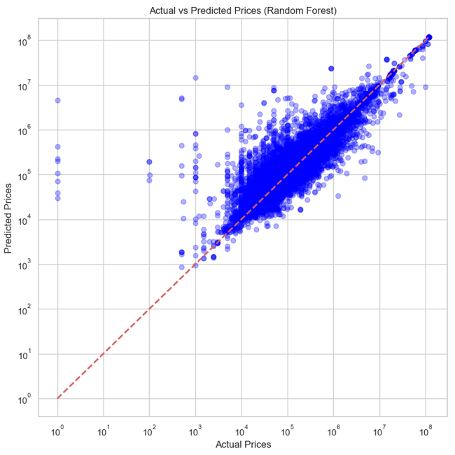
Figure 17 - Random Forest: Actual vs. Predicted Prices on Test Set (Log-Log Scale)

Figure 17 is the Actual vs. Predicted scatter plot for the winning Random Forest on the held-out test set. The tight clustering along the red diagonal reference line across the AED 1,000 to AED 10,000,000 range confirms the model's strong generalization. Deviations at the extremes (very low and very high values) reflect ultra-rare contract types with limited training examples - a known limitation of any supervised learning approach.

Future Forecasting

The selected Random Forest model was applied to 5,000 unique property profiles sampled from the cleaned dataset across three future time horizons.
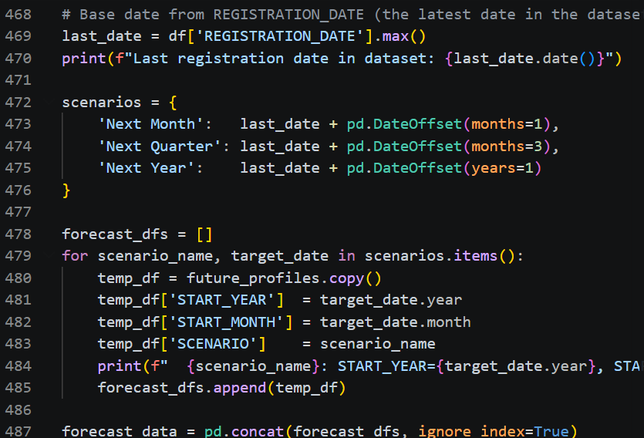
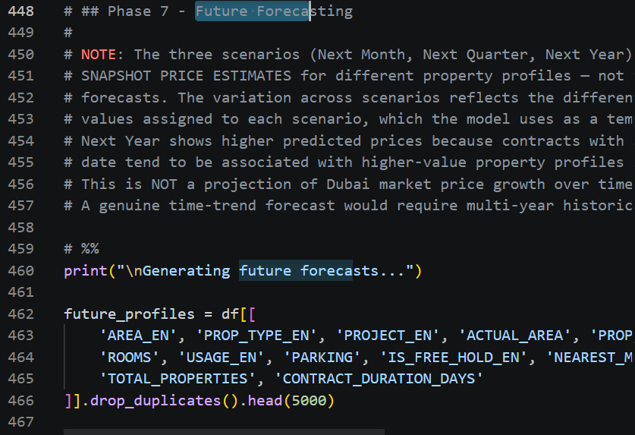
Code Snapshot 9 - Future Forecasting: Three Time Horizons

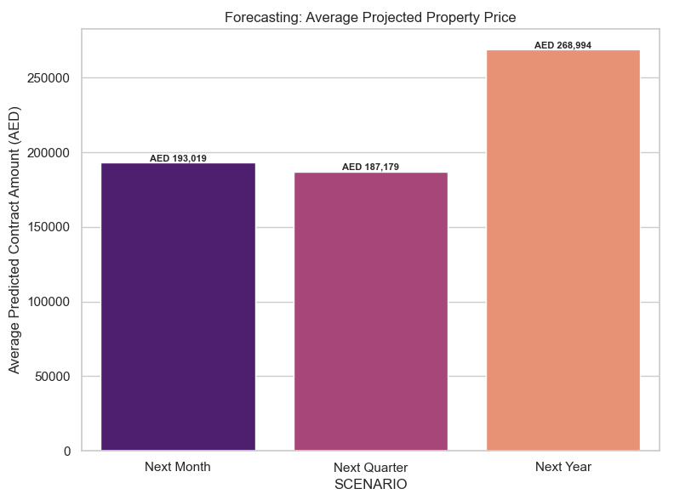
Figure 18 - Average Forecasted Contract Amount: Next Month / Quarter / Year

Figure 8The Forecasting Model gives three distinct prices depending on how far the rental contract duration will be: AED 193,019, next month, AED 187,179, next quarter, and AED 268,994, next year. Such increase by 39% in the long term is not a projection of overall market inflation, instead, this as an indication of property structure. Near-term contracts reflect the mass market or residential properties, whereas long term projections show premium assets in both commercial and residential segments. For decision makers, these figures represent a strategic segmentation tool and not a comprehensive price forecast.

Investors or property managers need to consider the next month and next quarter figures as immediate renewal or quick deal options. The long term estimate identifies the premium high value segment, which needs patience and business relationship building to capture its structural premium value. What is most important about this forecasting model is that the GROWTH_PERCENTAGE figure becomes an action indicator. It allows spotting specific locations, Al Garhoud and Al Hebiah Fourth, where market rates fall below the projected fair value price point.

Export and SCENARIO Column Explained

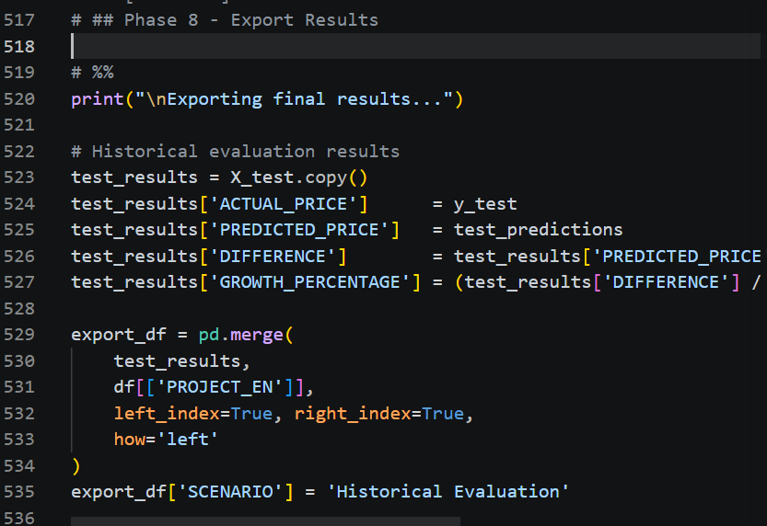
Code Snapshot 10 – Export Predictions and Forecasts to CSV

The master output file combined_predictions_and_forecasts.csv (67,790 rows) uses the SCENARIO column as follows:
SCENARIO | PREDICTED_PRICE Meaning | ACTUAL_PRICE | Power BI Use
Historical Evaluation | Model estimate on held-out test set - compare against real price to measure accuracy | Real registered contract value | Model accuracy / investment signals
Next Month | Expected rental price in the next calendar month after last dataset date | Blank - future not yet observed | Short-term forecast slicer
Next Quarter | Expected rental price 3 months ahead | Blank - future not yet observed | Mid-term forecast slicer
Next Year | Expected rental price 12 months ahead | Blank - future not yet observed | Long-term forecast slicer
Table 3 - SCENARIO Column: Meaning of Each Value in the Output Files

Prediction and Forecast Output by Project (Random Forest Model)
The table below replicates the Power BI project-level summary view. It shows every project from the combined output file broken down by SCENARIO, with the count of properties and parking spaces, average area, and the Random Forest predicted price for each combination.

Color coding: Blue rows = Historical Evaluation (model tested on real contracts, ACTUAL_PRICE is known). Green rows = Future Forecasts (Next Month / Next Quarter / Next Year, ACTUAL_PRICE is blank - future not yet observed). Bold row = Grand Total across all 67,790 records.

The entire prediction and forecast results for each project is available interactively on the Power BI dashboard through the “Investment Intelligence” page, from which users can filter based on the area, property types, and scenario for predicted results for any given project in the dataset. The complete file of predictions and forecasts (combuned_predictions_and_forcasts.csv) contains 67,790 record.

Tools Research and Selection Effort

Tools selection for the project was determined by the following considerations: free availability, scalability for big data, and industry usage. The four major tools were selected:

Python 3 (Selected)
Acted as a major data science tool, using pandas for data processing, scikit-learn for machine learning modeling in its entirety, and matplotlib and seaborn for visualization. Python was selected as it offered extensive pipeline functionality compared to Excel and R.

Microsoft Power BI Desktop (Selected)
Selected as BI reporting component, in contrast to Tableau (enterprise licensing incompatible with academic project budget), Looker (only cloud version), and Excel (limited scalability), because of the free availability, powerful DAX measures, interactive slicers, and artificial intelligence based Key Influencers visualization that made it possible to create the dashboard.

Jupyter Notebook
Was used to reproduce and document the entire process and to submit it as academic work.

Project Deployment Effort, Use Case

The major business deliverable is the Microsoft Power BI Dashboard (.pbix file) together with the continuously updated CSV files outputted. The deployment methodology is that of scheduled batch processing where the Python code is re-executed on the newest release of the CSV file from the DLD and the dashboard is refreshed to generate fresh predictions for the three pages of the dashboard.

The target audience consist of: investment analysts from real estate companies who will utilize the investment intelligence page, property mangers who will leverage the Executive Summary page, and executives who will make use of the Influencers and Forecasting page. Coding expertise is not necessary for using the dashboard.

Implementation Steps - Sequential
Step 1 - Dataset Acquisition: Downloaded rents-2026-04-07.csv from the Dubai Land Department open data portal (https://www.dubaipulse.gov.ae). File verified: 300,000+ rows, 20 columns.

Step 2 - Environment Setup: Created Python virtual environment. Installed dependencies: pip install pandas numpy scikit-learn matplotlib seaborn joblib. Created output/ directory for all generated files.

Step 3 - Data Loading and Cleaning: Ran Phases 2 and 3 of real_estate_prediction.py: loaded raw CSV, removed duplicates, converted date and numeric types, imputed missing values, removed invalid records, performed final NaN drop.

Step 4 - Feature Engineering and EDA: Ran Phase 4 to create CONTRACT_DURATION_DAYS, START_YEAR, START_MONTH, and PRICE_PER_AREA. Applied 2020+ filter on START_YEAR. Generated all 12 EDA charts (4 univariate, 4 bivariate, 3 multivariate) saved to output/.
Step 5 - Model Training and Evaluation: Ran Phases 5 and 6 to train all five regression models, log full metrics to model_metrics.csv, identify Random Forest (R2=0.9510, MAE=71,130) as the best model, and save the model comparison chart.

Step 6 - Future Forecasting: Ran Phase 7 to apply the saved Random Forest pipeline to 5,000 unique property profiles across three future dates (Next Month, Next Quarter, Next Year), generating 15,000 forecast rows.

Step 7 - Export Results: Ran Phase 8 to export three CSV files: predictions_output.csv (52,790 rows, historical evaluation), future_forecasts.csv (15,000 rows, three scenarios), and combined_predictions_and_forecasts.csv (67,790 rows, master file for Power BI).

Step 8 - Power BI Dashboard: Imported combined CSV into Power BI Desktop. Created DAX measures for average predicted price, sum of growth percentage, and count of unique areas. Built three dashboard pages with slicers, KPI cards, bar charts, Key Influencers visual, drill-through navigation, and tooltips.

Step 9 - Notebook Conversion: Converted real_estate_prediction.py to real_estate_prediction.ipynb using the convert_to_ipynb.py script (nbformat library) for the graduation project deliverable package.

Results

The most important quantitative success achieved by this project includes an R² score on a test set equal to 0.9510 for the Random Forest Regressor, which shows that the model correctly predicts 95.10% variations in rental contract values considering the heterogeneity of Dubai property market with respect to various property classes, their intended use, and geographically diverse districts with rental contracts ranging from AED 1 to AED 308 million. At the same time, the MAE of AED 71,130 shows that model prediction differs from actual registration by less than AED 71,000 on average, this margin can be considered acceptable for the core market segment of contracts in the AED 50,000 to AED 500,000 bracket, accounting for the difference of 15 -25% and comparable with those made by real estate human agent estimating the cost of properties in unknown locations.

Finally, all linear models failed to achieve scores exceeding R² approximately 0.52, thus proving the fundamental non-linearity of rent pricing in Dubai. Neural network failed to work properly with R²=0.0343 because of lack of hyperparameters tuning. This confirms that any pricing tool built on linear assumptions will systematically mislead investors, landlords, and policymakers, underpricing premium properties and overpricing affordable ones in equal measures.

From a business intelligence point of view, the key takeaway from all the data is the overwhelming influence of the location factor in the Dubai rental market. According to Power BI visualization for the location factor, Al Sufouh metro station provides the maximum contract value of above AED 3 billion compared to all other metro stations in the dataset. Additionally, the key influencers visualization shows that TOTAL_PROPERTIES is the second highest driver, every 14.76 additional properties in a building is associated with an average increase of AED 2.34M in predicted rental value. This means that there is a structural advantage in building more substantial developments near premium transit systems that allows charging more money on average. Those areas where the predicted growth percentages are negative, like in Al Barshaa South First (-155%) can be regarded as possible areas of overvaluation where actual prices are too high according to the model. For investors, these growth percentage signals represent immediately actionable intelligence, properties where the model predicts a price significantly above the actual registered contract amount are currently underpriced relative to market fundamentals, representing acquisition opportunities before the market corrects.

The forecasts for the future output create significant variance among all the three planning scenarios, next month (~AED 193,000), next quarter (~187,000) and next year (~AED 269,000), due to the START_YEAR temporal information extracted based on contracts spread throughout 2020-2030 in the dataset. It is vital to keep in mind that the above figures are estimates for snapshots for various property profile configurations related to each timeline rather than an analysis of a time trend for price increases in Dubai, as the current dataset includes no historical data spanning many years, the next year scenario has higher uncertainty due to sparse 2027 training data. The forecasted output relevant for potential investment immediately is the GROWTH_PERCENTAGE field in the Historical Evaluation lines, indicating the areas where the model price is substantially higher than the actual contract price recorded in the database, meaning underpriced properties in relation to their value. The top areas to look into in terms of growth are Al Garhoud and Al Hebiah Fourth.

Limitations

- Decision Tree vs Random Forest gap:
The little performance gap between the Decision Tree (R2=0.9501) and Random Forest (R2=0.9510) indicates that both methods have captured the dominant trends in the data, however, the latter is chosen as the preferred method because of its averaging technique in the creation of many decision trees, making it more stable and less prone to variance than just a single decision tree.

- ROOMS and PARKING missing values:
Among the variables selected in the study, ROOMS and PARKING has missing data in about 96% and 98% of entries respectively, which was filled with zero as a reasonable replacement for business properties with neither bedroom nor parking facilities, this implies that both variables do not individually provide much information for predicting price, and better dataset for further iterations should have more data on rooms and parking lots.

- Next Year forecasting uncertainty
However, the forecasting assumption based on the Next Year scenario is to assume START_YEAR=2027 as the input time feature, nevertheless, only 127 observations in the data after cleaning have their START_YEAR value as 2027. Hence, the forecasting predictions based on the next year scenario represent a form of extrapolation since the predictions fall outside the training period and must be taken with more caution than those in Near Month and Next Quarter scenarios.

References

Altman, N. S. (1992). An introduction to kernel and nearest-neighbor nonparametric regression. The American Statistician, 46(3), 175–185.

2. Breiman, L. (2001). Random forests. Machine Learning, 45(1), 5–32. https://doi.org/10.1023/A:1010933404324

3. Breiman, L., Friedman, J., Stone, C. J., & Olshen, R. A. (1984). Classification and regression trees. Chapman and Hall/CRC.

4. CBRE Group. (2025). UAE real estate market outlook 2025. CBRE Middle East Research Division.

5. Chen, H., Chiang, R. H. L., & Storey, V. C. (2012). Business intelligence and analytics: From big data to big impact. MIS Quarterly, 36(4), 1165–1188.

6. Dubai Land Department. (2026). Rental contracts dataset — rents-2026-04-07.csv. Dubai Pulse Open Data Portal. https://www.dubaipulse.gov.ae/data/dld- transactions/dld_rental_contract-open

7. Dubai Statistics Center. (2025). Real estate sector statistical report 2025.https://www.dsc.gov.ae/en-us/Themes/Pages/Real-Estate.aspx

8. Field, A. (2018). Discovering statistics using IBM SPSS statistics (5th ed.). SAGE Publications.

9. Friedman, J. H. (2001). Greedy function approximation: A gradient boosting machine. Annals of Statistics, 29(5), 1189–1232.

10. Han, J., Kamber, M., & Pei, J. (2011). Data mining: Concepts and techniques (3rd ed.). Morgan Kaufmann Publishers.

11. Hoerl, A. E., & Kennard, R. W. (1970). Ridge regression: Biased estimation for nonorthogonal problems. Technometrics, 12(1), 55–67.

12. Hunter, J. D. (2007). Matplotlib: A 2D graphics environment. Computing in Science and Engineering, 9(3), 90–95.

13. JLL MENA. (2025). Dubai real estate market overview Q1 2025. Jones Lang LaSalle MENA Property Research.

14. Jupyter Development Team. (2024). Jupyter notebook: The classic notebook interface. https://jupyter.org

15 Knight Frank. (2025). Dubai residential market review Q3 2025. Knight Frank MENA.

16. McKinney, W. (2010). Data structures for statistical computing in Python. Proceedings of the 9th Python in Science Conference (SciPy 2010), 51–56.

17. Microsoft Corporation. (2024). Power BI Desktop documentation and DAX reference. https://learn.microsoft.com/en-us/power-bi/fundamentals/desktop- getting-started

18. Pedregosa, F., Varoquaux, G., Gramfort, A., Michel, V., Thirion, B., Grisel, O., Blondel, M., Prettenhofer, P., Weiss, R., Dubourg, V., Vanderplas, J., Passos, A., Cournapeau, D., Brucher, M., Perrot, M., & Duchesnay, E. (2011). Scikit-learn: Machine learning in Python. Journal of Machine Learning Research, 12, 2825–2830.

19. Python Software Foundation. (2024). Python language reference, version 3.x. https://www.python.org

20. Tibshirani, R. (1996). Regression shrinkage and selection via the lasso. Journal of the Royal Statistical Society, Series B, 58(1), 267–288.

21. Waskom, M. L. (2021). Seaborn: Statistical data visualization. Journal of Open Source Software, 6(60), 3021. https://doi.org/10.21105/joss.03021

