JSC «INTERNATIONAL INFORMATION TECHNOLOGY UNIVERSITY»
Faculty of Business, Media and Management · Department of Information Systems
LABORATORY REPORT No. 6
Forms and Validation: Thymeleaf Templates, Form Object Binding, Bean Validation, Error Messages, Centralised Exception Handling
Course: | RWPSF 3305 — Web Application Development with Spring Framework
Educational Programme: | 6B06105 — Information Systems, year 3, semester 6
Student: | Tolegen Alikhan
Group: | IT1-2406 (2406IT)
Variant: | Variant 2 (Class-level constraint: reprintYear >= year, global errors)
Lecturer: | Yemberdiyeva Aknur, Senior Lector
――――――――――――――――――――――――――――――――――――――――――――――――――――――――――――
1. Aim of the Work and Repository Link
The primary objective of this laboratory work is to construct a production-ready, interactive web form utilizing Spring MVC, Thymeleaf, and Jakarta Bean Validation. The key architectural achievements include:
1. Form Object Binding: Binding an HTTP POST payload to a dedicated BookForm backing object, maintaining typed attributes independently from immutable domain entities.
2. Declarative Bean Validation: Utilizing standard Jakarta constraints (@NotBlank, @Size, @Min, @Max, @NotNull) and handling validation results non-destructively through BindingResult.
3. User Experience & PRG Pattern: Redisplaying validation errors alongside the corresponding inputs with retained user input upon failure, and enforcing the Post/Redirect/Get (PRG) pattern with flash attributes upon successful submission.
4. Internationalization (i18n): Centralizing UI labels, form captions, and validation error messages into localized resource bundles (English messages.properties and Russian messages_ru.properties) with dynamic locale switching via ?lang=..
5. Custom Constraint Development: Authoring a custom field-level validator (@NoDigits) ensuring author names contain no numerical digits.
6. Centralised Exception Handling: Directing application-wide exceptions using targeted @ControllerAdvice (producing customized HTML error pages) and @RestControllerAdvice (producing RFC 7807/9457 ProblemDetail JSON payloads).
7. Individual Assignment (Variant 2): Designing and implementing a class-level validation constraint (@ValidReprintYear) ensuring reprintYear >= year, surfaced via Thymeleaf's #fields.globalErrors().
Git Link: Repository Branch:
git checkout lab06 | Commit: lab06: form binding, validation, i18n, controller advice, variant 2
2. Implementation and Core Code Listings
2.1. The Form-Backing Object (BookForm.java)
The BookForm class acts as the Data Transfer Object (DTO) for form binding. It decouples browser interaction from the internal Book record, allowing partial binding and preserving invalid user inputs during re-rendering.
package kz.iitu.springlab.web;
import jakarta.validation.constraints.*;
import kz.iitu.springlab.catalog.Genre;
import kz.iitu.springlab.web.validation.NoDigits;
import kz.iitu.springlab.web.validation.ValidReprintYear;
@ValidReprintYear
public class BookForm {
@NotBlank(message = "{book.title.required}")
@Size(max = 120, message = "{book.title.size}")
private String title;
@NotBlank(message = "{book.author.required}")
@NoDigits
private String author;
@Min(value = 1450, message = "{book.year.range}")
@Max(value = 2100, message = "{book.year.range}")
private int year;
// Individual assignment: Variant 2
@Min(value = 1450, message = "{book.reprintYear.range}")
@Max(value = 2100, message = "{book.reprintYear.range}")
private Integer reprintYear;
@NotNull(message = "{book.genre.required}")
private Genre genre;
private boolean available;
public BookForm() {}
// Getters and Setters for all fields...
}

2.2. Custom Constraints: Field-Level and Class-Level
Field constraint @NoDigits validates that an author name contains no digits. Class-level constraint @ValidReprintYear (Variant 2) validates cross-field logic: reprintYear >= year.
// @NoDigits Validator
public class NoDigitsValidator implements ConstraintValidator<NoDigits, String> {
@Override
public boolean isValid(String value, ConstraintValidatorContext ctx) {
if (value == null) return true; // Null/empty check is delegated to @NotBlank
return value.chars().noneMatch(Character::isDigit);
}
}
// Variant 2: @ValidReprintYear Validator (Class-Level)
public class ValidReprintYearValidator implements ConstraintValidator<ValidReprintYear, BookForm> {
@Override
public boolean isValid(BookForm form, ConstraintValidatorContext context) {
if (form == null || form.getReprintYear() == null) return true;
return form.getReprintYear() >= form.getYear();
}
}

2.3. The Form Controller Handlers (BookPageController.java)
The controller wires the GET form display and POST acceptance. BindingResult is placed immediately following the @Valid BookForm.
@GetMapping("/new")
public String newForm(Model model) {
model.addAttribute("form", new BookForm());
model.addAttribute("genres", Genre.values());
return "books/form";
}
@PostMapping
public String create(@Valid @ModelAttribute("form") BookForm form,
BindingResult binding, // IMMEDIATELY AFTER @Valid!
Model model,
RedirectAttributes redirect) {
if (binding.hasErrors()) {
model.addAttribute("genres", Genre.values()); // Re-populate reference data
return "books/form"; // Redisplay with errors
}
Book saved = service.create(new Book(null, form.getTitle(), form.getAuthor(), form.getYear()));
redirect.addFlashAttribute("message", "Book «" + saved.title() + "» has been added");
return "redirect:/books"; // Post/Redirect/Get pattern
}

2.4. Centralised Exception Handling (@ControllerAdvice)
Two scoped advices differentiate browser error rendering (HTML error template) from REST client responses (RFC 7807 ProblemDetail).
@ControllerAdvice(annotations = Controller.class)
public class PageExceptionHandler {
@ExceptionHandler(BookNotFoundException.class)
public String handleNotFound(BookNotFoundException ex, Model model) {
model.addAttribute("message", ex.getMessage());
return "error/not-found";
}
}
@RestControllerAdvice(annotations = RestController.class)
public class ApiExceptionHandler {
@ExceptionHandler(BookNotFoundException.class)
@ResponseStatus(HttpStatus.NOT_FOUND)
public ProblemDetail handleNotFound(BookNotFoundException ex) {
ProblemDetail problem = ProblemDetail.forStatusAndDetail(HttpStatus.NOT_FOUND, ex.getMessage());
problem.setTitle("Book not found");
return problem;
}
}

3. Resource Bundles (Internationalization)
Default bundle (messages.properties) and Russian bundle (messages_ru.properties):
# src/main/resources/messages.properties
book.new=New book
book.title=Title
book.author=Author
book.year=Year
book.reprintYear=Reprint Year
book.genre=Genre
form.submit=Save
book.title.required=The title must not be empty
book.title.size=The title must not exceed 120 characters
book.author.required=The author must not be empty
book.author.nodigits=Author name must not contain digits
book.year.range=The year must be between 1450 and 2100
book.reprintYear.range=The reprint year must be between 1450 and 2100
book.reprintYear.invalid=A reprint year must not precede the first edition year
book.genre.required=Choose a genre
book.available=Available
book.back=Back to catalogue
error.notfound.title=Book Not Found
# src/main/resources/messages_ru.properties
book.new=Новая книга
book.title=Название
book.author=Автор
book.year=Год
book.reprintYear=Год переиздания
book.genre=Жанр
form.submit=Сохранить
book.title.required=Название не может быть пустым
book.title.size=Название не длиннее 120 символов
book.author.required=Автор не может быть пустым
book.author.nodigits=Имя автора не должно содержать цифры
book.year.range=Год должен быть в диапазоне 1450–2100
book.reprintYear.range=Год переиздания должен быть в диапазоне 1450–2100
book.reprintYear.invalid=Год переиздания не может быть раньше года первого издания
book.genre.required=Выберите жанр
book.available=В наличии
book.back=Назад к каталогу
error.notfound.title=Книга не найдена

4. Visual Verification and Demonstration Screenshots
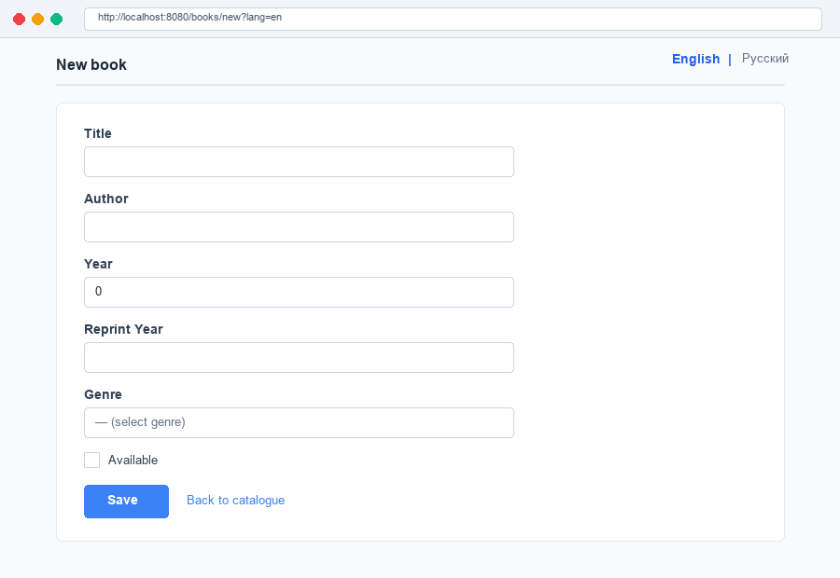
Figure 1: Initial empty form in English (GET /books/new?lang=en)
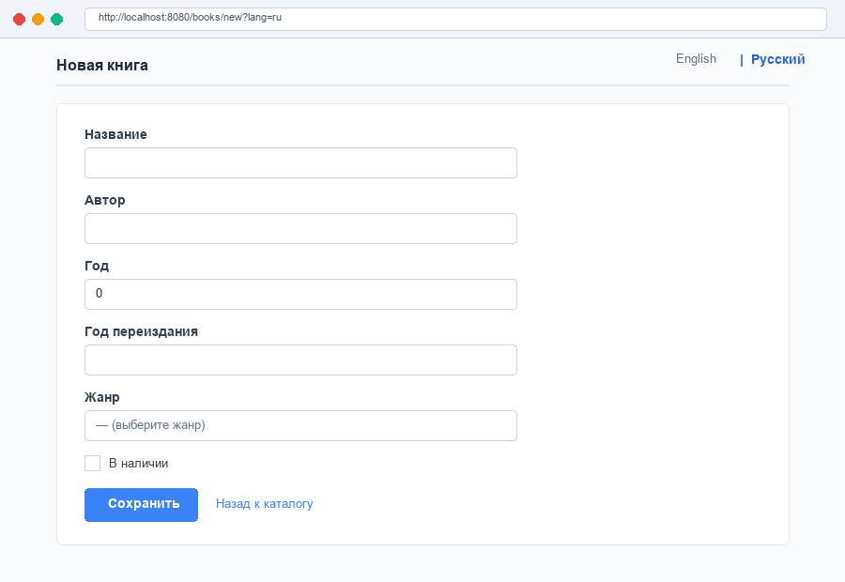
Figure 2: Initial empty form in Russian (GET /books/new?lang=ru)
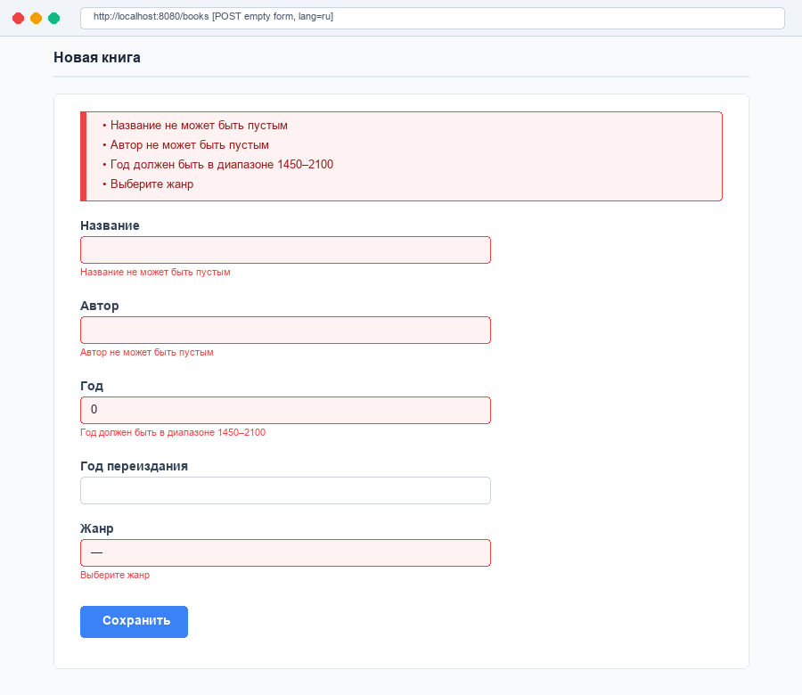
Figure 3: Submission of empty form in Russian, displaying localized error summary and per-field messages
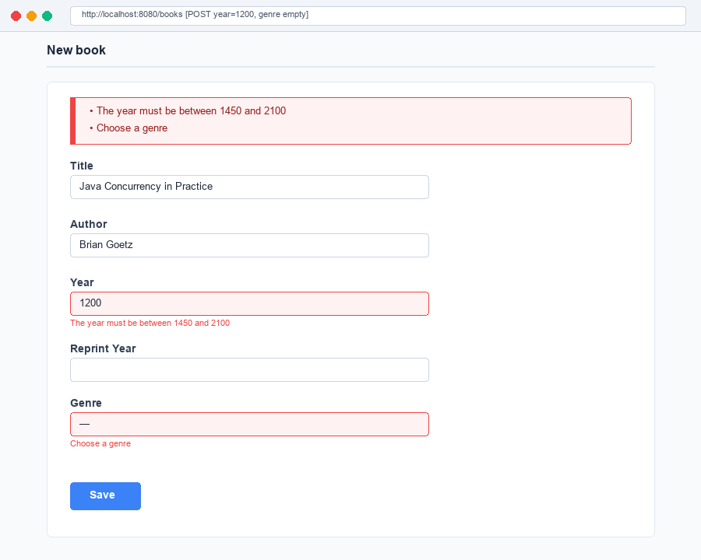
Figure 4: Invalid year (1200) and unselected genre rejected while typed inputs survive
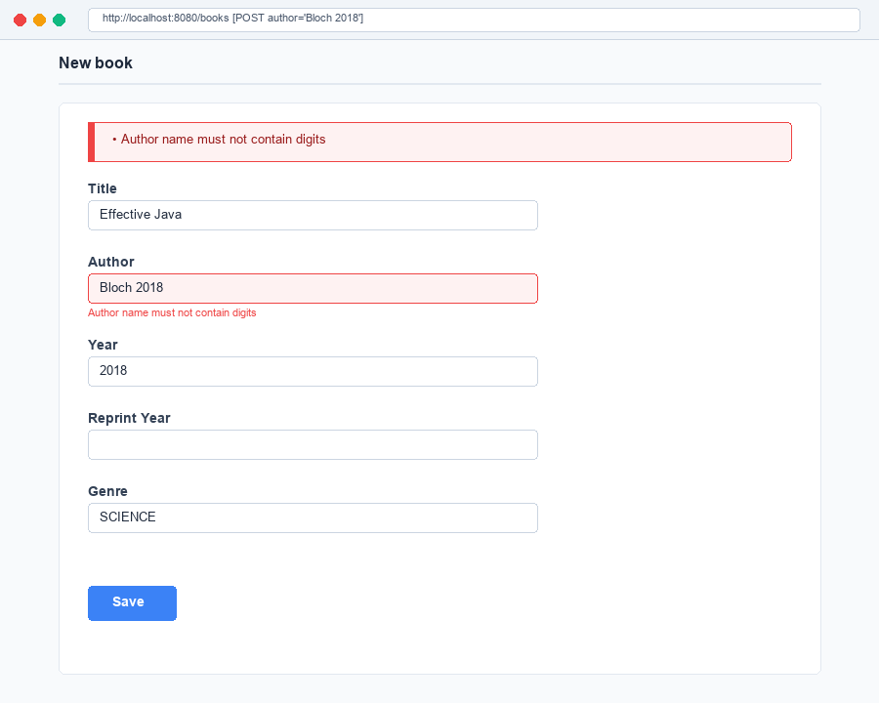
Figure 5: Rejection of author containing numerical digits («Bloch 2018») via custom @NoDigits validator
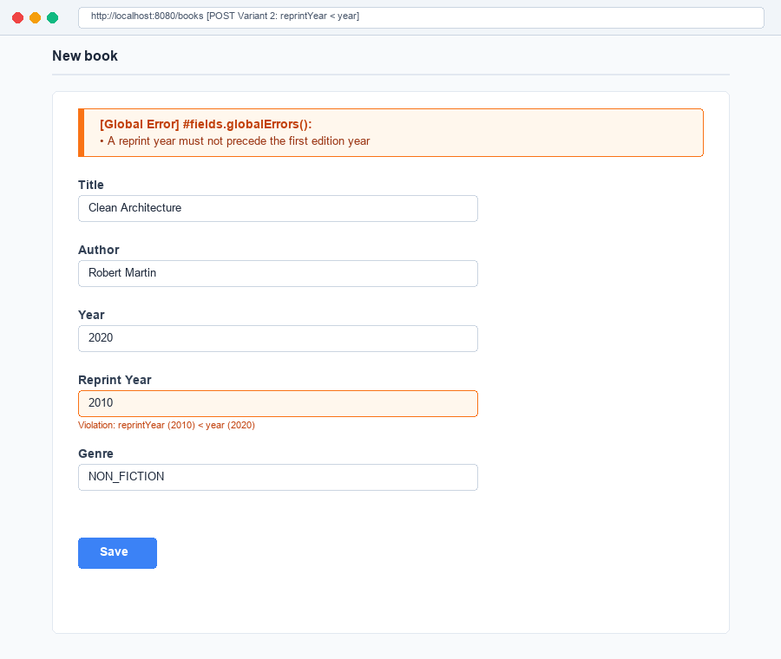
Figure 6: Individual Assignment (Variant 2) — class-level constraint rejecting reprintYear < year via #fields.globalErrors()
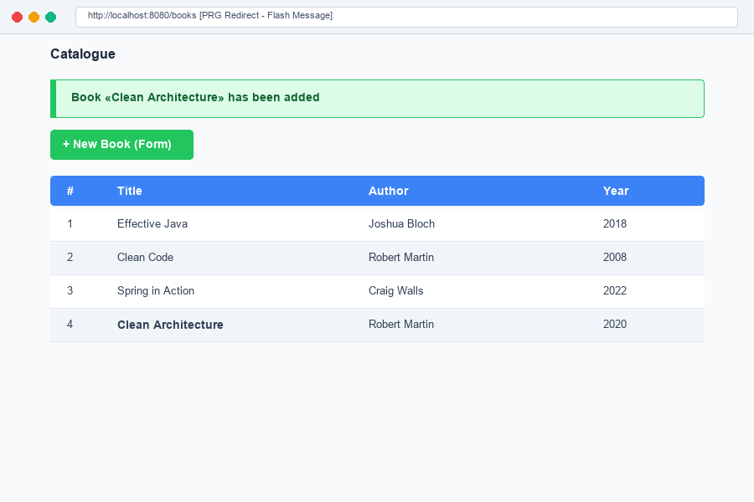
Figure 7: Successful submission, Post/Redirect/Get redirect to /books with one-time flash message banner
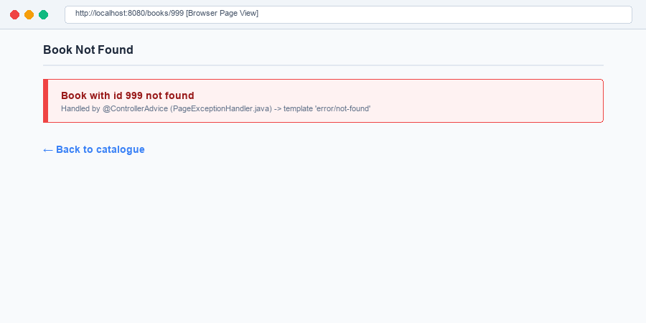
Figure 8: Browser request to GET /books/999 rendered as custom HTML error page by PageExceptionHandler
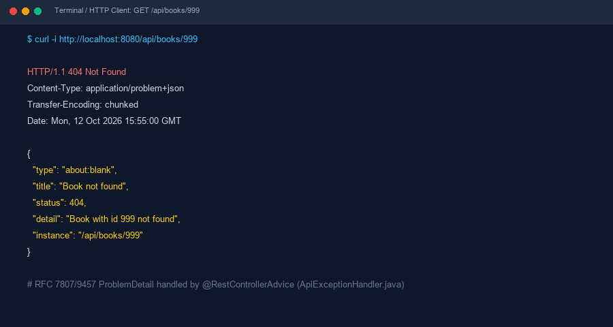
Figure 9: REST API request to GET /api/books/999 returning RFC 7807 ProblemDetail JSON by ApiExceptionHandler
5. Task 4.4 Verification Table: One Exception, Two Audiences
The table below documents the behavior of BookNotFoundException across page and API controllers:
Request | Status and Content-Type | Which Handler Ran
GET /books/999 (Browser) | 200 OK  Content-Type: text/html;charset=UTF-8 | PageExceptionHandler.handleNotFound  (returns template 'error/not-found')
GET /api/books/999 (curl / HTTP Client) | 404 Not Found  Content-Type: application/problem+json | ApiExceptionHandler.handleNotFound  (returns ProblemDetail JSON)
6. Individual Assignment (Variant 2) Detailed Analysis
Variant 2 specifies: «A class-level constraint: 'A reprint year must not precede the first edition year' — a global error shown by #fields.globalErrors()».
Architectural Implementation Details:
• Constraint Target: The annotation @Target(ElementType.TYPE) is placed on the class BookForm itself rather than a field, because validating reprintYear against year requires access to both properties concurrently.
• Validation Logic: In ValidReprintYearValidator, when form.getReprintYear() is non-null, the validator checks form.getReprintYear() >= form.getYear(). If false, a ConstraintViolation is generated.
• Error Classification: Because the violation belongs to the object rather than a specific property path, Spring MVC classifies it as a GlobalError (ObjectError), accessible via #fields.hasGlobalErrors() and iterated using #fields.errors('global').
• Template Presentation: In form.html, an orange-accented alert box specifically surfaces global errors directly above the input fields, complementing the general summary list.
7. Conclusions
Declarative validation using Jakarta Bean Validation and Spring MVC provides a robust, maintainable architecture compared to imperative checks in controllers. By annotating domain and form properties with standardized constraints, validation rules remain clear, reusable, and co-located with data models. Integrating BindingResult guarantees that invalid form submissions never trigger disruptive exceptions, enabling non-destructive form re-rendering with preserved user input. Furthermore, decoupling views through Spring's MessageSource enables seamless internationalization, while targeted @ControllerAdvice hierarchies establish clean separation between server-rendered web pages and REST API contracts.

