Part 1: Summary data frame

The analysis is conducted on Pyride urban drivers.

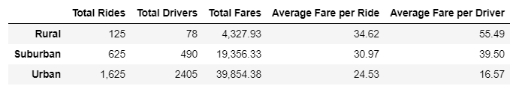

The number of drivers scales down from urban to rural areas respectfully.

The largest number of drivers is in the urban area, the lowest number is in rural area.

The distribution of drivers, impact the average fare per driver – Pyride earning and fare per ride i.e. Pyride pricing.

The lowest average fare ride per ride and driver are for Urban area and the highest are for the rural area

The ratio of rides to drivers for urban areas is less than 1. Which means that there is too many drivers.

The ratio of rides to drivers for rural areas is ~1.6 which mean that there is not enough drivers and there is potential risk of loosing customers for skipping rides or long waiting time.

The ratio in suburban area is ~1.2 which is the closest to optimal: gives 20% margin for increase of ride demand, no risk of not having too many or too little drivers.

Part 2. Time trace of fare prices

The lowest Pyride income is for rural areas and the highest are for urban areas.

Urban areas have slight drift up, which suggest potential income growth.

Suburban areas also have slight growth in Fares over 4 month period

Rural areas are at constant low level without visible drift.

Variation of fares is ~$500 for each city type