CSE 338 Computer Organization

Project 1

In this project, we implemented some procedures of MIPS assembly language.

Question 1

This program take an input to calculate the number series for square root of 2.

Firstly, we take an input from user which are the number of iterations **n**.

After that, we print the first two integers which are 1 and 1.

Then, our loop starts with this initial values, iteration counter starts with **n-1** because we had already printed first iteration. In the loop, we calculate the new values which are **a2**and**b2.**

*a2= a1+2b1*

*b2=a1+b1*

After these calculations, we print it and save these new values into register $t0 and $t1 which are previously holding the initial values. After each iterations, counter decrements by 1 and jump to beginning of the loop.

Here is the example run of the program.

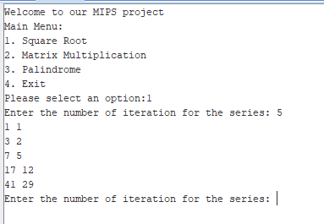

Question 2

In this question, we implemented the matrix multiplication in MIPS. We are taking two matrix input and then we take the dimensions of them. We multiply these matrices and print the outputs.

Firstly, we take inputs as a String. And then we are converting them into integer values with parsing the spaces between integers.

We record into new array which are integer array to make new operations.

After these operations, we

Question 3

This program performs case insensitive palindrome checker which is written in MIPS.

We take any string with maximum length of 100 characters, converting all characters into lower case and then check the string is palindrome or not.

Firstly, we take input as a string then we convert into lower case and at the same time, calculate the length of string that we need to compare first character and last character of the string using their addresses.

If first and last character is equal, then we continue with another comparison since check all the characters and reach the result which string is palindrome or not.

You can see the example run of the program below.

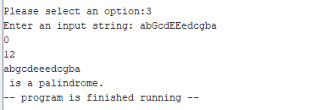

Menu

We prepare a menu for these programs to choose it and run the programs.

Here is a simple screenshot for the menu.

