def sel1(l):
for i in range(len(l)-1):
k=i
for j in range(i+1,len(l)):
if l[j]<l[k]:
k=j
if k!=i:
l[i],l[k]=l[k],l[i]

return l
def sel2(l):
for i in range(len(l)-1):
k=i
for j in range(i+1,len(l)):
if l[j]<l[k]:
k=j
l[i],l[k]=l[k],l[i]

return l
def sel1Count(l):
ass=0
com=0
for i in range(len(l)-1):
k=i
for j in range(i+1,len(l)):
com=com+1
if l[j]<l[k]:
k=j
com=com+1
if k!=i:
l[i],l[k]=l[k],l[i]
ass=ass+2
return l,ass,com
def sel2Count(l):
ass=0
com=0
for i in range(len(l)-1):
k=i
for j in range(i+1,len(l)):
com=com+1
if l[j]<l[k]:
k=j
l[i],l[k]=l[k],l[i]
ass=ass+2
return l,ass,com
Function sel1
Worst Case assignments: On the worst case scenario, for every k we pick we will do 1 swap of elements. This calculation disregards changes to k and only element swaps are taken into consideration.
A=2(n-1) (every swap takes 2 operations)
Best Case assignments: On the best case scenario there will be no swaps since sequence is ordered. When we pick a kth element it will be smaller than rest of the elements it is compared to.
A=0
Comparisons: Comparisons in worst and best case will be the same since amount of comparisons we have in our loops depends on size of our sequence and we iterate through all of them regardless.
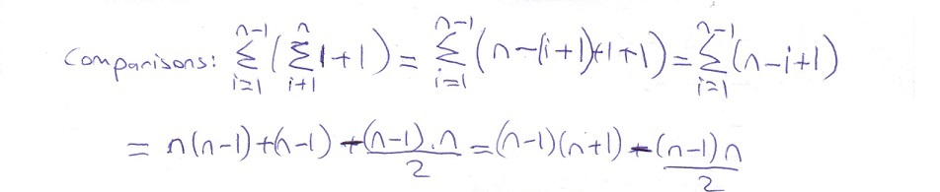
Function sel2
Worst Case assignments: On the worst case scenario swaps won't change compared to sel1 and it will be 2(n-1) since k!=i part won't be satisfied
Best Case assignments:Best case swap instead of 0 it will be n-1 because we didn't check whether the swap we do is with itself or not. Swap assignments will be 2(n-1).
Comparisons: Comparisons will reduce by n-1 times since we dont have the comparison at the end of our function and that will make it
C=n(n-1)-(n(n-1)/2)
Worst cases
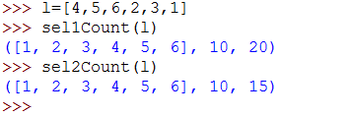
Best Cases
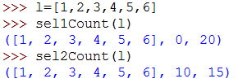
Average Cases
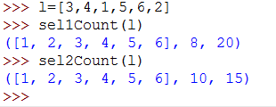
Comparing our results:
sel1 worst case swap assignments 2(n-1)=2*(6-1)=10 matches our result
sel1 best case swap assignments 0 matches our result
sel2 worst case swap assignments 2(n-1)=2*(6-1)=10 matches our result
sel2 best case swap assignments 2(n-1)=2*(6-1)=10 matches our result
sel1 comparisons (6-1)(6+1)-((6-1)6/2)=20 matches our result
sel2 comparisons 6(6-1)-(6(6-1)/2)=15 matches our result

