q1) Explain the difference between thread and process

Process

:A process is an instance of a running program. It has its own memory space, code, data, and system resources, meaning it is an independent unit of execution with everything needed to execute its task.

Thread:

A thread is the smallest unit of execution within a process. Threads run within a process, sharing the same memory space and resources, which makes them more efficient and lightweight compared to processes.

q2) Draw the process state diagram.if the current state of a process is waiting ,which state would it go to by receiving an I/O signal?

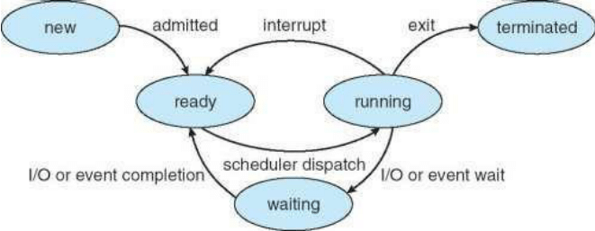

\*A process moves from the Waiting state to the Ready state after receiving an I/O signal or completing the event it was waiting for.

q3) What does happen if OS does not save the state of the process into PCB during context switch ?

A context switch occurs when the CPU switches from executing one process to another. This involves saving the state of the currently running process and loading the state of the next process. The Process Control Block (PCB) is a data structure that stores all the important information about a process, including:

Process State: Whether it is ready, running, waiting, etc.

Program Counter (PC): The address of the next instruction to execute.

CPU Registers: Values of all CPU registers that the process was using.

Memory Management Information: Such as page tables or memory segments.

I/O State Information: Status of pending I/O operations.

Incorrect Execution: The process will resume from an incorrect point, leading to unexpected behavior.

Data Loss and Corruption: Registers, memory pointers, and program counters will have wrong values, leading to data corruption.

Crashes and Instability: The system will likely experience frequent crashes or become unstable.

Security Risks: Unsaved states can lead to data from one process being exposed to another, leading to potential security vulnerabilities.