**COMP 305-Computer Organization - 2023 Midterm Exam**

**Q1 (40p)**

1. There are two types of instructions in a given ISA: Arithmetic Instructions and Memory Instructions. It takes 1 cycle to execute Arithmetic Instructions and 10 cycles to execute Memory Instructions. An application has 10.000 arithmetic instructions and 1.000 memory instructions. When we execute this given application in the given computer, what would be the Cycle Per Instruction (CPI)?

|  |  |  |
| --- | --- | --- |
|  | Arithmetic_ints | Memory_inst |
| Execution Time (cycle) | 1 | 10 |
| #Instructions | 10.000 | 1.000 |

1. For the same ISA and the computer hardware, you change the compiler to achieve better performance. How can a new compile reduce the execution time?

**Q2 (30p)** For the given microprocessor below, your are asked to fill in the table with the values of the asked signals. For that, values of several registers and some address locations in the memory are also given.

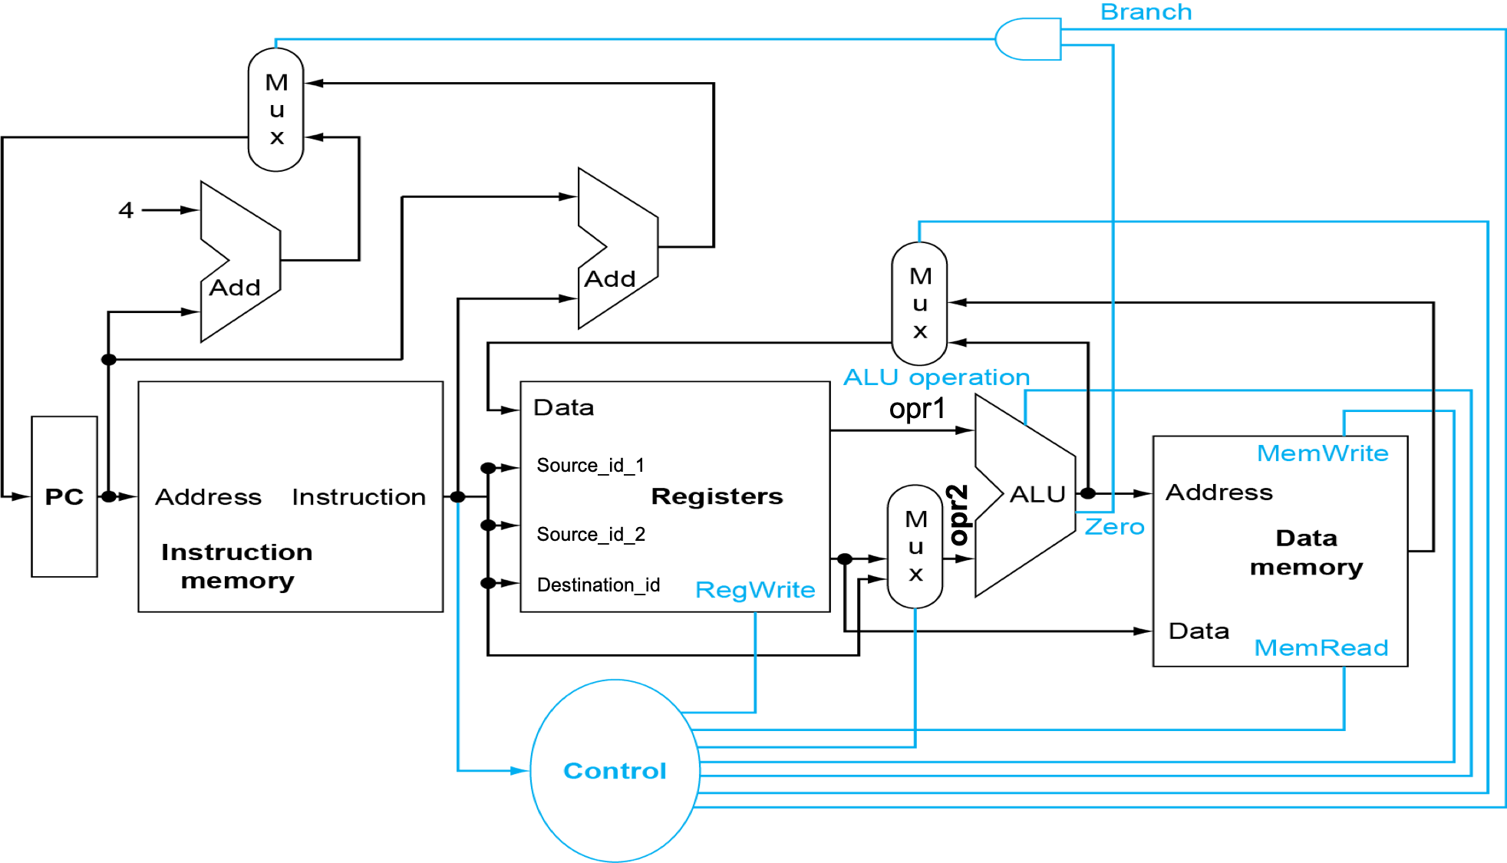

Register File Memory

|  |  |
| --- | --- |
| X1 | 42 |
| X2 | 85 |
| X3 | 127 |
| X4 | 2000 |
| X5 | 4000 |
| X6 | 6000 |
| X7 | 8000 |

|  |  |
| --- | --- |
| 2008 | 20 |
| 4008 | 40 |
| 6000 | 60 |
| 6016 | 80 |
| 8016 | 100 |

|  |  |  |  |  |  |  |  |  |
| --- | --- | --- | --- | --- | --- | --- | --- | --- |
| Instruction | RegWrite | Source_id_1 | Destination_id | Opr1 | Opr2 | MemWrite | MemRead | Data |
| add x1, x2, x3 |  |  |  |  |  |  |  |  |
| ld x4, 8(x5) |  |  |  |  |  |  |  |  |
| sd x6, 16(x7) |  |  |  |  |  |  |  |  |

**Q3) (30p) a.** What is the compiled versions of the following code in RISC-V? Note that the base address of Array is in x1. Use x3 for k.

void swap(){

k=Array[0];

k++;

Array[2]=k

}

**b**. For the method you implemented above, how would you call the method from main?