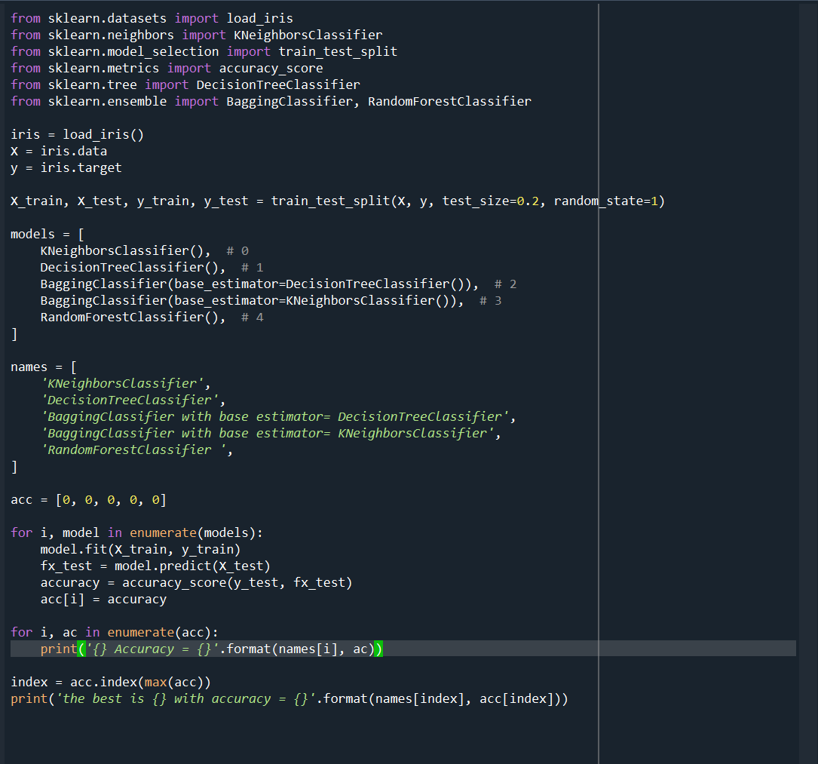

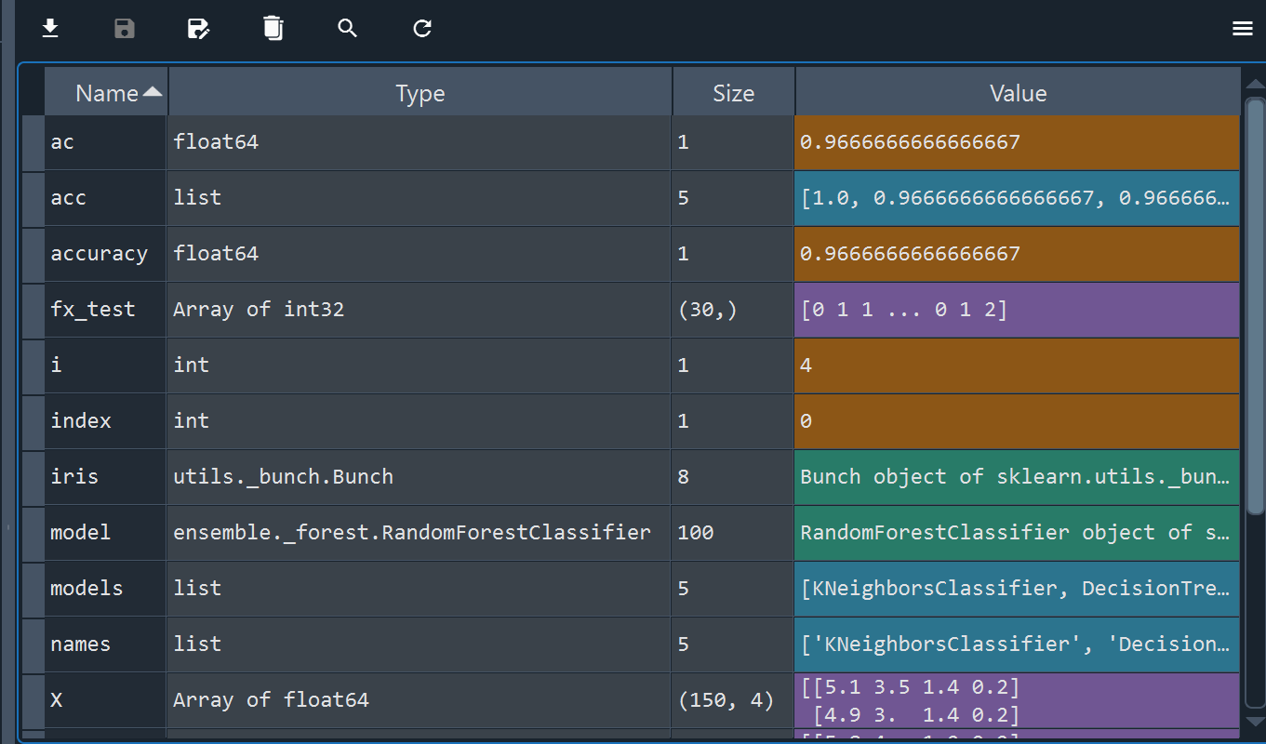

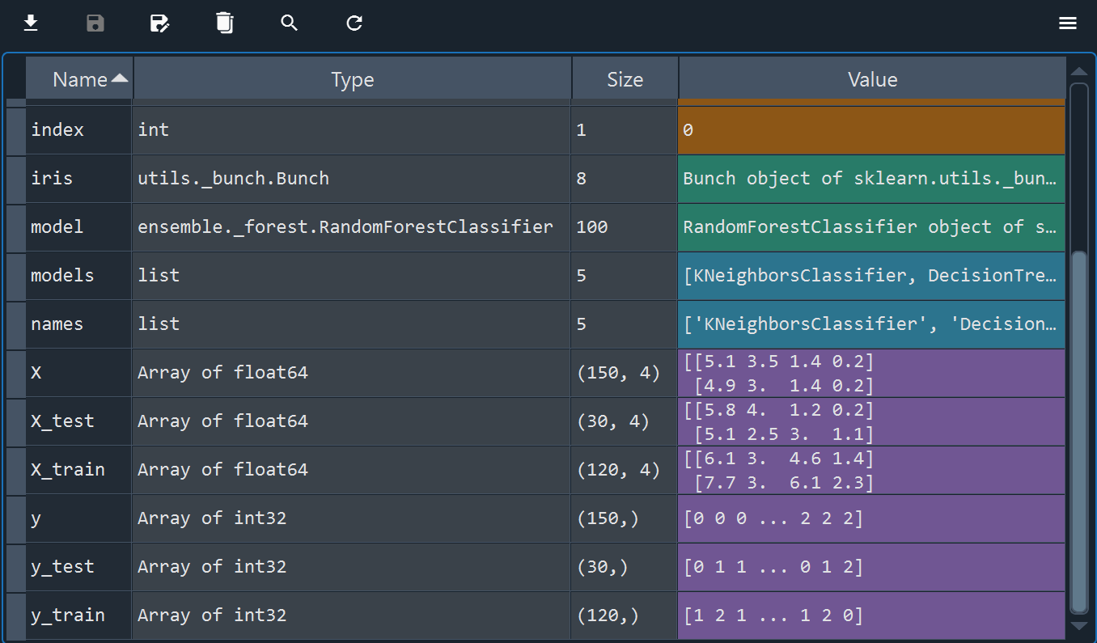

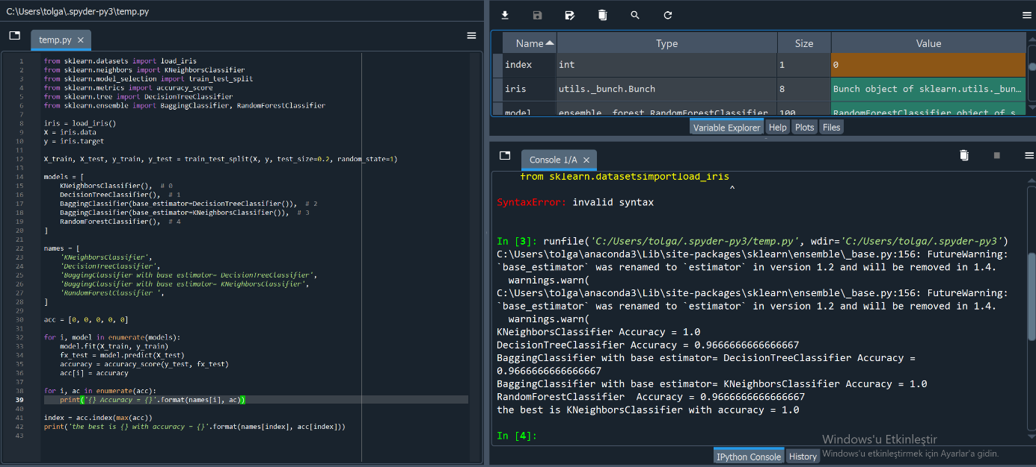

Best Parameters of each algorithm Using the same code above for each algorithm while playing with parameters i obtained the following optimum parameters:

|  |  |  |  |
| --- | --- | --- | --- |
| Algorithm | Parameters | Accuracy | note |
| KNN | n_neighbors < 7 (1,2,3,4,5 or 6) algorithm="auto" , “ball_tree” or “kd_tree” (same result) | 1.0 | Increasing the n_neghbors reduces generalization so keeping it relatively low is better |
| Decision Tree Classifier | criterion="entropy" or ”gini” splitter="random",min_sample s_split between 3 and 7 max_depth=6 | Average of 0.98 | Setting a fixed max-depth value enhanced this algorithm very well because it increased the generalization of the algorithm |
| Bagging Classifier with Decision Tree Classifier as the base estimator | base_estimator = DecisionTreeClassifier(criterio n="entropy", splitter="random", min_samples_split=28, max_depth=3), n_estimators=5 | Average of 0.973 | Increased min_samples_s plit so the algorithm better generalize a larger amount of data |
| Bagging Classifier with KNN as the base estimator | base_estimator = KNeighborsClassifier(algorith m="ball_tree",n_neighbors=3) n_estimators=5 | 1.0 | Reduced n_neigbors as above |
| Random Forest Classifier | criterion="gini", min_samples_split=2, max_depth=5, n_estimators=10 | 0.967 | The Random Forest Classifier achieved 96.7% accuracy on the iris dataset using the “gini” criterion, at least 2 replicate splits, a maximum depth of 5, and 10 predictors. |

Applying the table optimum parameters again to the previous code