## **Project “Dragon” 1-Page GDD**

*Diablo meets Monty Pyhton*

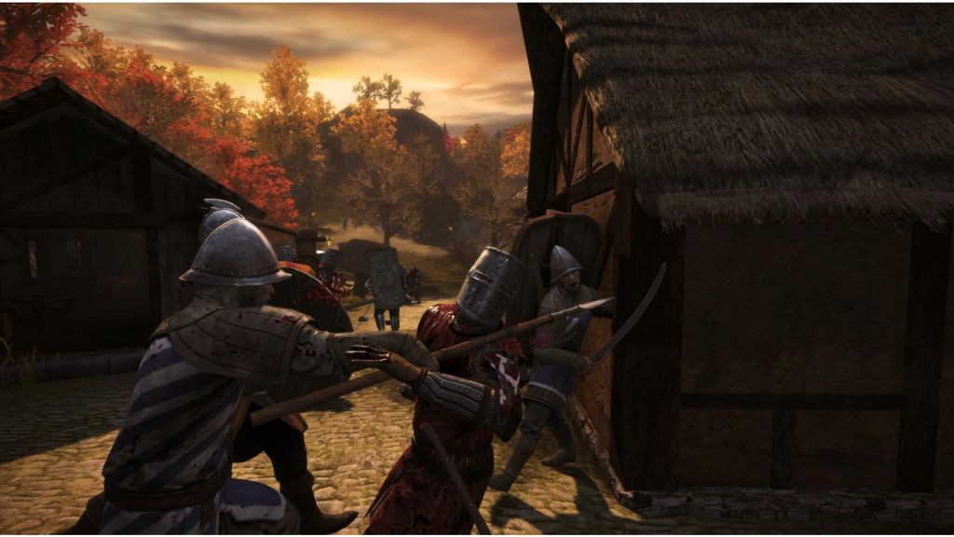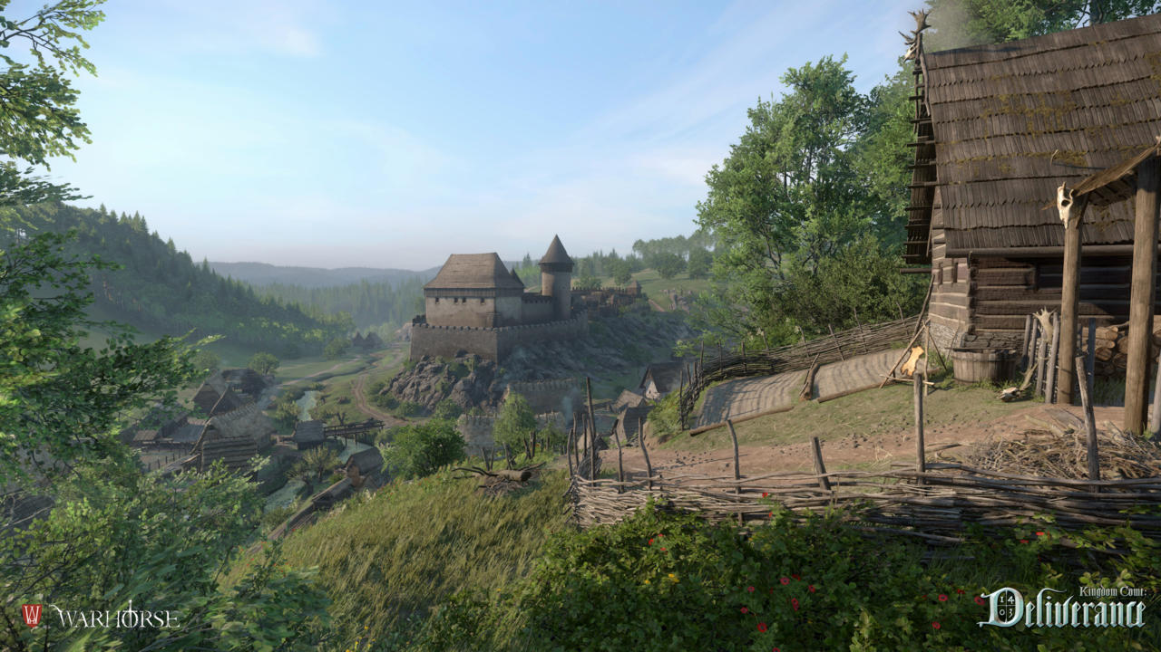

**Genre:** RPG, 3rd person fixed camera RPG,  
**Target Audience:** T for Teen

**Controls:** Mouse & Keyboard and Controller

**Thematic Setting:** Medieval fantasy – swords, knights, dragons

**Tech Stack:** Unity 5.5+, Blender, Gimp / Photoshop, Audacity

**Platform(s):** Steam

**Game Moment:** Smashing through enemies, travelling inbetween valleys

**Game Summary:**

**Core Player Experience:**

**Central Theme:**

**Design Pillar:**

**Anticipated Remarkability:**

**Anticipated Steam Early Access Launch date:**

**Feature Development Priorities:**

**Comparative Products:**