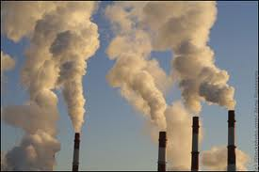
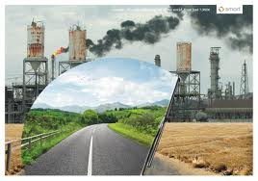
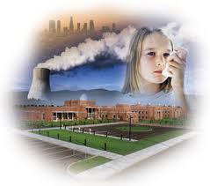
No part of our environment has escaped the effects of pollution. All over the world, our land, air and water have been contaminated by an increasing number of waste materials and substances that issue daily from factories, homes and vehicles .In some cases, this waste is only an eyesore, which spoils the beauty of our surroundings, while in other cases, It is a serious threat to our health and can result in death.
Some of the most dangerous waste substances are, without a doubt, those produced by factories. Industrial waste often contains toxic substances that can kill plant and animal life. When there is no proper government control, factories allow these substances to pour into rivers, while their chimneys fill the atmosphere with poisonous fumes, sometimes in areas no more than a few kilometers from heavily populated cities.
Nuclear waste is even more hazardous than industrial waste .Although everything is done to ensure that it is buried safely at great depths, the fact remains that plutonium waste continues to be dangerously radioactive for 24,000 years, while uranium waste remains so for 700 million years.
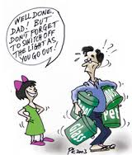
In towns and cities, the use of fossil fuels (oil, coal, and gas) for heating results in large amounts of carbon dioxide filling the atmosphere .Although some cities have been made "smokeless zones" where no coal or oil fires are allowed, the exhaust fumes from vehicles on the roads has meant that air pollution continues to be a major problem.
But, if we stop to think, each of us is guilty of polluting our environment to some extent. Almost everything we buy today comes in some sort of container or packaging , made of paper plastic, glass ,or aluminium which we usually throw away .Besides being expensive to collect, many of these materials -especially plastic , glass and aluminium -are very difficult to get rid of and lie in huge dumps on the outskirts of many cities , one of the ugliest types of pollution. Attempts have been made to encourage factories to recycle these materials , but few have shown any interest .
How much longer can we allow this pollution to continue? Scientists tell us that the increased amount of carbon dioxide in the atmosphere may soon have disastrous effects. They fear that it will raise average temperatures around the world and cause the polar ice caps to melt .If this happens ,they say the level of the world's oceans will rise by twelve to eighteen feet (four to six meters ), and vast populated areas of our planet will be covered by water. Can we afford to make such risks by continuing to pollute our environment?
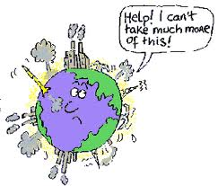
Comprehension.

A-Choose the best title for the passage.

A) Types of pollution.
B) A threat to our planet. ---------------------------------------
C) Recycling waste.

B-Are these sentences true or false? Justify.

1-Waste is not a real threat to our health. -------------------------------------------------
---------------------------------------------------------------------------------------------------------
2-The government is responsible for the waste factories produce. --------------------------------------------
-----------------------------------------------------------------------------------------------------------------------------------
3-Industrial waste is more dangerous than nuclear waste. -------------------------------------------------------
------------------------------------------------------------------------------------------------------------------------------------
4-The uranium waste is highly radioactive. ----------------------------------------------------------------------------
------------------------------------------------------------------------------------------------------------------------------------
5-The increased amount of carbon dioxide is the cause of global warming. ----------------------------------
------------------------------------------------------------------------------------------------------------------------------------
6-The more goods we buy, the more waste we produce. ----------------------------------------------------------
-------------------------------------------------------------------------------------------------------------------------------------

C-Answer these questions.

1-Why is industrial waste very dangerous? ---------------------------------------------------------------------------
-------------------------------------------------------------------------------------------------------------------------------------
2-How do factories dispose of nuclear waste? ------------------------------------------------------------------------
-------------------------------------------------------------------------------------------------------------------------------------
3-What are the causes of air pollution? ---------------------------------------------------------------------------------
--------------------------------------------------------------------------------------------------------------------------------------
4-What are "smokeless zones" in your opinion? ----------------------------------------------------------------------
-------------------------------------------------------------------------------------------------------------------------------------
5-What are the results of rising temperatures? -----------------------------------------------------------------------
--------------------------------------------------------------------------------------------------------------------------------------

D-Complete these sentences.

1-Our land, air and water have been contaminated because of --------------------------------------------------
--------------------------------------------------------------------------------------------------------------------------------------
2-Although many efforts have been done to recycle waste, -------------------------------------------------------
-------------------------------------------------------------------------------------------------------------------------------------
3-If the average temperatures rise, -------------------------------------------------------------------------------------

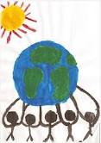
E-What do the underlined words in the text refer to?
1-it: ---------------------------------------------
2-their: ----------------------------------------
3-they: ------------------------------------------
4-this: --------------------------------------------

F-Find in the text words that mean almost the same as:

1-makes less attractive (paragraph 1) ------------------------------------
2-menace (paragraph 1) -----------------------------------------------------
3-dangerous (paragraph 3) -------------------------------------------------
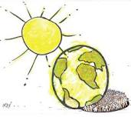
4-responsible for something wrong (paragraph 5) --------------------
5-to dispose of (paragraph 5) ----------------------------------------------
6-surroundings (paragraph 5) ----------------------------------------------

