Университет ИТМО

Факультет программной инженерии и компьютерной техники

Системы искусственного интеллекта

Лабораторная работа №3

### Создание информационной системы на базе семантической сети

Выполнил: Анищенко А.А.

Группа P33113

Преподаватель: Болдырева Е.А.

Санкт-Петербург

2020 г.

### Цель работы

Изучение семантической сети как инструмента создания информационных и обучающих систем? А также исследование методов логического вывода на основе правил.

### Предметная область

Генеалогическо дерево

### Code Semantic

facts.pl

|  |  |
| --- | --- |
| 1  2  3  4  5  6  7  8  9  10  11  12  13  14  15  16  17  18  19  20  21  22  23  24  25  26  27  28  29  30  31  32  33  34  35  36  37  38  39  40  41  42  43  44  45  46  47  48  49  50  51  52  53  54  55  56  57  58  59  60  61  62  63  64  65  66 | **f**("anischenko_alexey", "is_parent", "anischenko_anatoliy").  **f**("anischenko_julia", "is_parent", "anischenko_anatoliy").  **f**("anischenko_alexey", "is_parent", "anischenko_timofey").  **f**("anischenko_julia", "is_parent", "anischenko_timofey").  **f**("anischenko_vitaliy", "is_parent", "anischenko_alexey").  **f**("anischenko_olga", "is_parent", "anischenko_alexey").  **f**("anischenko_vitaliy", "is_parent", "anischenko_igor").  **f**("anischenko_olga", "is_parent", "anischenko_igor").  **f**("kukushkin_michail", "is_parent", "anischenko_julia").  **f**("kukushkina_tatiana", "is_parent", "anischenko_julia").  **f**("kukushkin_pavel", "is_parent", "kukushkin_michail").  **f**("kukushkina_vera", "is_parent", "kukushkin_michail").  **f**("kukushkin_pavel", "is_parent", "tsygonyaeva_elena").  **f**("kukushkina_vera", "is_parent", "tsygonyaeva_elena").  **f**("drobov_aleksandr", "is_parent", "kukushkina_tatiana").  **f**("drobova_nina", "is_parent", "kukushkina_tatiana").  **f**("drobov_aleksandr", "is_parent", "ilyicheva_luda").  **f**("drobova_nina", "is_parent", "ilyicheva_luda").  **f**("tsygonyaev_yuriy", "is_parent", "tsygonyaev_alexey").  **f**("tsygonyaeva_elena", "is_parent", "tsygonyaev_alexey").  **f**("tsygonyaev_yuriy", "is_parent", "tsygonyaev_vitaliy").  **f**("tsygonyaeva_elena", "is_parent", "tsygonyaev_vitaliy").  **f**("tsygonyaev_alexey", "is_parent", "tsygonyaev_ivan").  **f**("tsygonyaeva_tatiana", "is_parent", "tsygonyaev_ivan").  **f**("tsygonyaev_vitaliy", "is_parent", "tsygonyaev_michail").  **f**("tsygonyaeva_anna", "is_parent", "tsygonyaev_michail").  **f**("tsygonyaev_vitaliy", "is_parent", "tsygonyaev_sergey").  **f**("tsygonyaeva_anna", "is_parent", "tsygonyaev_sergey").  **f**("anischenko_alexey", "is_a", "Man").  **f**("anischenko_anatoliy", "is_a", "Man").  **f**("anischenko_timofey", "is_a", "Man").  **f**("anischenko_igor", "is_a", "Man").  **f**("anischenko_vitaliy", "is_a", "Man").  **f**("kukushkin_michail", "is_a", "Man").  **f**("kukushkin_pavel", "is_a", "Man").  **f**("drobov_aleksandr", "is_a", "Man").  **f**("tsygonyaev_yuriy", "is_a", "Man").  **f**("tsygonyaev_alexey", "is_a", "Man").  **f**("tsygonyaev_vitaliy", "is_a", "Man").  **f**("tsygonyaev_ivan", "is_a", "Man").  **f**("tsygonyaev_michai", "is_a", "Man").  **f**("tsygonyaev_sergey", "is_a", "Man").  **f**("anischenko_julia", "is_a", "Woman").  **f**("anischenko_olga", "is_a", "Woman").  **f**("kukushkina_tatiana", "is_a", "Woman").  **f**("kukushkina_vera", "is_a", "Woman").  **f**("drobova_nina", "is_a", "Woman").  **f**("ilyicheva_luda", "is_a", "Woman").  **f**("tsygonyaeva_elena", "is_a", "Woman").  **f**("tsygonyaeva_tatiana", "is_a", "Woman").  **f**("tsygonyaeva_anna", "is_a", "Woman").  **f**("anischenko_alexey", "is_spouse", "anischenko_julia").  **f**("anischenko_olga", "is_spouse", "anischenko_vitaliy").  **f**("kukushkin_michail", "is_spouse", "kukushkina_tatiana").  **f**("drobov_aleksandr", "is_spouse", "drobova_nina").  **f**("kukushkin_pavel", "is_spouse", "kukushkina_vera").  **f**("tsygonyaeva_elena", "is_spouse", "tsygonyaev_yuriy").  **f**("tsygonyaev_alexey", "is_spouse", "tsygonyaeva_tatiana").  **f**("tsygonyaeva_anna", "is_spouse", "tsygonyaev_vitaliy").  **t**("x").  **onto**("ontology.pl"). |

ontology.pl

|  |  |
| --- | --- |
| 1  2  3  4  5  6  7  8  9  10  11  12  13  14  15  16  17  18  19  20  21  22  23  24  25  26  27  28  29  30  31  32  33  34  35  36  37  38  39  40  41  42  43  44  45  46  47  48  49  50  51  52  53  54  55  56  57  58  59  60  61  62  63  64  65  66  67  68  69  70  71 | **c**("Person").  **c**("Woman").  **c**("Man").  **o**("Woman", "is_a", "Person").  **o**("Man", "is_a", "Person").  **r**([**t**("?x", "is_a", "&y"), **t**("?y", "is_a", "?z")], [**t**("?x", "is_a", "?z")]).  **r**([**t**("?x","is_spouse","?y")], [**t**("?y","is_spouse","?x")]).  **r**([**t**("?x","is_spouse","?y"), **t**("?x","is_a","Man")],  [**t**("?x","is_husband","?y")]).  **r**([**t**("?x","is_spouse","?y"),**t**("?x","is_a","Woman")],  [**t**("?x","is_wife","?y")]).  **r**([**t**("?x","is_parent","?y")], [**t**("?y","is_child","?x")]).  **r**([**t**("?x","is_a","Woman"),**t**("?x","is_child","?y")],  [**t**("?x","is_daughter","?y")]).  **r**([**t**("?x","is_a","Man"),**t**("?x","is_child","?y")],  [**t**("?x","is_son","?y")]).  **r**([**t**("?x","is_parent","?y"), **t**("?x","is_a","Woman")],  [**t**("?x","is_mom","?y")]).  **r**([**t**("?x","is_parent","?y"), **t**("?x","is_a","Man")],  [**t**("?x","is_dad","?y")]).  **r**([**t**("?x","is_parent","?y"),**t**("?y","is_parent","?z")],  [**t**("?x","is_grandparent","?z")]).  **r**([**t**("?x","is_a","Man"), **t**("?x","is_grandparent","?y")],  [**t**("?x","is_granddad","?y")]).  **r**([**t**("?x","is_a","Woman"), **t**("?x","is_grandparent","?y")],  [**t**("?x","is_grandmom","?y")]).  **r**([**t**("?x","is_grandparent","?y")], [**t**("?y","is_grandchild","?x")]).  **r**([**t**("?x","is_a","Man"), **t**("?x","is_grandchild","?y")],  [**t**("?x","is_grandson","?y")]).  **r**([**t**("?x","is_a","Woman"), **t**("?x","is_grandchild","?y")],  [**t**("?x","is_granddaughter","?y")]).  **r**([**t**("?x","has_child","?y"), **t**("?x","has_child","?z"), **t**("?y","differs","?z")],  [**t**("?y","is_sibling","?z")]).  **r**([**t**("?x","is_sibling","?y"),**t**("?x","is_a","Man")],  [**t**("?x","is_brother","?y")]).  **r**([**t**("?x","is_sibling","?y"),**t**("?x","is_a","Woman")],  [**t**("?x","is_sister","?y")]).  **r**([**t**("?x","is_grandparent","?y"),**t**("?y","is_parent","?z")],  [**t**("?x","is_great_grandparent","?z")]).  **r**([**t**("?x","is_a","Man"), **t**("?x","is_great_grandparent","?y")],  [**t**("?x","is_great_granddad","?y")]).  **r**([**t**("?x","is_a","Woman"), **t**("?x","is_great_grandparent","?y")],  [**t**("?x","is_great_grandmom","?y")]).  **r**([**t**("?x","is_great_grandparent","?y")], [**t**("?y","is_great_grandchild","?x")]).  **r**([**t**("?x","is_a","Man"), **t**("?x","is_great_grandchild","?y")],  [**t**("?x","is_great_grandson","?y")]).  **r**([**t**("?x","is_a","Woman"), **t**("?x","is_great_grandchild","?y")],  [**t**("?x","is_great_granddaughter","?y")]).  **r**([**t**("?x", "is_sibling", "?y"), **t**("?x", "is_parent", "?z")],  [**t**("?y", "is_uncle_or_aunt", "?z")]).  **r**([**t**("?x","is_uncle_or_aunt","?y"), **t**("?x","is_a","Woman")],  [**t**("?x","is_aunt","?y")]).  **r**([**t**("?x","is_uncle_or_aunt","?y"), **t**("?x","is_a","Man")],  [**t**("?x","is_uncle","?y")]).  **r**([**t**("?x","is_uncle_or_aunt","?y"), **t**("?y","is_a","Woman")],  [**t**("?y","is_niece","?x")]).  **r**([**t**("?x","is_uncle_or_aunt","?y"), **t**("?y","is_a","Man")],  [**t**("?y","is_nephew","?x")]). |

### Полученная сеть для выбранного элемента

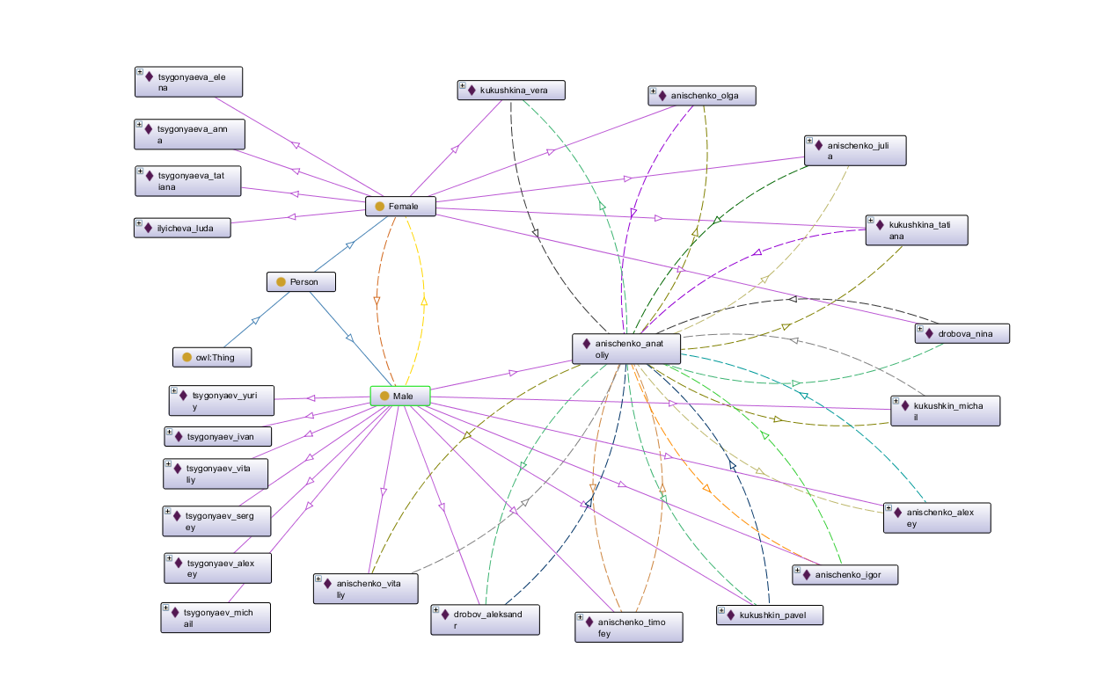

Вывод

Выполнив данную работу, я узнал про семантические сети и реализовал свою собственную. Также я освоил систему Protégé.