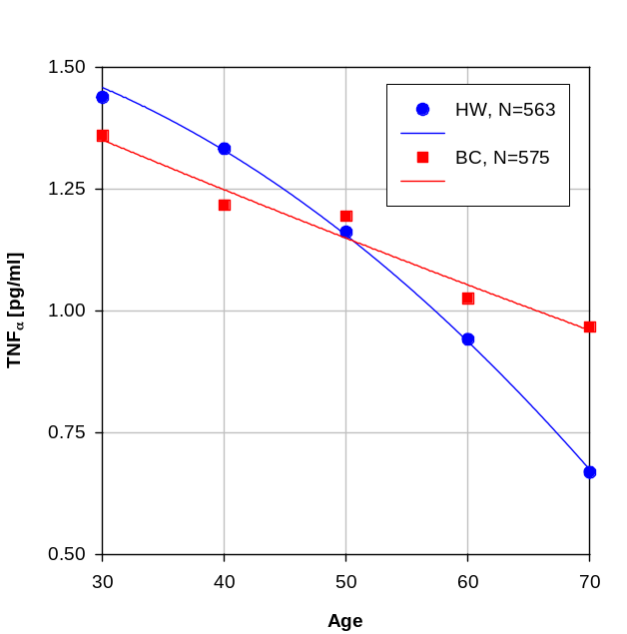 | 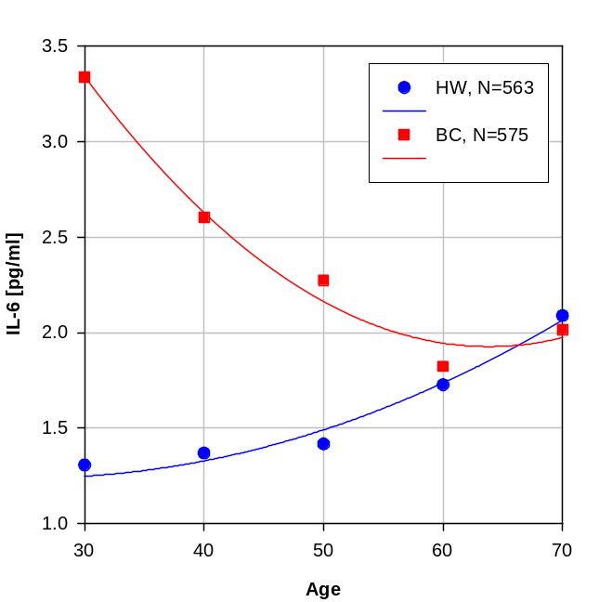
Figure 1: The age dependence for TNF_{α} in HW- and BC- cohorts. | Figure 2: The age dependence for IL-6 in HW- and BC- cohorts.
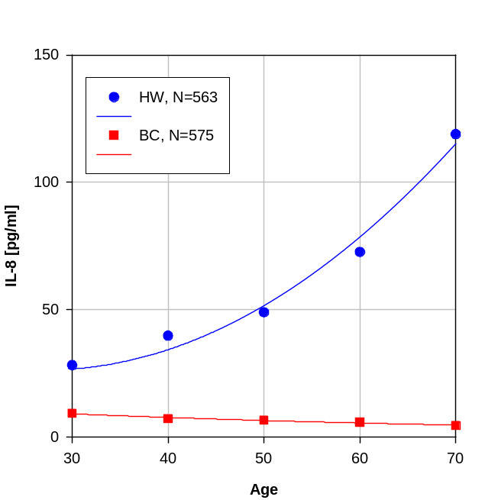
Figure 3: The age dependence for IL-8 in HW- and BC- cohorts.

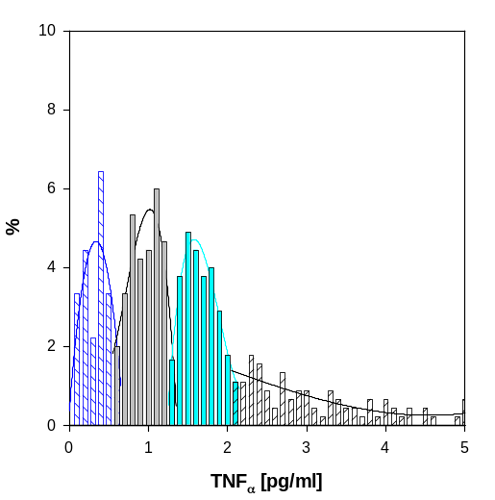 | 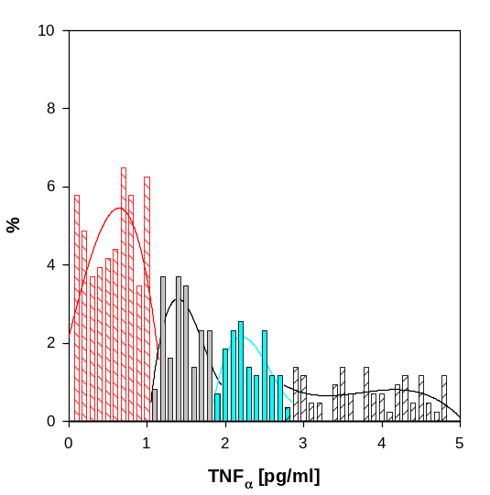
Figure 4: The TNF_{α} distribution in HW(N=563) cohort. | Figure 5: The TNF_{α} distribution in BC(N=575) cohort.
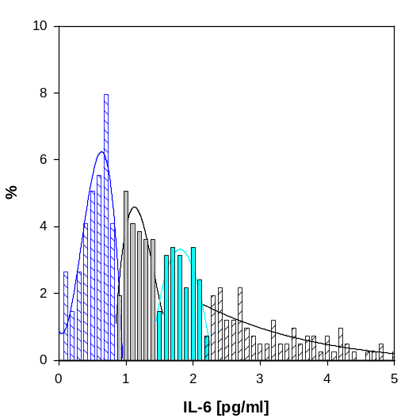 | 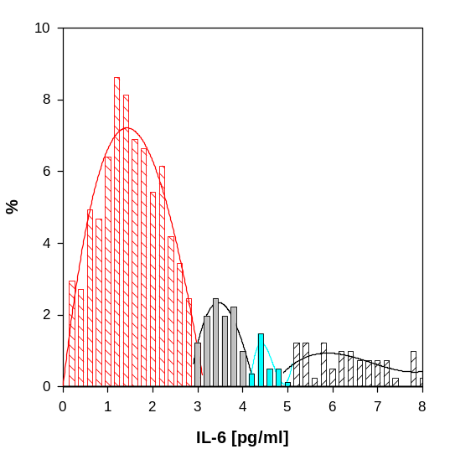
Figure 6: The IL-6 distribution in HW(N=563) cohort. | Figure 7: The IL-6 distribution in BC(N=575) cohort.
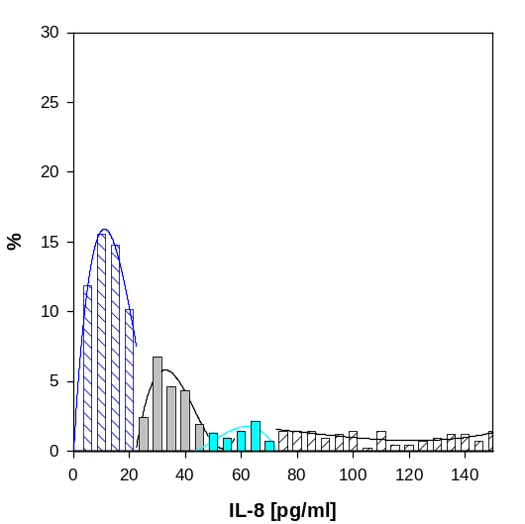 | 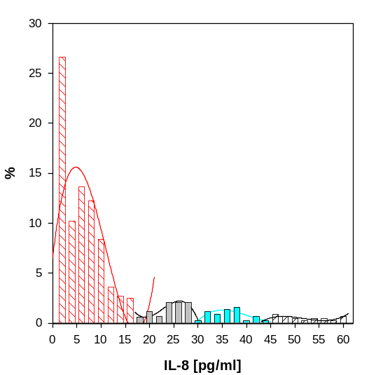
Figure 8: The IL-8 distribution in HW(N=563) cohort. | Figure 9: The IL-8 distribution in BC(N=575) cohort.

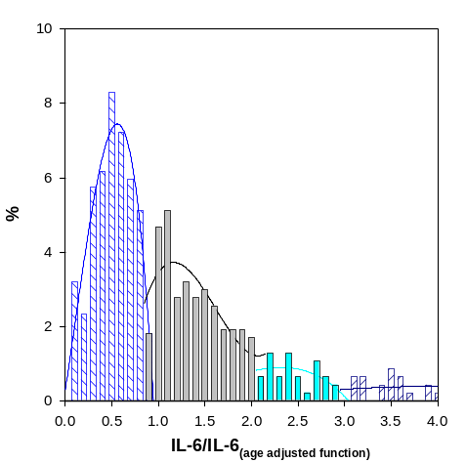 | 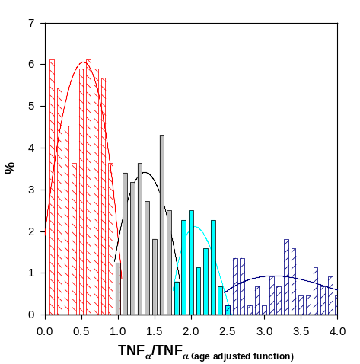
Figure 10: The TNF_{α} distribution in HW(N=563) cohort (normalized data). | Figure 11: The TNF_{α} distribution in BC(N=575) cohort (normalized data).
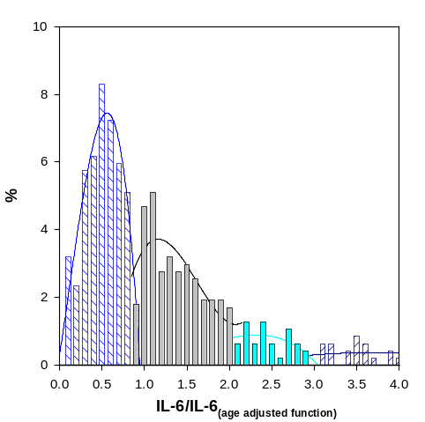 | 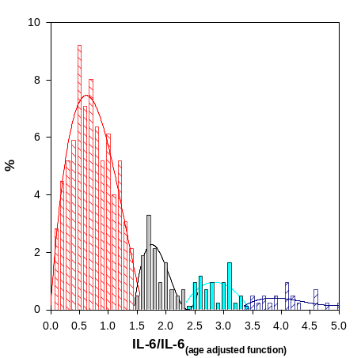
Figure 12: The IL-6 distribution in HW(N=563) cohort (normalized data). | Figure 13: The IL-6 distribution in BC(N=575) cohort (normalized data).
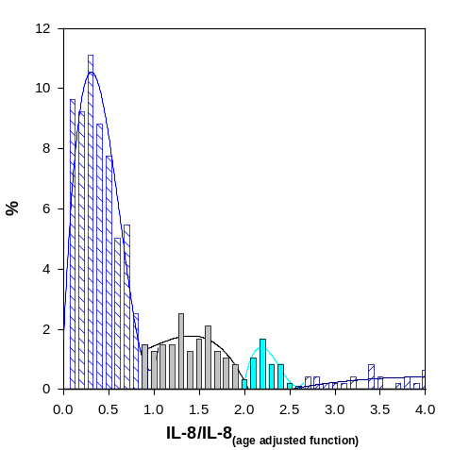 | 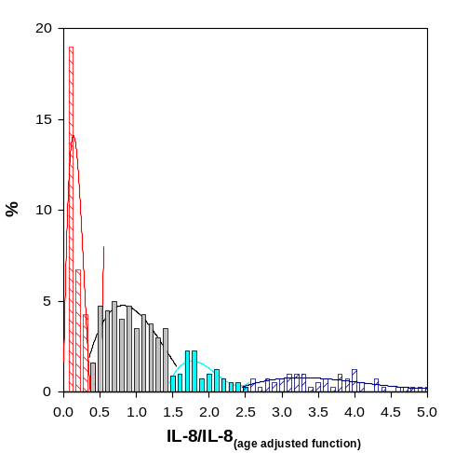
Figure 14: The IL-8 distribution in HW(N=563) cohort (normalized data). | Figure 15: The IL-8 distribution in BC(N=575) cohort (normalized data).

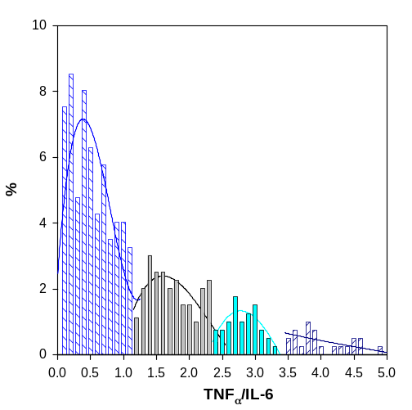 | 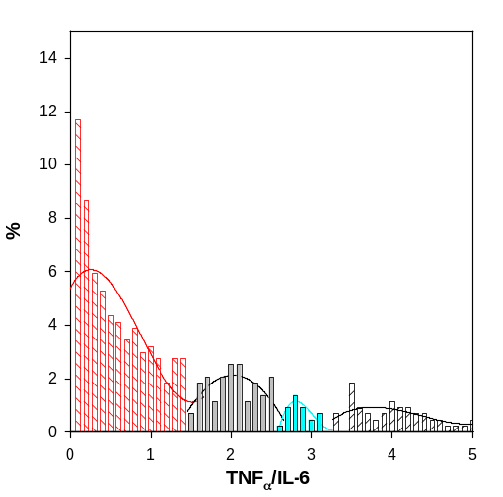
Figure 16: The Ratio 1 distribution in HW(N=563) cohort. | Figure 17: The Ratio 1 distribution in BC(N=575) cohort.
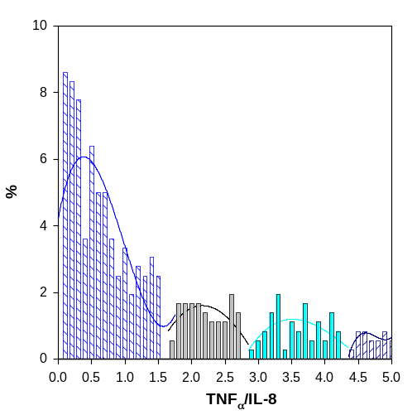 | 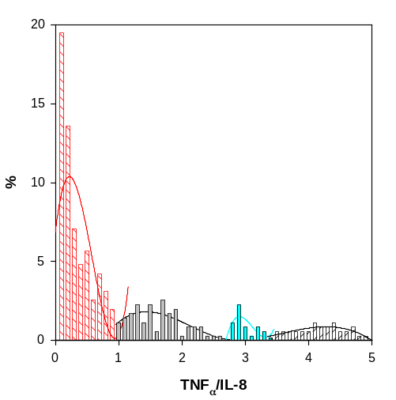
Figure 18: The Ratio 3 distribution in HW(N=563) cohort. | Figure 19: The Ratio 3 distribution in BC(N=575) cohort.
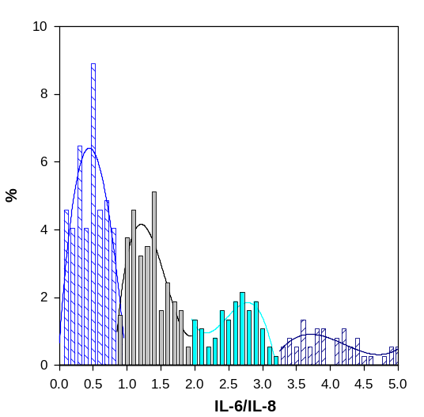 | 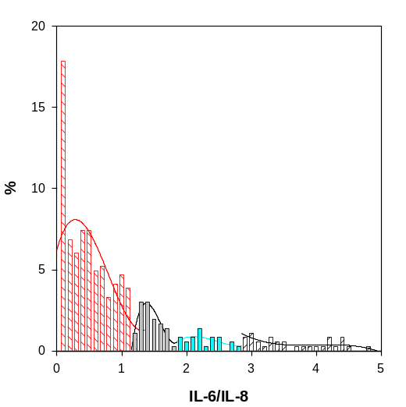
Figure 20: The Ratio 5 distribution in HW(N=563) cohort. | Figure 21: The Ratio 5 distribution in BC(N=575) cohort.

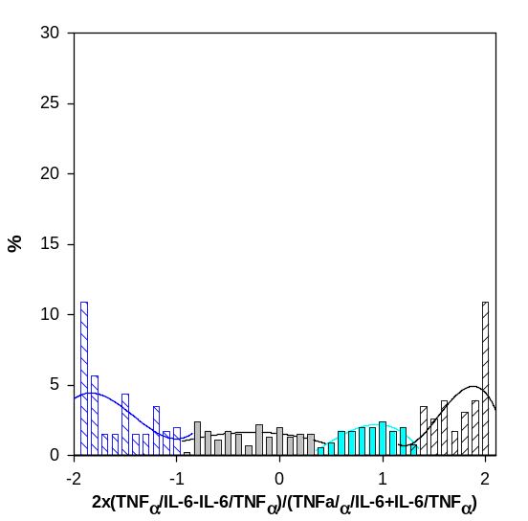 | 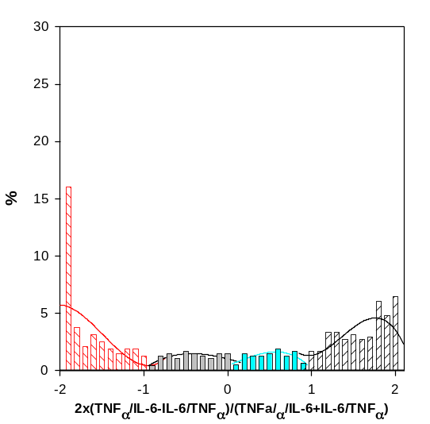
Figure 22: The Contrast 1 distribution in HW(N=563) cohort. | Figure 23: The Contrast 1 distribution in BC(N=575) cohort.
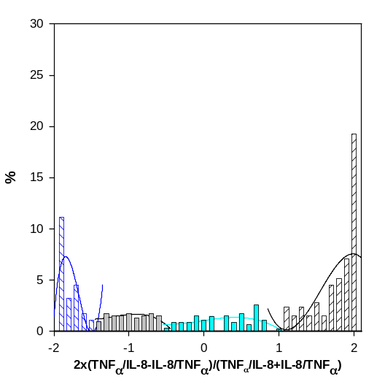 | 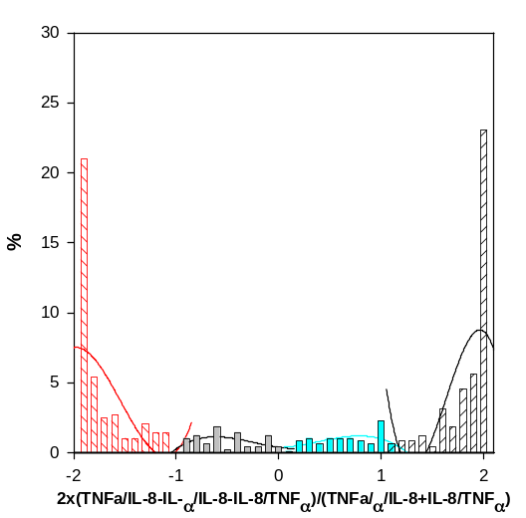
Figure 24: The Contrast 2 distribution in HW(N=563) cohort. | Figure 25: The Contrast 2 distribution in BC(N=575) cohort.
. | 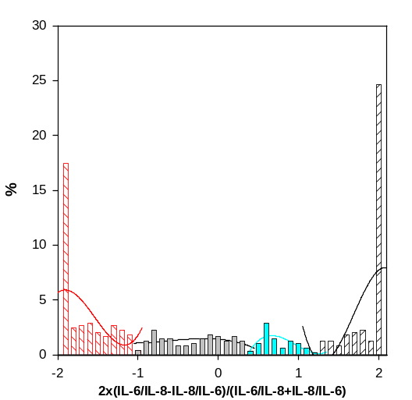
 | Figure 27: The Contrast 3 distribution in BC(N=575) cohort.

