**CSS Basics**

**DEADLINE:** 10/12/2019

## **FOLDER STRUCTURE**

FL12_HW2/* **\* - required**

├─ task/** **\*\* - restricted (no need to submit)**

├─ examples/**

   └─ homework/*

        └─ css/*

            └─ bootstrap.min.css*

└─ general.css*

└─ style.css*

        └─ img/*

     └─ index.html*

## **TASK**

1) Open **index.html**. You are provided with a mark-up of a web-page, **print preview mode**[1] of which looks as follows (see **Figure 1**):

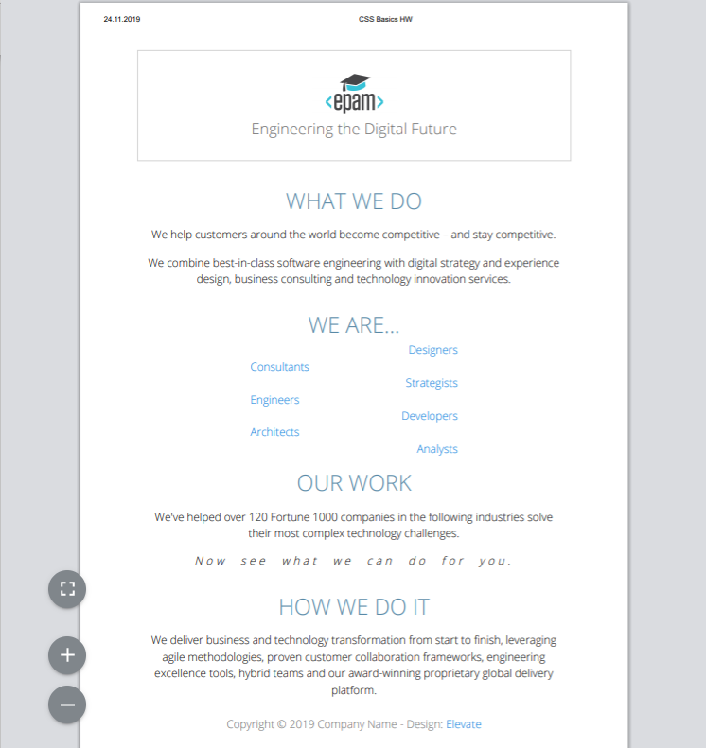

**Figure 1 — Print version**

Apply your custom CSS styles to modify the page print view. The result should look close (not pixel perfect) to the example provided in **Figure 2**.



##### **Figure 2 — Print version (mockup)**

2) Add a hover effect for the navigation items (background color – lightskyblue , text color - #fff). (see **Figure 2**).



**Figure 2 – Navigation hover effect(mockup).**

3) Add gradient from “lightskyblue” color to “burlywood “color for the banner.( see **Figure 3**)

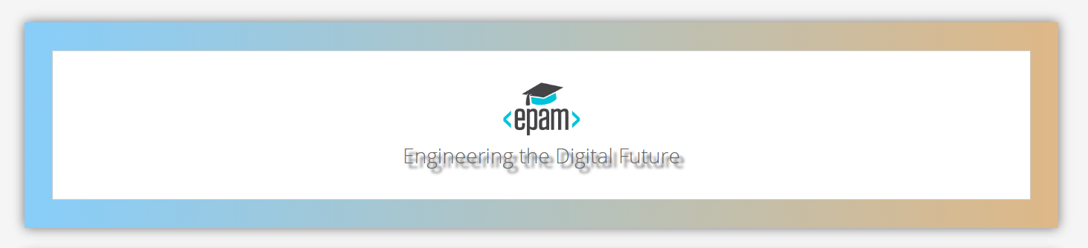**Figure 3 – Banner(mockup).**

4) The banner text should have a shadow. Color of shadow - #333. (see Figure 3)

5) Add animation to the banners text. Make it move from right (**200px)** to center.

(see examples/animation.gif).

6) Add styles for “What we do” section (see **Figure 4**):

- Picture from right side.

- Text from left side and in the center of section.

- Text “What we do” should be in the center.



**Figure 4 – ‘What we Do’ section(mockup).**

7) There is a gallery section in the markup. Please add a hover effect to it as shown in Figure 5. Colors: lightgrey and lightskyblue.

Note: All boxes with text inside should have a hover effect.

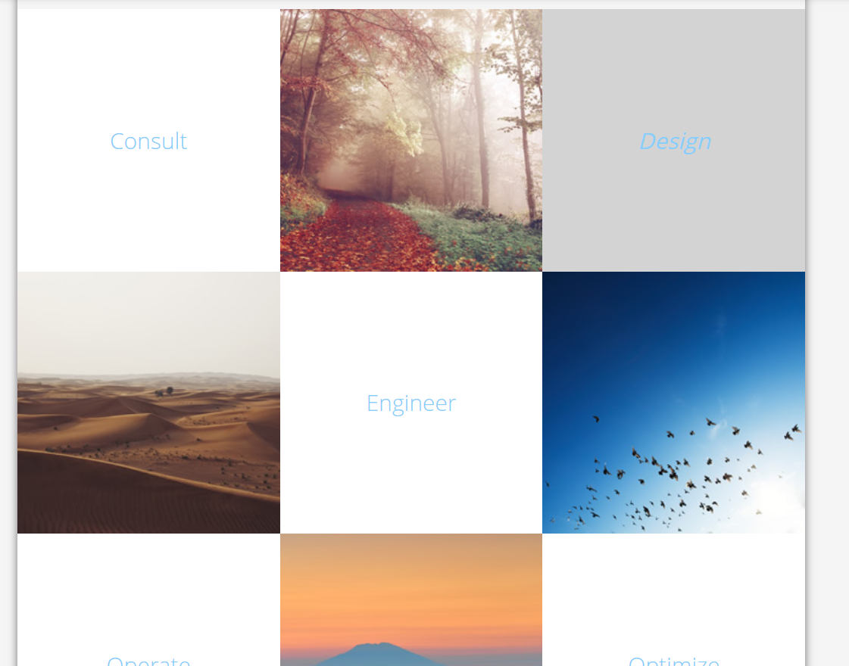

**Figure 5 – Gallery block (mockup).**

8) Add styling to the “We are…” section (see **Figure 6** for reference):

- add styling to section header;

- change list type to **lower-alpha**;

- add “>” to the start of every element of a list.

- add “New” label to the end of “Designers” and “Strategists” list items; change their font- variant and boldness

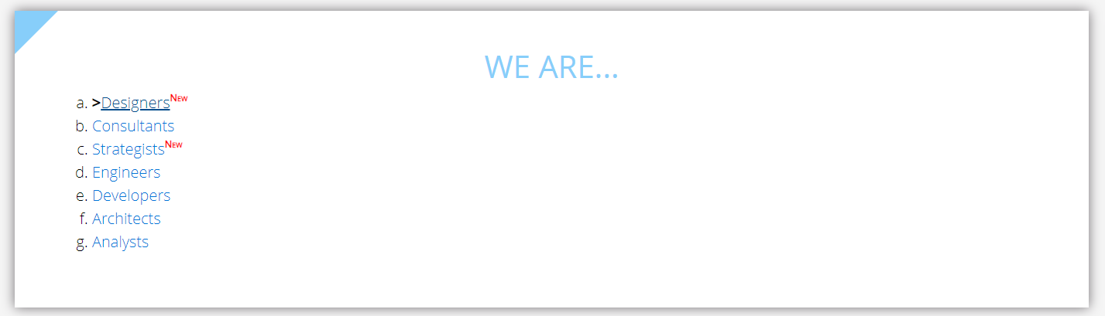

**Figure 6 – List styling (mockup).**

9) **For last paragraph** of section ‘Our work’ add space between letters 5px and space between words 10px and change style of font. Header should be from left side. (see Figure 7)

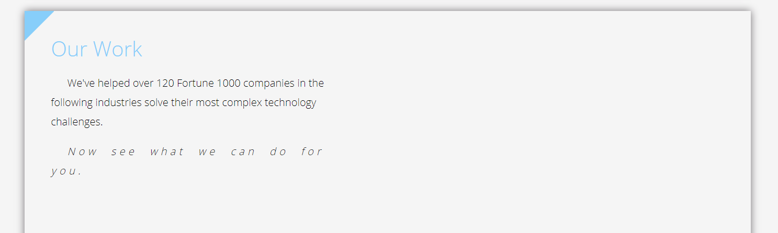

**Figure 7 – “Out Work” section(mockup)**

10) Style the following block as shown in **Figure 8**. Note: First letter of each paragraph is bold.

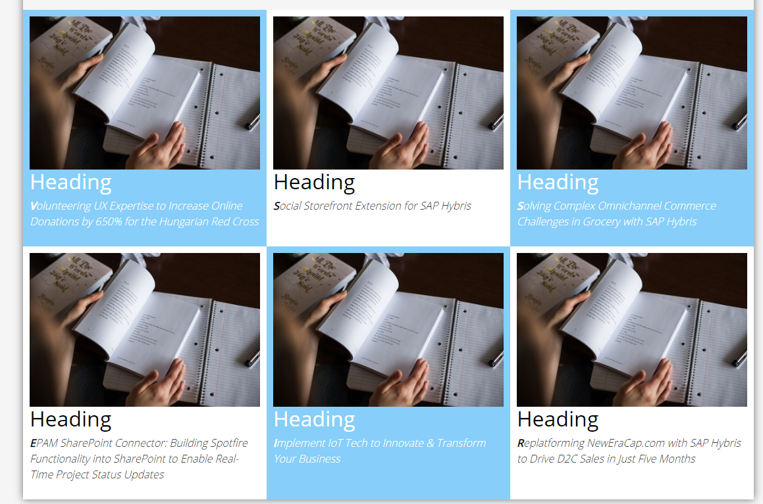

**Figure 8 - Block styling (mockup)**

11) For all paragraphs tm-section-description class set the length of empty space to 25px and height of a line box 30px; (see **Figure 9**)



Figure 9 – Paragraph with spaces(mockup)

12) Style form elements as shown in **Figure 10**. Note that textarea field contains an image (img/search-icon.png) and doesn't have styles for focus.

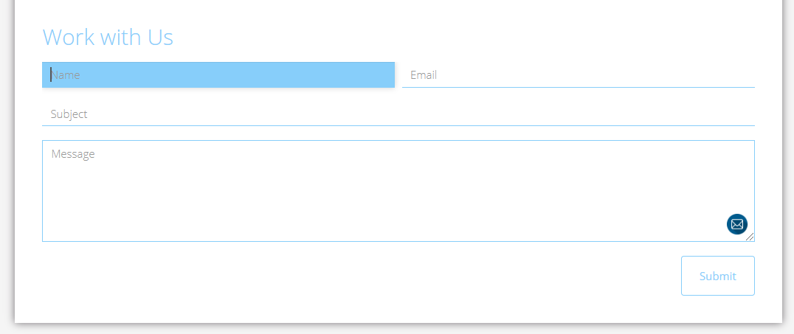

Figure 10 – Form(mockup)

13) Add a box-shadow to navigation and to each content block (color - ***rgba(61, 55, 61, 0.7)***).

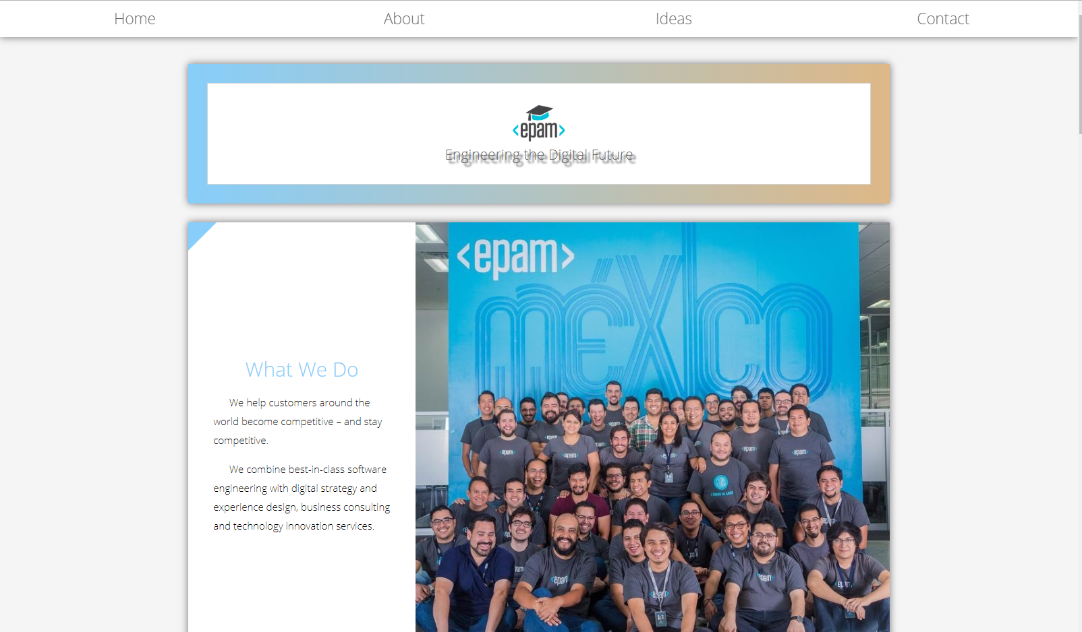

##### **Figure 11 — Blocks shadow and banner’s styling (mockup)**

14) Make use of pseudo-elements to add a blue triangle to each section of the page (see top left corner in **Figure 12**).

**Figure 5 —Triangle (mockup)**

## **RESTRICTIONS**

* Adding/editing styles in the **general.css** and **bootstrap.min.css** file is forbidden;
* Usage of **JavaScript** is forbidden;
* Adding anything to **index.html** is forbidden;
* Adding **task/** and **example/** folders is forbidden. Do not push it to repository (only homework/ folder should be pushed);
* No requirements for browser support (should work properly in Google Chrome last version).

## **BEFORE SUBMIT**

* Read requirements and compare to your homework result;
* Format the code (remove unnecessary lines of code);
* Make sure your GitHub folder structure meets the required one (without **task** and **examples** folders);
* Validate your CSS (https://jigsaw.w3.org/css-validator/.

## **SUBMIT**

* The **FL12_HW2** folder should be uploaded to GitHub repository **“FL-12”** into **master** branch

## **USEFUL LINKS**

* <https://www.smashingmagazine.com/2007/07/css-specificity-things-you-should-know/>
* <https://dev.to/doppelmutzi/understand-how-css-styles-are-applied-to-html-elements-by-learning-the-fundamentals-precedence-specificity-cascade-de4>
* <http://specificity.keegan.st/>
* <https://vegibit.com/css-selectors-tutorial/>
* <https://www.sitepoint.com/css-printer-friendly-pages/>
* <http://htmlbook.ru/css3-na-primerakh/lineinyi-gradient>

1. To see **print preview mode**, open **index.html** file in a browser and press **ctrl+p** (or **cmd+P** for Mac).