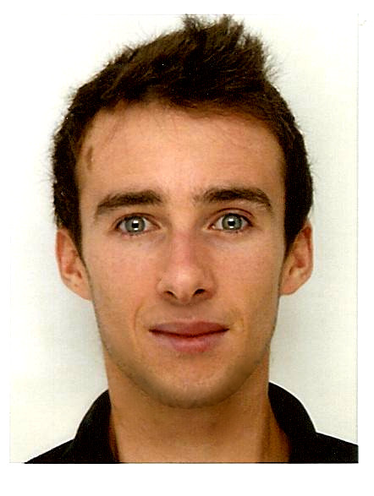
LOÏODICE Thomas
RM 2 17/F Yee Fung building
13 Yau San street
Yuen Long NT
☎: +852 6995 6786
@ : thomas.loiodice@ensimag.grenoble-inp.fr
√ Good interpersonal skills
√ Team worker
√ Dynamic

Applied Mathematics Engineer

Computing Skills

OS : Linux, Mac, Windows
git, svn, gdb, valgrind, Maya, Matlab,Scilab,Maple,Comsol, Wireshark, Blender, Gimp, FreeFem++, Inkscape
Software :

Languages :
C, C++, Python, JAVA, C#, ADA, VHDL, glsl,
SQL, HTML/CSS/JS,

Language

English : C1 Level
Spanish : A2 Level
Japanese : A1 Level
Cantonese : Beginner

Work Experience

- November-Mars 2018-2019 : Process Engineer, Deepsky corp. ltd., Hong Kong
  - Create automation script for LED screen production [Python]

- February-September 2018 : Internship, LIG laboratory, Grenoble (France)
  - Implement and evaluate new interaction for HCI academic research [C++]

- June-September 2017 : Internship, OLM Digital, inc., Tokyo(Japan)
  - Develop a Maya plug-in (API), to implement the Gabor noise [C++]

- July-September 2016 : Internship, Bosh ,Paris (France)
  - Find and implement a real time solution to simulate signal values to test braking systems, [C server, Perl Client]

- May-July 2015 : Internship, Bertin Technologies, Aix-en-Provence, (France)
  - Software solutions development, for The French Army [C#]

- June-July 2014: excellence Internship at Néel institute, CNRS-Grenoble (France)
  - Magnetism variation based on shape at The French National Center for Scientific Research

- September 2013 and 2014 : Host for clients at Bosh Siemens household appliance booth during Pro & Cie exhibition in Lyon (France)

- 2013 : worker internship : “DMC travaux”, Builds (France)
  - Laying floor titles

Education

- 2015-2018: Student at ENSIMAG, Top Computer Science engineer school,
- 2014-2015 : Mathematics and Informatics Third year diploma in Joseph Fourier Grenoble University

