The Role of AI in Transactional Customer Loyalty

Introduction: from Basic Transactions to Intelligent Loyalty
Traditional loyalty schemes reward purchases with points, discounts or cashback. While effective for driving short‑term sales, these “earn and burn” programs treat every customer the same and rarely build emotional loyalty. A 2024 McKinsey review notes that 76 % of consumers become frustrated when they don’t get a personalized shopping experience and are much more likely to engage with brands that tailor offers to them[1]. In a 2025 survey, Salesforce found that 76 % of customers expect companies to understand their unique needs[2]. In other words, consumers increasingly expect brands to remember them, anticipate their desires and offer meaningful value rather than generic discounts. This section explains how artificial intelligence (AI) is transforming transactional programs into intelligent loyalty ecosystems that meet those expectations.

How AI Transforms Transactional Loyalty Programs

Hyper‑personalization at Scale
AI allows brands to move from broad segmentation to a “segment‑of‑one” approach. Machine‑learning models analyze individual purchase history, browsing behaviour, location, weather and even product availability to recommend the most relevant reward or promotion in real time. For example, Starbucks’ Deep Brew platform combines app‑based transaction data with weather and store inventory; the system pushes timely offers (“half‑off cold brew because it’s 95 °F”) that led to 4 million additional store visits and a 13 % increase in active members in early 2024[3]. Such personalized triggers feel like a concierge service rather than a loyalty program and encourage habitual engagement.
Hyper‑personalization also extends to web and email interactions. HubSpot’s analysis of more than 330 000 calls‑to‑action (CTAs) found that personalized CTAs convert 202 % better than generic ones[4]. Shopify’s guide to one‑to‑one marketing cites McKinsey research showing that companies that excel at personalization generate 40 % more revenue than average competitors[5]. Bloomreach’s 2025 personalization report further notes that 78 % of consumers are more likely to make a repeat purchase when online shopping experiences are personalized[6]. These statistics illustrate why AI‑driven personalization has become essential for loyalty.

Predictive Analytics for Retention and Churn Prevention
AI models not only personalize offers; they also predict when customers are likely to disengage. Predictive retention engines synthesize historical purchases, engagement metrics, sentiment signals and external factors (e.g., subscription renewal dates) to estimate churn risk. Sobot’s 2025 churn‑prevention report highlights that real‑world case studies show AI‑driven outreach can reduce churn by up to 35 % and increase customer lifetime value by 35 %[7]. This proactive approach triggers “micro‑offers” or targeted messages when loyalty lapses are detected, letting brands intervene before it’s too late[3]. Telecom and subscription companies that adopted predictive analytics report churn reductions of 15–30 %[7].

Dynamic Pricing and Rewards
AI enables dynamic earn/burn thresholds and personalized pricing. Instead of static tiers, machine‑learning algorithms continuously adjust point accrual rates, redemption values or discount levels based on individual profitability, competitor pricing and inventory levels. This ensures that incentives are sufficient to motivate behaviour without eroding margins. QSR brands like CAVA and Papa Johns used AI to lower redemption thresholds for mid‑frequency guests and saw loyalty sales surge—CAVA’s program drove a 10.8 % year‑over‑year revenue increase with sign‑ups exceeding 50 000 per week in early 2025[8]. By optimizing reward structures in real time, businesses can remain competitive while safeguarding profitability.

Gamification and Engagement
Gamified loyalty programs leverage AI to design missions, quests and challenges based on members’ historical behaviours. Carrefour’s MyClub program sets personalized thresholds and goals that encourage shoppers to try new categories; ASDA’s gamified “Pounds, not points” initiative let members build pots of cash through in‑app quests and propelled the chain to Britain’s #3 supermarket loyalty spot within two years[9]. These game mechanics tap into psychological motivators like achievement and progress. AI constantly refreshes missions to keep them relevant and ensures that rewards align with both customer interests and business goals.

Fraud Detection and Operational Efficiency
AI protects program integrity and keeps operations running smoothly. Advanced computer‑vision and pattern‑recognition models flag duplicate accounts, tampered receipts and suspicious redemption patterns. Platforms like Snipp’s CORRAL use AI and real‑time monitoring to detect fraud across channels and automatically block invalid claims[10]. On the operational side, AI continuously monitors API performance and system health, alerting teams before technical issues affect users[11]. This “loyalty immune system” ensures the program remains reliable while allowing human teams to focus on high‑value activities.

Integration with Omnichannel and Partner Ecosystems
Modern loyalty ecosystems extend beyond a single brand. AI integrates loyalty platforms with customer‑data platforms (CDPs), e‑commerce engines and partner networks to deliver seamless experiences across channels. Sephora’s Beauty Insider program offers exclusive experiences—such as winery tours—through partners; CVS Health’s app combines personalized health reminders with partner content, resulting in a 22 % increase in active users[12]. These partner ecosystems are guided by AI‑driven segmentation and recommendation engines that match members with relevant experiences, thereby deepening emotional connections to the brand.

Evidence of Consumer Expectations and Business Impact
Insight | Statistic | Source
Consumers expect personalization | 76 % of consumers expect companies to understand their unique needs[2]. | Salesforce’s State of the Connected Customer report (2025)
Willingness to share data | 83 % of shoppers would exchange data for a more personalized experience[13]. | HubSpot/Accenture via World Light Media (2023)
Impact on repeat purchases | Personalization drives repeat purchasing: 78 % of consumers are more likely to repurchase from brands that personalize[6]. | McKinsey cited in Bloomreach report (2025)
Revenue uplift from personalization | Companies that excel at personalization generate 40 % more revenue than average players[5]. | McKinsey research (2024)
Personalized CTAs boost conversions | Personalized calls‑to‑action convert 202 % better than standard CTAs[4]. | HubSpot analysis of 330 000 CTAs (2025)
AI reduces churn and increases CLV | AI‑driven outreach can reduce churn by up to 35 % and increase customer lifetime value by 35 %[7]. | Sobot case studies (2025)
Marketer adoption of AI | 84 % of marketers say AI improves the efficiency of their marketing teams[14]. | Salesforce “State of Marketing” (2024)
AI boosts lead qualification | AI‑powered lead generation increases the number of qualified leads by up to 50 %[15]. | Harvard Business Review cited by the Center for Sales Strategy (2024)
These data points underscore why integrating AI into loyalty programs is not just a trend but a business imperative. Consumers demand personalization and are willing to share their data for it, while businesses that deliver see measurable gains in revenue, conversion and retention.

Future Outlook: Toward Intelligent, Emotion‑Driven Loyalty

Full Automation and Real‑Time Decisioning
The next generation of loyalty programs will use AI to orchestrate real‑time decisions across the entire customer journey. Context‑aware engines will determine the optimal reward, message and channel at each micro‑moment, balancing customer delight with profitability. As edge computing and 5G enable faster data flows, these systems will operate at the speed of life—adjusting promotions based on weather or local events, and updating rewards as inventory changes.

Integration with Emerging Technologies
AI will increasingly collaborate with other technologies to create immersive experiences. Internet‑of‑Things (IoT) devices will trigger rewards when customers enter a store or use a product; augmented‑reality (AR) experiences will bring gamified quests into physical spaces; and blockchain could power transferable or tradable loyalty tokens. Such integrations will extend loyalty beyond transactions to experiences, tapping into the 75 % of emotional drivers of loyalty[16].

From Loyalty to Advocacy and Community
Hyper‑personalization and predictive insights enable brands to identify and nurture potential advocates. AI can analyze sentiment, engagement and social influence to determine which members might become brand evangelists. By offering exclusive experiences or co‑creation opportunities to these advocates, businesses foster emotional bonds that transcend mere transactions. In essence, AI allows loyalty programs to evolve into community platforms where customers feel seen, heard and valued.

Ethical Considerations and Responsible AI
As AI processes ever more personal data, ethical stewardship becomes paramount. Research shows that 71 % of consumers feel “watched” when personalization becomes overly specific[17], underscoring the need for transparency and consent. Businesses must adhere to privacy regulations (e.g., GDPR and CCPA) and communicate the value exchange clearly: personalized experiences in return for data[18]. Responsible AI frameworks should include bias mitigation, explainability and governance to ensure fairness and trust.

Recommendations for Businesses
- Invest in a unified customer‑data platform (CDP). Accurate personalization and predictive analytics require comprehensive, real‑time customer profiles. Integrating disparate data sources (e‑commerce, POS, mobile apps) enables AI models to deliver relevant offers and detect churn early.
- Start small with pilot programs. Rather than overhauling the entire loyalty ecosystem, begin with targeted AI applications (e.g., predictive churn alerts or dynamic offer optimization). Measure success through clear KPIs such as uplift in repeat purchase rate or reduction in churn.
- Balance personalization with privacy. Offer value‑exchange messaging (“share your preferences to receive tailored rewards”) and provide customers control over their data. Ensure compliance with regional data regulations and implement strong cybersecurity measures.
- Leverage gamification and experiences. Incorporate missions, challenges and experiential rewards that align with customer interests. Use AI to refresh challenges regularly and adjust difficulty levels to keep engagement high.
- Foster a culture of experimentation. Continuously A/B test different reward structures, messaging and gamification mechanics. Let AI algorithms learn from these experiments to refine personalization and retention strategies.

Conclusion
AI is revolutionizing transactional loyalty programs by moving them from reactive, one‑size‑fits‑all point schemes to intelligent ecosystems that understand, predict and delight customers. Hyper‑personalization, predictive retention, dynamic rewards, gamification and fraud control are no longer futuristic concepts; they are being deployed today with measurable results. As consumers increasingly demand tailored experiences and businesses see clear returns from personalization, the fusion of AI and loyalty will become a cornerstone of competitive strategy. To stay ahead, brands must embrace AI responsibly, integrate it with emerging technologies, and design loyalty initiatives that cultivate emotional connections and brand advocacy.
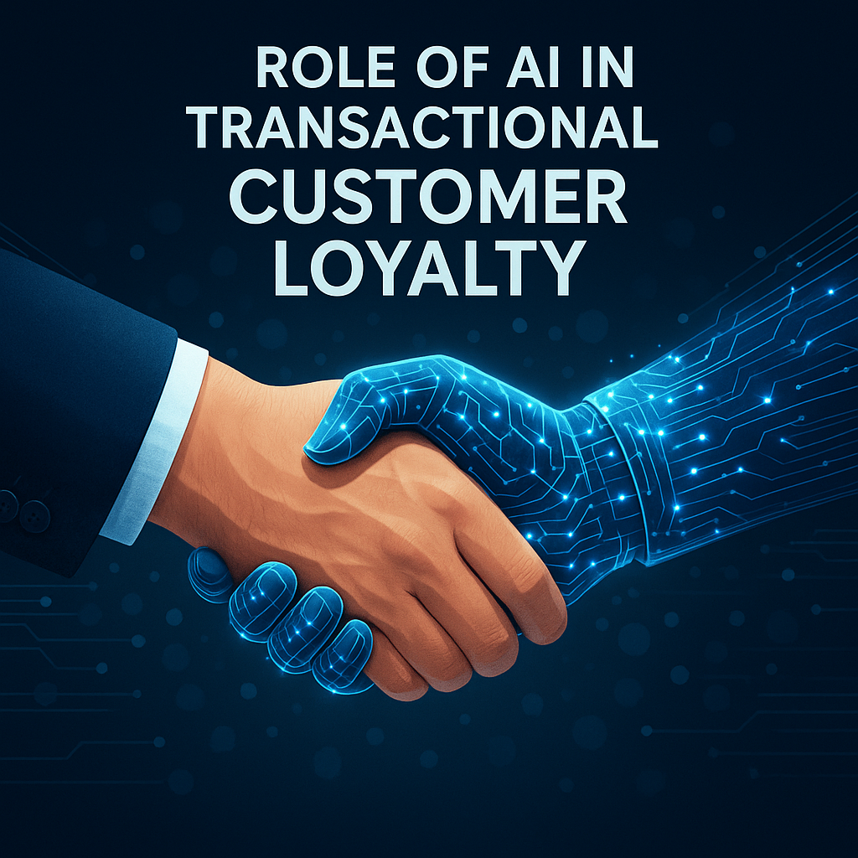

[1] [5] What Is One-to-One Marketing? Strategies To Drive Growth (2024) - Shopify
https://www.shopify.com/blog/one-to-one-marketing
[2] A Guide to Customer Retention Automation - Surva.ai
https://www.surva.ai/blog/customer-retention-automation
[3] [8] [9] [10] [11] [12] [16] [17] [18] How AI Loyalty Programs Are Powering Customer Engagement
https://www.snipp.com/blog/ai-loyalty-programs
[4] 15 Call-to-Action Statistics You Need to Know About to Increase Your Conversion Rate
https://blog.hubspot.com/marketing/personalized-calls-to-action-convert-better-data
[6] Marketing Technology Features You Need to Power Personalization | Bloomreach
https://www.bloomreach.com/en/library/guides/power-personalization-with-the-right-marketing-technology
[7] 10 Ways AI Is Transforming Churn Prevention This Year
https://www.sobot.io/article/ai-customer-churn-prediction-and-prevention-trends-2025/
[13] Why Personalization Is the Key to Winning More Inbound Leads
https://www.worldlightmedia.com/blog/why-personalization-is-the-key-to-winning-more-inbound-leads
[14] AI-Driven Marketing Strategies to Boost Business Growth
https://bolsterbiz.com/ai-driven-marketing-strategies/
[15] The Role of AI in Sales Strategy: Leveraging Predictive Analytics for Smarter Targeting
https://blog.thecenterforsalesstrategy.com/the-role-of-ai-in-sales-strategy

