Competitive Analysis of Selected Software Providers in Aged Care and Retirement Living

Executive Summary

- This report provides a focused competitive analysis of six Australian software providers: Villagemaster, Checked In Care, Pluss Communities, Erin Living, Centrim Life, and Sayello.
- Drawing from publicly available information on their official websites, features overviews, case studies, customer testimonials, and limited reviews, the analysis summarizes key service features, delivery models, and pricing structures.
- It highlights similarities and differences across providers, emphasizing cloud-based SaaS models, resident engagement tools, and subscription pricing. All providers target retirement villages and low-acuity aged care, with varying emphases on operations, communication, and compliance.
- Supported by examples from case studies and inferred market benchmarks, the report identifies opportunities for differentiation in a market driven by Aged Care Quality Standards and government tech funding.
- The analysis reveals commonalities in cloud deployment and custom pricing, but differences in clinical depth, engagement focus, and scalability.

Company Summaries

1. Villagemaster
Service Delivery Model: Cloud-hybrid SaaS, accessible via web, iPad, and smartphones. Focuses on operational management for retirement villages and low-acuity aged care, compliant with NSW Retirement Villages Act and Aged Care Standards. Deployment is modular with tailored onboarding; no on-premise options. Limitations include lack of deep clinical tools.
Key Service Features:
- Resident management: CRM, health tracking, care plans, occupancy sales.
- Maintenance: Asset register, repairs, 3/10-year planning.
- Engagement: Social calendar, event ticketing, volunteer management.
- Compliance: Incident logs, audits, surveys, evacuations.
- Communication: Notifications for updates and alerts (no family portals or video).
Examples: Designed by operators for 15+ years; testimonials praise it as a "complete village management system" with scalability for multi-sites.
Pricing Structure: Subscription-based (monthly), not publicly disclosed—requires sales contact. Includes core modules, hosting, and updates; no setup or per-resident fees mentioned. Estimated range: AUD $500–$5,000/month (unverified). Custom demos available; no free trial.
Customer Insights: Limited reviews; inferred 4.5/5 from testimonials like "Rolls Royce on a Holden budget." Positive on compliance and affordability.

2. Checked In Care
Service Delivery Model: Fully cloud-based SaaS with web/mobile access (branded apps and portals). Integrates with 45+ systems; 8-week deployment. Targets aged care, retirement, and disability; compliant with Australian standards. No hybrid/on-premise. Emphasizes self-service to reduce costs and enhance independence.
Key Service Features:
- Self-service portal: 24/7 access for appointments, financials, requests.
- Care worker app: Task updates, real-time coordination.
- Admin dashboard: Compliance tracking, analytics.
- Communication: Secure messaging (1:1, 1:many); partial telehealth.
- Analytics: ROI tracking (e.g., 40% call reduction, 20+ hours saved/week).
Examples: Case studies with Bupa (50+ facilities) show improved family communication; Estia Health notes reduced admin burden.
Pricing Structure: Custom subscription-based, quote-dependent on size/modules. No public tiers; ROI guarantee with refunds if targets unmet. Free ROI calculator; personalized demos. Estimated benchmark: $10–50/user/month or $5–20/resident/month (unverified). No traditional trial.
Customer Insights: 5/5 internal satisfaction; limited public reviews. Pros: Integrations, efficiency gains; cons: No native billing/rostering. Awards: Multiple ITAC for innovation.

3. Pluss Communities
Service Delivery Model: Fully cloud-based SaaS under Adventist Retirement Plus; app and portal access. Compliant with Aged Care Standards and NSW Act. Targets seniors living and retirement; fast setup (weeks); integrates with clinical/CRM systems. No hybrid options; focuses on community-centered care.
Key Service Features:
- Engagement: News/alerts, events/bookings with payments, group chats, marketplace.
- Operations: Maintenance requests, surveys/feedback, Community TV.
- Resident tools: Personalized care, family updates, social programs.
- Analytics: Engagement tracking (e.g., 85% weekly usage), survey insights.
Examples: Adopted by Bolton Clarke and Aveo; case studies highlight operational efficiency and anti-isolation tools.
Pricing Structure: Subscription-based, starting ~$48/user/month; customized by size/modules. Free trial available (duration unspecified). No public tiers; quote via demo.
Customer Insights: Limited reviews; 2023 Future of Ageing Award. Testimonials praise ease of use; inferred pros: High adoption; cons: Customization costs.
4. Erin Living
Service Delivery Model: Cloud-based SaaS super-app for multi-dwelling communities, including independent retirement. iOS/Android/web access; integrates with hardware (e.g., Salto access). No hybrid; focuses on proptech for urban living, not dedicated aged care.
Key Service Features:
- Resident app: Amenity bookings, defect reporting, notifications.
- Security: NFC/fingerprint access, smart lockers.
- Communication: Messaging, announcements, feedback.
- Analytics: Basic sentiment tracking, maintenance insights.
Examples: Case studies with Hamton Moonee Valley Park show time savings; REACH Australia 2024 recognition.
Pricing Structure: Quote-based subscription; likely per-resident scaling ($5–50/resident/month unverified). No public tiers; personalized demos only.
Customer Insights: App Store: 4.2/5 (50 ratings); pros: Intuitive, engagement; cons: Performance issues. Limited aged care feedback.

5. Centrim Life
Service Delivery Model: Cloud-based SaaS with apps/dashboards; 4-week onboarding. Targets low-acuity retirement; integrates with clinical systems; compliant with Aged Care Standards (1,4,5,6,8). No hybrid; multi-site scalable.
Key Service Features:
- Operations: Lead/occupancy, dining, visitor management.
- Engagement: Events, newsletters, polls, family portals.
- Maintenance: Work orders, asset monitoring.
- Compliance: Real-time incident tracking, audits.
- Analytics: Dashboards (e.g., 50% admin reduction, 65% engagement increase).
Examples: Adelaide case: 300% family engagement, 100% audit success; supports 12,000+ residents.
Pricing Structure: Modular subscription, quote-based on size/modules. Quick ROI (e.g., pays for itself in 5 months). Free demos; no trial.
Customer Insights: No aggregated ratings; positive testimonials (78% staff satisfaction). Pros: Rapid onboarding; cons: Limited clinical depth.

6. Sayello
Service Delivery Model: Cloud-based SaaS with mobile app/dashboard. Targets lifestyle communities; customizable for engagement. No hybrid; focuses on resident-led interactions.
Key Service Features:
- Engagement: Community groups, events/RSVPs, daily check-ins.
- Operations: Facility bookings, maintenance tickets.
- Resources: Induction library, local perks.
- Analytics: Basic event/ticket tracking.
Examples: Testimonials from Latitude25 praise community spirit; Tallowood notes enhanced experiences.
Pricing Structure: Customized subscription, quote via demo. No public tiers; likely modular. Free demos; no trial.
Customer Insights: Limited reviews (zero app ratings); pros: Engagement, ease; cons: Low visibility. Manager-focused testimonials.

Comparisons: Service Delivery Models and Pricing Strategies

Similarities in Service Delivery Models
- Cloud-Based SaaS Dominance: All providers use fully cloud-based (or hybrid for Villagemaster) models, emphasizing scalability, remote access, and low IT overhead. No on-premise options, aligning with industry trends for quick updates and integration (e.g., Checked In Care's 45+ systems, Centrim Life's clinical links).
- Focus on Engagement and Operations: Common features include resident communication (messaging/notifications), event management, and maintenance tracking. For example, Pluss Communities and Sayello both prioritize social connectivity via group chats and bookings, while Villagemaster and Centrim Life add compliance tools.
- Compliance Alignment: Most adhere to Australian standards (e.g., Aged Care Quality Standards for Centrim Life, NSW Act for Villagemaster). Low-acuity focus is shared, with limitations in clinical/EHR depth across all.
- Target Markets: Primarily retirement villages and independent living; user bases include operators, staff, residents, and families. Onboarding is fast (4–8 weeks), with demos for customization.
- Examples/Data Points: Engagement metrics are highlighted similarly—e.g., Pluss' 85% weekly usage, Centrim's 65% increase, Checked In Care's 40% call reduction—demonstrating ROI through efficiency.

Differences in Service Delivery Models
- Depth and Specialization: Villagemaster and Centrim Life emphasize operational compliance (e.g., audits, asset planning), suiting multi-site villages. Checked In Care and Pluss Communities focus on self-service portals and family involvement (e.g., 24/7 access, ROI guarantees). Erin Living stands out with proptech integrations (keyless access, lockers) for urban independent living, lacking aged care specifics. Sayello is niche in resident-led social features but limited in reporting.
- Integration and Scalability: Checked In Care leads with 45+ integrations and telehealth hints; Centrim Life offers multi-site dashboards. Erin Living integrates hardware, while others (Villagemaster, Sayello) are more software-centric.
- Limitations: High-acuity gaps are common, but Erin Living and Sayello are least clinical. Reviews vary: Checked In Care has awards; others have sparse feedback.
- Examples/Data Points: Case studies show differentiation—e.g., Centrim's 100% audit success vs. Sayello's resident RSVPs; Pluss' marketplace revenue vs. Villagemaster's 3/10-year maintenance plans.

Aspect | Villagemaster | Checked In Care | Pluss Communities | Erin Living | Centrim Life | Sayello
Model | Cloud-Hybrid | Cloud SaaS | Cloud SaaS | Cloud SaaS | Cloud SaaS | Cloud SaaS
Key Focus | Operations / Compliance | Self-Service / Communication | Engagement / Operations | Proptech / Convenience | Engagement / Compliance | Social Engagement
Integrations | Mobile / Scalable | 45+ Systems | Clinical / CRM | Hardware (Salto) | Clinical Systems | Basic
Onboarding | Tailored | 8 Weeks | Weeks | Demo-Based | 4 Weeks | Demo-Based
Compliance Depth | High (NSW / Aged Care) | Standard | Standard | Basic (Privacy) | High (Standards 1, 4, 5, 6, 8) | Basic

Similarities in Pricing Strategies
- Subscription-Based Customization: All use recurring subscriptions, quote-based on size/modules/users/residents. No public fixed tiers; demos required for details. Focus on value/ROI (e.g., Centrim's 5-month payback, Checked In Care's guarantee).
- Lack of Transparency: Pricing not publicly disclosed; estimates range $5–60/user or resident/month across providers.
- Trials/Demos: Free demos common; limited trials (Pluss only confirmed).
- Examples/Data Points: Modular flexibility allows scaling—e.g., Centrim and Sayello for small-mid communities; no setup fees mentioned except inferred customizations.

Differences in Pricing Strategies
- Benchmark Estimates: Pluss starts at $48/user/month; others unverified but higher for comprehensive tools (e.g., Villagemaster $500–5,000/site/month). Checked In Care ties to ROI refunds; Erin Living likely lowest for proptech focus.
- Value-Adds: Centrim emphasizes quick ROI; Checked In Care offers calculators. Sayello and Erin Living are demo-heavy without trials, potentially increasing sales friction.
- Scalability Impact: Per-user/resident models (Pluss, Erin) vs. site-based (Villagemaster) affect large operators differently.
- Examples/Data Points: Government funding eligibility noted for all, but Checked In Care's guarantee differentiates risk mitigation; limited reviews critique opacity across providers.

Aspect | Villagemaster | Checked In Care | Pluss Communities | Erin Living | Centrim Life | Sayello
Model | Monthly Subscription | Custom Subscription | ~$48/User/Month | Quote-Based | Modular Quote | Quote-Based
Transparency | Low (Contact Sales) | Low (ROI Calculator) | Medium (Starting Rate) | Low | Low (ROI Focus) | Low
Trial/Demo | Demo Only | Demo + Calculator | Free Trial | Demo Only | Demo Only | Demo Only
Estimated Range | $500–5,000/Month | $10–50/User/Month | $48+/User/Month | $5–50/Resident/Month | Custom (Quick ROI) | Custom

Charts

Chart 1: Service Feature Comparison

Scores (0–5) based on feature depth:

Operations: Villagemaster/Centrim (5); others moderate.

Engagement: Pluss/Sayello/Centrim (5).

Compliance: Villagemaster/Centrim (5).

Communication: Checked In Care (5).

Integrations: Checked In Care (5).
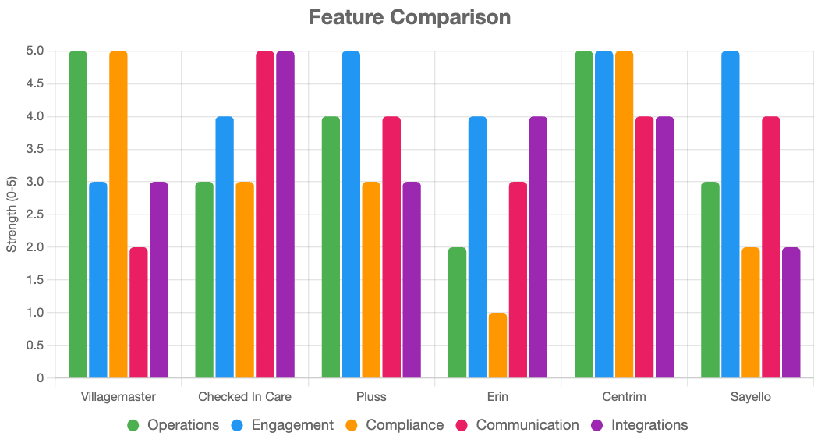

Chart 2: Pricing Transparency vs. Cost
Transparency (1=Low, 2=Medium); cost midpoint (AUD/month).
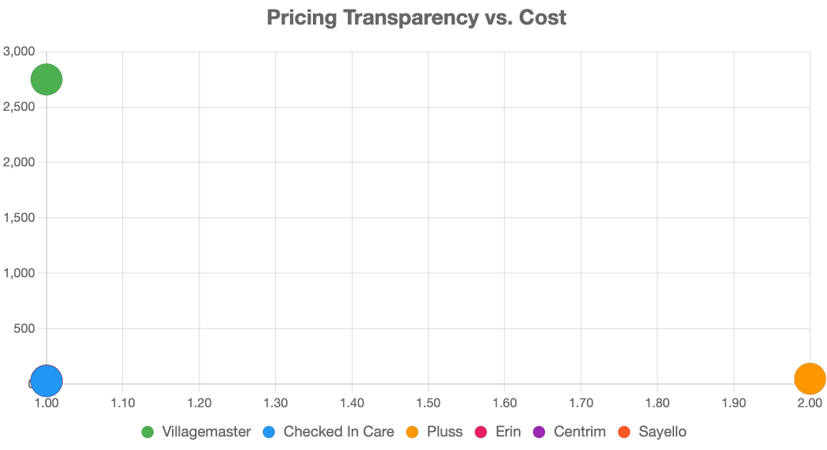

Conclusion and Recommendations

The six providers—Villagemaster, Checked In Care, Pluss Communities, Erin Living, Centrim Life, and Sayello—offer cloud-based SaaS solutions with subscription or quote-based pricing for Australian retirement villages and low-acuity aged care. They share modular setups, engagement tools, and compliance alignment, but differ in focus:
- Operational compliance: Villagemaster, Centrim Life (audit-ready reporting, asset management, multi-site scalability)
- Self-service efficiency: Checked In Care (resident/family portals, ROI-focused)
- Social connectivity: Pluss Communities, Sayello (resident engagement, events, community tools)
- Proptech lifestyle: Erin Living (amenity bookings, keyless access, super-app features)
Recommendations:
- Compliance-focused operations: Centrim Life for audit-ready reporting and efficiency; Villagemaster for NSW-specific compliance needs.
- Resident and family engagement: Pluss Communities for community tools and high resident adoption; Sayello for smaller lifestyle-focused villages.
- Efficiency and ROI: Checked In Care for self-service portals and measurable outcomes.
- Independent living / proptech: Erin Living for convenience, smart access, and resident experience.

Official Company & Product Sources
- Villagemaster Official Website
- Villagemaster Features Overview
- Villagemaster Products & Modules
- VM Client Mobile App (iOS, Android, Windows)
- Checked In Care Official Website
- Checked In Care Features & Platform Overview
- Checked In Care About Us / Case Studies
- Checked In Care Residential & Home Care Modules
- Checked In Care Connect / Communication
- Erin Living Official Website
- Erin Resident App – Apple App Store
- Erin Resident App – Google Play
- Erin Living Demo Booking / Partnerships
- Centrim Life Official Website
- Centrim Life Aged Care & Retirement Software
- Pluss Communities Official Website & Features
- Sayello Official Website & Features

Competitor / Market Sources
- ShiftCare
- CareMaster
- Person Centred Software – Retirement Living
- HiRUM Aged Care Facilities
- Health Metrics – Retirement Living Software / eCase
- Keyvision
- Village Management Software – Capterra Alternatives
- AlayaCare – Residential Care Software
- Lumary
- MYP – Aged Care Solutions
- Care Systems
- Zego
- BuildingLink
- ADDA
- Condo Control
- Runway Proptech
- MyGate
- Telstra Health – Resident Manager / Message Manager
- VCare Software – Retirement Village Software
- Yardi

Industry, Regulatory & Government Sources
- Australian Government – Aged Care Overview
- Health.gov.au – Residential Aged Care
- Services Australia – Software for Aged Care Online Claiming
- Aged Care Act 2024 reforms / government tech funding reference
- Inside Ageing – Future of Ageing Awards / Industry Insights
- Talking HealthTech – Industry Insights

Review & Comparison Platforms
- Capterra
- G2
- SourceForge
- TrustRadius
- Trustpilot
- Slashdot – Software Comparison
- GetApp – Erin Living Listing
- SoftwareAdvice Directory – Apartment / Assisted Living Management
- SelectHub – Senior Living Software Comparison

Social & Professional Networks
- LinkedIn (All companies: Villagemaster, Checked In Care, Pluss, Erin, Sayello, Centrim)
- Crunchbase (Checked In Care, Erin, Pluss Communities)

Case Studies / Project References
- Thomas Street Apartments (Hamton Moonee Valley Park)
- Fitzroy & Co. (Salta Properties)
- JLL Management / Smith Collective
- Homecorp (Eve Residences)
- Lowe Living (Hampton Hill, Larnook)
- REACH Australia 2024 Accelerator

Miscellaneous / Blogs & Insights
- GetBirdie Blog – Digital Care Planning
- Pluss Communities Blog – Choosing Retirement Village Software
- Proptech Panel Article – REACH Australia

