Planning notes for 2024 commissioning (see next page for the latest plan)

Field center is COSMOS again: 10:00:40 +02:14:30

Three scanning strategies explored (target rms of 1 mJy/beam):

- Az-EL (or RA-Dec) raster map of 1 sq degree area with a scan speed of 2 minutes/sec – 3.14 hr, 0.59h overhead (5 passes)
- Az-EL (or RA-Dec) raster map of 1 sq degree area with a scan speed of 5 minutes/sec – 3.66 hr, 1.22h overhead (12 passess)
- RA-DEC rasterjous map of 45’ x 45’ area – 1.1 hr, 0.1h overhead (1 pass, sigma=1.15 mJy, mapping speed = 1 deg2 / (h mJy2)

Grant suggests doing all three. The 1hr time limit for rasterjous can be broken up and restart after pointing and combined later. So we should explore this option.

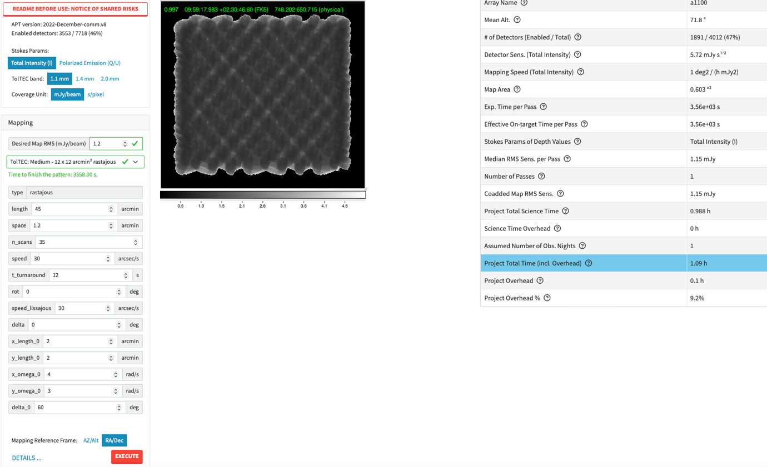

Updated Plan on January 28, 2024

- Rastajous scanning in two parts:

- 60’ x 30’ map centered on 10:00:40 +02:29:30 (“North”)
- 60’ x 30’ map centered on 10:00:40 +01:59:30 (“South”)

They each take 1.65h (0.14h overhead), so the total time is 3.3hr (0.3h overhead).

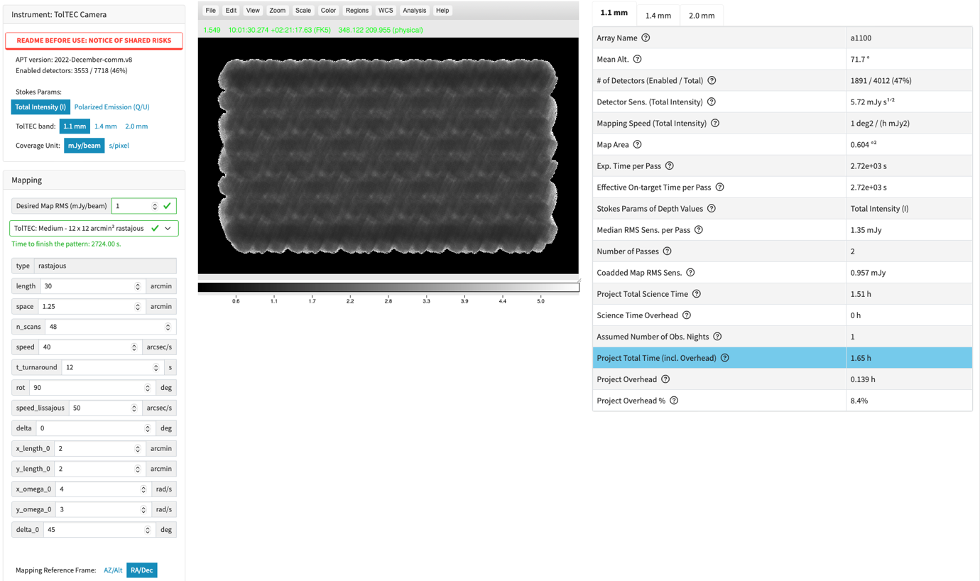

B. Raster mapping tests: (pick two out of three, depending on what modes need testing)

- Slow raster RA/Dec: 60’ x 60’ at 2 arcmin/s for 2.89h (0.56h overhead) in 7 passes
- Fast raster RA/Dec: 60’ x 60’ at 5 arcmin/s for 3.66h (1.22h overhead) in 12 passes
- Fast raster AZ/EL: 60’ x 60’ at 5 arcmin/s for 3.66h (1.22h overhead) in 12 passes

