EMERALD ROYAL INTERNATIONAL SCHOOL, MPAPE ABUJA
LESSON PLAN AND NOTE 1 FOR WEEK 1 ENDING FRIDAY, 15TH SEPTEMBER, 2023
TERM: FIRST TERM
WEEK: WEEK 1
SUBJECT: BASIC SCIENCE
TOPIC: THE SENSES - SEEING
SUB-TOPIC: SEEING (PARTS OF THE EYE)
DATE: TUESDAY, 12TH SEPTEMBER, 2023
TIME: 08:10 – 8:45AM AND 08:45 – 9:25AM
DURATION: 40 MINUTES
PERIOD: 1ST AND 2ND
CLASS: GRADE 1
NUMBER IN CLASS: SIX
AVERAGE AGE: FIVE
SEX: MIXED
LEARNING OBJECTIVES: By the end of the lesson, the pupils should be able to
- Identify the eye
- Identify parts of the eyes
- State parts of the eyes
RATIONALE: For pupils to learn and know the purpose of the eye.
PREVIOUS KNOWLEGDE: Pupils know they have eyes as part of the body.
INSTRUCTIONAL MATERIALS:
- Pupils eyes
- Picture charts of an eye
- Pupils textbooks
REFERENCE MATERIALS:
- Lantern Comprehensive Basic Science And Technology For Primary Schools Book 2 by O.J Ehindero, J.B Arubayi etal 2000
- Foundations of Basic Science and Technology Book 2 by chris Ijiyemi

LESSON DEVELOPMENT
STAGES/STEPS | TEACHER’S ACTIVITIES | PUPILS’ ACTIVITIES | LEARNING POINTS
INTRODUCTION | Review previous knowledge | Participate in the discussion | Arousing the pupils interest
PRESENTATION  STEP 1 | Leads pupils to identify an eye.  AN EYE  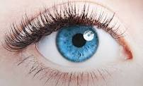  The eyes is an organ of sight. | Identify the eye | For proper understanding
STEP 2 | 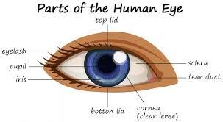  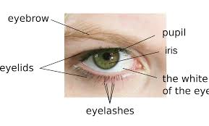  Leads pupils to identify parts of the eye. | Identify the parts of the eye | For better understanding
STEP 3 | Teaches pupils the parts of the eye.  Parts of the eye are  - Pupil  - Iris  - Upper eyelid  - Lower eyelid  - Eye lashes  - Cornea (eyeball) | List the parts of the eye | For further understanding
SUMMARY | Summarises the lesson by emphasising on the main concept and writes note on the board | Listen and copy their notes | For onward study
EVALUATION | Asks pupils to  - Identify the eye  - Identify parts of the eyes  - State parts of the eyes | Respond to the teachers questions | To test the understanding of the lesson
CONCLUSION | Summarises, reacts and corrects the pupils | Answer to the teachers questions | To consolidate the lesson
HOME WORK | Smart Basic Science and Technology Book 2  Page 4  Exercise 3 | Returns home with task | Extending the lesson home

LESSON PLAN AND NOTE 2 FOR WEEK 1 ENDING FRIDAY, 15TH SEPTEMBER, 2023
TERM: FIRST TERM
WEEK: WEEK 1
SUBJECT: BASIC SCIENCE
TOPIC: THE SENSES - SEEING
SUB-TOPIC: USEFULNESS OF THE EYE (NAMING OBJECTS BASED ON COLOUR)
DATE: WEDNESDAY, 13TH SEPTEMBER, 2023
TIME: 09:25 – 09:55AM
DURATION: 40 MINUTES
PERIOD: 3RD
CLASS: GRADE 1
NUMBER IN CLASS: SIX
AVERAGE AGE: FIVE
SEX: MIXED
LEARNING OBJECTIVES: By the end of the lesson, the pupils should be able to
- State the usefulness of the eyes
- Identify different colours
- Name objects with different colours
RATIONALE: For pupils to learn and know the usefulness of the eye.
PREVIOUS KNOWLEGDE: Pupils identify eye and learnt about parts of eyes.
INSTRUCTIONAL MATERIALS:
- Pupils eyes
- Picture charts of an eye
- Pictures charts of objects
- Colours
- Pupils textbooks
REFERENCE MATERIALS:
- Lantern Comprehensive Basic Science And Technology For Primary Schools Book 2 by O.J Ehindero, J.B Arubayi etal 2000
- Foundations of Basic Science and Technology Book 2 by chris Ijiyemi

LESSON DEVELOPMENT
STAGES/STEPS | TEACHER’S ACTIVITIES | PUPILS’ ACTIVITIES | LEARNING POINTS
INTRODUCTION | Review previous knowledge | Participate in the discussion | Arousing the pupils interest
PRESENTATION  STEP 1 | Teaches pupils the usefulness of the eyes.  We see with our eyes.  The eyes is used to see  - Objects around us  - The road we walk on  - What we read and write  - The food we eat  - The clothes we wear  Etc. | Learn attentively | For proper understanding
STEP 2 | Leads pupils to Identify different colours.  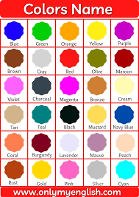 | Identify the colours | For better understanding
STEP 3 | Leads pupils the name objects with different colours.  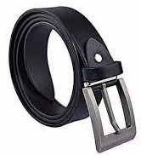  A black belt  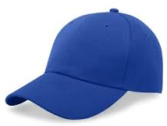  A blue cap  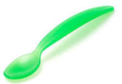  A green spoon  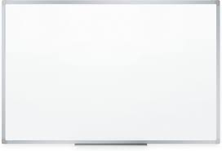  A white board  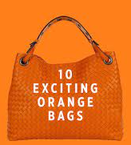  An orange bag  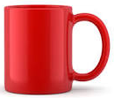  A red cup  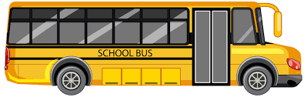  A yellow bus  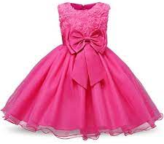  A pink dress  Etc. | Name objects with colours | For further understanding
SUMMARY | Summarises the lesson by emphasising on the main concept and writes note on the board | Listen and copy their notes | For onward study
EVALUATION | Asks pupils to  - State the usefulness of the eyes  - Identify different colours  - Name objects with different colours | Respond to the teachers questions | To test the understanding of the lesson
CONCLUSION | Summarises, reacts and corrects the pupils | Answer to the teachers questions | To consolidate the lesson
HOME WORK | Smart Basic Science and Technology Book 2  Page 7  Exercise 7 | Copy and Returns home with task | Extending the lesson home

Approved as a working document.
Dep. Head Instructor (Academics)
15th September, 2023

