EMERALD ROYAL INTERNATIONAL SCHOOL, MPAPE ABUJA
LESSON PLAN AND NOTE FOR WEEK 2 ENDING 12TH MAY, 2023

TERM: THIRD
WEEK: 2
DATE : 8TH - 12TH MAY, 2023.
SUBJECT: BIOLOGY
CLASS : SS 2
TOPIC : THE SKIN
SUB - TOPIC: 1. the skin
- Layers of the skin.
- Functions of the each layer.
PERIOD : 7th
TIME : 12: 30 - 1:00
DURATION : 40 minutes
AVERAGE AGE : 15 years
SEX: mixed
LEARNING OBJECTIVES: by the end of the lesson,the students, should be able to;
- Describe the skin.
- State the layers of the skin.
- Explain the components of each layer.
RATIONALE: the students should understand the skin and components of each layer.
PREVIOUS KNOWLEDGE: The students have been taught the kidney.
INSTRUCTIONAL MATERIALS: chart showing the skin.
Reference Material: Essential Biology foe Senior Secondary School by M.C. Michael.

LESSON DEVELOPMENT
STAGES | TEACHER’S ACTIVITIES | STUDENTS’  ACTIVITIES | LEARNING POINT
INTRODUCTION | The teacher introduces the lesson by reviewing the previous lesson. | The students were active. | To arouse the students interest.
PRESENTATION  STEP 1 | The teacher describes the skin. | The students pay attention. | To keep them focus.
STEP 2 | The teacher asks the students to state the layers of the skin. | The students states the layers of the skin. | To encourage critical thinking.
STEP 3 | The teacher explains the components of each layer of the skin. | The students were active. | To keep them focus.
BOARD SUMMARY | THE SKIN  The skin is the body’s largest organ, made of water, protein, fats and minerals. Your skin protects your body from germs and regulates body temperature. Nerves in the skin help you feel sensations like hot and cold.  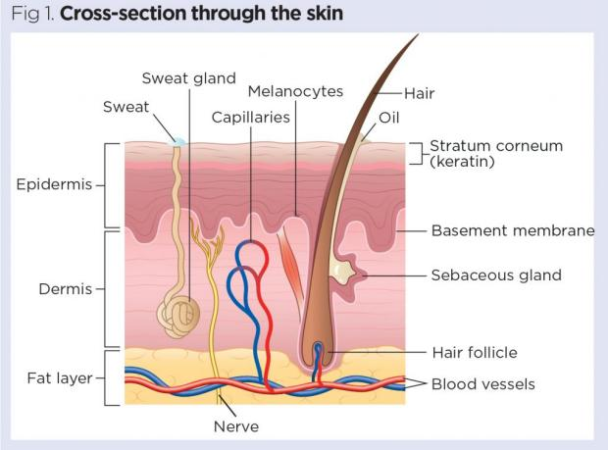  LAYERS OF THE SKIN  The skin is made up of two main layers namely;  The epidermis - This is the outer layer of the skin and it is made up of three layer namely;  - Horny or cornified or The stratum corneum is the outermost layer of the epidermis, and is made up of 10 to 30 thin layers of continually shedding, dead and scaly cells and it is impregnated with protein keratin The stratum corneum is also known as the "horny layer," because its cells are toughened like an animal'. the cells in the cornified layer are constantly being worn out and replaced by cell from the layer below. The horny layer varies in the thickness from one part of the body to the other. It is usually very thick on the sole of the feet and palms and thin on the eyelids.  - Granular layer - This layer consist of living cells produced by the malpighian layer beneath. The cell continue to move up towards the surface of the skin through this layer. In the process they become greatly flattened, accumulate keratin and eventually die.  - malpighian (germinative) layer - This layer consist of actively dividing cells. It contains a pigment called melanin which gives the skin its colour. It also consist of keratin. This layer has many in folding. Some penetrate deep into the dermis to form hair follicle and sebaceous glands. The cells of this layer gets their nutrients and supply of oxygen by diffusion fro the blood in the capillaries found in the dermis.  The dermis -This composed mainly of connective tissue containing;  - Blood capillaries - it brings food and oxygen to the dermal and epidermal cells and remove their waste.  - Sebaceous gland - it secrete sebum an oil substance into the hair follicle. Sebum keeps the hair and the epidermis water proof.  - Hair follicle - it is a deep pit formed by the in-folding of the malpighian layer. The malpighian cells at the base of each pit keeps dividing to produce a long cylindrical hair. The nerve ending in the follicle responses when the hair is touched. A hair erector muscle is attached to each follicle.when we feel cold the hair erector muscle contract and we get goose pimple.  - Sweat glands - it is found in the dermis as coiled tube which continue as sweat ducts that open at the surface of the skin as sweat pores.  - Sensory nerve ending - the skin as a sense organ contains sensory cells which can receive stimuli from internal surrounding and send them to the appropriate parts of the body for interpretation and action.  - Sub- cutaneous fat - below the dermis is a layer of connective tissue which contains variable number of fat cells. This is the sub cutaneous fatty (adipose) tissue. It act as a long term food store as well as an insulating layer that prevents heat loss from the body. | The students ask questions for further clarification. | To create room for slow learners.
Evaluation | The teacher evaluates the students with the following questions: | The students attempt the questions. | To ascertain their level of understanding.
Conclusion | The teacher concludes by coping the note on the board. She checks and marks the note. | The students copy the note on the board. | For future use.
Assignment | Find the Latin names the skin layers. | The students did and submit their assignment for marking and correction. | To encourage the students to study at home.


11/5/2023
Principal Head Instuctor

